**DEVOPS**

DAY – 5

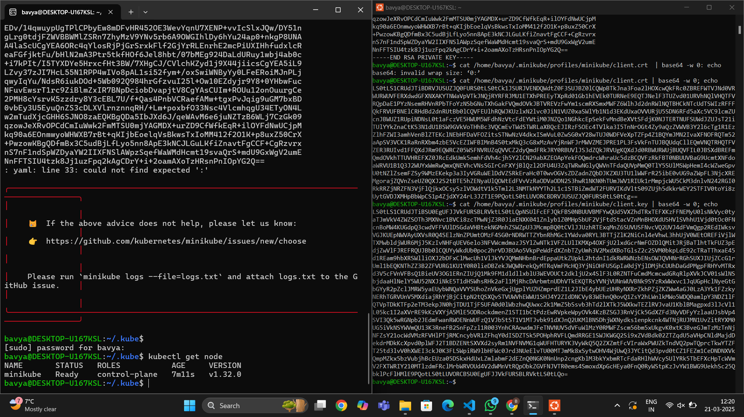

Deployment of Yml

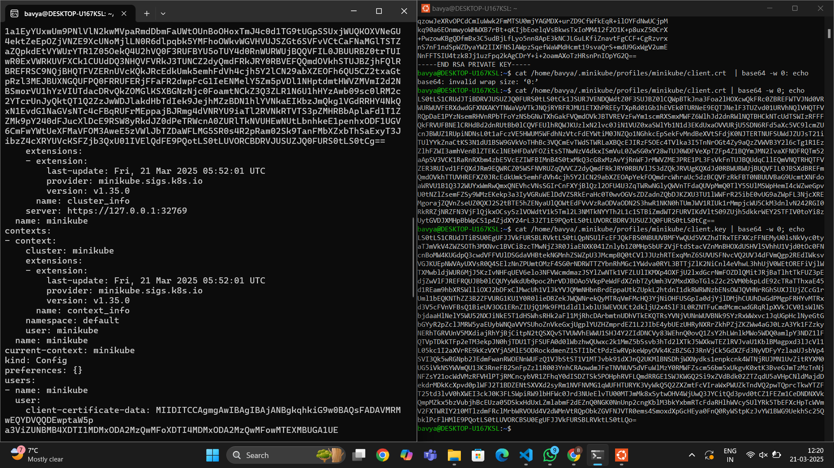

sudo vi config

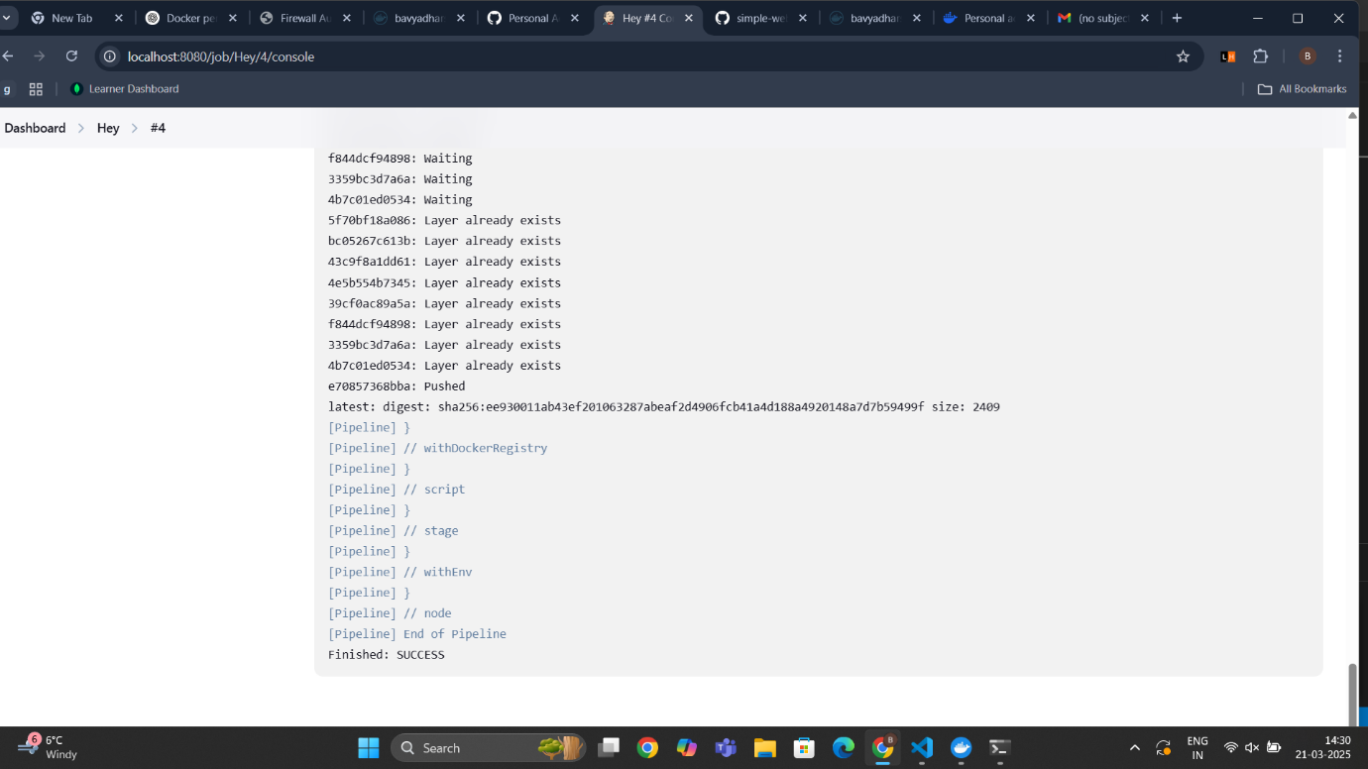 JavaApplication Success Output

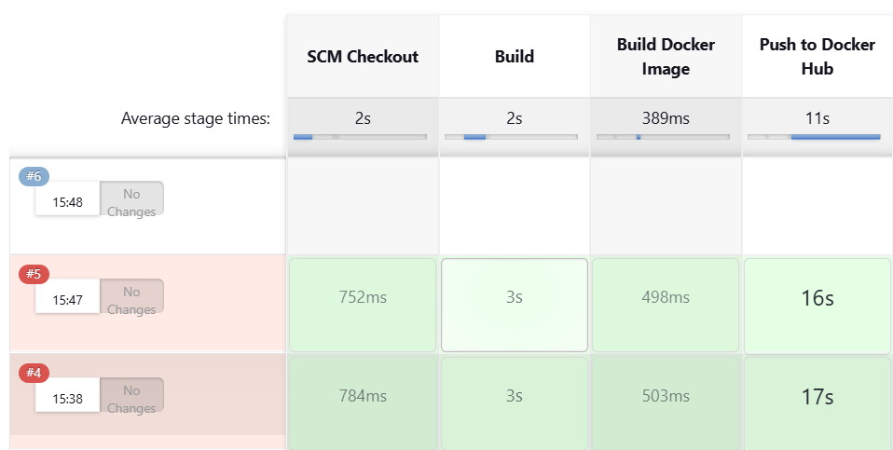

Stage View of Output

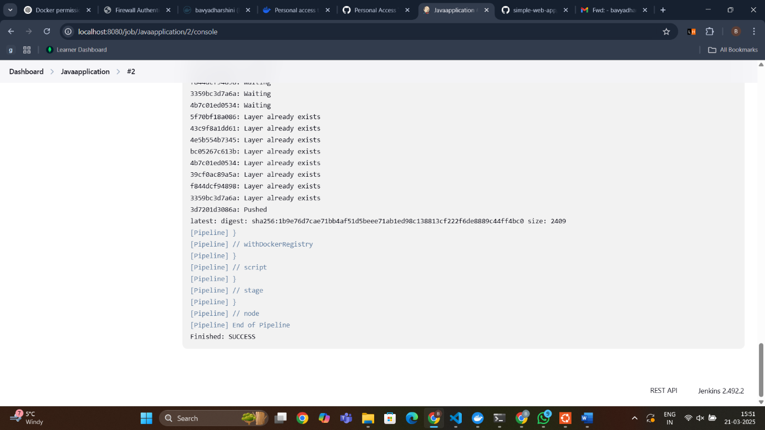

Output

**Visudo:**

1. sudo visudo

2. Add jenkins ALL=(ALL) NOPASSWD: ALL

**ssh installtion:**

1. sudo systemctl restart ssh.service

2. sudo systemctl restart sshd.service

3. sudo apt update

4. sudo apt install openssh-server

5. sudo systemctl restart ssh

6. sudo systemctl status ssh

7. ls /etc/systemd/system/sshd.service or ls /usr/lib/systemd/system/sshd.service

8. sudo systemctl daemon-reload

9. sudo systemctl status ssh

**Deployment:**

1. cd ~/.kube

2. ls

3. cat config

4. sudo vi config

5. i

6. -data

7. cat url | base64 -w 0; echo

8. minikube start

9. kubectl get node

**Pipeline Script:**  
  
pipeline {  
    agent any  
  
    stages {  
        stage('SCM Checkout') {  
            steps {  
                git branch: 'main', url: '<https://github.com/Bavyadharshini-Rajaganapathy/simple-web-app.git>'  
            }  
        }  
  
        stage('Build') {  
            steps {  
                sh 'mvn clean'  
                sh 'mvn install'  
            }  
        }  
  
        stage('Build Docker Image') {  
            steps {  
                script {  
                    sh 'docker build -t bavyadharshini/simplewebapp .'  
                }  
            }  
        }  
  
        stage('Push to Docker Hub') {  
            steps {  
                script {  
                    withDockerRegistry(credentialsId: 'Docker_cred', url: '<https://index.docker.io/v1/>') {  
                        sh 'docker push bavyadharshini/simplewebapp'  
                    }  
                }  
            }  
             
        }  
        stage('test') {  
            steps {  
                withKubeConfig(caCertificate: '', clusterName: 'minikube', contextName: 'minikube', credentialsId: 'minikube_cred', namespace: '', restrictKubeConfigAccess: false, serverUrl: '[https://192.168.39.226:8443](https://192.168.39.226:8443/)')  
                sh 'kubectl apply -f deployment.yml --validate=false'  
            }  
            }  
    }  
}