Лабораторна робота №4

Код

<!DOCTYPE html>

<html>

<head>

  <meta charset="utf-8">

  <title>JS Bin</title>

</head>

<body>

  <input type="number" id="num">

  from <select id="from"></select> to

  <select id="to"></select> =

  <span id="result"></span>

  <script>

    var Money = function(symbol, value){

  this.symbol = symbol;

  this.value = value;

}

var arr = [

  new Money("$", 27.2),

  new Money("₽", 3.33333),

  new Money("¥", 0.24),

  new Money("₴", 1)

];

var numInput = document.getElementById("num");

var fromSelect = document.getElementById("from");

var toSelect = document.getElementById("to");

var resultSpan = document.getElementById("result");

arr.forEach(function(money){

  var option = document.createElement("option");

  option.text = money.symbol;

  fromSelect.add(option);

  option = option.cloneNode();

  option.text = money.symbol;

  toSelect.add(option);

});

numInput.oninput = fromSelect.oninput = toSelect.oninput = function(event){

  var money1 = arr[fromSelect.options.selectedIndex];

  var money2 = arr[toSelect.options.selectedIndex];

  var num = +numInput.value;

  if(!numInput.value.length || isNaN(num)){

    return;

  }

  console.log(numInput.value.length)

  var result = money1.value / money2.value \* num;

  resultSpan.innerHTML = Math.round(result \* 1000) / 1000 + " " + money2.symbol;

}

  </script>

</body>

</html>

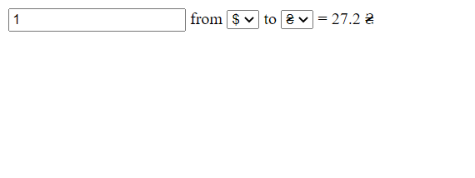

Результат виконаго коду