**REPORT SP1**

**TEAM “LEXICON”**

Contents

**1.** **Overview** 3

**2.** **Code of Conduct** 3

**2.1** **Purpose** 3

**2.2** **When and How This Code Applies** 3

**2.3** **Expected Behaviour** 4

**2.4** **Unacceptable Behaviour** 4

**2.5** **Collaboration and Technical Best Practices** 5

**2.6** **Addressing Challenges and Resolving Disagreements** 5

**2.7** **Academic Integrity and Ethical Conduct** 5

**2.8** **Reporting Issues and Seeking Support** 5

**2.9** **Continuous Improvement** 5

**2.10** **Agreement and Commitment** 5

**3.** **Meeting Notes** 6

**4.** **Personas** 7

**1.1** **Client-Side Persona** 7

**1.2** **Organizer-Side Persona** 8

**5.** **Ethical Considerations** 8

**5.1** **Privacy & Data Protection** 8

**5.2** **Safety & Security of Users** 8

**5.3** **Fairness & Accessibility** 8

**5.4** **Preventing Discrimination & Harassment** 8

**6.** **External Project Links** 8

**1.1 GitHub Repository link** 8

**1.2** **Project Link** 9

# **Overview**

**Group Name**: Lexicon

**Project Name:** PeerRide

**Project Description:** PeerRide is a ride-sharing dynamic web application created to make college students' commutes more economical and efficient. By connecting students going in the same direction, the app allows them to carpool to campus, save money on transportation, and lessen their carbon footprint. Through the application, users may connect with neighbouring students, provide or request transportation, and securely communicate.

**Team Members:**

1. **Bakhtiyor Sohibnazarov – SOH22590018**
2. **Zubair Yusuf –**
3. **Aboubacar Sylla -**
4. **Ismail Abdullahi –**

# **Code of Conduct**

## **Purpose**

Our team is committed to fostering a **safe, inclusive, and collaborative environment** where every member can contribute effectively. We believe that respect, open communication, and teamwork are fundamental to the success of our **Software Engineering Group Project**.

We welcome participation from all members, regardless of:

* Background
* Family status
* Marital status
* Age
* Ability or disability
* Race and/or ethnicity
* National origin
* Socioeconomic status
* Religion or belief system
* Geographic location

Diversity strengthens our work. These guidelines exist to ensure that all team members can **interact, collaborate, and contribute in a supportive and professional manner**.

## **When and How This Code Applies**

This Code of Conduct applies to all project-related activities, including but not limited to:

* **Team meetings** (in-person or virtual)
* **Online communication** (GitHub, email, messaging apps, discussion forums)
* **Project contributions** (code commits, documentation, reviews, discussions)
* **Collaborative spaces** (pair programming, stand-ups, group work sessions)
* **Class presentations and discussions** related to the project

## **Expected Behaviour**

All team members are expected to:

**Be Respectful**

* Treat teammates with kindness and professionalism.
* Be open to feedback and differing perspectives.
* Address disagreements constructively and focus on problem-solving rather than personal criticism.
* Give credit where it is due and acknowledge the contributions of others.

**Communicate Openly and Professionally**

* Use clear, respectful, and inclusive language in all discussions.
* Ensure that feedback is constructive and aimed at improving the project.
* Actively listen and avoid interrupting others.
* If there is a conflict, approach the situation calmly and respectfully.

**Be Inclusive**

* Ensure everyone has a voice in discussions and decision-making.
* Support teammates who may have different communication styles or needs.
* Encourage participation from all team members, including those who may be less vocal.
* Accommodate different learning styles, time zones, and commitments where possible.

**Take Responsibility**

* Complete assigned tasks within the agreed deadlines.
* Keep the team informed of progress and any blockers.
* Ask for help when needed and offer support to teammates when possible.
* Use version control best practices to track changes and contributions properly.

## **Unacceptable Behaviour**

The following behaviours are not acceptable and will not be tolerated:

**Harassment and Discrimination**

Harassment includes offensive comments related to **gender, disability, physical appearance, body size, race, religion, or other personal characteristics**. It also includes deliberate intimidation, stalking, sustained disruption of discussions, and unwelcome physical contact.

**Personal Attacks and Toxic Behaviour**

* Insults, threats, or personal attacks against other team members.
* Dismissing or belittling the contributions of others.
* Public or private harassment in any form.
* Repeatedly interrupting or talking over others.

**Exclusionary Behaviour**

* Deliberately excluding teammates from discussions or decision-making.
* Dismissing feedback without consideration.
* Making participation difficult for others through uncooperative behaviour.

**Unethical Conduct**

* Plagiarism or presenting someone else’s work as your own.
* Failing to properly attribute contributions.
* Submitting misleading or falsified information.
* Violating academic integrity policies.

## **Collaboration and Technical Best Practices**

To ensure smooth collaboration, we follow these principles:

**GitHub Workflow and Version Control**

* Use **GitFlow** for structured development.
* Make **frequent, meaningful commits** with clear commit messages.
* Use **pull requests** and peer reviews before merging code.
* Resolve merge conflicts respectfully and collaboratively.

**Meetings and Decision-Making**

* Attend all scheduled meetings or provide prior notice if unable to attend.
* Use structured agendas and take meeting notes.
* Strive for consensus when making decisions but respect the majority if necessary.
* Assign clear action points after each meeting.

## **Addressing Challenges and Resolving Disagreements**

Conflicts may arise, and our goal is to resolve them in a fair and professional manner.

1. **Direct Resolution:** Discuss concerns openly and respectfully with the person involved.
2. **Team Discussion:** If needed, involve the whole team to find a fair resolution.
3. **Instructor Mediation:** If an issue remains unresolved, seek guidance from the lecturer.

Our focus is always on **finding solutions and maintaining a positive team environment**.

## **Academic Integrity and Ethical Conduct**

We adhere to **university policies on academic integrity** and ensure that:

* All work submitted is **original** and properly cited.
* **Plagiarism, collusion, and academic misconduct** are avoided.
* If unsure about citation practices, team members should **ask for clarification** rather than risk misconduct.

## **Reporting Issues and Seeking Support**

If a team member experiences or witnesses a **breach of this Code of Conduct**, they should:

* Speak privately with the individuals involved (if comfortable doing so).
* Bring the issue to the team for discussion and resolution.
* If needed, escalate the concern to the lecturer for support.

Reports will be handled with confidentiality and respect.

## **Continuous Improvement**

This Code of Conduct is a living document. If any member identifies areas for improvement, they are encouraged to propose changes. Updates will be discussed and agreed upon as a team.

## **Agreement and Commitment**

By participating in this project, each team member **agrees to uphold these principles** and contribute to a **respectful, professional, and effective** team environment.

# **Meeting Notes**

|  |  |
| --- | --- |
| **Date and Time** | 04.02.2025 |
| **Project Name** | PeerRide – A Ride Sharing app to university |
| **Meeting Goal** | * Agree code of conduct * Agree group name * Choose project * Assigning tasks |
| **Facilitator** | Bakhtiyor Sohibnazarov |
| **Note taker** | Ismail Abdullahi |
| **Attendees** | * Bakhtiyor Sohibnazarov * Zubair Yusuf * Aboubacar Sylla * Ismail Abdullahi |
| **Roundtable Updates** | * Discussion of use of GitHub and Git version control systems. * Discussion of running docker container. |
| **Discussion points** | * Git and GitHub will be used to track changes in the code. * Each Team Member will have their own branch in GitHub repository. Team Members should pull changes from master branch before merging. |
| **Actions** | * Bakhtiyor Sohibnazarov – Set Up GitHub Repository, Backlog, Kanban Boards, Code of Conduct and final pdf file for submission * Aboubacar Sylla – Review and upload scaffolding files * Ismail Abdullahi – Car Owner Side Persona * Zubair Yusuf – Student Side Persona |

# **Personas**

## **Client-Side Persona**

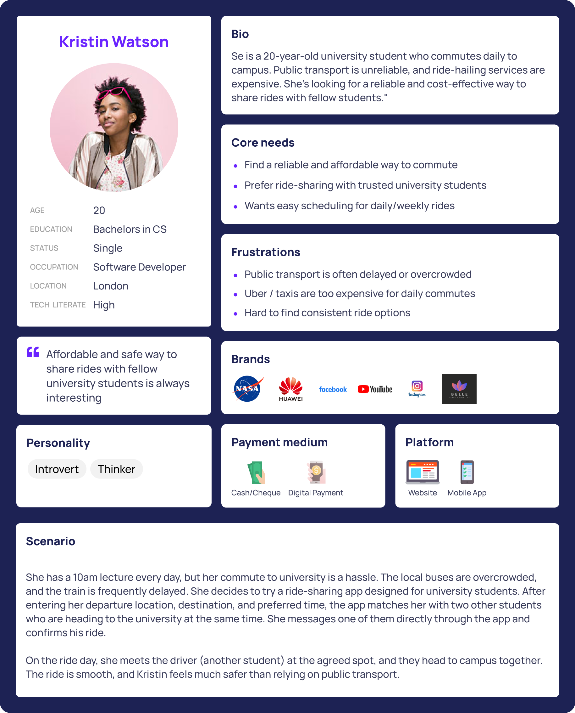

## **Organizer-Side Persona**

Here Should Be image of Persona

# **Ethical Considerations**

## **Privacy & Data Protection**

**Issue:** Collecting and storing personal data must be done securely and with consent.

**Solution:**

Use encryption for sensitive data.

Implement GDPR-compliant privacy policies.

Allow users to delete their data upon request.

## **Safety & Security of Users**

**Issue:** Users must feel safe when carpooling with strangers.

**Solution:**

User verification (e.g., university email sign-up).

Allow ratings and reviews for drivers and passengers.

Implement an SOS/emergency contact feature.

## **Fairness & Accessibility**

**Issue:** Ensuring equal access for all students, including those with disabilities.

**Solution:**

Allow users to filter rides based on accessibility needs.

Ensure UI is accessible (clear fonts, etc.).

## **Preventing Discrimination & Harassment**

**Issue:** Users may experience discrimination or harassment.

**Solution:** Implement a code of conduct and reporting system.

Have strict policies against discrimination.

# **External Project Links**

## **1.1 GitHub Repository link**

Lexicon: <https://github.com/Baxa0104/Lexicon>

## **Project Link**

Project: <https://github.com/users/Baxa0104/projects/1>