Is *grade inflation* in climbing real?

PRA2026

Samuel Badin

[s.badin@student.maastrichtuniversity.nl](mailto:s.badin@student.maastrichtuniversity.nl)

Table of Contents

Introduction 3

Methods 4

Data 4

Analysis 4

Results 5

Bibliography 6

Appendices 7

# Introduction

Just like any other sport, there is a certain aspect of competitiveness imbued in climbing. No matter their motivations climbers usually feel a sense of accomplishment after overcoming themselves and pushing their grades further. And with the world being as digital as ever, there is no lack of climbing related content to be found online. Through this, people often get exposed to the climbing scene in distant countries. It can be confusing or even demotivating seeing someone online, who appears to perform like a beginner, climb routes apparently graded miles higher than your own personal best. Now this could be attributed to the ‘glorifying’ social media effect, but is there any statistical significance? In this paper I will attempt to tackle the age-old question; Would that really be a V2 in your gym?

# Methods

## Data

The data used for the project was acquired online from Kaggle (reference), it is a cleaned-up version of raw data scraped of 8a.nu, a website which allows climbers to log their data, ascents and detail to see their progress and compare and compete with others. The clean data was created by Jordi Zaragoza (reference). It consists of 3 files;

climber_df

A data frame containing the information uploaded by users about themselves

routes_rated

A data frame containing information about outdoor climbing routes in different countries

grades_conversion_table

A data frame containing the conversion between numerical grading used in the files and the French numerical grading system

## Analysis

The analysis was conducted using the R programming language and the related software RStudio. (reference) A Dunnett test supported by the ‘multcomp’ library was used to compare the significance of differences between the mean grades logged by climbers per country and the mean grades of the climbing routes for that country. All the figures observed below were produced using base R.

# Results

Most climbers express a lower performance in comparison to French climbers, these results show strong significance. On the other hand, almost all routes per country show lower mean grading than France with high significance, expcept for; CZE, DNK, FIN, NLD, which have insufficient data entries.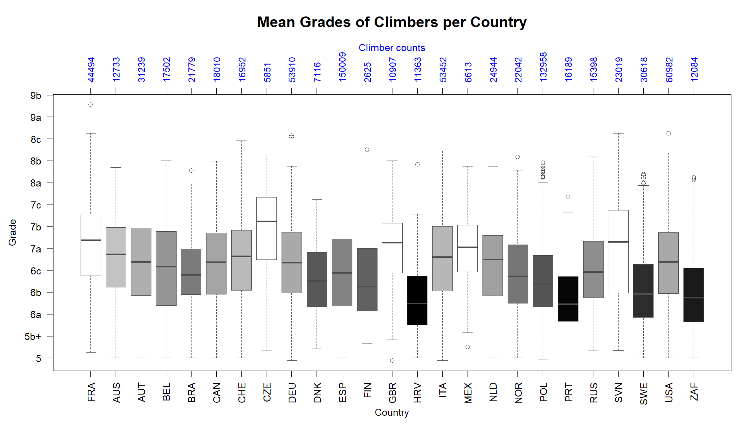

Figure 1

A depiction of differences in climber grades per country in comparison to France. All significant results are shaded grey to black based on magnitude of difference. 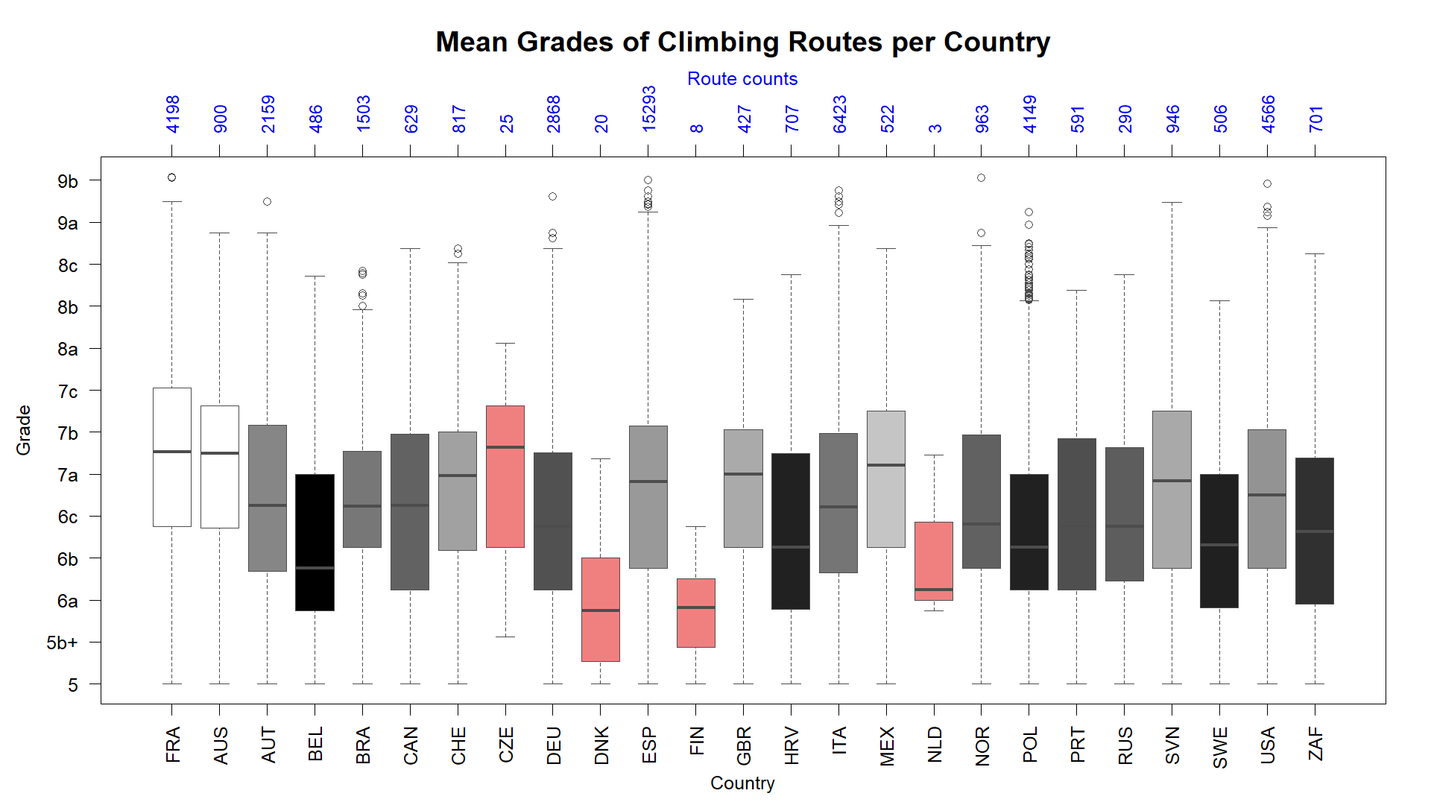

Figure 2

A depiction of differences in grades of climbing routes per country in comparison to France. All significant results are shaded grey to black based on magnitude of difference. Red represents invalid countries due to insufficient data (n<30)

## Discussion

While there are many limitations, mentioned below, which don’t allow for conclusions to be drawn. The data suggests that for countries like; GBR, MEX, and SVN, the grading may be soft. As the climbers keep up with the French standard for grades climbed, but, the average grading for routes in their country is significantly lower. This could indicate that their perceived performance seems higher than it actually is, as the routes are graded harder than they should be. With the assumptions that both climbers and routes follow normal distributions. This would mean that the average climbers in GBR, MEX and SVN are significantly stronger than they statistically should be. On the other hand, the results for AUS may indicate stiff grading, as the performance of the climbers appears lower while the grading is up to par with the French routes. Other countries also show differences, but less major.

Limitations

The main limitations lie in the data and cultural standards:

There is no proof checking, allowing for people to enter untrue data. A more significant issue is an observable mismatch as the routes are only outdoors, while climbers can also log indoor ascents, where the grading is decently different for bossiness reasons, and nowadays, indoor climbing in comparison to outdoor climbing is almost a different sport. Another limitation is sample bias, as climbers may not log their warmup accents, also, not all climbers log, creating a possible skew as only more motivated and experienced climbers participate.

Different countries participate in outdoor climbing less or more than the others, skewing the results. Also, the ascent climbers log are in no way limited to being in their country, leaving no way of knowing where they are located or climb. Especially for countries like NLD and DNK which have no actual routes outdoors, their climbers either log indoor or travel abroad.

# Bibliography

# Appendices

## Data

The data can be found at the original source of:

<https://www.kaggle.com/datasets/jordizar/climb-dataset>

## Scripts