Objective | Passionate Tourism and Hospitality graduate seeking a challenging position in the hospitality industry. |  |  |  | 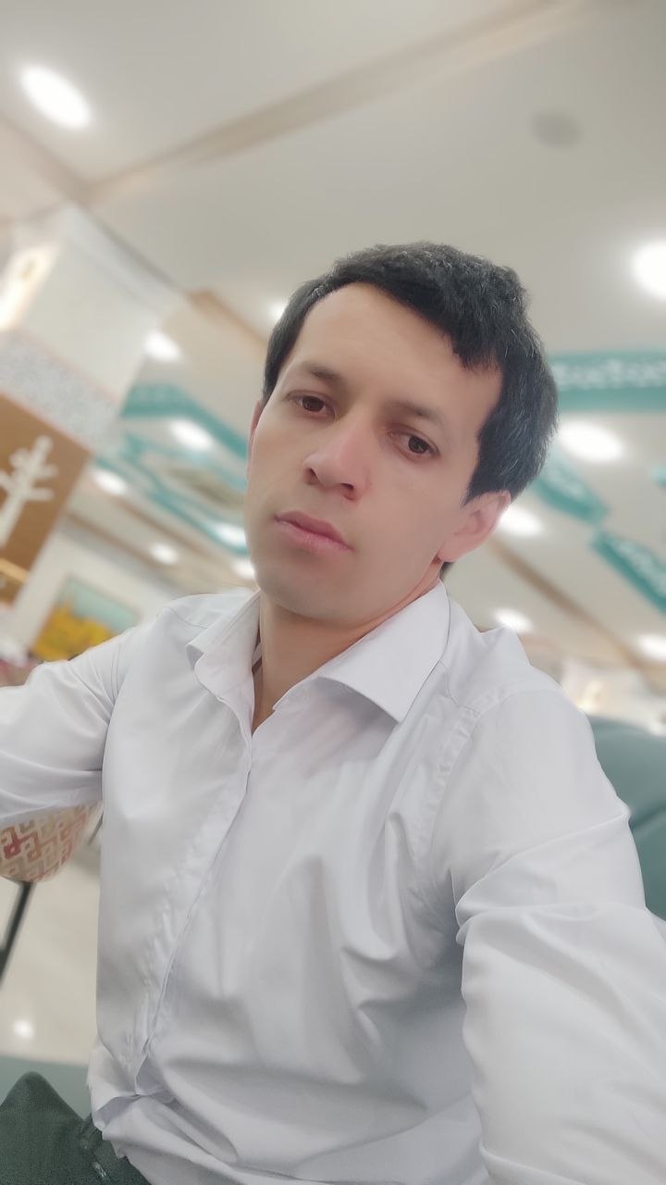
Name | ABDULLO G'UlOMOV |  | Day of Birth | 12 09 1997
Height | 160CM |  | Education | Tourism and Hospitality
Telephone | + 998 93 908-12-97 |  | Wechat
E-mail | abdullogulomov33@gmail.com
Address | Tashkent, Uzbekistan
EDUCATION BACKGROUND
WORK EXPERIENCE
Sales Assistant / Cashier Korzinka Supermarket — Tashkent, Uzbekistan 2022 – 2025 (3 years)
- Provided excellent customer service to hundreds of customers daily in a fast-paced retail environment.
- Developed strong communication and problem-solving skills while handling customer inquiries and complaints.

SKILLS AND AWARD
• Customer Service Excellence
• Communication and Interpersonal Skills
• Tour Guiding & Organization
• Foreign Languages: Russian (Intermediate)

ABOUT ME
Energetic and service-oriented Tourism and Hospitality student with a genuine passion for creating memorable guest experiences. I possess strong communication skills and the ability to work effectively in multicultural environments. Quick learner and adaptable professional who is ready to bring positive energy and dedication to the hospitality industry.

RESUME

