* **Stata dataset: EuroStat_Enterprise_Statistics.dta**

Link: <https://ec.europa.eu/eurostat/databrowser/view/SBS_SC_SCA_R2/default/table?lang=en>

Click on Download, select the option Full dataset.

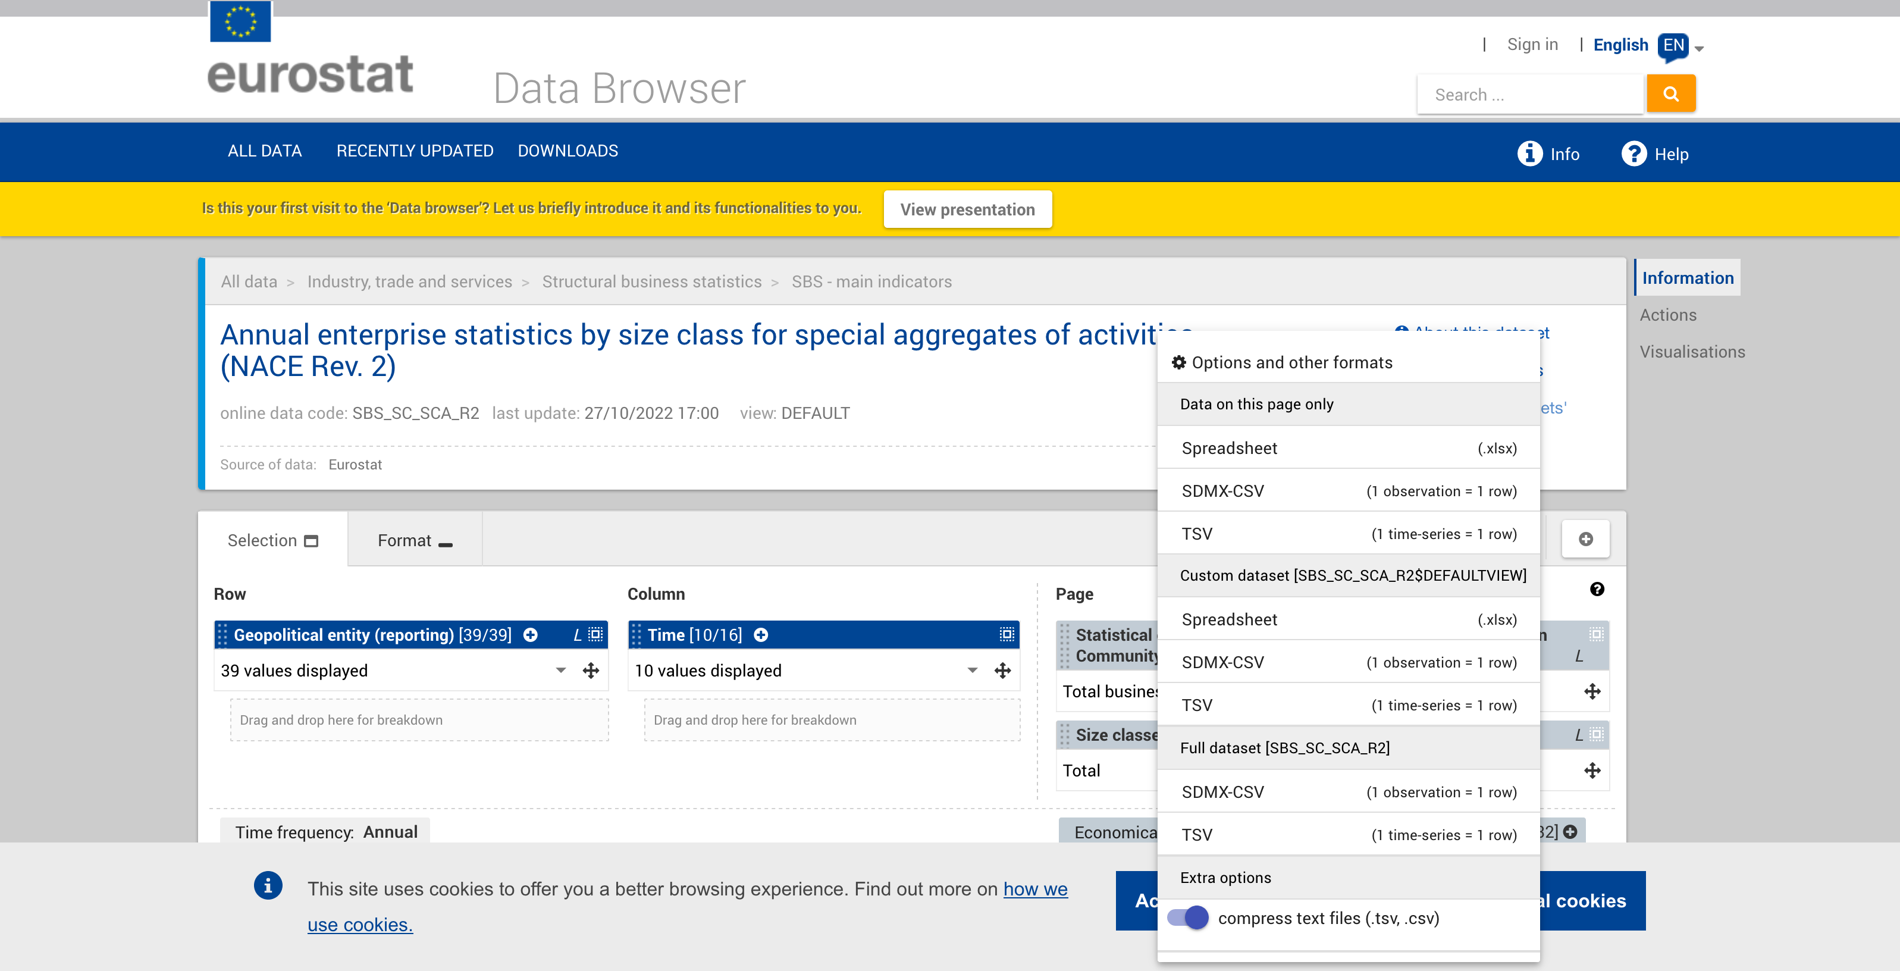

This will download a csv file. To obtain the stata dta file required for calculations follow the next steps:

1. Decompress the .gz file downloaded, and rename the file to “EuroStat_Enterprise_Statistics_RAW”.
2. Use the file “EuroStat_Annual_Enterprise_Statistics_Cleaning.py” modifying the path for the input file, and the output files. The input and the output files are .csv files.
3. Run the “EuroStat_Enterprise_Statistics_Cleaning.do” to get the “.dta” file with the Eurostat database in a panel version that now matches the OB setup.
4. The output file from step 3 is now the input for the “EuroStat_Enterprise_Statistics.do” file, which creates the graphs and tables:
   * **TABLE: EuroStat: Share of Employment by EuroStat Size Categories**
   * GRAPH (not in the report): EuroStat_BySizeCat_ShareEmployment.pdf
   * GRAPH (not in the report): EuroStat_BySizeCat_nFirms.pdf
5. The output file from step 3 is now also the input for the “OB_Employment_Firms_EuroStat_comparison.do” and the “OB_Employment_Firms_EuroStat_Yearly_Comparison.do” files, which create the graphs and tables (in a yearly fashion for the latter file)
   * **GRAPH: Orbis v. EuroStat: Share of Employment by Size Category**
   * **GRAPH: Orbis v. EuroStat: Number of Employees by Size Category**
   * **GRAPH: Orbis v. EuroStat: Number of Firms by Size Category**
   * **GRAPH: Orbis v. EuroStat: Number of Firms by Size Category - Zooming in big firms.**

* **Stata dataset:** **EuroStat_Ownership.dta**

**Link** [**https://ec.europa.eu/eurostat/databrowser/view/acf_s_own/default/table?lang=en**](https://ec.europa.eu/eurostat/databrowser/view/acf_s_own/default/table?lang=en)

This will download a csv file. To obtain the stata dta file follow the next steps:

1. Decompress the .gz file downloaded, and rename the file to “EuroStat_Ownership_RAW_Enterprise_Statistics_RAW”.
2. Use the file “EuroStat_Ownership.do” modifying the path for the input file, and the output files. The input is a csv file and the output files is a dta file.

* **Stata dataset:** **EuroStat_Success_Finance.dta**

**Link** [**https://ec.europa.eu/eurostat/databrowser/view/acf_d_eq/default/table?lang=en**](https://ec.europa.eu/eurostat/databrowser/view/acf_d_eq/default/table?lang=en)

This will download a csv file. To obtain the stata dta file follow the next steps:

1. Decompress the .gz file downloaded, and rename the file to “EuroStat_Financial_Access_RAW”.
2. Use the file “EuroStat_Financial_Access.do” modifying the path for the input file, and the output files. The input is a csv file and the output files is a dta file.

* **Stata dataset:** **EuroStat_Enterprises_Managed_Founder.dta**

**Link:** [**https://ec.europa.eu/eurostat/databrowser/view/FOBS_AGE/default/table?lang=en**](https://ec.europa.eu/eurostat/databrowser/view/FOBS_AGE/default/table?lang=en)

This will download a csv file. To obtain the stata dta file required for calculations follow the next steps:

1. Decompress the .gz file downloaded, and rename the file to “EuroStat_Firms_Managed_Age_entrepreneur_RAW”.
2. Use the file “EuroStat_Firms_Managed_Age_entrepreneur.py” modifying the path for the input file, and the output files. The input and the output files are .csv files.
3. Run the “EuroStat_Firms_Managed_Age_entrepreneur.do” to get the “.dta” file with the Eurostat database in a panel version that now matches the OB setup.

* **Stata dataset:** **EuroStat_Business_Demography_LegalForm.dta**

Link: <https://ec.europa.eu/eurostat/databrowser/view/SBS_SC_SCA_R2/default/table?lang=en>

Click on Download, select the option Full dataset.

This will download a csv file. To obtain the stata dta file required for calculations follow the next steps:

1. Decompress the .gz file downloaded, and rename the file to “EuroStat_Business_Demography_LegalForm_RAW”.
2. Use the file “EuroStat_Business_Demography_LegalForm.py” modifying the path for the input file, and the output files. The input and the output files are .csv files.
3. Run the “EuroStat_Business_Demography_LegalForm.do” to get the “.dta” file with the Eurostat database in a panel version that now matches the OB setup.

* **Stata dataset: EuroStat_Business_Demography_SizeClass.dta**

Link: <https://ec.europa.eu/eurostat/databrowser/view/BD_9BD_SZ_CL_R2/default/table?lang=en&category=sbs.bd>

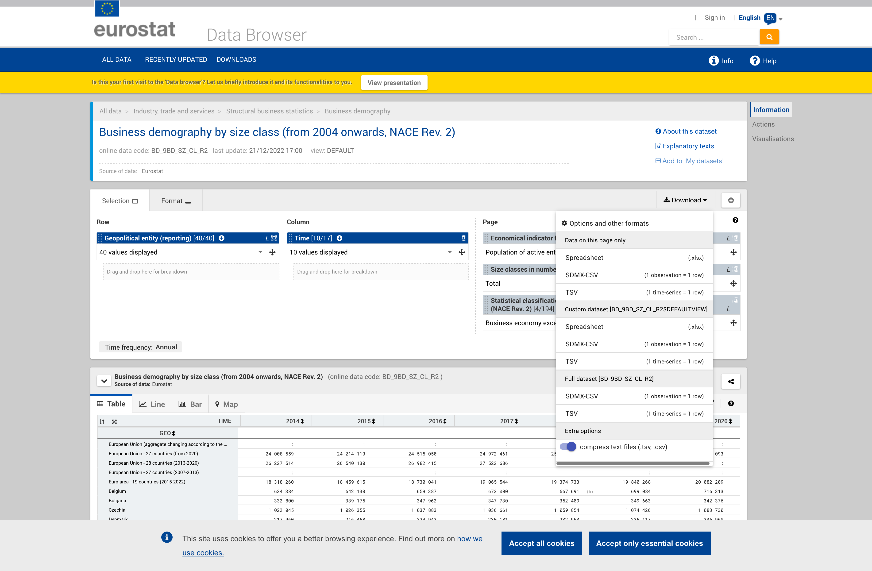

Click on Download, select the option Full dataset.

This will download a .csv file. To obtain the Stata “.dta” file required for processes, follow the next steps:

1. Decompress the .gz file downloaded, and rename the file to “Business_Demography_SizeClass_RAW”. This file is too big to add, so I kept it compressed.
2. Use the file “Business_Demography_SizeClass_Cleaning.py” modifying the path for the input file, and the output files. The input and the output files are .csv files.
3. Run the “Business_Demography_SizeClass_Cleaning.do” to get the “Business_Demography_SizeClass.dta” file (in the Data_Cleaned folder) with the Eurostat database in a panel version that now matches the OB setup.