PopulationSim 2023 County Analysis
County-Level Performance and Distribution Analysis
Generated: November 19, 2025

This report contains county-level performance analysis for the Bay Area 9-county region. Charts show control versus result comparisons, performance metrics, and demographic distributions at the county geography level.

County Performance Summary
County | Control Total | Result Total | Difference | Diff % | MAE
San Francisco | 396,119 | 395,670 | -449 | -0.113% | 4,128.4
San Mateo | 275,368 | 275,352 | -16 | -0.006% | 2,719.5
Santa Clara | 687,503 | 687,199 | -304 | -0.044% | 6,348.5
Alameda | 635,505 | 634,945 | -560 | -0.088% | 6,520.1
Contra Costa | 413,812 | 413,706 | -106 | -0.026% | 4,276.8
Solano | 158,312 | 158,276 | -36 | -0.022% | 1,337.0
Napa | 52,721 | 52,718 | -3 | -0.006% | 344.7
Sonoma | 193,977 | 194,051 | 74 | 0.038% | 1,677.1
Marin | 106,933 | 106,762 | -171 | -0.160% | 1,000.7

Performance Overview

Performance Overview


Variable Heatmap
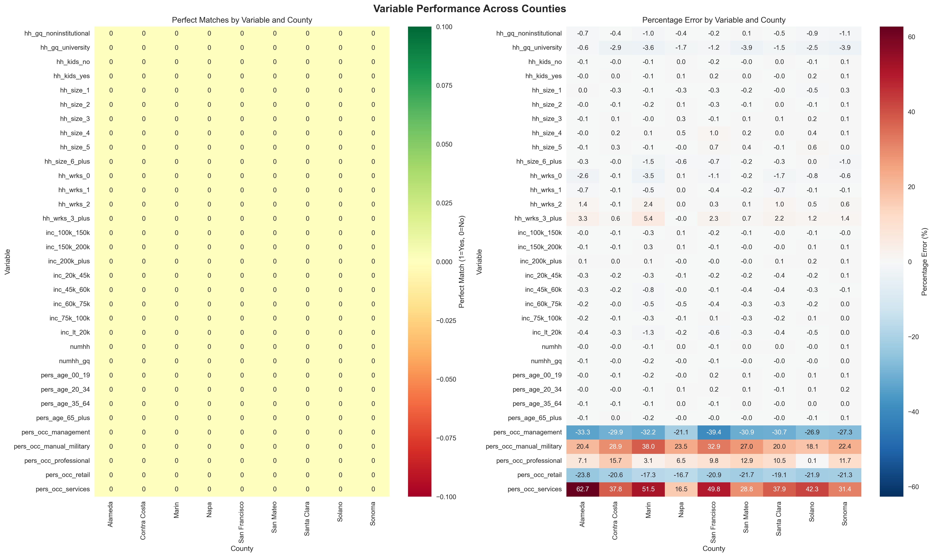

Demographic Analysis

Household Size
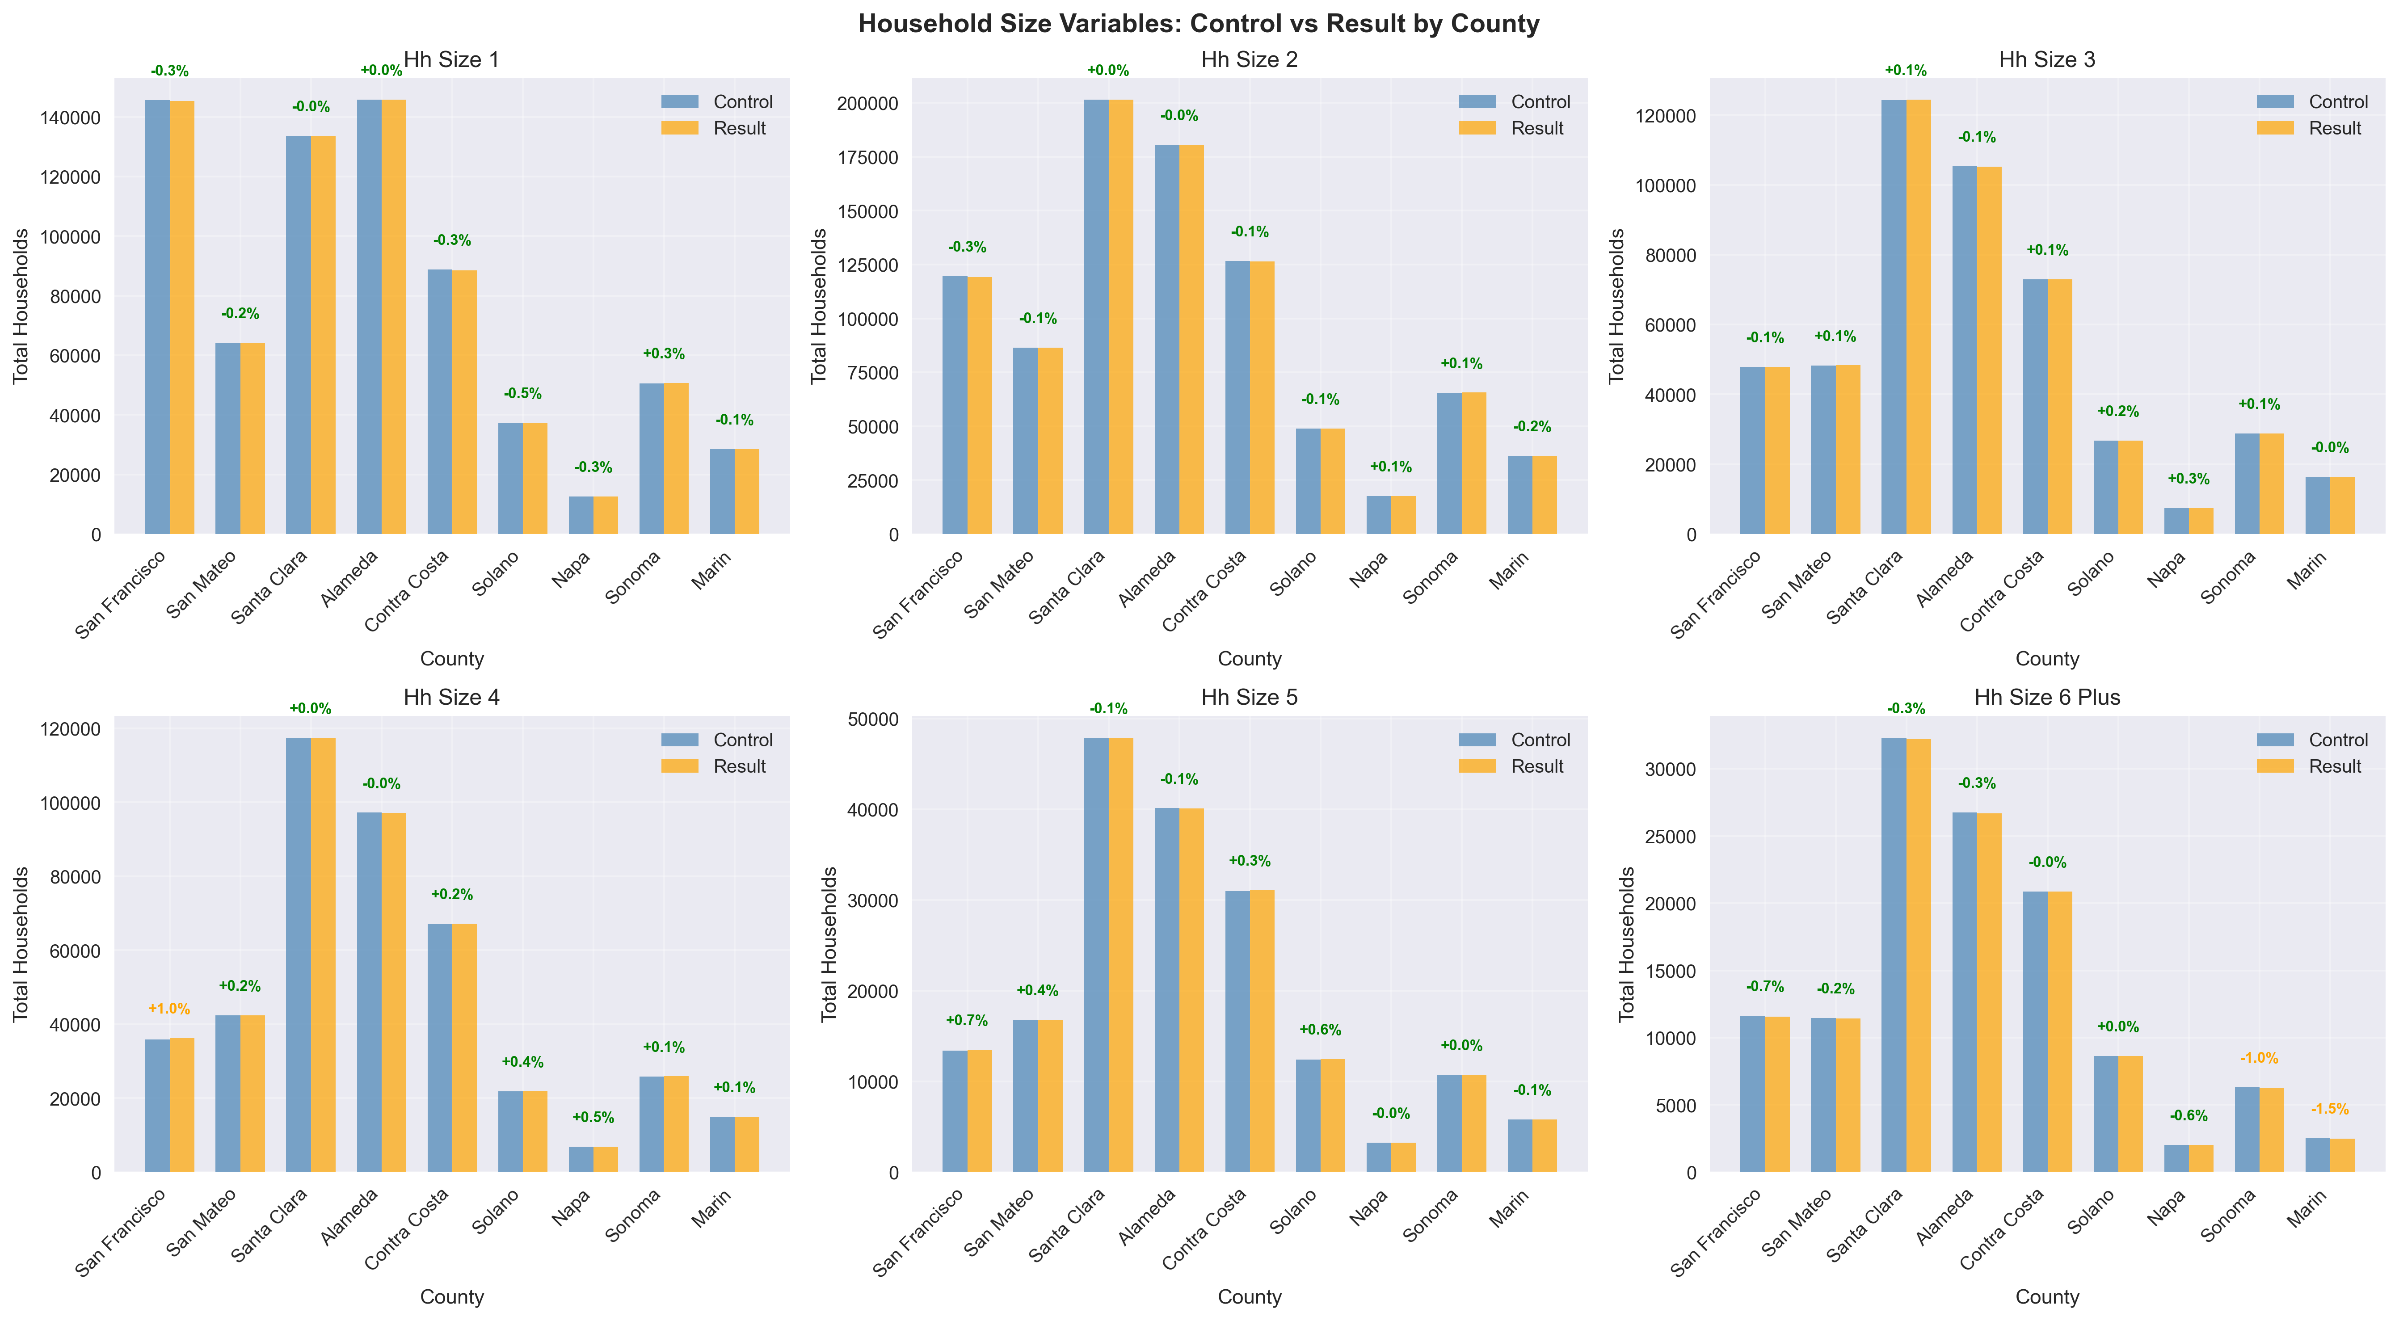

Workers
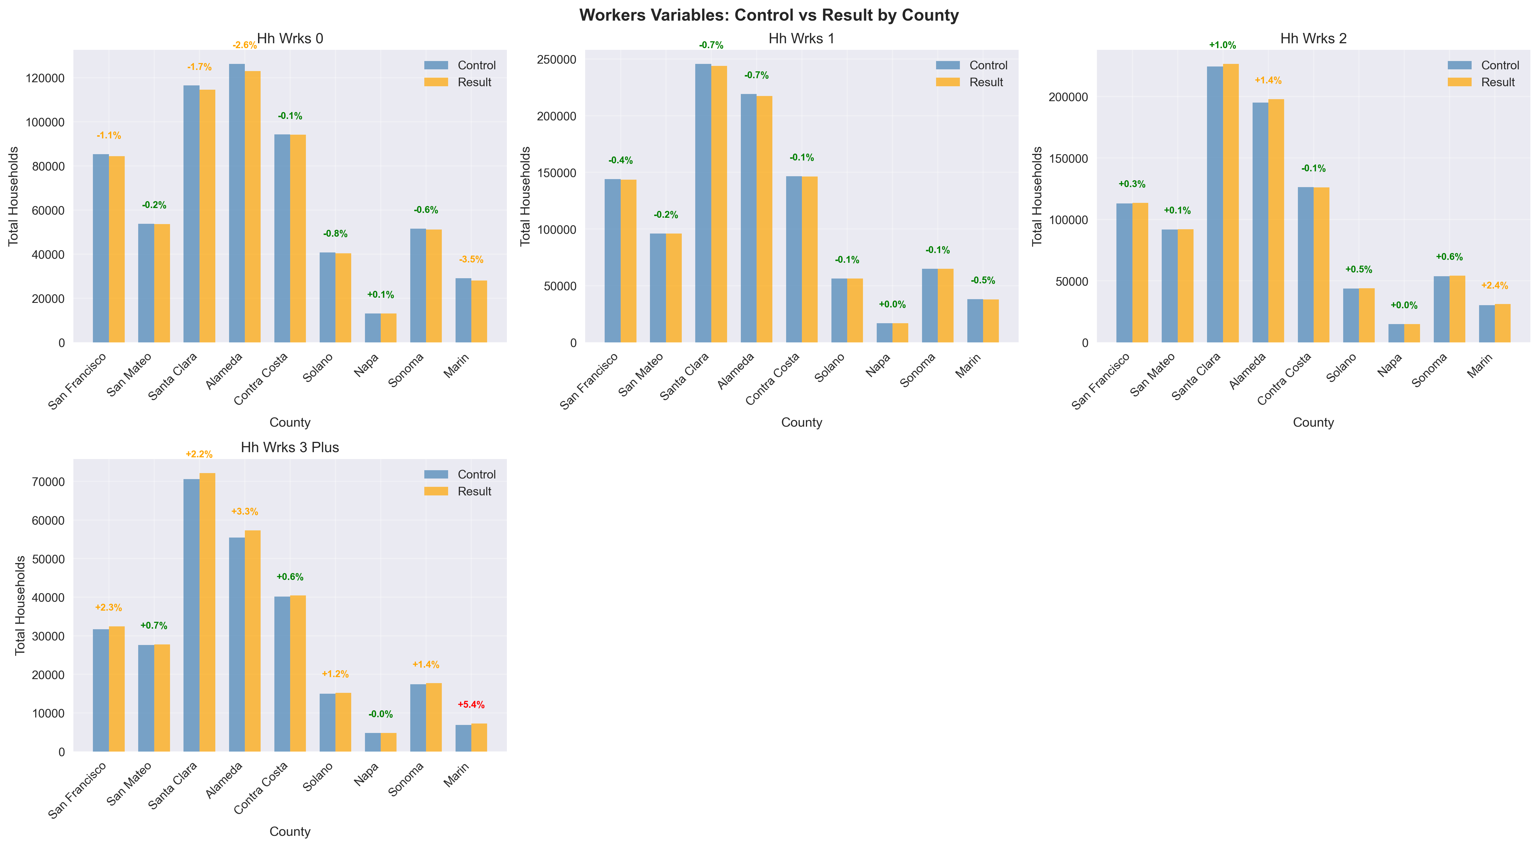

Income
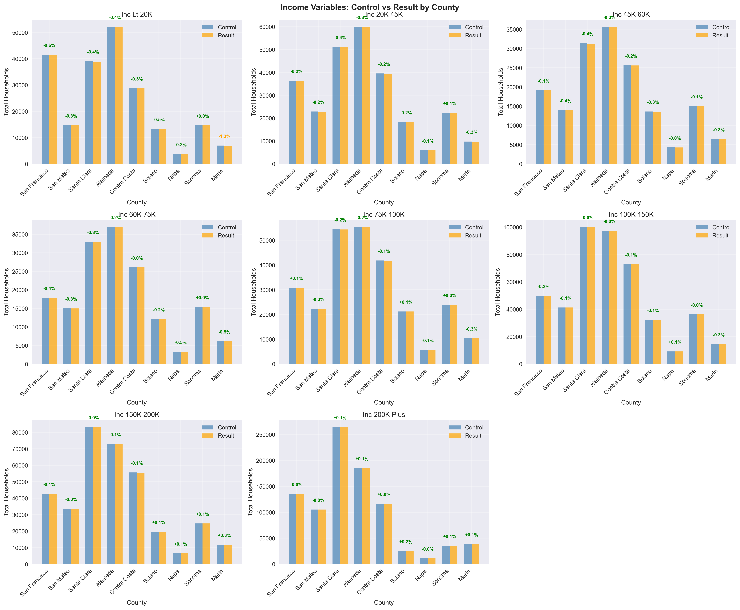

Detailed Variables

Age Groups
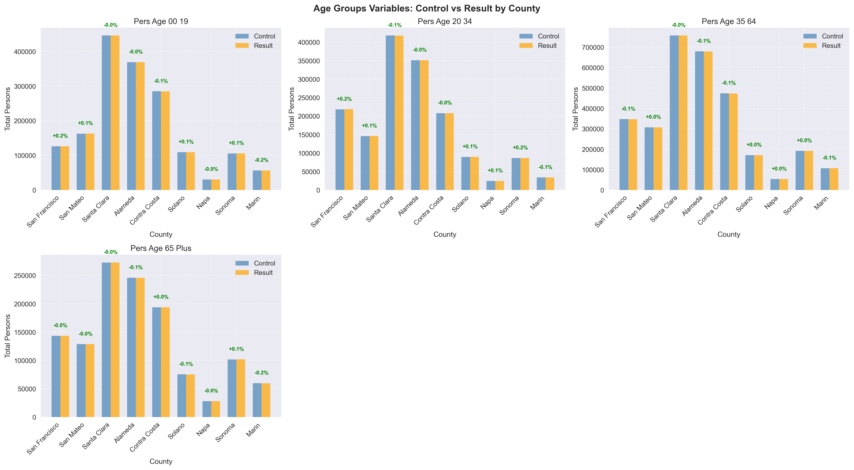

Group Quarters
