DAF Handbook

The common-daf-v2 project contains the DAF version 2 source code.
The common-daf-v2-tests project contains a small DAF test application named “testapp”.

DAF Overview
A DAF cluster is defined by the contents of a daf.properties file and is both an administrative and application specific delineation.

Administratively, DAF will manage queues and tasks across the nodes in a single cluster. Applications can be started and stopped within a cluster and runtime information such as the number of tasks running and messages queued can be reported.

From an application perspective, all the nodes in the cluster can be used to run tasks. If a particular task specifies that it will be run on all nodes in the cluster then DAF will start that task on nodes in the defined cluster.

An application running in a cluster is defined by an application specific properties file. This implies that an application runs in the context of a cluster and can use nodes in that cluster.

Logically, there are two ways to approach configuring DAF clusters and subsequently running applications in a cluster. Figures 1 and 2 below, show these options.

Figure 1 shows a cluster of 4 nodes (i.e. Java VMs) with two applications running. Each application is running on two nodes in the cluster and nodes are not being shared between applications.

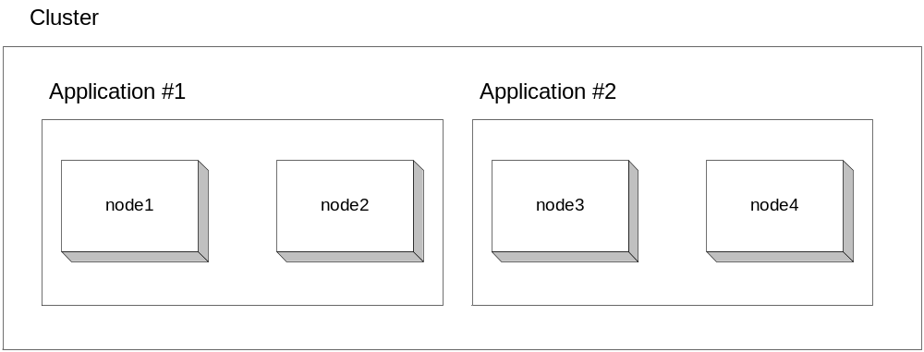

Figure 1 Single DAF Cluster with Multiple Applications

Because most applications are CPU bound, running multiple applications on the same node will cause the Tasks to compete for CPU and memory. This degrades the overall quality of service that each application will experience.
Figure 2 shows two clusters, each running a single application. In this case the clusters are completely separate and the applications are completely isolated.

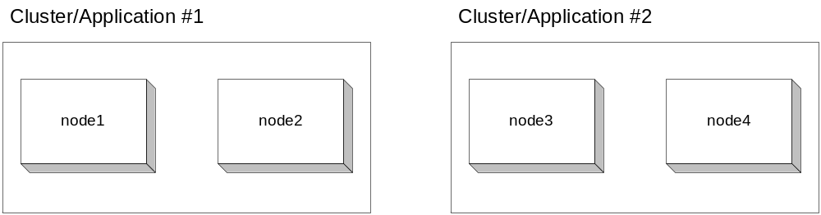

Figure 2 Multiple DAF Clusters with Multiple Applications

Because a cluster is an administrative entity, meaning application metrics can be gathered and reported for the cluster, there is some benefit to running multiple applications in as single cluster. In this case, it’s probably beneficial to separate the applications so they are dedicated to separate nodes in the cluster. This guarantees the best possible quality of service for each task running in each application.

Running the Test Application
A small test application is provided in the common-daf-v2-tests project. Scripts for starting nodes and starting an application are in the common-daf-v2\bin directory. Because your daf application is located in a separate directory you must first set 2 environment variables: BASEDIR and CONFIGDIR. Remember that you must open a new command window for each node that you are starting and set the environment variables in those windows before calling the other commands.

Step 0 – Set BASEDIR and CONFIGDIR in the current command window
Open a command window and set the environment variables:

BASEDIR should point to the location of your common-base and common-daf-v2 projects. For example: set BASEDIR=c:/code/JavaModules/

CONFIGDIR should point to the location of your daf.properties file and your application-specific daf properties file (i.e. daf.properties and testapp.properties)
Example: set CONFIGDIR=c:/code/JavaModules/common-daf-v2-tests/config

Step 1 – Start Node1 – repeat steps 0 and 1 for the number of nodes in your cluster (defined in the daf.properties file)
The test cluster has 2 nodes in it. To start node 1, run the “startNode” batch file:

..\common-daf-v2\bin>startNode node1

The parameter “node1” is the name of the node. The name given on the command-line should match one of the names used in the daf.properties file. Repeat step 0 and 1 for node 2.

Step 2 – Start Cluster and Start Application
Open a new command window.

Use the “runCommand” batch file to run the “startCluster” command to start the daf cluster.

..\common-daf-v2\bin>runCommand -startCluster

Use the same “runCommand” batch file to run the “startApplication” command and supply the name of the application properties file as a parameter:

..\common-daf-v2 \bin>runCommand.cmd -startApplication testapp

This will cause an instance of the administrative node to be started which in turn reads the testapp.properties from the current classpath and then sends a message to node2.

Step 3 – Stop Application
Use the “runCommand” batch file to stop the same application:

..\common-daf-v2\bin>runCommand -stopApplication testapp

You must use a Ctrl-C to terminate the “startNode” command for
each node you started. (Ctrl-C in each command window that you opened)

# ===================================================================
# DAF properties
# ===================================================================

# -------------------------------------------------------------------
# Administrative properties
#
adminServerPort = 7000
adminServerContentDir = /files/workspace/common-daf-v2-tests/src/html

connectonRetryTime = 1000
receiveWaitTime = 5000
defaultQueueSize = 1000
timeToLive = 1200000

# -------------------------------------------------------------------
# Node definitions
#
nodeList = node1,node2

node1.address = localhost
node1.messagePort = 9000
node1.adminPort = 8000

node2.address = localhost
node2.messagePort = 9001
node2.adminPort = 8001

Figure 3 DAF Properties File for Test Cluster

# ===================================================================
# Test Application Properties
#
# The test application contains two tasks which run on the same node
# and access a remote queue. One tasks publishes messages to the
# queue while the the other task removes messages.
# ===================================================================

# -------------------------------------------------------------------
# Classpath to application classes and properties files
#
classpath = /files/workspace/common-base/build/classes, \
/files/workspace/common-daf-v2/build/classes, \
/files/workspace/common-daf-v2-tests/build/classes

# -------------------------------------------------------------------
# Task Definitions
#
taskList = MasterTask, WorkerTask

MasterTask.className = com.pb.common.daf.tests.SampleMasterTask
MasterTask.queueName = ResultsQueue
MasterTask.nodeName = node1

WorkerTask.className = com.pb.common.daf.tests.SampleWorkerTask
WorkerTask.queueName = WorkQueue
WorkerTask.nodeName = node2

# -------------------------------------------------------------------
# Queue Definitions
#
queueList = WorkQueue, ResultsQueue

WorkQueue.nodeName = node1
WorkQueue.size = 1000

ResultsQueue.nodeName = node2
ResultsQueue.size = 1000

Figure 4 Test Application Properties File

