Overview
A simple text file is used as a “command file” and serves as a distributed communication mechanism. Each machine in a DAF cluster will run an instance of the FileMonitor class in a small Java VM. This class monitors the command file for changes. When a change in the last-accessed-time attribute is detected, the FileMonitor class reads the contents of the file and executes the commands found in the file.

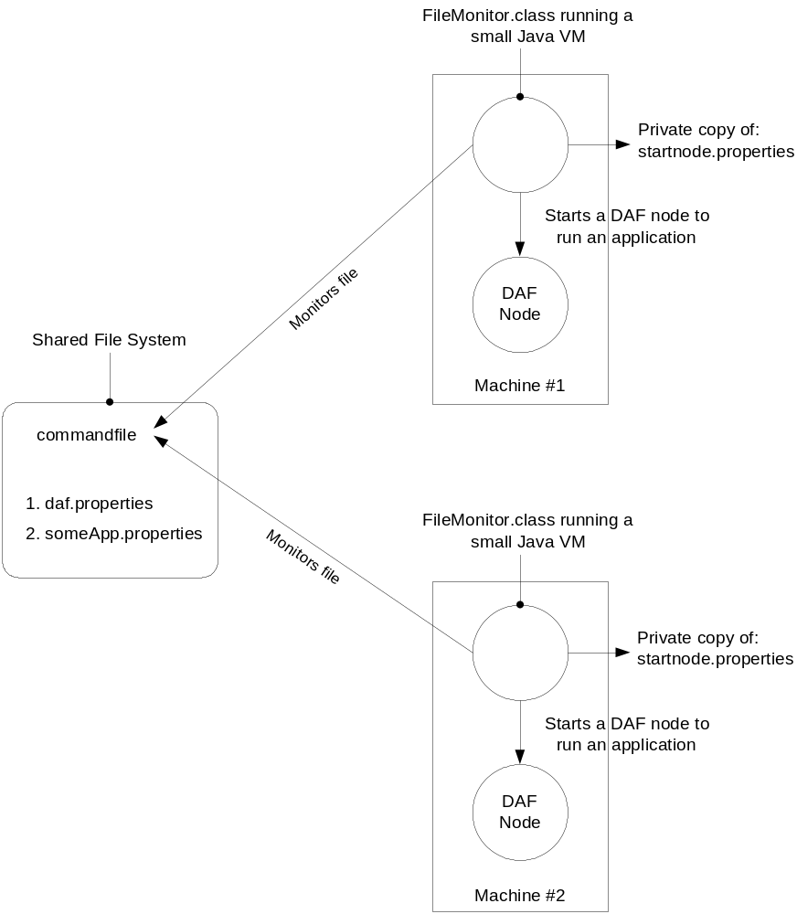

Command File
The command file is a text file with any valid file name. The picture above uses a filename of “commandfile”. The name of the command to run is supplied in the file on the first line. Some commands require a parameter which is provided in the file on the second line.

Valid commands in command file:

1. StartNode
Starts a DAF node running. The contents of the startnode.properties file are used to start the underlying Java VM with the desired properties. (See details on this file below).

2. StartCluster
nodeName
Starts a DAF cluster based on the contents of the shared daf.properties file that each FileMonitor class finds in the classpath. Note, an application has not been started yet. The nodeName parameter determines which node will start the cluster. A valid nodeName from the daf.properties file must be listed as the second line when this command is used.

3. StartApplication
applicationName
Starts an application running. The applicationName parameter is the name of the application properties file without the .properties extension.

4. StopNode
Stops the DAF node running on all the machines monitored by the FileMonitor class. Has the effect of stopping any running applications in the node as well.

5. StopMonitor
Shuts down the FileMonitor class. A manual restart of the FileMonitor class will be needed before any further distributed commands can be processed.

Shared Files
Three files should be shared between the nodes running in a single DAF cluster:

1. command file
2. daf.properties
3. applicationName.properties

This can be done by assigning a drive letter to a shared directory on a Windows machine or mounting a Samba directory on a Linux machine.

FileMonitor Parameters
A helper script named “startMonitor” is used to start the FileMonitor class. The FileMonitor class takes two parameters:

1. Full path to the command file
2. Full path to the node properties that will be used to start a DAF node on the current machine.

The startMonitor script is run like this:

startMonitor s:/commandfile c:/temp/startnode.properties

In this example, the s:/ is used to store the shared files that all FileMonitor classes will

Sample startnode.properties:

java
-classpath
W:/common-base/build/classes;W:/common-daf-v2/build/classes;S:/
-Xms1200m
-Xmx1200m
-DnodeName=node1
-Djava.util.logging.config.file=W:/common-base/config/info_logging.properties
com.pb.common.daf.admin.StartNode

Each line in this file will be used as a parameter on the command-line to start a new Java VM. This file is specific to each physical machine that will run a DAF node. This allows the parameters to be tailor to the machine characteristics such as physical memory available. In the example (above) a machine specific configuration is loaded from the c:/temp directory.

