Lab 3: Normalization

**Q1**: You need a database to manage information about the magazines that you buy habitually. For each magazine, its title, the ISSN (code that identifies the publication), number and year are stored. You need also data about the articles, including its title, page of beginning and page of ending. It is assumed that there are no two articles with the same title.

Every article can be written by several authors, whose name, e-mail address and  
ascription are stored. Besides, a number that indicates the order of has to be stored.

**Q2**: A Non-Government Organization (NGO) wants to prepare a database for all its projects. It has diverse head offices in several countries which take manage and coordinate the projects of that country. On head offices, an identifier, the city and country where it is located, its address, a phone number and the name of the director are stored. Every head office manages a set of projects, with a co d e, a title, dates of beginning and end, the assigned budget and the name of the person in charge. One project is formed by a set of actions that can affect to several cities.

We want to know what actions are realised in each city, storing its name, country  
and no of inhabitants. We also need an identifier to differentiate them. Also there is wished the investment of the project that corresponds to the city and a small description of the action.

General steps:

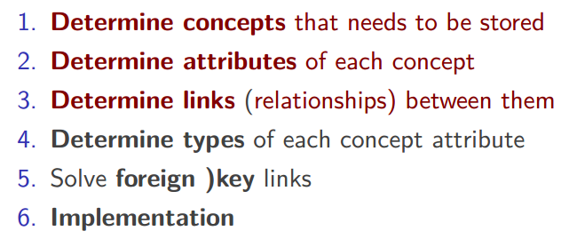

Restaurant example:

Design a database to maintain the menu of a restaurant. For each course, its name, a short description, its difficulty level, a photo and the final price are stored.

Each course has a category. Categories are characterised by their name, a short description and the name of the employee in charge of them.

Besides the courses, recipes are stored. They are formed by the name of their ingredients, the required a mount, units of measurement (grams, litres, ...) and the current amount in the storehouse.

Determine attributes of each concept and links (relationships) between them:

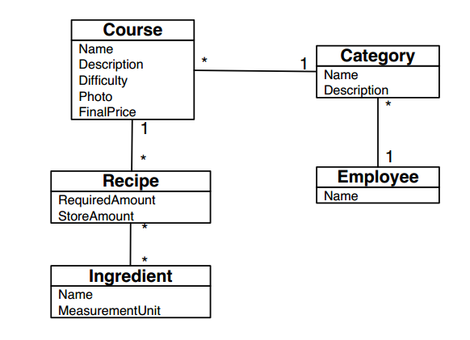

Determine type of each concepts attribute:

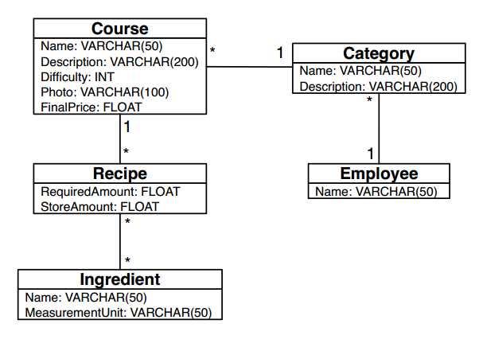

Add primary and foreign keys:

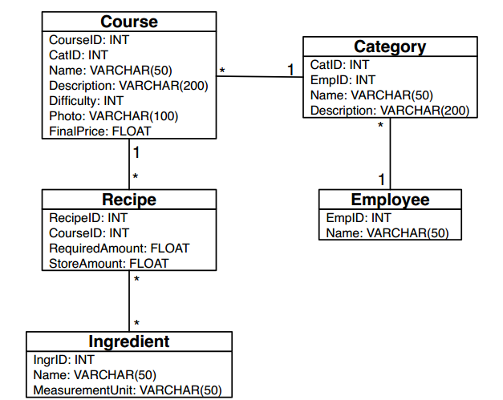

Solve many-many problem

