Thesis Title

Submitted by

Name
ID-

Name
ID-

BACHELOR OF SCIENCE IN
COMPUTER SCIENCE AND ENGINEERING

.

Department of Computer Science and Engineering
CCN University of Science and Technology
Kotbari, Bangladesh January, 2026
This thesis titled, “Title”, submitted by Name, Roll No.: ID-, Name, Roll No.: ID-, Session: Fall 2025, has been accepted as satisfactory in partial fulfillment of the requirement for the degree of BACHELOR OF SCIENCE in Computer Science and Engineering on 2nd August, 2025.

BOARD OF EXAMINERS

Name Chairman
Designation
CCN University of Science and Technology

Md. Saiful Islam Member Coordinator & Lecturer, Dept of CSE (Ex-officio)
CCN University of Science and Technology

Name Member
Designation (External)
University

Name Member
Designation Internal
CCN University of Science and Technology


CCN University of Science & Technology^{Font-size-14}
Cumilla-3506, Bangladesh
JANUARY 2026^{Font-size-12}

APPROVAL^{Font-size-14}

This Research/Project titled “Title of the project/research”, submitted by [Your Name] to the Department of Computer Science and Technology, CCN University of Science and Technology, has been accepted as satisfactory for the partial fulfillment of the requirements for the degree of B.Sc. in Computer Science and Engineering and approved as to its style and contents.^{Font-size-12}

Declaration^{Font-size-14}

This is to certify that the work presented in this thesis entitled, “Title”, is the outcome of the research carried out by Name-1, Name-2 under the supervision of Supervisor Name, Department, Department of Computer Science and Engineering, CCN University of Science and Technology, Kotbari, Cumilla, Bangladesh.
It is also declared that neither this thesis nor any part thereof has been submitted any- where else for the award of any degree, diploma, or other qualifications.^{Font-size-12}

Submitted by:

[Your Name]
ID: xxxxxxx
Department of Computer Science and Engineering
CCN University of Science and Technology

[Your Name]
ID: xxxxxxx
Department of Computer Science and Engineering
CCN University of Science and Technology

ACKNOWLEDGEMENT^{Font-size-14}
Thanks to Almighty Allah for giving us the strength and the ability to understand, learn and complete the research successfully.^{Font-size-12}

I am really grateful and wish my profound my indebtedness to Supervisor [Name], [Designation], Department of Computer Science and Engineering, CCN University of Science and Technology. Deep knowledge & keen interest of my supervisor in the field of [Your research field] to carry out this research was really helpful. His/Her endless patience, scholarly guidance, continual encouragement, constant and energetic supervision, constructive criticism, valuable advice, reading many inferior draft and correcting them at all stage have made it possible to complete this research.

I would like to express my heartiest gratitude to [Name of chairman of your department], Chairman, Department of Information and Communication Technology, for his kind help to finish my thesis and also to other faculty members and the staff of CSE department of CCN University of Science and Technology.

I would like to thank my entire course mate in CCN University of Science and Technology, who took part in this discuss by providing valuable suggestions.

Finally, I must acknowledge with due respect the constant support and patients of my parents.

Abstract^{Font-size-14}

This is the abstract body.Font-size-12, Alignment- Justify

TABLE OF CONTENTS^{Font-size-14}
CONTENTS PAGE

BOARD OF EXAMINERS^{Font-size-14} ii
APPROVAL…………………………………………………………… iii
DECLARATIONS iv
ACKNOWLEDGEMENT v
ABSTRACT vi
TABLE OF CONTENTS vii
LIST OF FIGURES ix
LIST OF TABLES x
CHAPTER 1: INTRODUCTION 1
1.1 Introduction^{Font-size-12} 2
1.2 Motivation 4
1.3 Rationale of the Study 5
1.4 Research Questions 5
1.5 Expected Output 5
1.6 Report Layout 5
CHAPTER 2: BACKGROUND 7
2.1 Introduction 8
2.2 Related Works 8
2.3 Research Summary 12
2.4 Scope of the Problem 12
2.5 Challenges 13
CHAPTER 3: RESEARCH METHODOLOGY 14
3.1 Introduction 15
3.2 Research Subject and Instrumentation 15
3.3 System Model 16
3.4 Implementation Requirements 23
CHAPTER 4: EXPERIMENTAL RESULTS AND DISCUSSION 27
4.1 Introduction 28
4.2 Experimental Results 28
4.3 Descriptive Analysis 37
4.4 Summary 41

CHAPTER 5: CONCLUSION AND RECOMMENDATIONS 42
5.1 Summary Of The Study 43
5.2 Conclusions 44
5.3 Recommendations 44
5.4 Implication for Further Study 44
REFERENCES 45

LIST OF FIGURES^{Font-size-14}
FIGURES^{Font-size-12} PAGE NO

Figure 1.1: Sequence diagram 16
Figure 1.2: Data flow diagram 17
Figure 2.1: Implementation of the proposed system 17
Figure 3.1: Activity diagram of the system 24
Figure 4.1: Architecture diagram of the system 26

LIST OF TABLES
TABLES PAGE NO

Table 4.1: Dataset 1 39
Table 4.2: Comparison 40
Table 4.3: Classification Report 40

CHAPTER 1^{Font-size-14}
INTRODUCTION

  - Introduction^{Font-size-14}
This is the introduction.Font-size-12,Alignment- Justify
Introduction section start with the background history of the domain/research area. It must goes broader to narrower (specific) aspects of your works. Writings of this section should be properly cited (Uses of AI are strictly prohibited) according to the standard referencing styles.
1.2 Motivation
  - Rationale of the Study
  - Research Questions
  - Expected Output
  - Report Layout

CHAPTER 2^{Font-size-14}
BACKGROUND

2.1 Introduction2^{Font-size-14}
2.2 Related Works
How to write a literature review [1].
2.3 Research Summary
2.4 Scope of the problem
The Globality of Inflation in a Post-Covid World and Way Forward for Bangladesh [2].
2.5 Challenges

CHAPTER 3^{Font-size-14}
RESEARCH METHODOLOGY

3.1 Introduction^{Font-size-14}
3.2 Research Subject and Instrumentation (Data collection / Data preparation)
3.3 System Model /Architecture
3.4 Implementation Requirements
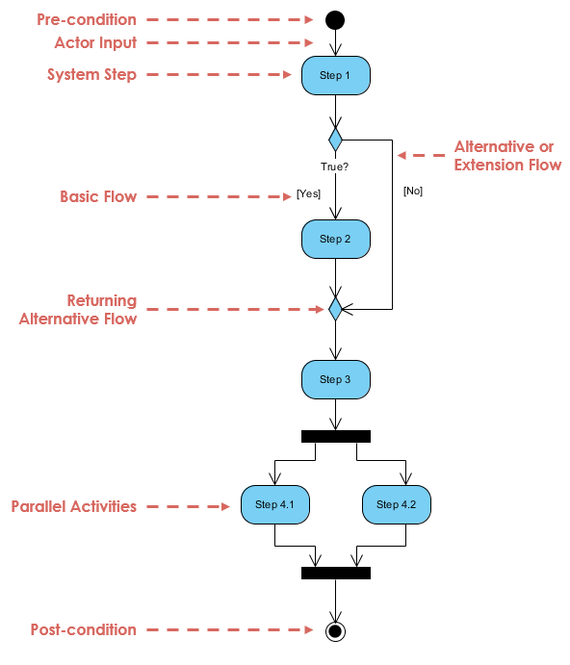
Figure 3.1: Activity Diagram of the system^{Font-size-12, Alignment-Center}

CHAPTER 4^{Font-size-14}
EXPERIMENTAL RESULTS AND DISCUSSION

4.1 Introduction^{Font-size-14}
4.2 Experimental Results
4.3 Discussion (should be Descriptive according to your findings)
Table 4.1: Gas consumption of the smart contracts^{Font-size-10, Alignment-Center}
Item Name^{FS-10, Center} | Attribute 1 | Attribute 2 | Attribute 3
Item 1 | 306084 | 0.00612168 | $7.94
Item 2 | 306072 | 0.00612144 | $7.94
Item 3 | 306072 | 0.00612144 | $7.94
Item 4 | 306084 | 0.00612168 | $7.94
Item 5 | 2321137 | 0.04642274 | $60.21

4.4 Summary

CHAPTER 5^{Font-size-14}
CONCLUSION AND RECOMMENDATIONS

5.1 Summary of the Study^{Font-size-14}
5.2 Conclusions
5.3 Recommendations
5.4 Implication for Further Study

REFERENCES: (Recommended IEEE referencing Style)

[1] A. S. Denney and R. Tewksbury, “How to Write a Literature Review,” Journal of Criminal Justice Education, vol. 24, no. 2, pp. 218–234, Jun. 2013, doi: 10.1080/10511253.2012.730617.

[2] Globality of inflation in post-Covid world and Bangladesh, available at, << https://shorturl.at/begDP >>, last accessed on 20-09-2022 at 07:50 AM.

