**OBJECTIVES**

The purpose of this second experiment is to verify the three important theorems experimentally. These are namely Superposition Theorem, Thevenin and Norton Theorem and Maximum Power Transfer Theorem. For part A, to prove Superposition Theorem we calculated the overall current in the circuit and then separately calculated when each of the voltage source and current source is acting alone .We used Kirchhoff’s Current law to verify the superposition theorem of the circuit using the calculated current .For part B, we proved the Thevenin and Norton theorem by choosing the desired circuit and calculated open circuit voltage and short circuit current .To get the open circuit voltage and short circuit we used the principle of Thevenin and Norton theorem and finally we calculated the power transfer across the load resistance.

**INTRODUCTION**

In the first Laboratory session, students became familiarized with important electrical circuit analysis tools. Students were asked to use the Fluke 8010 as an Ammeter to measure current in a **DC** **circuit**, as well as the Agilent 34405A as a Voltmeter to determine the voltage and resistance in a circuit. During the measurement of the DC circuit, results of measurement were recorded and afterwards, the results were used to test and prove Kirchhoff's current and voltage law (KCL and KVL). In addition to this, students used a function generator and a Digital Storage Oscilloscope to view and measure output signals of **AC** **circuits**. Then, to determine the following: phase shift of the two frequencies measured, voltage gain, and to compare the actual values with theoretical values.

**PROCEDURE**

 For the Superposition theorem we followed the following steps

* We first connect the protoboard terminals with their respective terminals at the power supply panel in order to get the power supply.
* We construct the given circuit in the protoboard and check the value of the potentiometer and set the value of the load resistor.
* Before turning on the power supply panel the ground of the circuit is to be checked properly.
* We first calculate the current Io across the load resistor and then the current when   Vs is acting alone and the current when Is is acting alone .

For Thevenin ,Norton’s and Maximum power transfer theorem  we followed the following steps

* We first choose the circuit which we want to construct on  the breadboard .We also connect the source with the circuit on the breadboard and set the value of the load resistor to a fixed resistance .
* After turning on the power source we measured the open circuit voltage across the node voltage  V4 and the ground using voltmeter .
* We then using the same process measure the short circuit current across  the node voltage V4 and the ground using the ammeter.
* We then decrease the value of the load resistor to 50% of the open circuit voltage and then calculate the correspondence value of the maximum power transfer resistance and the associated load voltage.
* PREPARATION  : To make the circuit less complicated better use separate  color wires for grounding purposes (DC circuit) .Also better read the lab  manual before starting the work.
* CALIBRATIONS: Calibration of the potentiometer present on the protoboard is needed .Also calibrate the digital multimeters before using them.
* SAFETY ISSUES: Before turning on the power supply panel the grounding of the circuit has to be ensured.

**Results and Discussion**

* 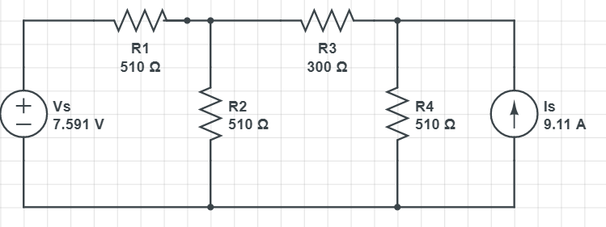**Question #5**
* Ra= 470 ohm
* Rb= 300 ohm
* Rc= 250 ohm
* Rd= 220 ohm
* Re= 510 ohm
* Vs= 7.591 V
* Is= 9.11 mA
* Io= 44.4 mA

    Io1+Io2= 37.97 +5.82=43.79

    Io≈ Io1+Io2

* A screenshot of a cell phone

  Description automatically generated**Question 11**

Rth= (VTh)(IN)

Rth = 1.80.0069=260.9 Ω

 VT=1.8 V

 IN=6.9 mA

The experimental values are very close to the theoretical

**Theoretical value:** VT = 1.776 V

**Experimental value:** V= 1.8 V

**Percentage of difference:** 1.35%.

**Theoretical value:** IN =6.68 mA

**Experimental value:** 6.9 V

**Percentage of difference:** 3.3%.

**Theoretical value:** RT= 255 Ω

**Experimental value:** 266 Ω

**Percentage of difference:** 4.1%.

|  |  |  |
| --- | --- | --- |
| RL (Ohm) | VL (VOLT) | PL (Watt) |
| 150 | 0.66 | 2.904 |
| 200 | 0.7823 | 3.0599 |
| 255 | 0.9 | 3.176 |
| 300 | 0.965 | 3.104 |
| 350 | 1.03357 | 3.052 |

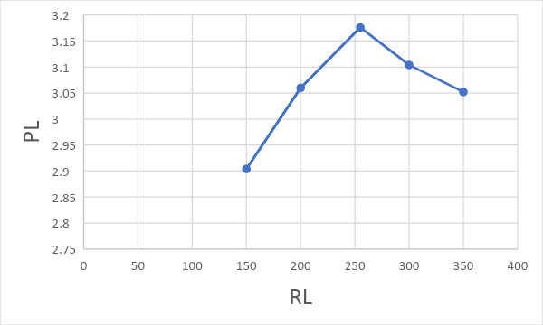

**DISCUSSION**

To sum up, for Superposition theorem we verified that current passing through the circuit when both sources were acting alone was approximately the same as when one source is active and other is inactive .We also verified the Kirchhoff’s current law at the given node .Now in case of Thevenin ,Norton and Power transfer ,while doing the calculation in regulating the potentiometer as it might be the reason of error .Also while checking Norton’s current we need to be very careful about be place the ammeter in the circuit . In this experiment our experimental values are very close to the theoretical values.

**Conclusion**

By the end of this lab, I was able to understand the circuit theorems that we had in the lecture class, I get more familiarized with the lab equipment, and I learnt to use an online circuit builder to draw the circuit for this experiment.