**OBJECTIVES**

The purpose of this experiment is to become familiar with the **Operational Amplifier** (‘op-amp’) basics. For DC signal circuit we are going to see how different amplifiers namely

*Inverter, Summing, Inverter, Non-Inverter, Voltage follower, Differential* amplifier works by displaying their output voltage. For AC signal circuit, we are going to construct a low pass filter

using the operational amplifier and check the output signal at definite frequency and voltage.

**INTRODUCTION**

  Operational amplifier circuits: generally, opamp circuits are used to determine the output voltage Vo or to obtain the voltage gain AV which is equal Vo/Vin.

To obtain these results, we usually do nodal analysis at the input terminals.

When the ideal opamp is used KCL equations is written at all terminals, that is Vo is found as a function of Va and Vb.

Applying nodal analysis to the opamp input when I+=I-=0 and V=V+=V-

+ and

The figure below illustrates two different ideal opamps.

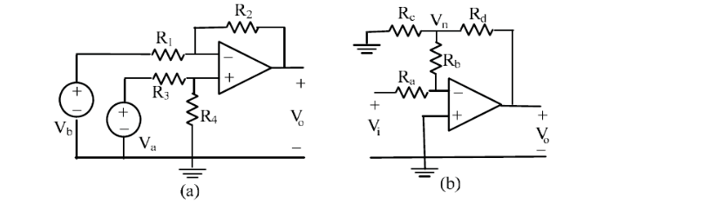

**Figure 1:** ideal opamp. (elec 273 lab manual)

AC opamp circuits: when an AC sinusoidal input is used requires the presence of a linear operating range, when the input signal amplitude is increased, the output voltage waveform is displayed on the oscilloscope.

Opamp filter circuits incorporate RC networks.

The following figure shows the basic first order low-pass LPF and high pass filters, generally used to filter out high frequencies and low frequencies.

The voltage gain Av for both circuits. For LPF, Av=R2/R1 when the frequency is equal to zero, but falls off when f increases.

The frequency fc is called the cutoff frequency of the LPF.

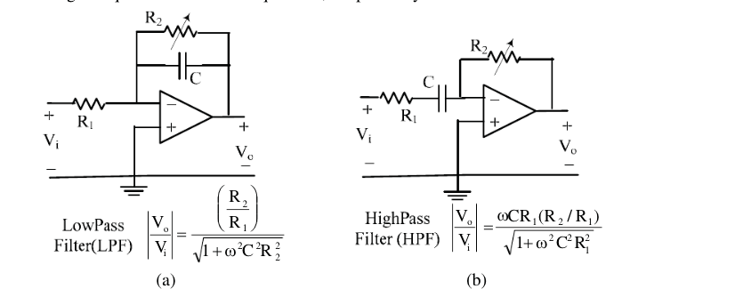

**Figure 2:** Low Pass filters LPF and high pass HPF filters. (source: Lab Manual elec273)

**PROCEDURE**

**DC Operational amplifier circuits:**

* While the PSP is still turned off, make the general connections between the 3140 opamp box, PSP and the DMM’s after that set the Fluke 8010A to the 20 volts DC and the Agilent 34405A to DCV auto, after that turn on the master supply to energize the PSP.
* After that check the opamp IC, no other inputs should be implied temporarily.
* Next, build the circuits in figure 3.
* For the Inverter: short circuit the input terminal to the ground after that, build the inverter with two different gain values, measure Vo and check that (Vo/Vi)=-(R2/R1).
* For the summing inverter: short circuit the input (+) ( do the same steps as for the inverter) using the 100kOhms resistor, then build a summing inverter circuit with Rf/Rx, after that measure Vo, Vo=-[(Rf/Ra)Va+Vb(Rf/Rb)]
* For the non-inverting amplifier, remove the short circuit between the input terminals and the ground then connect the ground to the end of resistor R1, after that apply the input Vi directly to the non inverting one, finally measure Vo for two values, it should check the relation Vo=[1+(R2/R1)]Vi.
* For the voltage follower: basically, it is a special case of the non-inverter, when R2=0 and R1 goes to infinity, measure Vo for different values of Vi, it should very that Vo=Vi.
* For the differential amplifier, link the opamp as a differential amplifier with a gain of one, measure Vo and verify that Vo=Va-Vb.

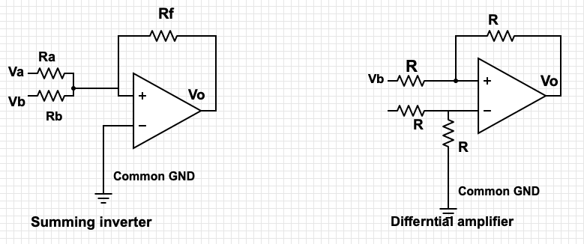

**Figure 4: Simulation of the summing inverter and differential amplifier respectively.**

**AC Operational amplifier circuits:**

* While the psp off, do the connection between the 741 opamp box, PSG,FG and DSO
* Set the FG to sinewave 10kHz, channel 1 and channel 2 both to 1vol/div and 2.5 msec/div time base
* Next, set the DSO to display the Ch1 frequency and the RMS ampl.
* Adjust the FG controls to obtain a 2volt RMS, 1kHz sinewave as measured in the DMO.
* Turn the gain magnitude to unity using the 10 turn knob.
* Increase the gain to max, that is done by turning the 10 turn control knob.
* After that, turn the Ch2 sensitivity to 5volt/div.
* Finally, increase the input magnitude to its max and observe the effect of saturation.
* Then, build the LPF circuit, by adding the two links P and Q as shown in figure 5.
* Vary the frequency and record the RMS output voltage.

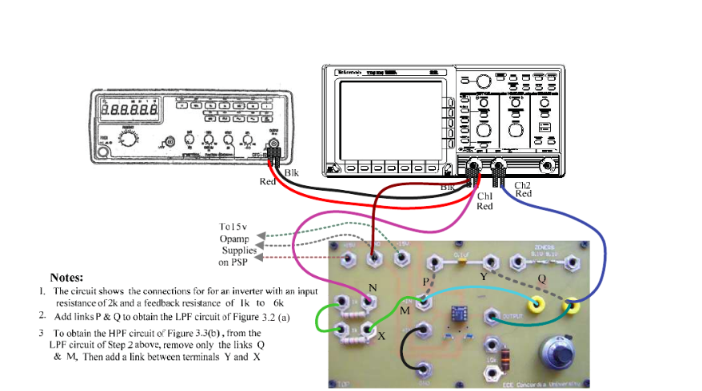

**Figure 5: Ac opamp circuit Test Setup.**

**RESULTS**

**DC Circuits**

**(a)Inverter**

when R1=50 kOhms and R2=100kOhms, Vo=1.25 V, Vi=-2.5, Vo/Vi=-2

-R2/R1=-100/50=-2, -2=-2 which means that **Vo/V1=-R2/R1.**

When R1=20kOhms and R2= 100 kOhms, Vo=1.26 V, Vi=-6.29 thus Vo/Vi=-4.99=5

So,the relation between -R2 andR1 that is equal to -5, which means that Vo/V1=-5.

**(b)Non inverter**

R1=100kOhms and R2=100kOhms.

Vo measured in the experiment is equal to 1.258, and Vi is equal to 2.52.

The theoretical value Vo=[1+(R2/R1)]Vi = 2, which is approximately equal to Vo=1.987 V.

R1=50kOhms and R2=100kOhms, Vi=1.26 V and Vo=3.775 V

**(c)Summing inverter**

Ra=20kOhms, Rb=50kOhms. , Rf=100kOhms.

Va measured in the experiment is 1.28V ,Vb=1.28V and Vo=-8.79V.

The theoretical value of Vo = -8.78 V, which is approximately equal to -8.79 V.

Ra=50kOhms,Rb=100 kOhms and Rf=100kOhms.

Va measured in the experiment is 1.26 V, Vb=1.26 V and Vo=-3.76V.

The theoretical value of Vo=-3.75 V which is approximately equal to -3.76 V.

**(d)Voltage-follower**

All the following data was measured during the lab experiment.

Vi=1.26V, Vo=1.255V, they are approximately equal.

Vi=3.502V, Vo=3.499V, they are approximately equal.

Vi=4.175V, Vo=4.172V, they are approximately equal.

**(e)Differential amplifier**

All 100 kOhms resistors, the gain is 1.

Va=1.695 V, Vb=2.02 V, Vo=-0.32 V, these are the values measured during the lab experiment.

Vo=1.695 V – 2.02 V= -0.32 V, the theoretical value matches the experimental one.

**Question #4:**

Summing-inverter circuit

Differential amplifier circuit

**AC Circuits**

Using the following formula (Vo/V1)=(R1/R2)/()=A0, to calculate the % error [(A0/A0Lab)X100]-100.

**Question #9**

fc=795.77 Hz

f1= 200 Hz

The experimental voltage gain is 2.353

The theoretical voltage gain is 2.45

The percentage of error is 3.9%

F2= 2000 Hz

The experimental voltage gain is 0.4563

The theoretical voltage gain is 0.44

The percentage of error is 3.7%

**DISCUSSION**

DC Circuits part, In this part we connected 5 types of opamps, one that does the inversion, one that does the sum, another one that is a non-inverting amplifier, voltage follower and the last one does the differential.

In the inverter, the relation that states Vo/V1 (calculated in the lab) is equal to -R2/R1 which means that our results match the theoretical ones.

In the summing inverter the theoretical value of Vo matches approximately the one found in the lab session within the limits of trial and measurement errors.

In the non-inverting amplifier, [1+(R2/R1)]Vi = 2.52=Vo2.51V.

In the voltage follower, Vo=Vi in all cases.

In the differential amplifier, Vo=Va-Vb for all the cases.

Thus, all the results measured in the lab match the theorical values, which means that all my calculations are true.

For the AC circuit part, The % of error in some cases states that our percentage of error is very little since when (Vo/ Vi ) over the low pass filter gain is approximately 1, means that they probably equal which means that our experiment is valid.

**CONCLUSION**

To conclude, the investigation of Operational Amplifier circuits with DC and AC signals is completed since all my calculations are correct. I can connect op-amp circuits and test the.