**LABORATORY REPORT**

**Basic Circuits & Systems Laboratory**

**This cover page must always be the top sheet**

 **Course:** ELEC 273 275 **Lab Section:**

YM-X

( Circle )

20 03 12

**Experiment No.:**  **Date Performed:** 20 – –

4

# YYYY – MM – DD

**Experiment Title:**

Dynamic Response of RC, RL, and RLC Circuits

**Name:**  **ID No.:**

40105034

Bayan Al Salem

**Lab Partner Name:**  **Lab Partner ID:**

40006267

Sara Haj Hasan

**I certify that this submission is my original work and meets the Faculty’s Expectations of Originality**

20 04 01

**Signature:**  **Date:** 20 – –



# YYYY – MM – DD

**OBJECTIVES**

The purpose of this experiment is

* To inspect the transient response of RC, RL and RLC circuits.
* To define the frequency response of RC, RL and RLC circuits.
* To discuss the resonance and impedance topics.

**INTRODUCTION**

**1.Transient Response:**

A first order circuit is a circuit that contains only one equivalent storage element; C or L and the resistor R. The speed at which the output can respond to a sudden change in input is called the transient response.

The theoretical transient response is a solution to a linear differential equation which is equal to

Where

, where A is a constant.

The capacitor in a circuit acts as an open circuit, whereas the inductor acts as a short circuit.

A second order circuit is a circuit that contains R, L and C or R or two storage elements that cannot be combined.

It’s linear differential equation is of the general form , where .

ζ = α/ω

o

relates to three cases which

are : over-damped ζ>1, critically damped ζ=1, and under damped ζ<1

ζ = α/ω

o

relates to three cases which

are : over-damped ζ>1, critically damped ζ=1, and under damped ζ<1

We can distinct three cases in a second order equation.

“Over damped “OD occurs when

“Critically-damped” CD occurs when =.

“Under-damped” UD occurs when

**2.Frequency response:**

The impedances in a circuit are frequency dependant.

They keep the magnitude of the input voltage Vi of a circuit constant while changing the frequency.

**3.Resonance:**

resonance occurs when the admittance is equal to 0 due to the change in frequency or in elemental values.

Z=R+j

**4.Impedance measurement:**

Z=VZ/IZ where Vz=VA-VB and IZ=VB/R.

Z=R(VZ/VB)

**PROCEDURE**

1- Make the general connection following the same steps as shown in figure 1, and then connect the different circuits shown in figure 2.

Following these settings:

**FG:**

Waveform: square wave.

Amplitude: volts peak-peak.

DC Offset: OFF.

Frequency range: as required.

**DSO:**

Ch1 & Ch2 sensitives: 2Volts/div or 1 Volt/div.

Input Coupling (both channels): DC.

Bandwidth (both channels): 20MHz.

Measure: Display Ch1 & Ch2 Peak-to-Peak amplitudes & Ch1.

Frequency: Cursors: Select ‘Paired’, and use on Ch2 waveform.

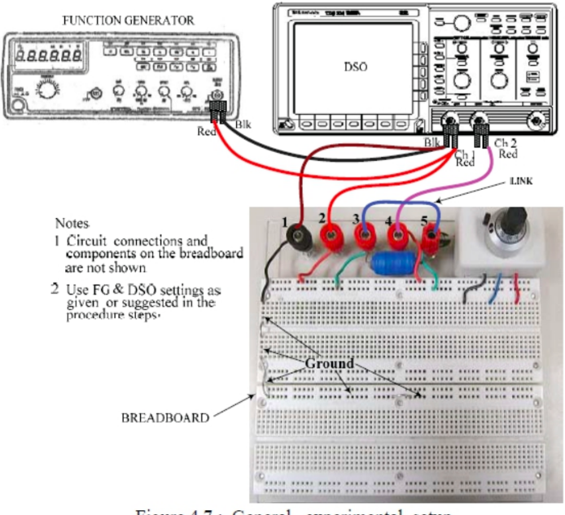

**Figure 1:** General experimental setup **( ELEC273-Lab Manual)**

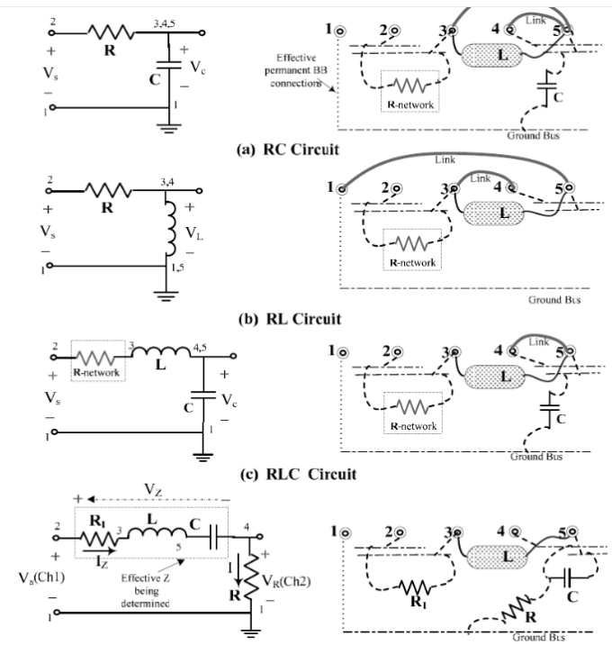

**Figure2**:Circuits to be designed in the experiment **(ELEC273-Lab Manual)**

**RC**:

* Set C to 0.1 and R between 300 Ohms and 1500 Ohms, R=470 Ohms.
* After that, adjust the square-wave frequency on the FG(following the requirements as mentioned previously).
* Simulate the RC circuit using the appropriate software where Vs =4V.

**RL:**

* Using the same value of R=470Ohms, and L=20mH construct circuit b) in figure 2 following the same instructions as for RC circuit.
* Find the time constant from the material.

RLC:

* Set C=0.1µF, R=894.43Ohms.
* Simulate the RLC circuit (only the under damped condition) using Vs=4V.

The following settings for the FG & DSO are used for the frequency response, resonance and impedance tests.

**FG:**

Waveform: Sinusoidal.

Amplitude:

DC Offsite : OFF.

Frequency Range: 10kHz(Max 100 kHz)

**DSO:**

Ch1 & CH2 sensitives 1Volt/div.

Input Coupling (both channels): AC.

Bandwidth (both channels):20Mhz.

Measure: Display Ch1 & Ch2 RMS amplitudes, Ch1 Frequency.

Cursors: Select ‘V-bar’ cursors [ for (phase)measurement].

* Measuring resonance: f=fo=.
* Make the connections in figure 2,d) using R1=0 Ohms, R=100Ohms, C=0.1µF and L=0.002H, fr=3.6kHz.
* Z=R1+j[.

Measurement of impedance:

* Using the same circuit in d)RLC, R1=500Ohms,R=100Ohms and C=0.1, on the DSO, the math channel M=CH1-CH2.

**RESULTS and DISCUSSION**

**Question 1**

* RC circuit: while which means that they are approximately equal, the difference is probably due to the instruments used in the lab and the non-precision in the experiment. Meanwhile, the simulation in the software is the same as the graph obtained in the printout.

**Question 2**

* RC circuit: while

**Question 3**

* RLC: the damping ratio when **R=1490** Ohms is more than one which means that the circuit is **over-damped**.

The damping ratio when **R=880** Ohms is equal to one which means that the circuit is **critically damped**.

The damping ration when **R=120** Ohms is less than one which means that the circuit is **under damped**.

The simulation of the RLC UNDER DAMPED condition is probably the same as the one obtained in the printout.

**CONCLUSION**

We can conclude that we have successfully observed transient response (RC, RL, RLC) circuit as well as the frequency response of RC and RLC circuit and showed

us the accurate output but while calculating impedance of RLC circuit at 2 kHz we see a

significant difference of experimental and theoretical value and this might happen because of

not setting the DSO the measurement properly or not placing the cursor properly at the

oscilloscope.

