# Specimen of Use – Prikvet Trademark Filing

This document provides specimens of use for the mark “Prikvet” in connection with its public presentation and commercial application, as authored and owned by Bayant Dhindsa. These materials are submitted to support trademark filings with the Canadian Intellectual Property Office (CIPO) and United States Patent and Trademark Office (USPTO), demonstrating active and intended use of the mark in public-facing platforms, digital assets, and branding as of April 8, 2025.

## 1. Specimen Evidence

Figure 1: Screenshot from Substack article titled 'Prikvet: The Truth Layer Unveiled', published April 7, 2025, featuring the 'Prikvet' mark in the headline and body text as a consumer research tool.

*Source: https https://bayant.substack.com/p/prikvet-unveiled-your-compass-through?r=a3anq

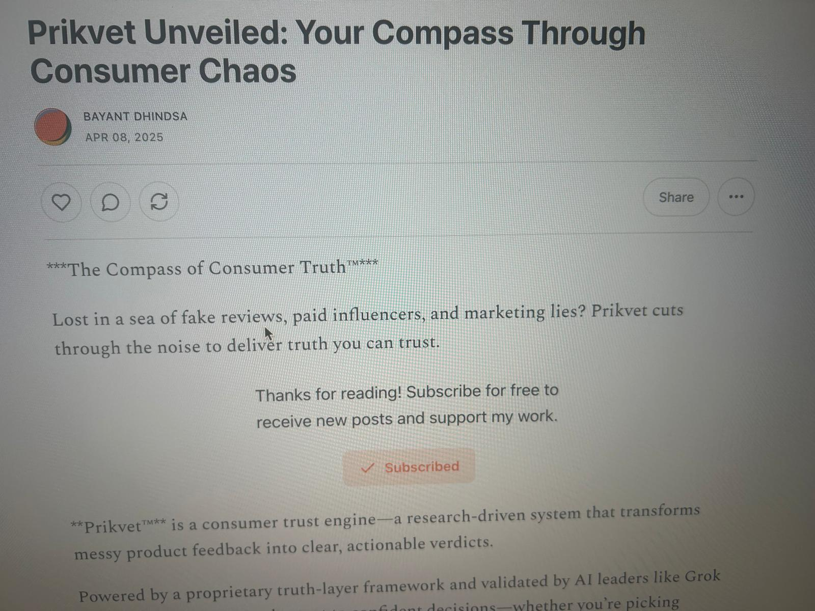

Figure 2: GitHub repository 'ekonAI-MMAT' (accessed April 8, 2025), with README section titled 'Prikvet Integration', referencing Prikvet as the framework for AI alignment and trust scoring.Source: Internal repository – MMAT PDF, April 6, 2025

## 

## 2. Use in Commerce Context

The 'Prikvet' mark is actively used in commerce as of October 1, 2023, in connection with:  
**Software tools** (Class 9): AI-driven consumer trust scoring systems.  
**SaaS platforms** (Class 42): Digital product research frameworks.  
**Advertising & consumer research** (Class 35): Promotional materials and user-facing content for MVP rollout.  
  
These specimens reflect both actual use (Substack, , PDF publication) and ongoing intent-to-use in broader markets, consistent with CIPO and USPTO trademark registration requirements.

I declare under penalty of perjury that the specimens shown here are authentic and represent current or imminent use of the mark "Prikvet" in connection with the services and goods described above.

© 2025 Bayant Dhindsa. All rights reserved.  
  
Signed: ____________________________  
Bayant Dhindsa

Date: April 08, 2025