# Lab 1 - Ben Weinstein

## Question 1

The equations are independent, so the joint probability is the multiplication of the individual probabilities.

$$\frac{2}{x^{3}}\frac{3}{y^{4}}$$

## Question Two

require(reshape)  
require(ggplot2)  
#Define Functions  
  
gx<-function(x){  
 2/(x^3)  
}  
  
hy<-function(y){  
 3/y^4  
}  
  
#plot functions  
s<-seq(1,2,0.01)  
  
r<-data.frame(s,g=gx(s),h=hy(s))  
r<-melt(r,id.var="s")  
  
ggplot(r,aes(x=s,y=value,col=variable)) + geom_point() + geom_line()

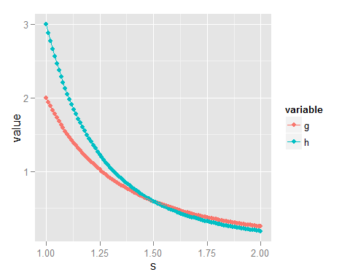

Verbal explanation of question two answer: We want to know the area under the pdf for x from 1 to y, where y is evaluated from 1 to infinity. This is a double integral in the form of

$$\int_{1}^{+∞}{\int_{1}^{y}{\frac{2}{x^{3}}}}\frac{3}{y^{4}} dx. dy.$$

after some fancy algebra that it took me far too long to understand (see attached):

$$\int_{1}^{+∞}{\frac{−3*y^{−}5}{5}}+\int_{1}^{+∞}{\frac{−3y^{−}3*}{3}} dx. dy.$$

remembering that lim of y as approaches Inf = 0 for any negative polynomial, we can find that we just need to evaluate at 1 for each and add the results, which is:

$$\frac{−3}{5}+1=\frac{2}{5}$$

hurrah! alot of credit to marisa and elise for sticking it out with me.