DRIVE: Daily Route Investigation Via an Efficient Bayesian Adaptive Trial Design

Protocol

**Version date:** November 14, 2023

**Principal Investigator:** Naima Alam, MS

**Co- Investigators:**

Sreejata Dutta, MS (Data Manager)

Geethanjalee Mudunkotuwa, MS (Protocol & Statistical Analysis Plan)

Kaustubh Nimkar, MS (Analysis)

Elena Shergina, MS (Study Design)

Xiaosong (Fred) Shi, MS (Data Manager)

Jianzheng Wu, PhD, MS (Analysis)

Kate Young, PhD (Protocol & Statistical Analysis Plan)

**Key Personnel:**

Joshua Bernal, MS

Eric Dai, MS

Milind Phadnis, PhD, MS

Md Tamzid Islam, MS

Lauren Yoksh, MS

**Data Safety Monitoring Board:**

Alexandra Brown, PhD

Jo Wick, PhD

**Table of Contents**

1. Purpose, Background, and Rationale 3

1.1. Aim and Hypotheses 3

1.2. Background and Significance 3

2. Research Plan and Design 3

2.1. Study Objectives 3

2.1.1. Primary Objective 4

2.1.2. Secondary Objectives 4

2.2. Study Type and Design 4

2.3. Sample Size, Statistical Methods, and Power Calculation 5

2.4. Inclusion and Exclusion Criteria 6

2.4.1. Inclusion Criteria 6

2.4.2. Exclusion Criteria 6

2.4.3. Withdrawal/Termination Criteria 6

2.5. Study Procedures 7

2.5.1. Accrual and Interim Analysis 7

2.5.2. After Interim Analysis with no Early Stopping 8

2.5.3. After Interim Analysis with Early Stopping or End of Study 8

2.6. Risk/Benefit Assessment 8

2.7. Assessment of Subject Safety and Development of a Data and Safety Monitoring Plan 8

3. Subject Participation 9

3.1. Informed consent process and timing of obtaining of consent 9

3.2. How new information will be conveyed to the study subject 9

4. Data Collection and Protection 9

4.1. Data Management and Security 9

4.2. Quality Assurance and Monitoring 9

5. Data Analysis and Reporting 10

5.1. Statistical and Data Analysis 10

5.2. Interim Analyses 10

5.3. Final Analysis 10

# Purpose, Background, and Rationale

## Aim and Hypotheses

Reducing the amount of time spent driving from home to work can help maximize productivity in the workplace. This study utilizes adaptive designs to determine the optimal driving route from Dr. Byron Gajewski’s home to his workplace at KUMC.

There are two main aims of this study:

1. To find the best route for Dr. Gajewski to drive to work
2. To provide the opportunity for students to experience designing and conducting a Bayesian adaptive clinical trial.

## Background and Significance

This study aims to give biostatisticians experience designing, conducting, and analyzing a Bayesian adaptive clinical trial. Specifically, this will give us a platform to experiment with sophisticated and novel features of adaptive clinical trials such as response adaptive randomization and early stopping. Additionally, we plan to publish a paper describing the learning experience.

The use of adaptive designs in clinical trials has been increasing due to its flexibility and efficiency gains, besides being more ethical as they assign fewer subjects to treatment arms with inferior outcomes. Their use is gradually being extended to other areas to capture the already realized benefits. Hence, it is important for graduate students to have experience in the processes involved in conducting an adaptive clinical trial.

Several study designs were considered for this trial, including two fixed designs and four adaptive designs. Each proposed design was evaluated in terms of its ability to control the overall type I error rate, its power to detect differences in the travel times of the evaluated routes, the expected number of drives, and feasibility. The final design chosen by the study team involves three interim analyses and response adaptive randomization.

# Research Plan and Design

## Study Objectives

Dr. Gajewski currently takes three different routes to work: Rainbow, State Line, and Plaza. The plaza route goes through the country club plaza and is more indirect compared to the other two routes. The Rainbow primarily involves driving down Rainbow Blvd. to get to KUMC, while the State Line route involves driving down State Line Road. All routes are shown in Figure 1.

|  |  |  |
| --- | --- | --- |
| **Plaza (Control)** | **Rainbow** | **State Line** |
|  |  |  |

*Figure 1: The three routes evaluated in this study. The starting point of each route lies south of the displayed areas and has been omitted. All routes are the same in this omitted area.*

### Primary Objective

The primary objective of this study is to select the route (out of two comparator routes) that has the highest probability of being faster than the control arm (Plaza route).

### Secondary Objectives

The secondary objectives of this study are:

1. To identify the route associated with the most adverse events
2. To assess the effect of the following conditions on commute time:
   * + 1. Number of serious adverse events
       2. Number of adverse events
       3. Departure time
       4. Starting time of Dr. Gajewski’s first meeting of the day
       5. Time of the sunrise
       6. Car type
       7. Day of the week

## Study Type and Design

This is a randomized controlled trial utilizing response adaptive randomization. Early stopping and updates to the allocations will occur at three interim analyses based on the number of drives that Dr. Gajewski has completed. Interims will occur after 8, 16, and 24 drives. The study design is illustrated in Figure 2.

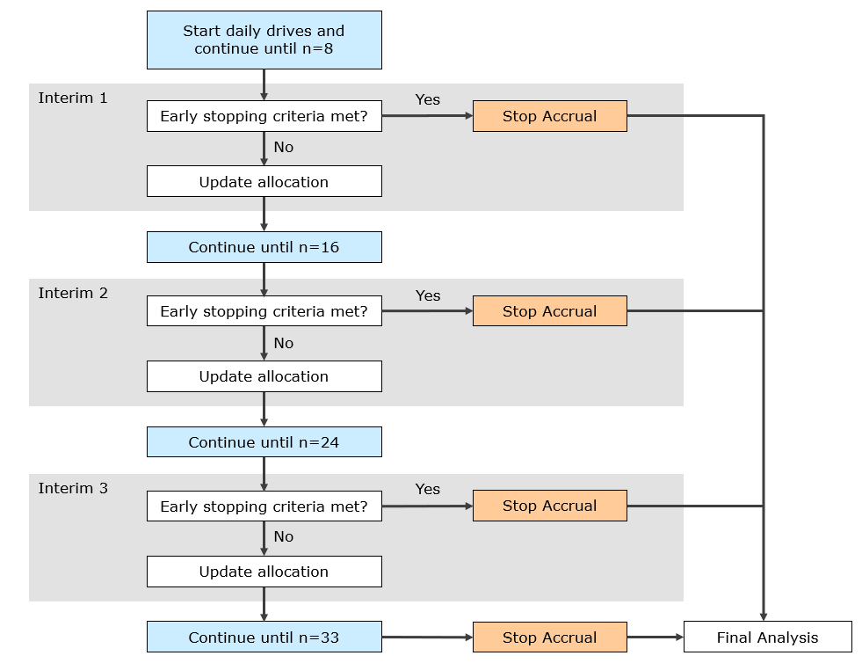

*Figure 2: Study Design*

## Sample Size, Statistical Methods, and Power Calculation

The trial will start with a 2:1:1 (Plaza:Rainbow:State Line) allocation. Following the first interim analysis, drives will be randomized in block sizes of 4. Within each block, 1 drive will be allocated to the control arm and the remaining drives will be allocated adaptively. The allocations associated with the intervention arms (Rainbow and Stateline) will be updated at each interim analysis to allocate more days to the better-performing arm. More details regarding the randomization are provided in the Statistical Analysis Plan (SAP).

Dr. Gajewski will be blinded to the randomization until just prior to departure. All study team members will be blinded to the two comparator routes except for the data managers and protocol team. The data managers will provide a blinded version of the analysis dataset to the analysis team prior to each interim analysis and final analysis. This dataset will contain coded values for each comparator route, and this code will be maintained by the data managers. Because the allocation to the control arm will be different from the comparators prior to the first interim analysis, and fixed for the remainder of the trial, maintaining the blind for the control arm may not be possible. Hence, all study team members will only be blinded to drives assigned to one of the two comparator arms.

After the final analysis and upon written approval (via email) from the PI, the Data Managers will send the code to the analysis team. The analysis team will then unblind the interim and final analyses for reporting.

The maximum number of drives included in the study will be 33. Final success will be determined if the probability that the best of the two comparator routes is better than the control is greater than 0.9836. To estimate the sample size and power, we consider three scenarios: expected outcome, null hypothesis (all routes have the same drive time), and one best. These are summarized in Table 1. We simulate multiple virtual trials and track the behavior of each trial, including the final outcome of the trial, the estimated mean response, etc. The power and selected sample size based on these simulated virtual trials are also summarized in Table 1. More details are provided in the SAP.

*Table 1: The estimated power and expected sample size based on three simulation scenarios*

|  | Drive Time (minutes) | | |  |  |
| --- | --- | --- | --- | --- | --- |
| Scenario | Plaza (Control) | Rainbow | State Line | Power  (probability of success) | Expected Sample Size |
| Expected | 15 | 13 | 13 | 0.9796 | 24 |
| Null | 15 | 15 | 15 | 0.0238 | 24 |
| One Best | 15 | 13 | 14 | 0.9453 | 26 |

## Inclusion and Exclusion Criteria

### Inclusion Criteria

All weekday drives that start between 7:00AM and 8:30AM will be included unless they meet one of the exclusion criteria given below.

### Exclusion Criteria

The following days will be excluded from the study:

1. Days with extreme weather conditions (i.e., a once-in-a-lifetime Kansas City weather event such as a hurricane)
2. Weekends
3. KUMC-recognized holidays
4. KUMC campus closures

### Withdrawal/Termination Criteria

If Dr. Gajewski changes or stops the route for any reason, that drive will be considered a dropout.

## Study Procedures

A timeline of activities to be completed at each stage of the study is illustrated in Figure 3. Each activity is described in more detail in sections 2.5.1 to 2.5.3.

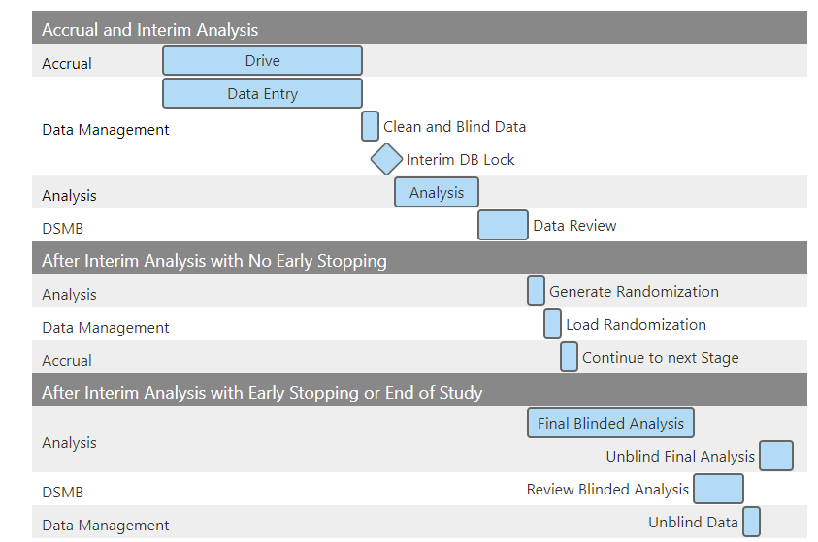

*Figure 3: Study Timeline*

### Accrual and Interim Analysis

1. **Drive/Data Entry:** On each included study day Dr. Gajewski will obtain the randomized route from an app that he will have on his phone. After obtaining the route, he will proceed with his commute, while tracking the time using a stopwatch. After arriving to work, he will receive an email with a link to a survey to collect the drive time, adverse events, and other data related to his drive. The data managers will enter any additional data into the database such as the time of sunrise, and the time of Dr. Gajewski’s first meeting.
2. **Clean and Blind Data:** The data managers will conduct quality checks on the data and generate a blinded dataset.
3. **Interim Database (DB) Lock:** The data managers will lock the database and send the (blinded) data to the analysis team. No changes can be made to the database until the next accrual period.
4. **Analysis:** The analysis team will conduct the blinded analysis and produce a report for the DSMB. This report will contain the early stopping decision.
5. **Data Review:** The DSMB will review the report provided by the analysis team and determine if the trial can move forward with either continued accrual or early stopping. Any requested changes to the analysis or report will take place at this time.

### After Interim Analysis with no Early Stopping

If the results of the interim analysis do not warrant early stopping, the study will proceed by generating the next randomization scheme.

1. **Generate Randomization:** The analysis team will generate a blinded randomization table.
2. **Load Randomization:** The data managers will unblind the randomization table and load it into the database.
3. **Continue driving:** The trial will continue to the next stage of the study, starting again at step 1.
4. **Early Stopping/End of Study:** If the results of the interim analysis warrant early stopping, the study team will conduct the final analysis.

### After Interim Analysis with Early Stopping or End of Study

1. **Final Blinded Analysis:** The analysis team will conduct the blinded analysis and produce a report for the DSMB.
2. **Review Blinded Analysis:** The DSMB will review the report provided by the analysis team. Any requested changes to the final blinded report will take place at this time.
3. **Unblind Data:** The data managers will provide the unblinded dataset to the analysis team.
4. **Unblind Final Analysis:** The analysis team will re-run the final analysis with the unblinded data to create the final analysis report.

## Risk/Benefit Assessment

Because the data entry will occur after arrival at KUMC, Dr. Gajewski will take on no additional risk by participating in this study.

Because this study involves response adaptive randomization that will allocate more drives to the route more likely to be optimal, this will save him time on driving during the duration of the study.

## Assessment of Subject Safety and Development of a Data and Safety Monitoring Plan

Dr. Gajewski will report all adverse events (AEs) through a REDCap survey that will be sent to his email following randomization. He will categorize each AE as either serious or non-serious.

The following will be considered an adverse event (AE):

1. Any problem related to the road conditions
2. Any problem related to the conditions of the vehicle
3. An encounter with law enforcement
4. Anything that may cause a change in route (contributes to a dropout)
5. Any emergent illness that could affect driving (e.g. headache, muscle cramp, etc.)
6. Anything else that causes a delay longer than 3 minutes

Anything that may cause Dr. Gajewski to stop the journey will be considered a serious adverse event and will contribute to a dropout.

# Subject Participation

## Informed consent process and timing of obtaining of consent

Dr. Gajewski will give his implied consent at the beginning of the study. Through the implied consent process, Dr. Gajewski will agree to enter all study data after completing his drive to work (i.e., not while driving). He will also agree to abide by all applicable laws and safe-driving recommendations.

## How new information will be conveyed to the study subject

Any new information related to the study will be communicated to Dr. Gajewski through email.

# Data Collection and Protection

## Data Management and Security

The data managers and the protocol team will have access to the unblinded data. They will send the blinded data to the analysis team prior to each interim analysis and final analysis. The data managers will store the code for unblinding in the REDCap database. Unblinded data will be collected and stored in REDCap. The blinded data will be stored in the S drive.

Dr. Gajewski is the only human subject, and his personal information will not be collected. He will use his cellphone or office computer to enter departure times and driving times into the REDCap survey following arrival at KUMC.

More details about the database management will be provided in the Data Management Plan.

## Quality Assurance and Monitoring

The data quality tools provided in REDCap will be used to ensure data quality.

# Data Analysis and Reporting

## Statistical and Data Analysis

The trial will enroll up to a maximum of 33 drives, randomized among 3 arms, including a control arm and 2 treatment arms. We label these arms generically by their arm index as: d= 0 (Control), 1 (Rainbow), 2 (State Line). The primary endpoint will be driving time (in minutes) starting at key-in and ending at key-out.

## Interim Analyses

Up to three interim analyses will occur after Dr. Gajewski completes 8, 16, and 24 drives. Accrual will be suspended while waiting for the results of the interim analysis. Based on the results of these interim analyses, accrual may be stopped for either “early futility” or “early success.” Allocations to routes will also be updated at each interim analysis. More details regarding the interim analyses are provided in the SAP.

## Final Analysis

The final analysis will occur either after the trial is stopped early or following the completion of 33 drives. More details regarding the final analysis are provided in the SAP.

Following the final statistical analysis, a paper will be submitted for publication based on the learning experience in designing and conducting a Bayesian adaptive clinical trial.