**Information and Communication Technology, Fall 2024**

Group: IT1-2407

Name (First and Last): Zhumakhan Bagdat

**Assignment – 11**

“Fundamentals of Website Authoring with HTML-5”

#### **HTML – Login page, index.html**

<!DOCTYPE html>

<html lang="en">

<head>

<meta charset="UTF-8">

<meta name="viewport" content="width=device-width, initial-scale=1.0">

<title>Login Page</title>

<link rel="stylesheet" href="styles.css">

<script>

function validateLogin() {

const username = document.getElementById("username").value;

const password = document.getElementById("password").value;

if (username === "Bagdat" && password === "Harrypotter72"){

window.location.href = "personal.html";

} else {

alert("Неверный логин или пароль. Попробуйте снова.");

}

return false;

}

</script>

</head>

<body>

<h1>Login</h1>

<form onsubmit="return validateLogin();">

<label for="username">Username:</label>

<input type="text" id="username" required><br><br>

<label for="password">Password:</label>

<input type="password" id="password" required><br><br>

<button type="submit">Login</button>

</form>

</body>

</html>

#### **HTML Structure with Head and Body Sections – personal.html**

<!DOCTYPE html>

<html lang="en">

<head>

<meta charset="UTF-8">

<meta name="viewport" content="width=device-width, initial-scale=1.0">

<title>My Personal Webpage</title>

<link rel="stylesheet" href="styles.css">

</head>

<body>

<h1>Welcome to My Webpage about Joseph Stalin</h1>

<p>Hi this is my website dedicated to Joseph Stalin</p>

<a href="#contact">Contact Me</a>

<h2>About Him</h2>

<p>Joseph Vissarionovich Stalin (1878–1953) was a Soviet statesman and political leader who ruled the USSR from the late 1920s until his death in 1953.

As General Secretary of the Communist Party and leader of the Soviet Union,

he implemented policies of rapid industrialization, agricultural collectivization, and the consolidation of a totalitarian regime.

Stalin's rule was marked by extensive political purges, mass arrests, and deportations.

However, the Soviet Union under his leadership played a pivotal role in the defeat of Nazi Germany during World War II and emerged as a global superpower.</p>

<img src="joseph.jpg" alt="A picture of me" width="200">

<h2>My Favorite Animation</h2>

<img src="ussr.gif" alt="Animated GIF of a waving hand">

<h2>My Favorite Animation</h2>

<video width="350" controls>

<source src="ussr.mp4" type="video/mp4">

Your browser does not support the video tag.

</video>

<h2>My Favorite Music</h2>

<audio controls>

<source src="USSR.mp3" type="audio/mpeg">

Your browser does not support the audio element.

</audio>

<h2>My Weekly Schedule</h2>

<table style="border: 1px solid black; width: 100%; text-align: center;">

<tr>

<th>Day</th>

<th>Activity</th>

</tr>

<tr>

<td>Monday</td>

<td>Meetings with the Politburo or ministers.</td>

</tr>

<tr>

<td>Tuesday</td>

<td>Work with military reports, meetings with commanders.</td>

</tr>

<tr>

<td>Wednesday</td>

<td>Receiving foreign diplomats, reading telegrams.</td>

</tr>

<tr>

<td>Thursday</td>

<td>Analysis of reports, discussion of current tasks.</td>

</tr>

<tr>

<td>Friday</td>

<td>Meetings on agricultural issues.</td>

</tr>

<tr>

<td>Saturday</td>

<td>Meetings with secretaries and preparation of decrees.</td>

</tr>

<tr>

<td>Sunday</td>

<td>Personal rest or work with documents.</td>

</table>

<h2>Helpful Resources</h2>

<a href="https://en.wikipedia.org/wiki/Joseph_Stalin" target="_blank">Example Resource</a>

<h2 id="contact">Contact Me</h2>

<p>Email: <a href="mailto:bayk0nur@icloud.com">bayk0nur@icloud.com</a></p>

</body>

</html>

#### **3. External CSS (styles.css)**

body {

background-color: #2F4F4F;

font-family: 'Russo One', sans-serif;

color: #D3D3D3;

margin: 20px;

}

h1 {

color: #FFD700;

font-size: 2em;

text-align: center;

}

a {

color: #1E90FF;

text-decoration: none;

}

img {

border: 2px solid #ddd;

border-radius: 8px;

padding: 5px;

}

table {

border-collapse: collapse;

width: 100%;

}

th, td {

padding: 10px;

border: 1px solid #ccc;

}

audio {

display: block;

margin: 20px 0;

}

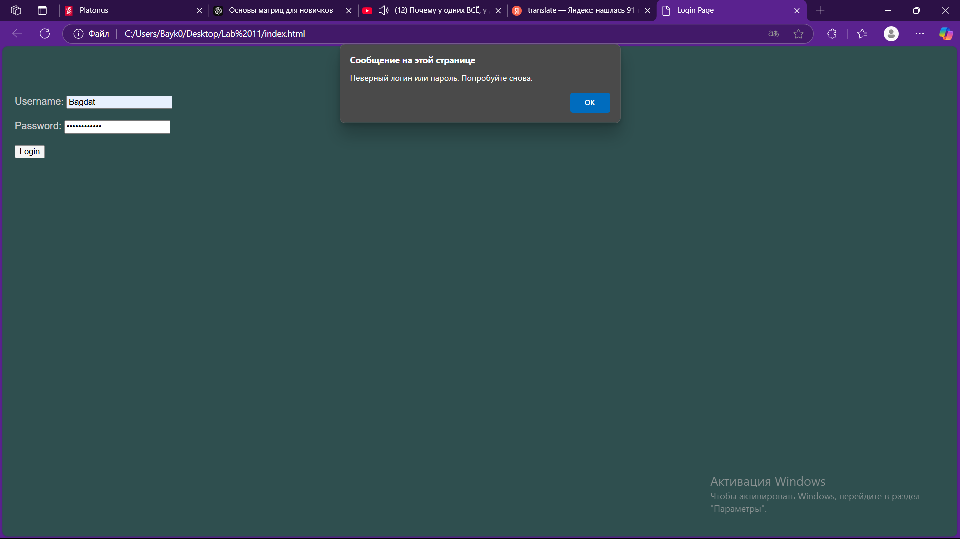

1.picture - incorrect password

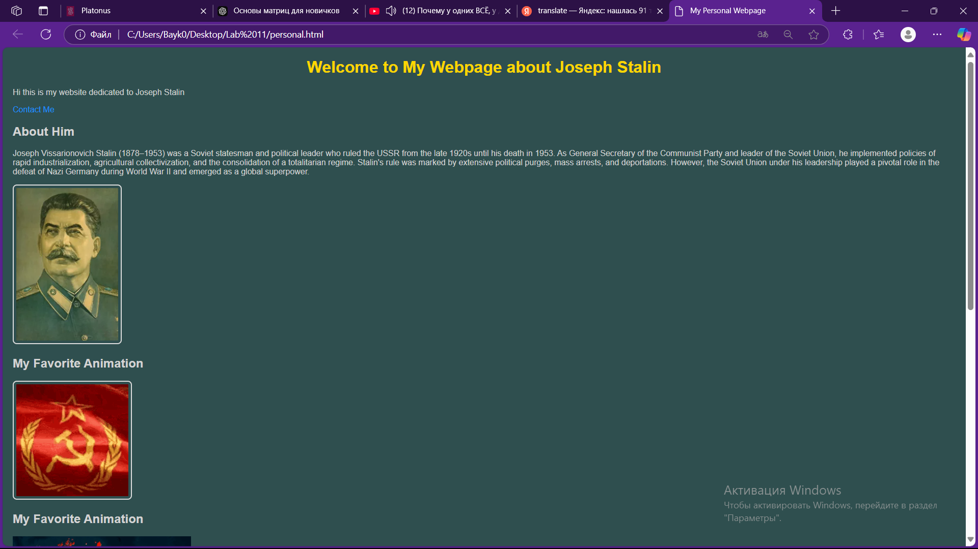

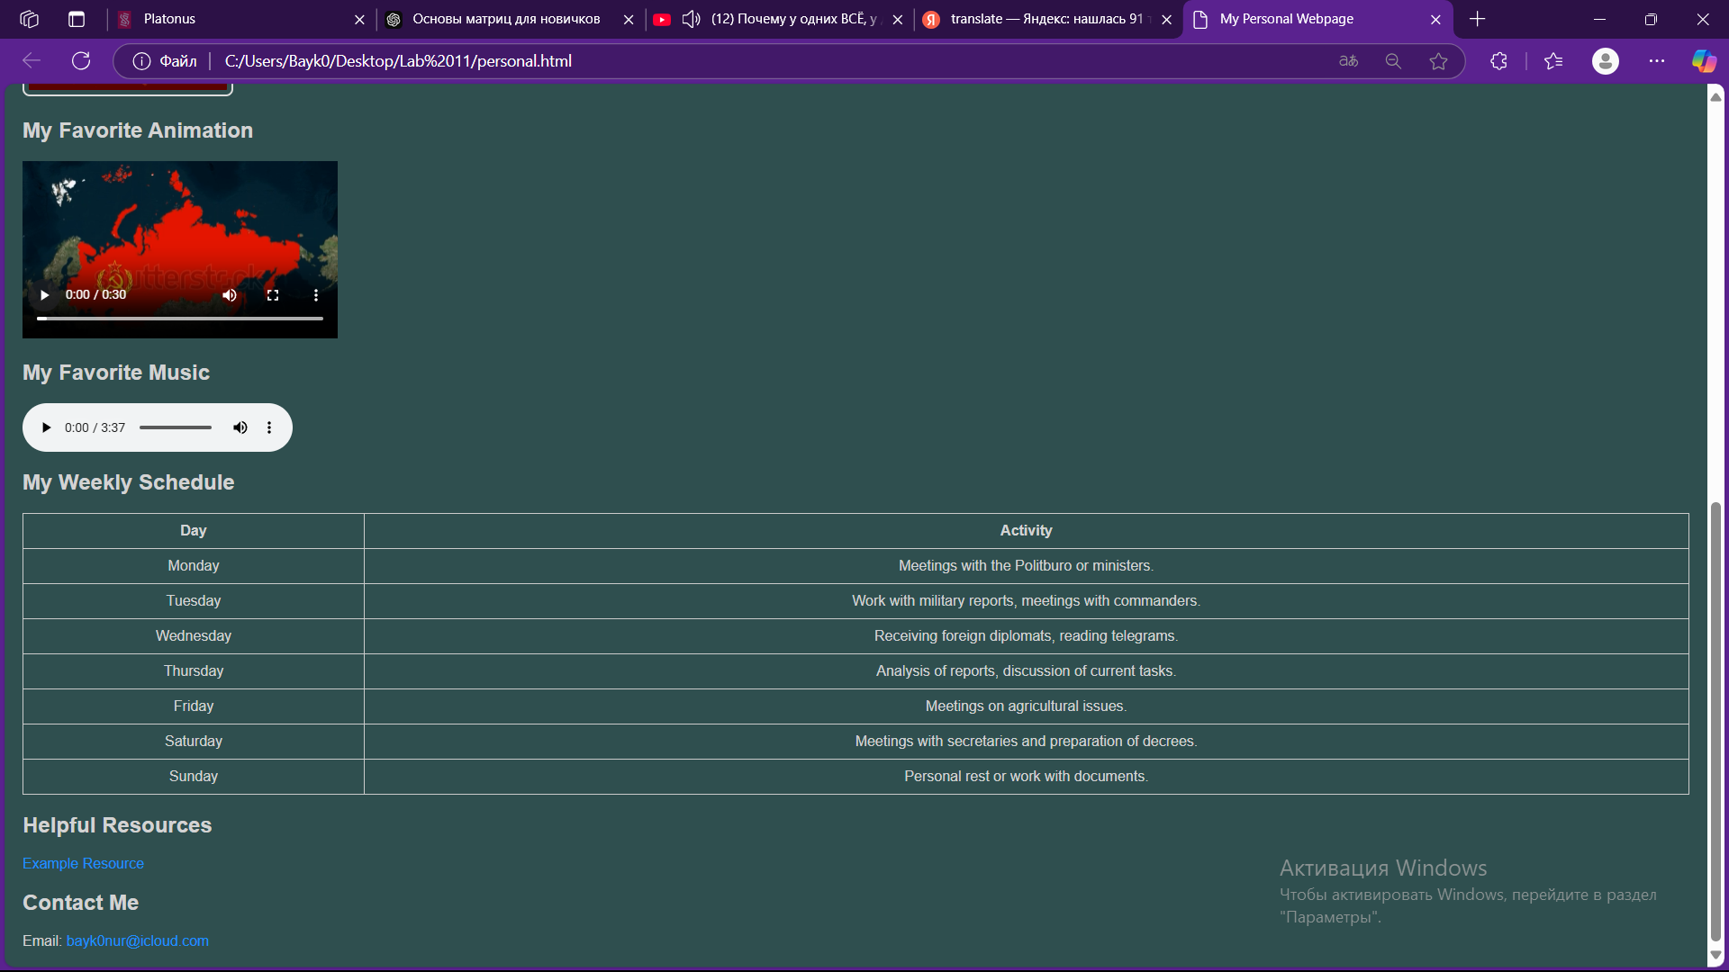

2-3.picture - personal page

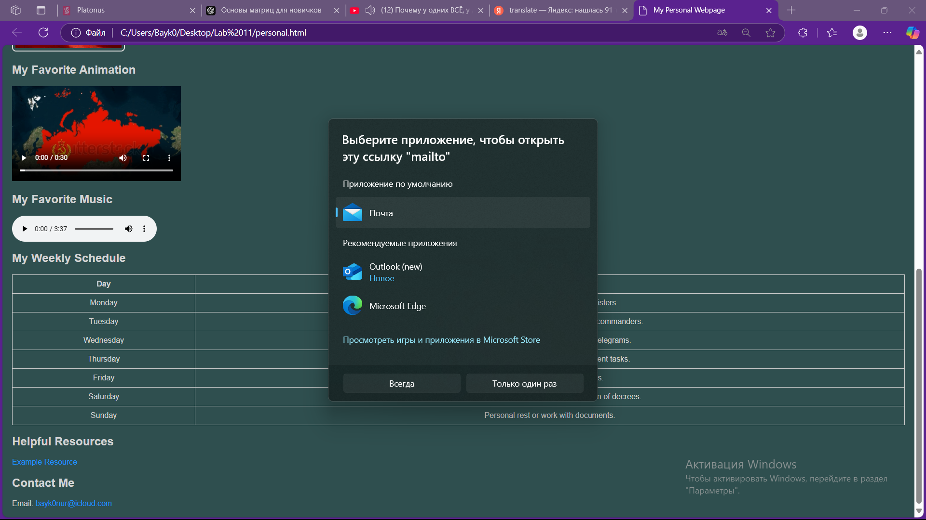

4.picture - Mail to my e-mail address

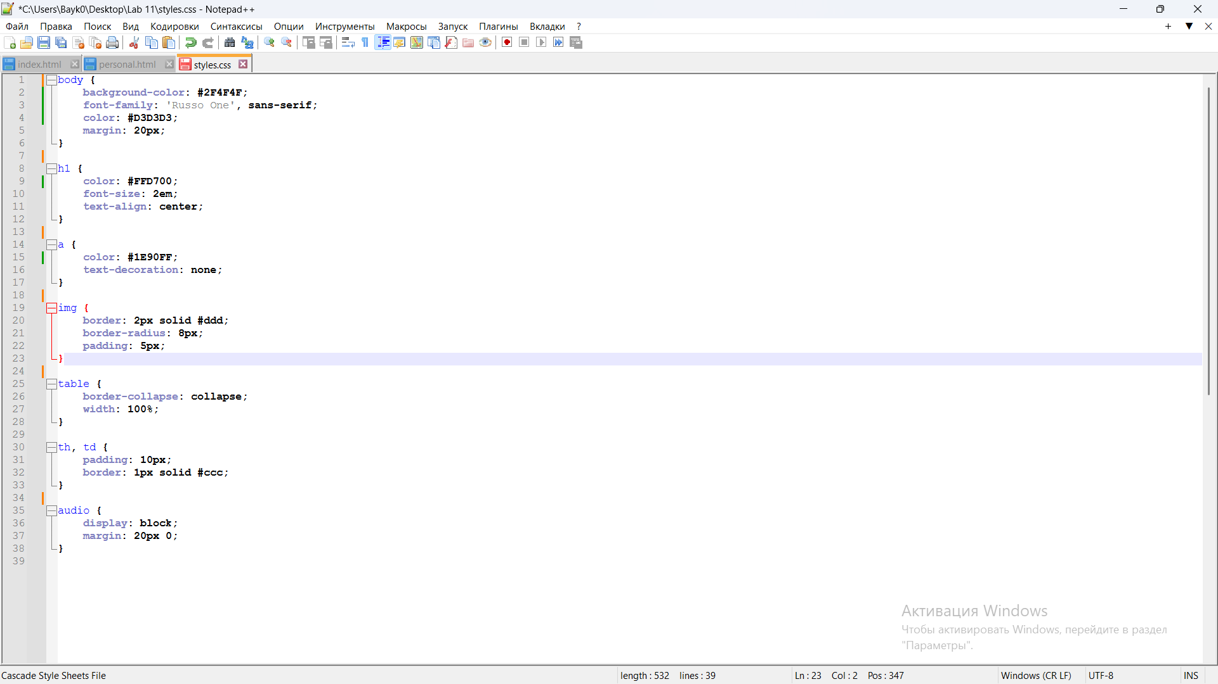

5.picture - CSS file

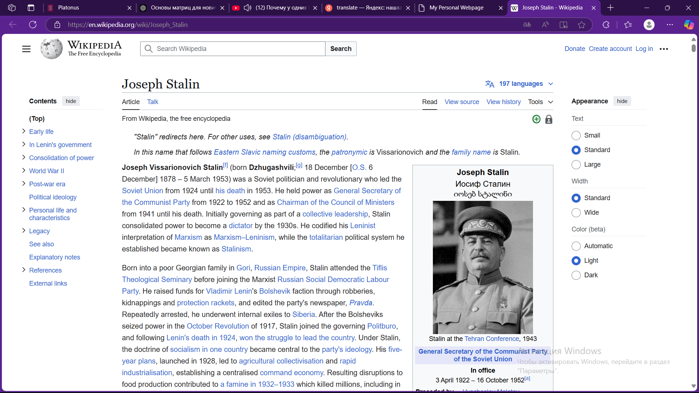

6.picture - Helpful resource