Reese Ford

Lab03 – Fetch Stage

02/01/2024

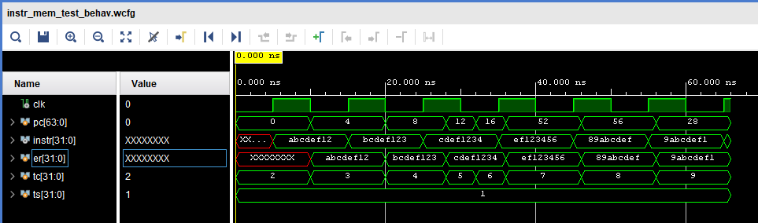

******* BEGIN TEST RESULTS *******

Test Case 1

+++ Step 1: Pass: |instruction| time = 10 ns | er = abcdef12 | ar = abcdef12 | er_bits = 32 | ar_bits = 32 +++

Test Case 2

+++ Step 1: Pass: |instruction| time = 20 ns | er = bcdef123 | ar = bcdef123 | er_bits = 32 | ar_bits = 32 +++

Test Case 3

+++ Step 1: Pass: |instruction| time = 28 ns | er = cdef1234 | ar = cdef1234 | er_bits = 32 | ar_bits = 32 +++

Test Case 4

+++ Step 1: Pass: |instruction| time = 32 ns | er = cdef1234 | ar = cdef1234 | er_bits = 32 | ar_bits = 32 +++

Test Case 5

+++ Step 1: Pass: |instruction| time = 36 ns | er = ef123456 | ar = ef123456 | er_bits = 32 | ar_bits = 32 +++

Test Case 6

+++ Step 1: Pass: |instruction| time = 46 ns | er = 89abcdef | ar = 89abcdef | er_bits = 32 | ar_bits = 32 +++

Test Case 7

+++ Step 1: Pass: |instruction| time = 56 ns | er = 9abcdef1 | ar = 9abcdef1 | er_bits = 32 | ar_bits = 32 +++

Test Case 8

+++ Step 1: Pass: |instruction| time = 66 ns | er = 23456789 | ar = 23456789 | er_bits = 32 | ar_bits = 32 +++

Pass Count = 8

Fail Count = 0

******* END TEST RESULTS *******

******* BEGIN TEST RESULTS *******

Test Case 1

+++ Step 1: Pass: |cur_pc| time = 10 ns | er = 0 | ar = 0 | er_bits = 64 | ar_bits = 64 +++

+++ Step 2: Pass: |instruction| time = 10 ns | er = abcdef12 | ar = abcdef12 | er_bits = 32 | ar_bits = 32 +++

Test Case 2

+++ Step 1: Pass: |cur_pc| time = 20 ns | er = 4 | ar = 4 | er_bits = 64 | ar_bits = 64 +++

+++ Step 2: Pass: |instruction| time = 20 ns | er = bcdef123 | ar = bcdef123 | er_bits = 32 | ar_bits = 32 +++

Test Case 3

+++ Step 1: Pass: |cur_pc| time = 30 ns | er = 8 | ar = 8 | er_bits = 64 | ar_bits = 64 +++

+++ Step 2: Pass: |instruction| time = 30 ns | er = cdef1234 | ar = cdef1234 | er_bits = 32 | ar_bits = 32 +++

Test Case 4

+++ Step 1: Pass: |cur_pc| time = 42 ns | er = 12 | ar = 12 | er_bits = 64 | ar_bits = 64 +++

+++ Step 2: Pass: |instruction| time = 42 ns | er = def12345 | ar = def12345 | er_bits = 32 | ar_bits = 32 +++

Test Case 5

+++ Step 1: Pass: |cur_pc| time = 52 ns | er = 44 | ar = 44 | er_bits = 64 | ar_bits = 64 +++

+++ Step 2: Pass: |instruction| time = 52 ns | er = 6789abcd | ar = 6789abcd | er_bits = 32 | ar_bits = 32 +++

Test Case 6

+++ Step 1: Pass: |cur_pc| time = 62 ns | er = 48 | ar = 48 | er_bits = 64 | ar_bits = 64 +++

+++ Step 2: Pass: |instruction| time = 62 ns | er = 789abcde | ar = 789abcde | er_bits = 32 | ar_bits = 32 +++

Test Case 7

+++ Step 1: Pass: |cur_pc| time = 64 ns | er = 48 | ar = 48 | er_bits = 64 | ar_bits = 64 +++

+++ Step 2: Pass: |instruction| time = 64 ns | er = 789abcde | ar = 789abcde | er_bits = 32 | ar_bits = 32 +++

Test Case 8

+++ Step 1: Pass: |cur_pc| time = 74 ns | er = 20 | ar = 20 | er_bits = 64 | ar_bits = 64 +++

+++ Step 2: Pass: |instruction| time = 74 ns | er = f1234567 | ar = f1234567 | er_bits = 32 | ar_bits = 32 +++

Test Case 9

+++ Step 1: Pass: |cur_pc| time = 84 ns | er = 32 | ar = 32 | er_bits = 64 | ar_bits = 64 +++

+++ Step 2: Pass: |instruction| time = 84 ns | er = 3456789a | ar = 3456789a | er_bits = 32 | ar_bits = 32 +++

Test Case 10

+++ Step 1: Pass: |cur_pc| time = 94 ns | er = 36 | ar = 36 | er_bits = 64 | ar_bits = 64 +++

+++ Step 2: Pass: |instruction| time = 94 ns | er = 456789ab | ar = 456789ab | er_bits = 32 | ar_bits = 32 +++

Test Case 11

+++ Step 1: Pass: |cur_pc| time = 104 ns | er = 40 | ar = 40 | er_bits = 64 | ar_bits = 64 +++

+++ Step 2: Pass: |instruction| time = 104 ns | er = 56789abc | ar = 56789abc | er_bits = 32 | ar_bits = 32 +++

Pass Count = 22

Fail Count = 0

******* END TEST RESULTS *******