Reese Ford – Lab 8 Report

03/25/2024

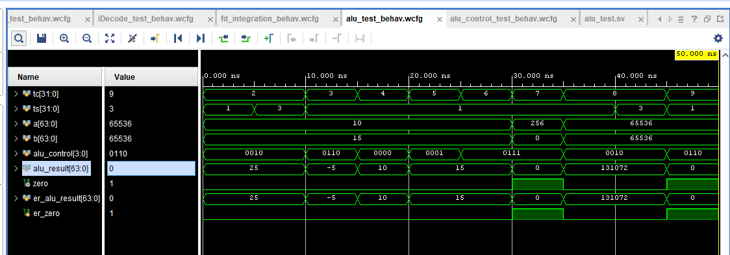

******* BEGIN TEST RESULTS *******

Test Case 1: | (10 + 15)

+++ Step 1: Pass: |alu_result| time = 5 ns | er = 25 | ar = 25 | er_bits = 64 | ar_bits = 64 +++

+++ Step 2: Pass: |zero| time = 5 ns | er = 0 | ar = 0 | er_bits = 1 | ar_bits = 1 +++

Test Case 2: | (10 - 15)

+++ Step 1: Pass: |alu_result| time = 15 ns | er = -5 | ar = -5 | er_bits = 64 | ar_bits = 64 +++

+++ Step 2: Pass: |zero| time = 15 ns | er = 0 | ar = 0 | er_bits = 1 | ar_bits = 1 +++

Test Case 3: | (10 & 15)

+++ Step 1: Pass: |alu_result| time = 20 ns | er = 10 | ar = 10 | er_bits = 64 | ar_bits = 64 +++

+++ Step 2: Pass: |zero| time = 20 ns | er = 0 | ar = 0 | er_bits = 1 | ar_bits = 1 +++

Test Case 4: | (10 | 15)

+++ Step 1: Pass: |alu_result| time = 25 ns | er = 15 | ar = 15 | er_bits = 64 | ar_bits = 64 +++

+++ Step 2: Pass: |zero| time = 25 ns | er = 0 | ar = 0 | er_bits = 1 | ar_bits = 1 +++

Test Case 5: | PASS b=15

+++ Step 1: Pass: |alu_result| time = 30 ns | er = 15 | ar = 15 | er_bits = 64 | ar_bits = 64 +++

+++ Step 2: Pass: |zero| time = 30 ns | er = 0 | ar = 0 | er_bits = 1 | ar_bits = 1 +++

Test Case 6: | PASS b=0

+++ Step 1: Pass: |alu_result| time = 35 ns | er = 0 | ar = 0 | er_bits = 64 | ar_bits = 64 +++

+++ Step 2: Pass: |zero| time = 35 ns | er = 1 | ar = 1 | er_bits = 1 | ar_bits = 1 +++

Test Case 7: | (65536 + 65536)

+++ Step 1: Pass: |alu_result| time = 40 ns | er = 131072 | ar = 131072 | er_bits = 64 | ar_bits = 64 +++

+++ Step 2: Pass: |zero| time = 40 ns | er = 0 | ar = 0 | er_bits = 1 | ar_bits = 1 +++

Test Case 8: | (65536 - 65536)

+++ Step 1: Pass: |alu_result| time = 50 ns | er = 0 | ar = 0 | er_bits = 64 | ar_bits = 64 +++

+++ Step 2: Pass: |zero| time = 50 ns | er = 1 | ar = 1 | er_bits = 1 | ar_bits = 1 +++

Pass Count = 16

Fail Count = 0

******* END TEST RESULTS *******

******* BEGIN TEST RESULTS *******

Test Case 1: | LDUR

+++ Step 1: Pass: |alu_control| time = 5 ns | er = 10 | ar = 10 | er_bits = 4 | ar_bits = 4 +++

Test Case 2: | STUR

+++ Step 1: Pass: |alu_control| time = 10 ns | er = 10 | ar = 10 | er_bits = 4 | ar_bits = 4 +++

Test Case 3: | ADD

+++ Step 1: Pass: |alu_control| time = 15 ns | er = 10 | ar = 10 | er_bits = 4 | ar_bits = 4 +++

Test Case 4: | SUB

+++ Step 1: Pass: |alu_control| time = 20 ns | er = 110 | ar = 110 | er_bits = 4 | ar_bits = 4 +++

Test Case 5: | AND

+++ Step 1: Pass: |alu_control| time = 25 ns | er = 0 | ar = 0 | er_bits = 4 | ar_bits = 4 +++

Test Case 6: | ORR

+++ Step 1: Pass: |alu_control| time = 30 ns | er = 1 | ar = 1 | er_bits = 4 | ar_bits = 4 +++

Test Case 7: | CBZ Positive

+++ Step 1: Pass: |alu_control| time = 35 ns | er = 111 | ar = 111 | er_bits = 4 | ar_bits = 4 +++

Test Case 8: | CBZ Negative

+++ Step 1: Pass: |alu_control| time = 40 ns | er = 111 | ar = 111 | er_bits = 4 | ar_bits = 4 +++

Test Case 9: | B Positive

+++ Step 1: Pass: |alu_control| time = 45 ns | er = 10 | ar = 10 | er_bits = 4 | ar_bits = 4 +++

Test Case 10: | B Negative

+++ Step 1: Pass: |alu_control| time = 50 ns | er = 10 | ar = 10 | er_bits = 4 | ar_bits = 4 +++

Test Case 11: | Default

+++ Step 1: Pass: |alu_control| time = 55 ns | er = 0 | ar = 0 | er_bits = 4 | ar_bits = 4 +++

Pass Count = 11

Fail Count = 0

******* END TEST RESULTS *******