Matthew Gale

COSC 603

February 24, 2016

Project 1 Task 3

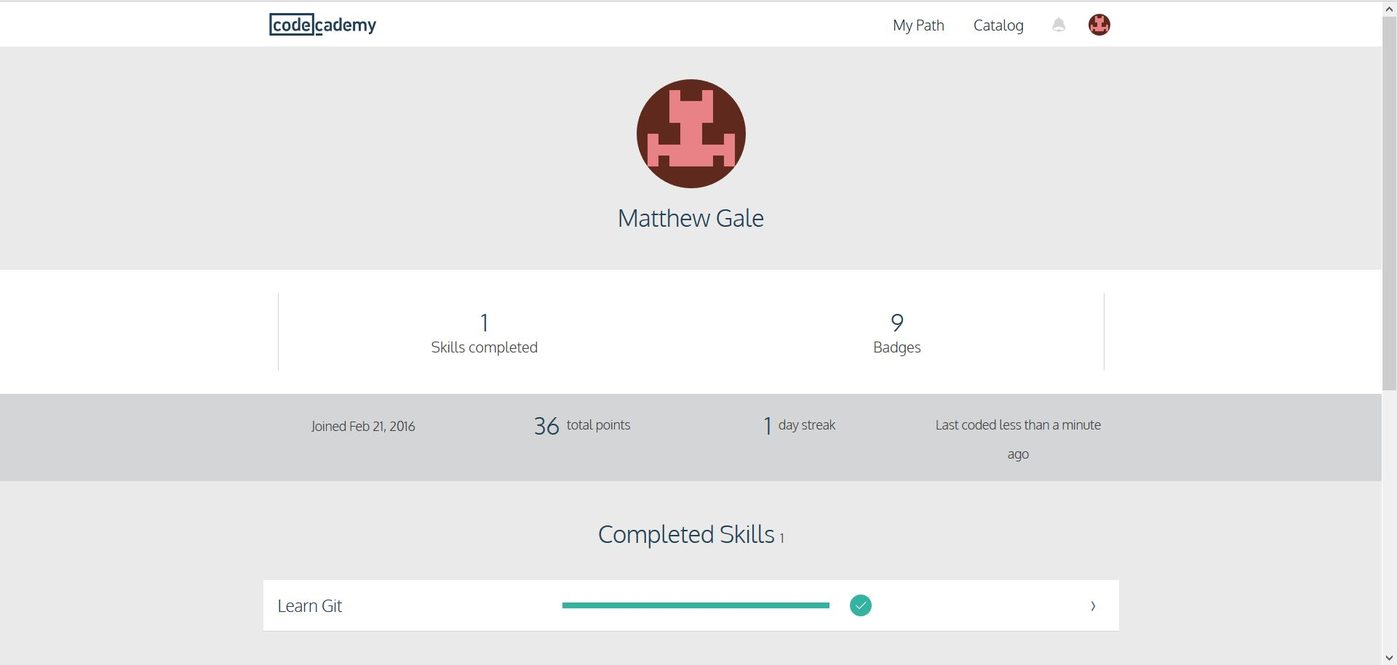

What I learn about using a configuration management tool is, it is very useful when having a lot of people developing on the same project. The branches are very useful because it allows one person to go off and develop one aspect of the project while others work on their portions. Once a person has completed their task they can then can combine their work to the master project. At first, the commit and staging area was a little confusing but as I progressed through the class it became clearer. I am using the GIT tool that is found on eclipse because it seemed more straight forward, however I have not been able to “fetch” yet. The desktop GIT tool seems to very easy to use, I was able to pull and push files using it. I hope one project will make us team up with a partner, where we have to develop different aspect of a program. This will help me better understand branches and how to use them.