

OCSpeed Powered By Laurel Boys & Girls Club
Universal Speed Development for Youth Athletics
Speed is earned. Confidence is built. Character is Developed.


Athlete Requirements:
Student Athlete Contract- The purpose of this document is to have every student athlete realize the responsibility and privilege that comes with being a member of OCSpeed Powered By Laurel Boys & Girls Club
-Track is an excellent opportunity to experience many of the things that can help an individual mature as a person. Through adversity, as well as victory, student athletes can challenge themselves, and their teammates to achieve goals.
-This process of accepting and overcoming challenges teaches student athletes to respect one another, themselves and allows them to reach their fullest potential.
-The nature of track and field requires student athletes to take responsibility demanded of them as a team member and as an individual.
-Fee: $2 (Meets) Fee: $1 (train) Fee: $3 (Meet/Weights)
This document spells out the rules of OCSpeed Powered By Laurel Boys & Girls Club which we can all succeed. Each athlete must follow the team rules in order to participate and pay fees on time of $1.
Please complete payment on our website linked below:
OCSpeed Powered By Laurel Boys & Girls Club
•Make sure coaches know if you have any medical issues.
- Training Contacts:
  - Coach Brenen Garrett ( Coach B) - 240-355-3719 - ocspeed123@gmail.com
This document spells out the rules of the OCSpeed Powered By Laurel Boys & Girls Club . These rules will help create a winning environment in which we can all succeed. Each athlete must follow the team rules to participate.

-Athlete must realize on, and off the track, they represent OCSpeed Powered By Laurel Boys & Girls Club and themselves. Therefore, athletes expected to maintain loyalty toward their peers and respect toward adult figures.
Athlete Behavior: Athletes expected to maintain appropriate behavior on and off the track.
a. Speak with their event coach before, after practices and all competitions!
Ex: Athletes must be around so coaches can explain phases of the race/before and after warm-ups/cool-downs
-Athletes may not miss any races while at the meets.
-Athletes/parents must let coaches know if they feel any pain/injuries!
-Athletes are allowed to ask questions about training and events.
Ex: It is not what you say, it is how you ask it…
-Athletes must stay together as a group:
Ex: Hotels, restaurants, malls, and other team activity sights!
Attendance: Athletes are required to attend ALL practices during the week to compete in the meets. It is expected that the athletes attend practices ON TIME and participate for the ENTIRE practice. (Family vacations are understandable, but just let coaches know ahead of time for fees purposes).

NOTE:
Practice |  | Others
Monday. Tuesday, and Thursday | @ Laurel Highschool, or Boys and Girls Club (TBA)  - 6:15PM (All ages) | -Track practice, plyometrics/hills, swimming, and road running.  TBA

-Uniform: The attire for all athletes at practice must include a warm-up (pants and jacket/sweatshirt) on top of work-out clothing and proper training shoes. The team uniform must be worn to identify athletes at large competitions. Coaches will inform athletes/parents before the meet’s changes.
NOTE: Team colors Navy Blue, Grey, White bring all uniforms/gear to the meets!

Academic Performance:
We are student athletes first; all students’ athletes must maintain a 2.0 or higher GPA to compete on the team..
-Parents/Athletes need to sign up for the NCAA Eligibility Center to participate/ receive any scholarship funds for college. (Highschool Student Athletes)
-Lastly, student athletes must fill out 5 college questionnaires every 2 weeks and let the coaches know which schools/coaches contact information. (Highschool Student Athletes)
-Youth athletes must keep a mental journal, each month expressing long term and short-term goals.
-Let your coaches know if you need college assistance so we can support you in scheduling recruiting visits.(Highschool Student Athletes)

ABSENCES
-Attending all practice sessions and competitions is a crucial aspect of training for ALL track and field events to obtain your short/long term goals.
-If you are unable to attend practice due to an illness, a doctor’s appointment, or a family emergency, you or your parents must call or notify coaches by 2:00 PM the day before or that day.
(Rules are set so parents will know where they kids are at practices and meets)

If expectations not met, the following consequences would take place:
*Injured: will sit the athlete down for the next scheduled practice.
1st Offense- If the student athlete comes late to practice and with or without a note: they will receive an alternative workout. Ex: double up on missed workouts. Missing practice all together without a note, coaches will double up on workouts missed. (Call Home)
2nd Offense - Student/athlete will be suspended from the next scheduled track and field meet and will be required to attend as a team manager. If the student/athlete does not attend the meet, this will be treated as another offense. (Meeting with Parents)
Parent Expectations:
•Drop their kids off on time. (Please walk younger kids down to the track area)
•Provide your kids with enough water for practices and meets!
•Drop kids off at the meet on time. (Please let someone know if you would like to carpool)
•Please, watch practice from a distance (No extra coaching) and ask questions before or after practice.
(Coaches may be too focused to answer questions while training athletes, and we would like to answer your questions appropriately)
•Please, restrain from coaching any student athletes during practices and meets.
Focus on development (short/long-term goals (not rivalries)
•Create a loving atmosphere and allow athletes to set goals and go after them.
(Tough love/coaching will be provided during practice)
-Remember: as a coach and parent, your attitude towards sports and competition will directly affect your athlete or child.

Coaches Expectations:
Provide respect for athletes, parents, coaches, and game officials.
-Control emotions and behaviors
-Remember: as a coach and parent, your attitude towards sports and competition will directly affect coaches, parent, and team
-Focus on times (short/long-term goals (not rivalries)
-Provide the fairest and most positive training
-Focus on the lifelong benefit of coaching
-Teach fundamentals, rules, and regulations
-Help in the recruiting process if needed
-Communicate with parents and other coaches about any changes before, during, and after practice/meets.

Recruitment Process

Name | Description | Links
High school 4 year plan | -Speak with your guidance counselor about your four-year scheduling plan that meets the NCAA requirements.  -Stay on top of your grades  -try out for your high school team or youth team.  -Clean up your social media sites  -Increase skills and performances | How To Get A Track & Field Scholarship (Including Tips & Tricks) - YouTube  How I got a Track Scholarship to USC || My NCAA Recruiting Story || KingsleyTV - YouTube
NCAA Information | Why Are There NCAA Divisions?  The NCAA created divisions to have competitive balance and level the playing field in NCAA sports. The idea behind divisions is for schools to be competing against other schools of a similar size and with similar resources. | eligibility center: New NCAA Student Athlete Eligibility Rules. (athleticscholarships.net)
SAT/ACT Guidance | The SAT is an entrance exam used by most colleges and universities to make admissions decisions. The SAT is a multiple-choice, pencil-and-paper test created and administered by the College Board. | www.collegeboard.org  How Do I Register My Child for the SAT? - SAT Registration (testive.com)  The SAT – SAT Suite | College Board  https://www.act.org
Recruiting Questionnaires | Recruiting questionnaires introduce guidelines to future student-athletes and provides coaches with information about your inquiry.  * look up junior college and prep schools if needed. | Why you fill out (and update!) recruiting questionnaires (usatodayhss.com)
Alternative Measures | Juico:  Community College:

Coach ___________,
My name is Nate Gainey, and I am currently a junior at Mount Hebron High School in Ellicott City, MD. I currently maintain a 4.0 core GPA, 4.6 weighted GPA. I am interested in your track program and wanted to learn more about the University of ______________. I run events from the 100 meters to the 500 meters. Lately, I have been focusing on my 400 meter and 500-meter races indoor.

My big accomplishments of the 2010-2011 seasons are:
- setting the school record in the 400m
- becoming the Maryland 3A state qualifier in the open 400m and 1600m relay

My big accomplishments of the 2011-2012 indoor season are:
- setting the school record in the 500m, indoor 200m, and indoor 400m
- becoming the Howard County champion in the 500m
- setting school records (as lead-off) in 800m and 1600m relay
- Qualifying for the 2012 New Balance Indoor Nationals in both the 200m and 400m

My PRs include:
200m: 21.9 (Indoor)
300m: 35.91 (Indoor)
400m: 48.51
500m: 1:05:4 (Indoor)
300h: 40.

This is the schedule for our 2012 Outdoor Track season.

Date | Weekday | Meet Name | Time | Location
04/07/12 | Saturday | D. Scott Invite | 09:00 AM | Boonsboro HS
04/14/12 | Saturday | Pikesville Classic | 09:00 AM | Pikesville HS
04/21/12 | Saturday | Viking Invite | 09:00 AM | Walt Whitman
04/26/12  04/28/12 | Thursday  Saturday | Penn Relays | TBA | University of  Penn
04/28/12 | Saturday | HoCo Spring Classic | 10:00 AM | Reservoir HS
05/7/12  05/8/12 | Monday  Tuesday | HoCo County Championship | 04:00 PM | Reservoir HS
05/17/12  05/19/12 | Thursday  Saturday | 3A Region Championship | 04:00 PM/  10:00 AM | Reservoir HS
05/24/12  05/26/12 | Thursday  Saturday | State Meet | 04:00 PM/  10:00 AM | Morgan State University

Any videos from listed races can be made available upon request.

Hope to hear from you soon and Go _________________!

Nate Gainey Coach Brenen Garrett
n.gainey1@google1.net ocspeed123@gmail.com
(443)- 878- 0000 (cell) (240) 355 3719(cell)
(410)- 418- 0000 (home)
0000 Arcing Road
Ellicott City MD 21033
Step for Receiving an Athletic Scholarship
- Run the times or jumps, throws
- Sign up for the NCAA (eligibility center) http://web1.ncaa.org/ECWR2/NCAA_EMS/NCAA.jsp
- Type up an performance Profile letter
- Search the internet for all division I & II programs example: USTFCCCA.org or http://espn.go.com/college-football/conferences
- Find the head coach's email address and send your performance Profile letter to every school you would like to attend.
I hope this helps!!! ☺

Track and field scholarship information

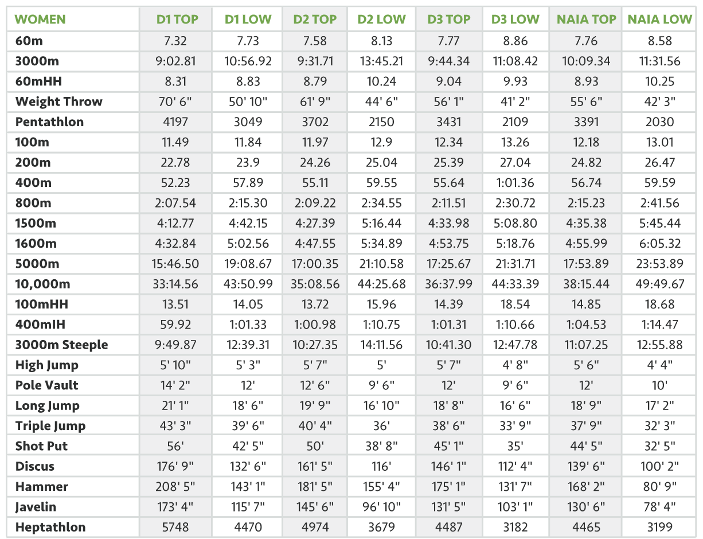
Track and field scholarship information

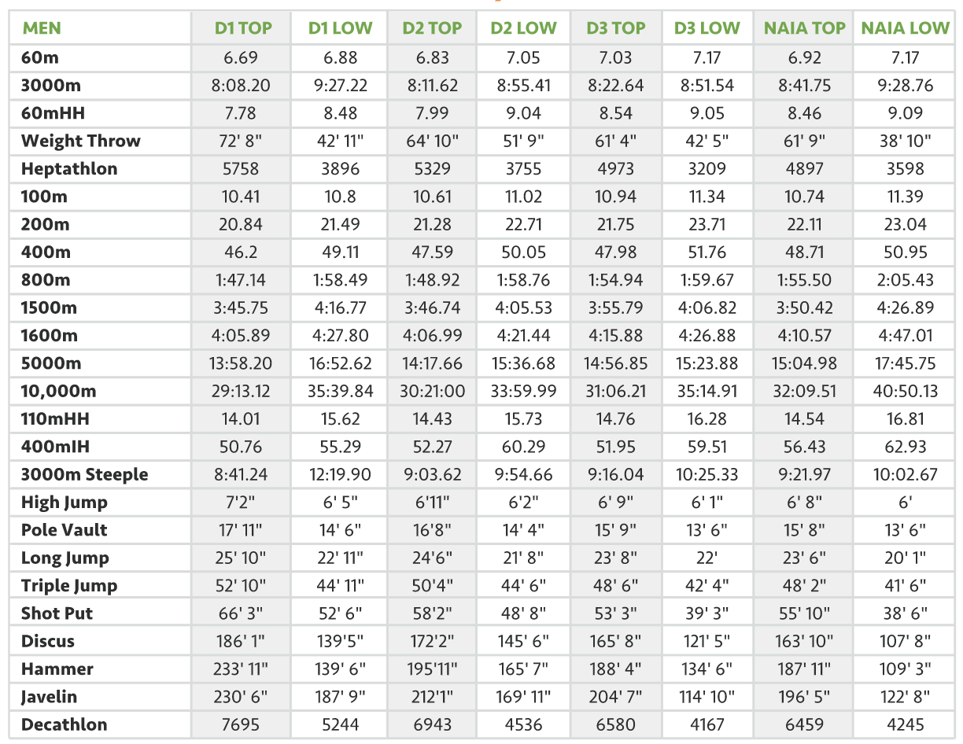
Nutrition
Complete this survey by answering each question as honestly as you can.
1. Who buys most of the food at your house? __________________________________________
2. Who prepares most of the meals at your house? ______________________________________
3. How many meals a day do you eat? ________________________________________________
4. If you skip meals, which meal or meals do you skip the most often? ______________________
_______________________________________________________________________________
5. How often in a month do you eat at a fast-food restaurant? _____________________________
6. How often in a month do you eat at a regular restaurant? _______________________________
7. How often in a day do you snack? _________________________________________________
8. What time of the day do you usually snack? _________________________________________
9. Do you sometimes eat when you’re not hungry? ______________________________________
10. What type of food do you avoid eating? _____________________________________________
11. What food do you crave the most? _________________________________________________
12. How much water do you drink in a day? _____________________________________________
13. Does your family usually enjoy a meal together, or do you often eat separately? _____________
________________________________________________________________________________
14. Where do you eat most of your meals (for example, in front of the TV, at the table, and so on)? __________________________________________________________________________
15. Do you take vitamins or supplements? _____________________________________________
15a. If so, which ones? ___________________________________________________
16. If you eat when you’re studying, what do you eat? _____________________________________
17. If you eat when you’re stressed, what do you eat? ______________________________________
18. Do you eat when you watch TV or a movie? __________________________________________
After you have completed this survey, on the back of this piece of paper list the concerns you have about that person’s eating habits. Evaluate the eating habits and create a healthy athletic plate.

Athletic Meal Plan
 | Monday | Tuesday | Wednesday | Thursday | Friday | Saturday | Sunday
Breakfast
Snack
Lunch
Snack
Dinner
Water
Physical Activity Level
Sleep

Tips:
-Rest is especially important
-Mental health is important
-Social life is important
-Massages & flexibility important
-Set reasonable goals for yourself
-Make permanent but gradual changes to your physical and eating habits.
- Eat raw fruits and veggies
-Purchase frozen goods instead of canned products.
-purchase alkaline water
MyPlate includes five major food groups:
  - Whole Grains Group (6oz.)
  - Vegetable Group (2.5 C.)
  - Fruit Group (2 C.)
  - Dairy Group (3 C.) & Water (8 C.)
  - Protein Foods Group (5.5 oz.)
Oils, solid fats, and sugars are not food groups and should be used rarely


OCSpeed
Powered By Laurel Boys & Girls Club
Try Out Standards

Upon tryouts, please make sure you turned in the following:
- Parent Permission Slip Form
- Information sheet
- Medical forms
- Waiver form
- Program fee: $1 (see page 1)

PLEASE DRESS FOR THE WEATHER- BRING WATER & RUNNING SHOES”
(Regular play shoes are NOT recommended to protect our Student Athletes health)
Groups are subject to change based on performance and motivation 😊
 |  |  |  |  | 400H
 | 80mH | 100mH  /110H | 100 | 200/  200H | 400 | 800 | 1600 | H/Decathlon | LJ/TJ | HJ | Throws  Dis/Shot
8 under g |  |  | 17 | 50 | 125 | 3:40 | 7:30 | 3422 | 11’4/18
8 under b |  |  | 15 | 40 | 119 | 3:10 | 8:23 | 3866 | 12’6/22
9-10g |  |  | 15.4 | 38 | 116 | 3:10 | 7:00 | 3500 | 12’5/22’ | 4’2 | 88/20
9-10b |  |  | 13.6 | 35 | 110 | 2:39 | 6:00 | 3600 | 13’0/25 | 5’0 | 108/26
11-12g | 13.5 |  | 14.3 | 30 | 106 | 2:50 | 6:32 | 3700 | 13’8/25 | 4’4 | 100/25
11-12b | 15.8 |  | 12.3 | 27 | 60 | 2:20 | 5:32 | 3897 | 17’6/30 | 5’3 | 119/32
13-14g |  | 16.3 | 13.3 | 27 | 103 | 2:40 | 6:25 | 3999 | 14’6/28 | 4’6 | 106/28
13-14b |  | 17.3 | 11.8 | 25 | 55 | 2:12 | 5:20 | 4970 | 18’8/35 | 5’5 | 125/37
15-16g |  | 15.6 | 12.8 | 26 | 59 | 2:30 | 6:12 | 4200 | 15’4/31.2 | 4’8 | 110/31
15-16b |  | 16.4 | 11.5 | 24.3 | 53 | 2:07 | 5:00 | 5000 | 19’6/37 | 5’8 | 130/42
17-18g |  | 16.0 | 12.58 | 25.1 | 58.2 | 2:25 | 5:45 | 4349 | 16’8/35.4 | 5’0 | 124/36
17-18b |  | 15.5 | 11.33 | 23.4 | 52 | 2:02 | 4:40 | 5159 | 20’7/41.2 | 6’1 | 135/48
College B |  | 15.62 | 10.8 | 21.4 | 49.11 | 1:58 | 4:27 | 5244 p | 22’11/44’11 | 6’5 | 139/52’6
College G |  | 14.05 | 11.84 | 23.9 | 57.89 | 2:15 | 5:02 | 4470 p | 18’6/39’6 | 5’3 | 132/42’5
Adults
* Marks based on training groups, traveling teams, and relays. *Some will be ahead of the times 😊*Adults: adult tryouts are based on individual goal setting.



OCSpeed Powered By Laurel Boys & Girls Club
Please hand this section to Coaches
Parents/Guardian Permission Slip Form
Athlete’s name: ______________________________________ Gender: ________________
DOB: _____________________________ Size: Top-____ Bottom- ____
Parent/guardians name: _________________________ ______________________________
Guardians Numbers: ___________________________ ______________________________
Guardians Emails: ______________________________________________________________________________
Athletes number: _______________________________________________________________
Quick medical history: (circle ones that apply) -allergies -asthma -diabetes -disabilities
Medication: (other chronic medical information) ______________________________________________________________________________
AAU Membership Card Due: $15.00 (ASAP)

Athletic goals: ______________________________________________________________________________

CONTACT INFORMATION
Athlete’s Name __________________________________________________________

Nickname __________________________________________________________
Male or Female: ___________________________________________ Age: _______________
Parent’s Name __________________________________________________________
Address ___________________________________________________________
___________________________________________________________
___________________________________________________________

Home Number ___________________________________________________________

Athlete’s Cell ____________________________________________________________

Parent’s Cell ___________________________________________________________
Preferable email _________________________________________________________
Uniform Size ____________________________________________________________
(Adult or Youth/Top & Bottom)
Is it ok to share your info with other team members? ( ) Yes () No (Please check one)
Medical Information for Athlete
Athlete’s Name _______________________________________________________

Date of Birth _______________________________________________________

Home Address _______________________________________________________
Home Tel No. _______________________________________________________
Parent/Guardian Name ___________________________________ Work ______________
Cell No. ______________________________
Parent/Guardian Name ___________________________________ Work ______________
Cell No. ______________________________
Family Physician __________________________________________________________
Physician Tel No. __________________________________________________________
Date of Last Tetanus Shot ________________________________
Allergies _________________________________________________________________
Medicine(s) ________________________________________________________________
Does your child have medical insurance? ( ) yes ( ) no
If yes, name of insurance company: _____________________________________________
RELEASE FOR TREATMENT:
I hereby give permission to the attending physician or hospital to administer appropriate medical treatment in the event I cannot be reached.
____________________________________________________ ______________________
Signature, Parent/Guardian Date
Laurel Boys & Girls Club Track Program
Athlete Waiver/Release Form for Iconic Force Track Program, Practice Participation
Undersigned being a parent or legal guardian of the child requesting team participation, does hereby affirm that the applicant is physically able to perform activities conducted by the Laurel Boys & Girls Club Track Program. I hereby give permission for the team coach to seek medical assistance for the team member in the event of sickness or injury. I understand that as a condition of joining the team, the undersigned, on behalf of all parents and guardians, and on behalf of the team member, hereby releases Coach Brenen Garrett and all agents of the team of all liability from injury or illness, mental or physical, suffered by the team member during or related to practice.
The team member is covered by:
Insurance Company _______________________________________________________________________
PRINTED NAME OF PARENT/GUARDIAN: ___________________________________
ADDRESS: ______________________________________________________________________
_________________________________________________________________________________
PHONE: ________________________________________________________________________
PHONE: ________________________________________________________________________
PARENT/GUARDIAN SIGNATURE (only if participant is a minor):

_____________________________________________________________________________

OCSpeed Powered By Laurel Boys & Girls Club
- Accident Report Form
- Name: ______________________________ Address: _________________________
_________________________
__________________________
- School: ______________________________ Grade/Class: ______________________
- Date of Accident: ______________________ Time: ___________________________
- Date Reported: ________________________
- Description of Accident: How did it happen? What was the person doing? Where was the person? ______________________________________________________________________________________________________________________________________________________________________________________________________________________________________________________________________________________________________________________________________________________________________________________________________
- Injured Person’s Statement: __________________________________________________________________________________________________________________________________________________________________________________________________________________________________________
- Location of Accident: _____________________________________________________________
- Nature of the Injury: _____________________________________________________________
- Part of the body: ________________________________________________________________
- Subject/Activity: ________________________________________________________________
- Action plan: __________________________________________________________________________________________________________________________________________________________________________________________________________________________________________
- Equipment Involoved: ____________________________________________________________________________________________________________________________________________________________
- Were parents or other people notified? YES/NO
Time: ____________ How: ________________ Person Notified: ___________________
By whom: _________________________________
- Was property damaged? YES/NO What was it: ______________________
- Person in charge when incident occurred: _____________________ Present at the scene?
YES/NO
Coach Signature: ________________________________
Parent/ Athlete Signature: ________________________________ __________________________

