Istanbul Bilgi University
Department of Computer Engineering

CMPE 351: Database Systems
Travel Booking & Reservation System Database Design

Student:
Bayram YAVUZ
122200058

Instructor:
Assoc. Prof. Elena Battini Sönmez

1. System Purpose, Business Rules, and Constraints
1.1 System Purpose
The purpose of the Travel Booking & Reservation System is to manage customers, travel packages, service inventories (flights and hotels), bookings, and financial transactions in a structured and efficient way. The system allows customers to select travel packages, issues tickets for flights, creates reservations for hotels, and processes payments securely. It employs a relational database to ensure data integrity across all entities.
1.2 Business Rules
- A customer must register to make bookings.
- A booking must be fully paid (or have payment records) to be valid.
- Services are categorized as either Flights or Hotels (Inheritance structure).
- Every Flight has a fixed set of Seats; every Hotel has a fixed set of Rooms.
- A Ticket is only issued when linked to a Booking and assigned a Seat.
- A Reservation is only confirmed when linked to a Booking and assigned a Room.
- Deleting a booking cascades to delete its associated Payments, Tickets, and Reservations.
1.3 Constraints
1.3.1 Makes (Customer — Booking)
- Cardinality: 1:N because a customer can make many bookings over time, but each specific booking file is created by exactly one customer.
- Participation: Customer (Partial) because a registered customer might not have made any bookings yet; Booking (Total) because every booking must be linked to a customer account.
1.3.2 Selects (Booking — Travel Package)
- Cardinality: N:1 because many bookings can select the same standard travel package, but a single booking instance refers to one specific package.
- Participation: Booking (Total) because a booking cannot exist without selecting a package product.
1.3.3 Offer (Travel Package — Destination)
- Cardinality: N:1 because many packages can go to the same destination, but a package is defined by its primary destination.
- Participation: Travel Package (Total) because a package must have a destination defined.
1.3.4 Contain Travel (Travel Package — Service)
- Cardinality: 1:N (Implemented as M:N via Package Contents) because a package contains multiple services (flight + hotel), and a service can be part of multiple packages.
- Participation: Total for both, as a package must contain services and services are cataloged to be sold in packages.
1.3.5 HAS_PAYMENT (Booking — Payment)
- Cardinality: 1:N because a booking can be paid for in installments, but a payment belongs to one booking.
- Participation: Payment (Total) because a payment is a Weak Entity; it cannot exist without the Booking it pays for.
1.3.6 HAS_R (Booking — Reservation)
- Cardinality: 1:N because a booking folder may contain multiple reservations, but a reservation record belongs to one booking.
- Participation: Reservation (Total) because a reservation is a detail record of a booking.
1.3.7 IsFor (Reservation — Service)
- Cardinality: N:1 because a reservation is for a specific service type (e.g., a specific Hotel).
- Participation: Reservation (Total) because a reservation must specify which service is being reserved.
1.3.8 Issues (Booking — Ticket)
- Cardinality: 1:N because a booking issues tickets (one per passenger/flight), but a ticket comes from one booking.
- Participation: Ticket (Total) because a ticket is invalid without a booking source.
1.3.9 Assigned_to_Room (Reservation — Room)
- Cardinality: 1:1 (for this scope) because a reservation assigns a specific room for the duration.
- Participation: Reservation (Total) because a hotel reservation implies a room assignment.
1.3.10 Assigned_to_Seat (Ticket — Seat)
- Cardinality: 1:1 because a ticket grants access to exactly one seat on a flight.
- Participation: Ticket (Total) because a flight ticket must have a seat assignment.
1.3.11 Has-H (Hotel — Room)
- Cardinality: 1:N because a hotel has many rooms.
- Participation: Room (Total) because a room physically exists inside a hotel; it cannot exist independently.
1.3.12 Has-F (Flight — Seat)
- Cardinality: 1:N because a flight (aircraft) has many seats.
- Participation: Seat (Total) because a seat is physically part of a flight’s inventory.
1.3.13 ISA (Service — Hotel / Flight)
- Type: Disjoint, Total Generalization. Every Hotel or Flight IS A Service. They share attributes like ID and Base Price but have unique attributes (Stars vs. Airline).

2. ER Diagram and Design Justification
2.1 Design Justification
The design separates customers, products (packages), and inventory (services like flights and hotels) to ensure modularity.
- Inheritance (ISA Relationship): The Service entity acts as a superclass for Hotel and Flight. This avoids data redundancy for shared attributes like price and ID, while allowing specific attributes (like airline for flights and stars for hotels) to be stored separately.
- Weak Entities: Payment is modeled as a weak entity dependent on Booking, ensuring that financial records cannot exist without a valid transaction context.
- Normalization: Address information is kept within Destination, and multi-valued attributes like names are properly structured.
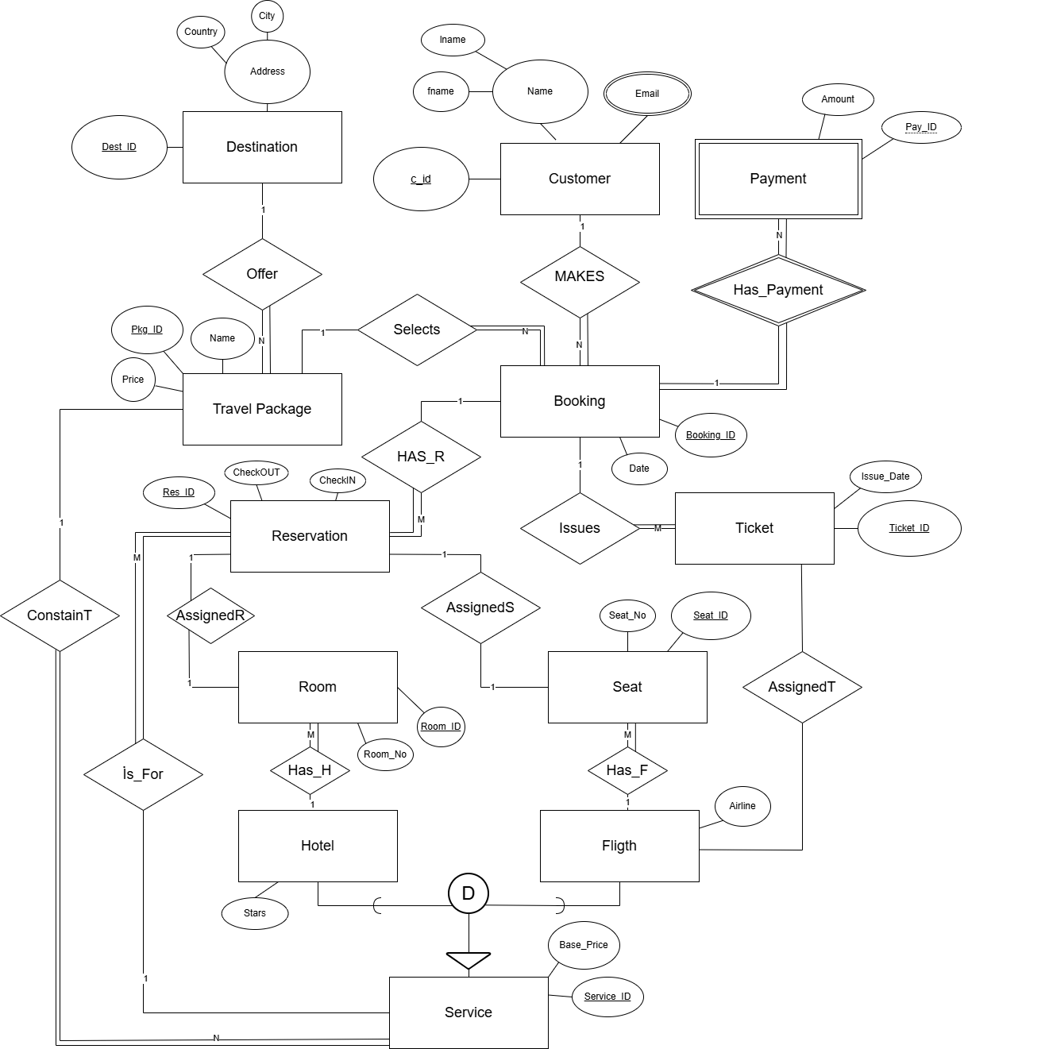

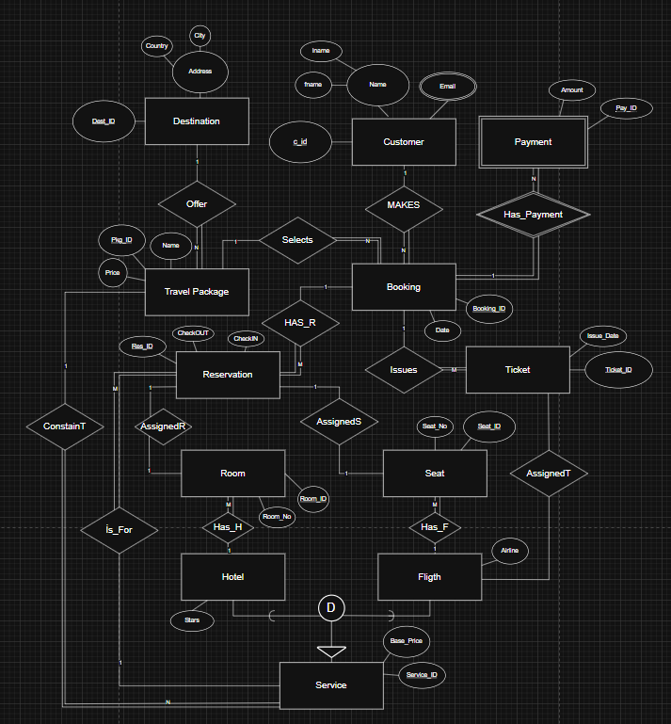

3. ER Schema and Relational Schema
3.1 ER Schema
The conceptual model is defined by the following entities and their attributes:
• Customer =(cust_id, name (fname, lname) , {email})
• Destination = (dest_id, address (city, country))
• Travel Package = (pkg_id, pkg_name, price)
• Booking = (booking_id, date)
• Payment=(payment_id, amount)
• Reservation = (res_id, check_in , check_out)
• Service = (service_id, service_name, base_price)
• Hotel = (service_id, stars)
• Flight = (service_id, airline)
• Room=(room_id, room_no)
• Seat = (seat_id, seat_no)
• Ticket = (ticket_id, issue_date)
Relationships:
• Makes=(cust_id, booking_id)
• Selects = (booking_id, pkg_id)
• Offer=(pkg_id, dest_id)
• Contain Travel = (pkg_id, service_id)
• HAS_PAYMENT=(booking_id, payment_id)
• HASR=(booking_id, res_id)
• isFor = (res_id, service_id)
• Issues = (booking_id, ticket_id)
• Assigned_to (Room) = (res_id, room_id)
• Assigned_to (Seat) = (ticket_id, seat_id)
• Has-H =(hotel_id, room_id)
• Has-F = (flight_id, seat_id)
• ISA =(service_id) [Inheritance]

3.2 Relational Schema
The logical database structure is mapped as follows:
• Customers = (cust_id, fname, lname , email)
• Destinations = (dest_id, city, country)
• Services = (service_id, service_name, base_price)
• Hotels = (hotel_id, service_id, stars)
• Flights = (flight_id, service_id, airline)
• Rooms=(room_id, hotel_id, room_no)
• Seats = (seat_id, flight_id, seat_no)
• TravelPackages = (pkg_id, dest_id, pkg_name, price)
• PackageContents = (booking_id, pkg_id, service_id)
• Bookings = (booking_id, cust_id, pkg_id, date)
• Payments =(payment_id, booking_id, amount)
• Reservations = (res_id, booking_id, service_id, room_id, check_in)
• Tickets = (ticket_id, booking_id, seat_id, issue_date)

4. Example Tables
Below are the example tables populated with sample data demonstrating the relationships and constraints defined in the system.
4.1 Customers
cust_id | fname | lname | email
101 | Ali | Yilmaz | ali.yilmaz@mail.com
102 | Ayse | Kaya | ayse.kaya@test.com
103 | John | Doe | john.doe@example.com
104 | Emily | White | emily.w@mail.com
105 | Mehmet | Demir | m.demir@test.com

4.2 Destinations
dest_id | city | country
201 | Paris | France
202 | Rome | Italy
203 | Tokyo | Japan
204 | Antalya | Turkey
205 | New York | USA

4.3 Services (Superclass for Hotels & Flights)
service_id | service_name | base_price
301 | THY Flight TK1923 | 5000
302 | Hilton Paris | 2000
303 | Pegasus Flight PC202 | 1500
304 | Rixos Antalya | 4500
305 | Delta Flight DL101 | 8000

4.4 Hotels (Subclass of Service)
hotel_id | service_id | stars
H01 | 302 | 5
H02 | 304 | 5

4.5 Flights (Subclass of Service)
flight_id | service_id | airline
F01 | 301 | Turkish Airlines
F02 | 303 | Pegasus
F03 | 305 | Delta

4.6 Rooms (Linked to Hotels)
room_id | hotel_id | room_no
R101 | H01 | 101
R102 | H01 | 102
R201 | H02 | 201
R202 | H02 | 202

4.7 Travel Packages
pkg_id | dest_id | pkg_name | price
PKG01 | 201 | Romantic Paris Tour | 15000
PKG02 | 204 | Summer in Antalya | 12000
PKG03 | 203 | Tokyo Adventure | 25000

4.8 Bookings
booking_id | cust_id | pkg_id | date
B001 | 101 | PKG01 | 2024-05-10
B002 | 102 | PKG02 | 2024-06-12
B003 | 103 | PKG01 | 2024-05-15
B004 | 104 | PKG03 | 2024-09-01
B005 | 101 | PKG02 | 2024-07-20

4.9 Payments
payment_id | booking_id | amount
PAY01 | B001 | 15000
PAY02 | B002 | 6000
PAY03 | B002 | 6000
PAY04 | B003 | 15000
PAY05 | B004 | 25000

4.10 Reservations (Hotel Bookings)
res_id | booking_id | service_id | room_id | check_in | check_out
RES01 | B001 | 302 | R101 | 2024-06-01 | 2024-06-07
RES02 | B002 | 304 | R201 | 2024-07-01 | 2024-07-05
RES03 | B003 | 302 | R102 | 2024-06-10 | 2024-06-15

4.11 Tickets (Flight Bookings)
ticket_id | booking_id | seat_id | issue_date
TKT01 | B001 | S01 | 2024-05-11
TKT02 | B002 | S05 | 2024-06-13
TKT03 | B004 | S10 | 2024-09-02
4.12 Seats (Flight Inventory)
seat_id | flight_id | seat_no | class
S01 | F01 | 1A | Business
S02 | F01 | 1B | Business
S03 | F01 | 10A | Economy
S04 | F01 | 10B | Economy
S05 | F02 | 1A | Economy
S06 | F02 | 1B | Economy
S10 | F03 | 20C | Economy
4.13 PackageContents (M:N Relationship)
Pkg_id | Service_id | Details
PKG01 | 301 | THY Flight included
PKG02 | 302 | Hilton Paris Stay included
PKG03 | 303 | Pegasus Flight included
PKG04 | 304 | Rixos Antalya Stay included
PKG05 | 305 | Delta Flight included

