

**Are All Citizens Created Equal?**

***VOTER INFLUENCE***

**By**

**Team 1.38**

Bay Rodriguez

Chris Tran

Emil Rodulfo

Nichelle Nesbitt

Tim Besaw

***VOTER INFLUENCE***

Contents

BACKGROUND 3

TEAM NAME 3

GOAL 3

OBJECTIVE 4

ETL PROCESS 4

Extract 4

Transpose 4

Load 4

FINAL VIZUALIZATION 5

PROBLEMS AND CHALLENGES 6

OVERALL ASSESSMENT AND RECOMMENDATIONS 6

Options for Change: 7

CONSIDERATIONS FOR POSSIBLE FUTURE ENHANCEMENTS 7

# BACKGROUND

The electoral college was created in the US for a couple of reasons. The first purpose was to create a buffer between population and the selection of a President. The second as part of the structure of the government that gave extra power to the smaller states. (<https://www.historycentral.com/elections/Electoralcollgewhy.html>)

Consequently, although individuals vote during the elections, the American popular vote is not a direct factor when it comes to the elected U.S. President and Vice President.

About the Electoral College:

* 538 electoral votes in the country
* 270 needed to win the election
* 538 is made up of ….
  + 438 … 1 vote for each member of the US House of Representatives
    - The distribution of representatives allocated to each state is evaluated every 10 years, with a minimum of 1 congressman per state.
  + 100 … 1 vote for each senator

Elections Results:

* 5 times the winner of the electorate did not win the national popular vote
  + Most recently in 2016 and 2000
  + The others occurred in 1888, 1876 and 1824

Electors:

* Are not required to vote for the person who won their states election.
* Are not required to vote at all; have the option to abstain.
  + 7 such voters in 2016
* Are subject to submitting the wrong name / typos.

# TEAM NAME

The population vs. the influence ratio for the state of Florida.

# GOAL

This project helps shed some light on the true voting influence states have in Presidential elections for the last year of the 20th Century to present day.

# OBJECTIVE

To tell a story, through data visualizations, regarding voter influence in the U.S elections. Our focus will include a dashboard. This will show the variance in weighted votes from different states and the impact they carry in presidential elections due to the electoral college process.

In addition, this project will demonstrate a “real time” voting process during the class presentation with user interaction.

This project will include Python Flask powered by RESTful API, **HTML/CSS**, **JavaScript**, and MySQL.

This project includes a dashboard page with multiple views all updating from the same data.

# ETL PROCESS

### Extract

* Data for this project was acquired from the following websites:

<https://www.infoplease.com/history-and-government/us-elections>

<https://transition.fec.gov/pubrec/fe2016/federalelections2016.xlsx>

https://www.archives.gov/federal-register/electoral-college/votes/index.html

* We extracted spreadsheets into a comprehensive workbook and saved them to independent CSV files.
* Extracted independent data for election years 2000-2016 to include (but not limited to) state population and electoral votes (senators and house seats) and election winners.
* Project included over 100 records.

### Transpose

* Datasets contained more columns than we needed, so we opted to only stage a subset of total data.
* Created import table structures to store the raw acquired data.
* Created relational table structures eliminate redundant information and enforce referential integrity.
* Created appropriate DML statements to transition the data form the import tables to the relational structures.
* Created logical views to hide join complexity.

### Load

* Created presentation views to transform the results into how we wanted the data rendered in the flask site.
* Created flask presentation table to simplify the logic within the flask application (allow native reflection by SQLAlchemy).

# FINAL VISUALIZATION

Final visualization includes at least **three views**

Project will include some level of **user-driven interaction** (e.g. menus, dropdowns, textboxes, etc.)

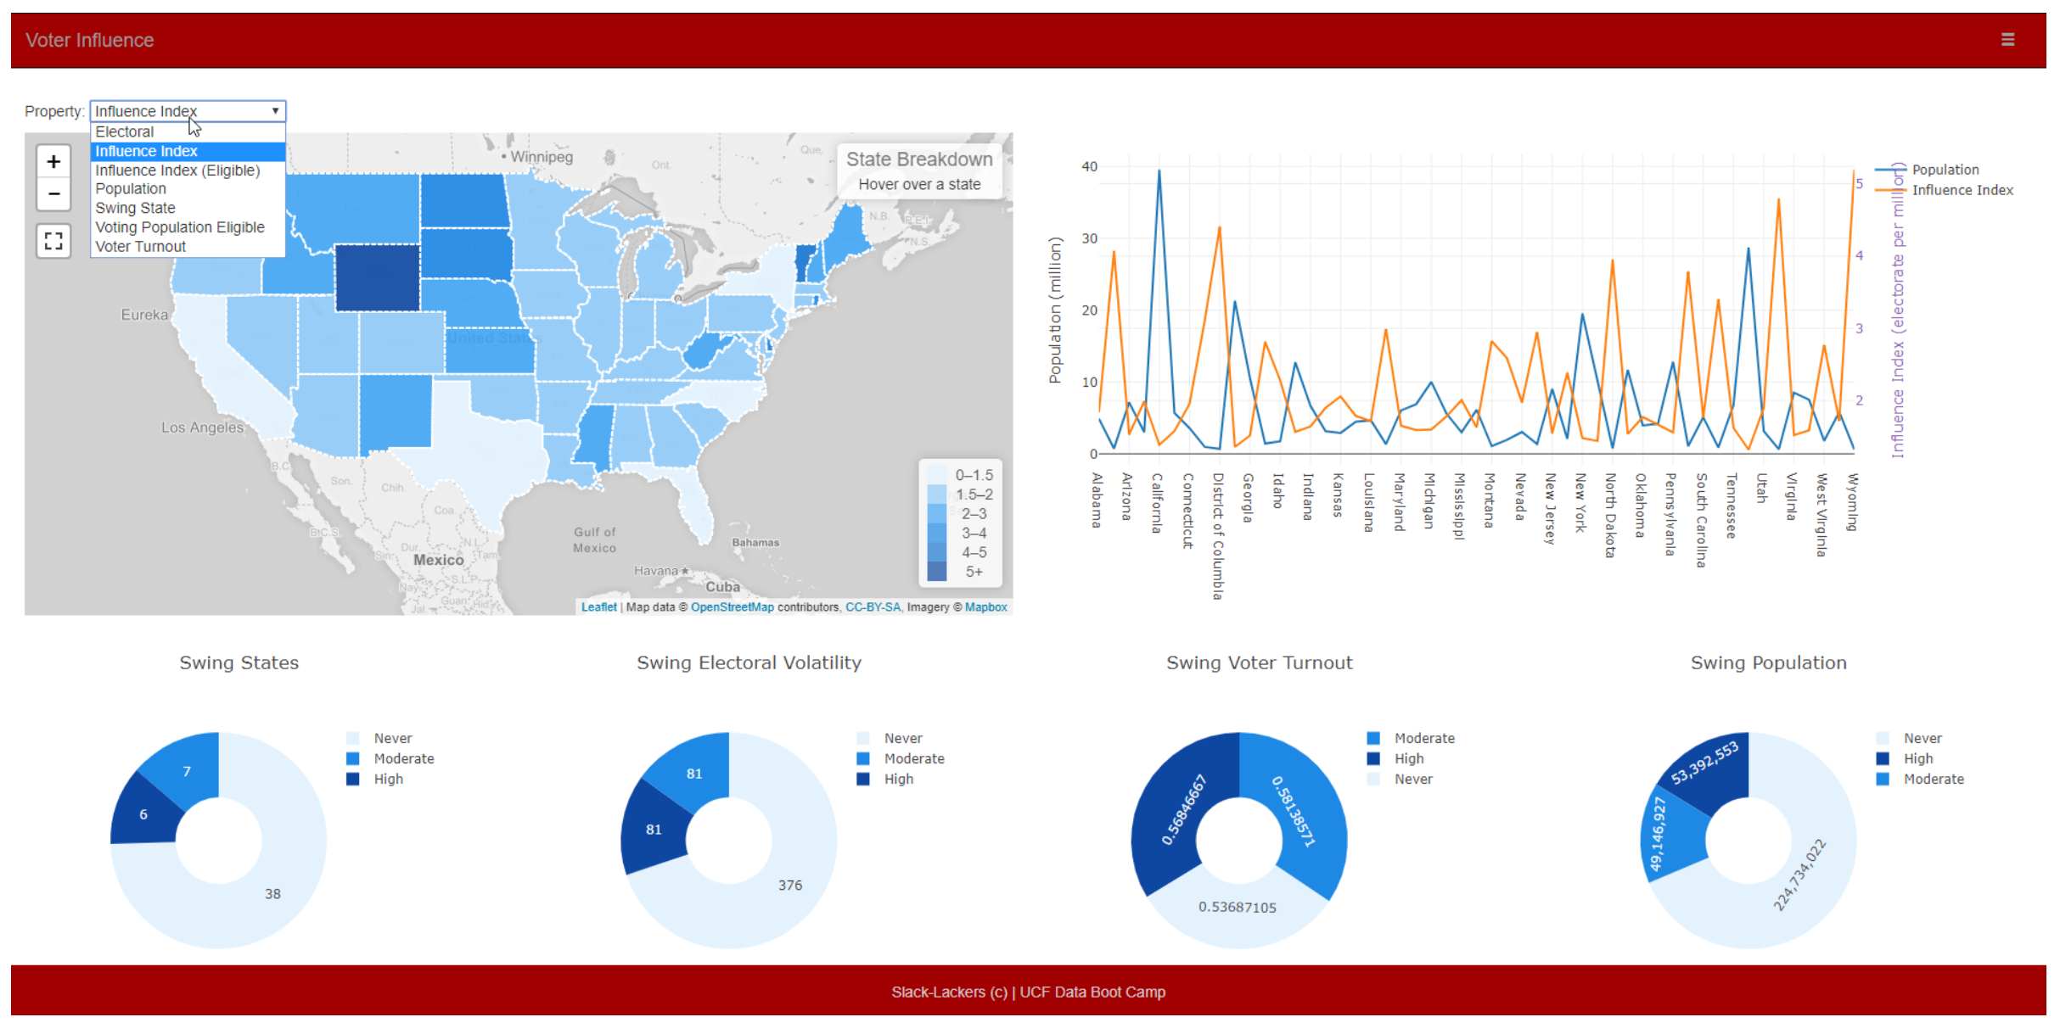

Project includes at least one JS Library not covered in class such as the “full screen control” that is added to map.

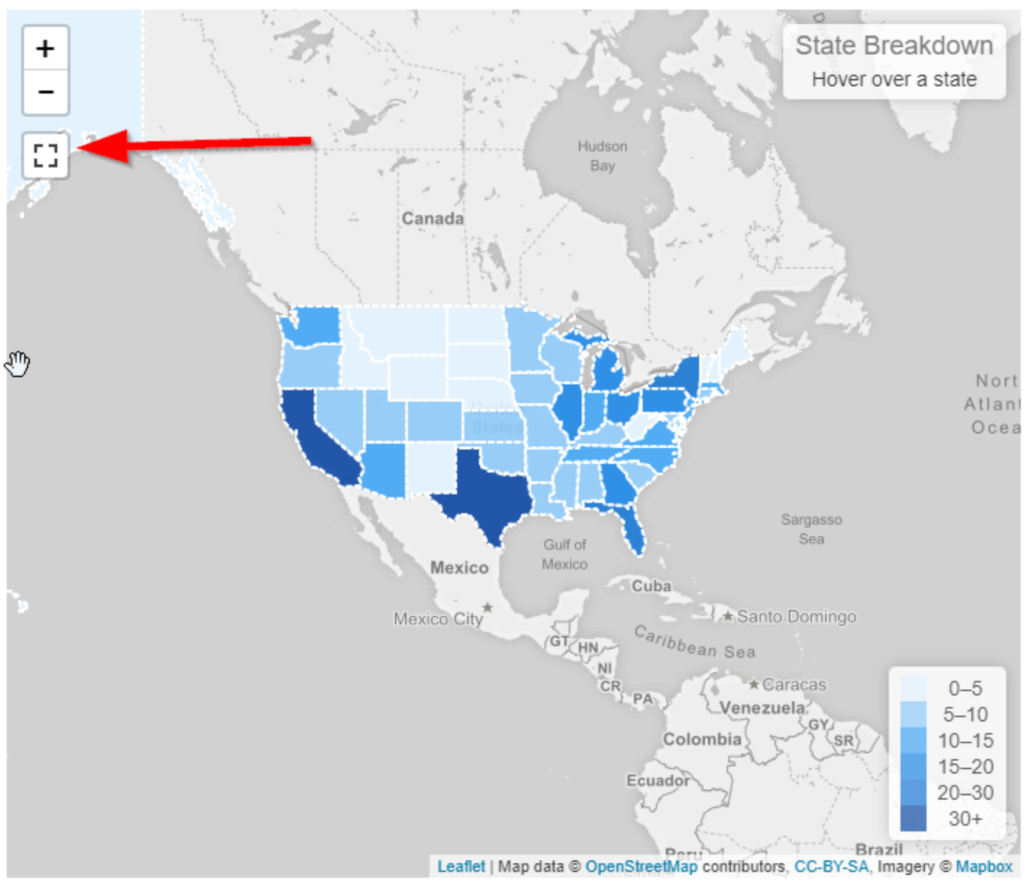

# PROBLEMS AND CHALLENGES

* All data representing US election electoral and popular votes are not accurate. We found data that had incorrect winners on one site.
* Working with multiple files was challenging when merging all programs due to different computer systems.
* 2016 presidential popular votes were not as easy find online as anticipated.

# OVERALL ASSESSMENT AND RECOMMENDATIONS

* The top 4 states in by population have close to 20 million people and hold a total of approximately one third (33%) of the U.S. population.
* Despite the population, these states (California, Texas, Florida and New York) have approximately one and a half (1.5) electoral vote per million people.<
* Keep in mind, each state gets 2 senate votes in as it pertains to the electoral college; therefore, the house votes has the biggest influence on the votes in regard to the large states.
* There are a couple of states, worth noting, that visually have close to the same population and influence (South Carolina and Kentucky) on the dual line chart.
* Those states with the minimum number of electoral votes (Montana, Delaware, South Dakota, North Dakota, Alaska, Vermont, and Wyoming) have low population but have the highest influence ranging from 3 votes per million to 5 votes per million). These states have the high voter influence.



### Options for Change:

* Eliminating electorate in favor of popular vote
  + Would level the playing field and every vote would have the same weight no matter which state the voter resides.
  + Would encourage a higher voter turnout as each vote would now carry more weight.
  + Would require encourage candidates to focus on the county at large and not just “swing” states which have tendencies to flip from one national party to another.
* Retain electorate concept; but eliminate the winter takes all approach within each state.
  + Have each congress district cast its own regional winner / vote.
  + Would encourage higher voter turnout.
  + Open question: How would the 2 senator votes be cast?
    - Potentially eliminate the senator votes altogether.
    - The con of this approach is votes in small states would still weigh more than others; but not to the same influence as in the current system.
* Existing system discourages those in “fixed” party states (those which historically always vote for the same national party) from going to the polls.
  + A republican in California has no bearing on the election in the winner takes all approach. Same can be said for a Democrat in Texas; the outcome is already determined prior to voting taking place.
    - Based on the past 5 elections; 70% of the electorate votes are already predetermined to “fixed” states.
      * 37 states
    - 81 electorate votes are associated with moderate swing states (those which have votes differently in 1 election of the 5.
      * 7 states
    - 81 electorate votes are associated with true swing states (those which have votes differently in 2 of the 5 elections.
      * 6 states

# CONSIDERATIONS FOR POSSIBLE FUTURE ENHANCEMENTS

Understand the voter turnout impact by gender, economic status and age.

Were there any variables that could have been evaluated that might have impacted Americans from voting (i.e., weather/road constraints, voting equipment challenges, rezoning of voting locations, etc.)?

Does data from early voting or absentee data impact or persuade the popular vote on voting day (i.e., if your candidate is in the lead, then you might stay at home and not vote at all)?

Evaluate the voter’s employment status. Analyze data for voters employed and unemployed to determine if the traditional first Tuesday after the first Monday is a good day to cast votes. Does the work day impact voting?