Infringement Chart Strength: High
Priority Date: September 3, 2015
Square contactless payment reader Launch Date: November 23, 2015 (Source 1, Source 2)
Square Terminal Launch Date: October, 2018 (Source)
US10872329B2 | Square Terminal accepting payment from Mobile payment system (e.g., Samsung Pay)
1. A point of sale (POS) terminal of a merchant of a mobile payment system, the POS terminal comprising: | A point of sale (POS) terminal (i.e., Square Terminal) of a merchant (i.e., Restaurant or Retail etc.,) of a mobile payment system (i.e., accepting payments from Google pay or Apple Pay or Samsung Pay).  Note: We have used evidence from Samsung Pay for exemplary purposes.  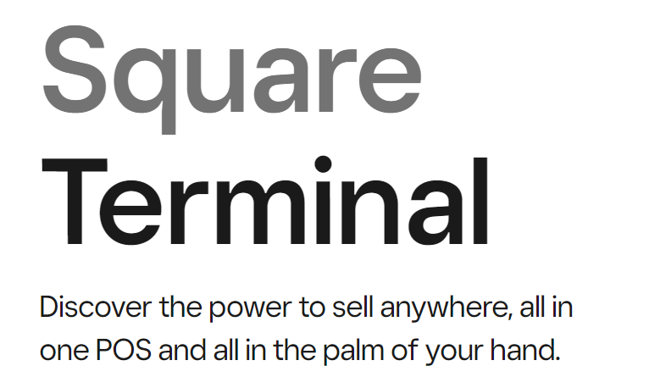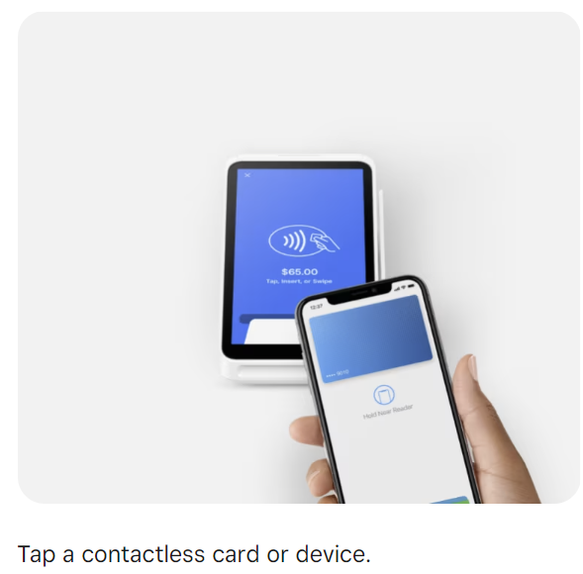  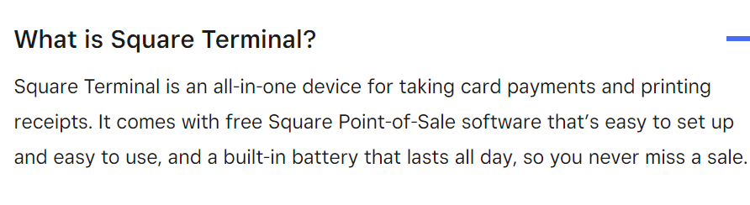  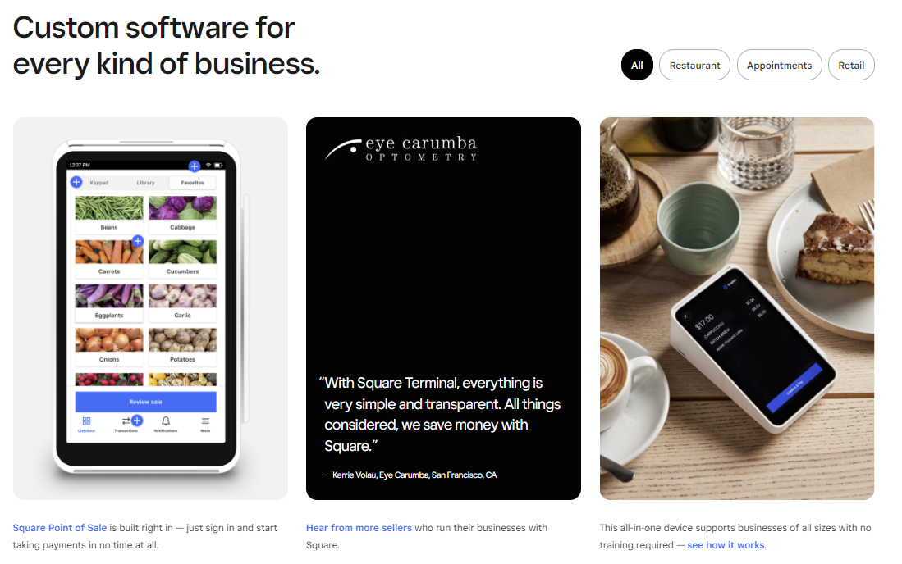  Source: https://squareup.com/us/en/hardware/terminal  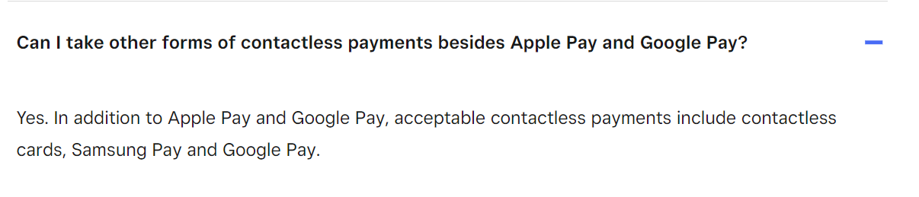  Source: https://squareup.com/help/ca/en/article/6540-square-terminal-payments-faq  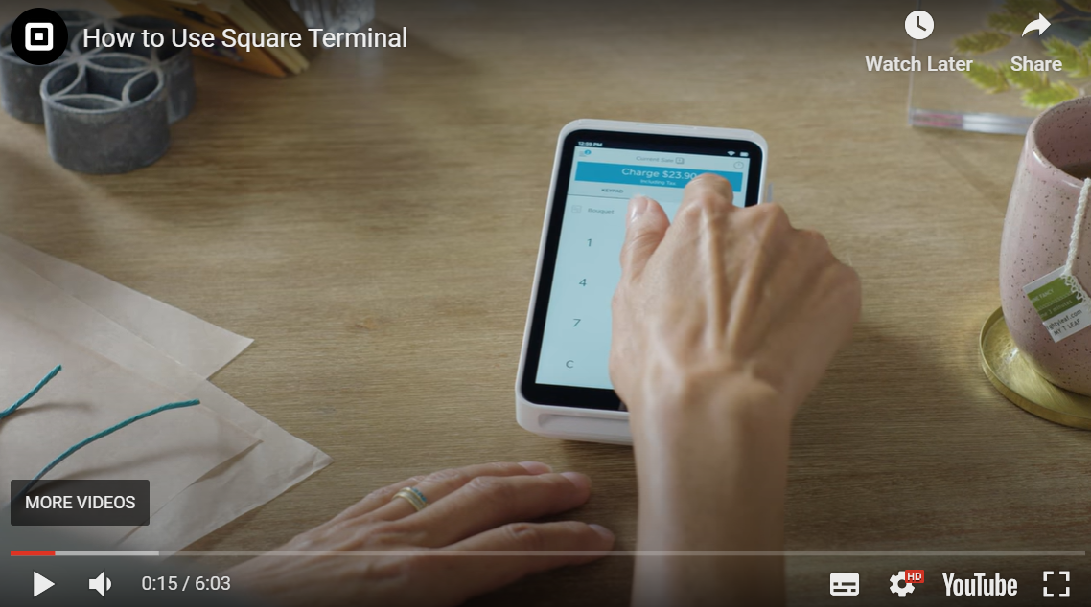  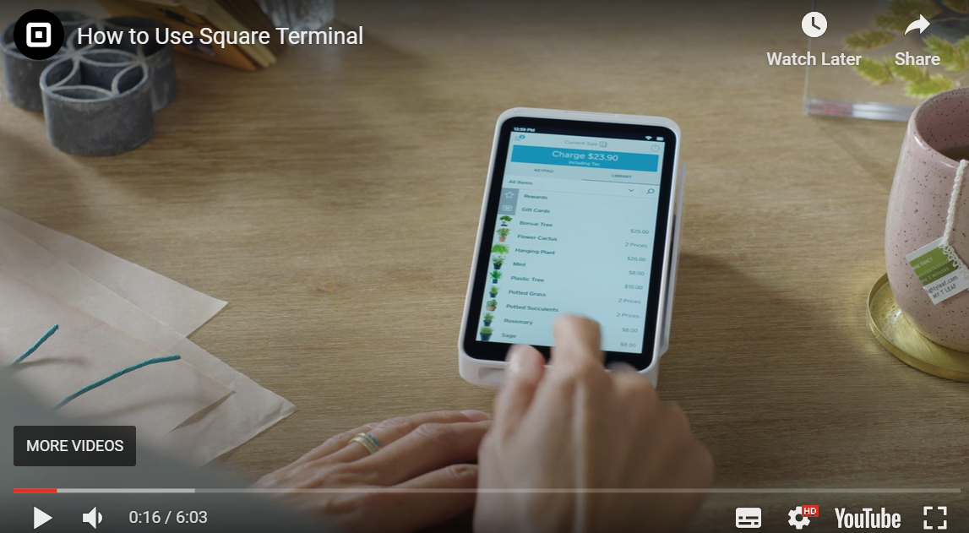  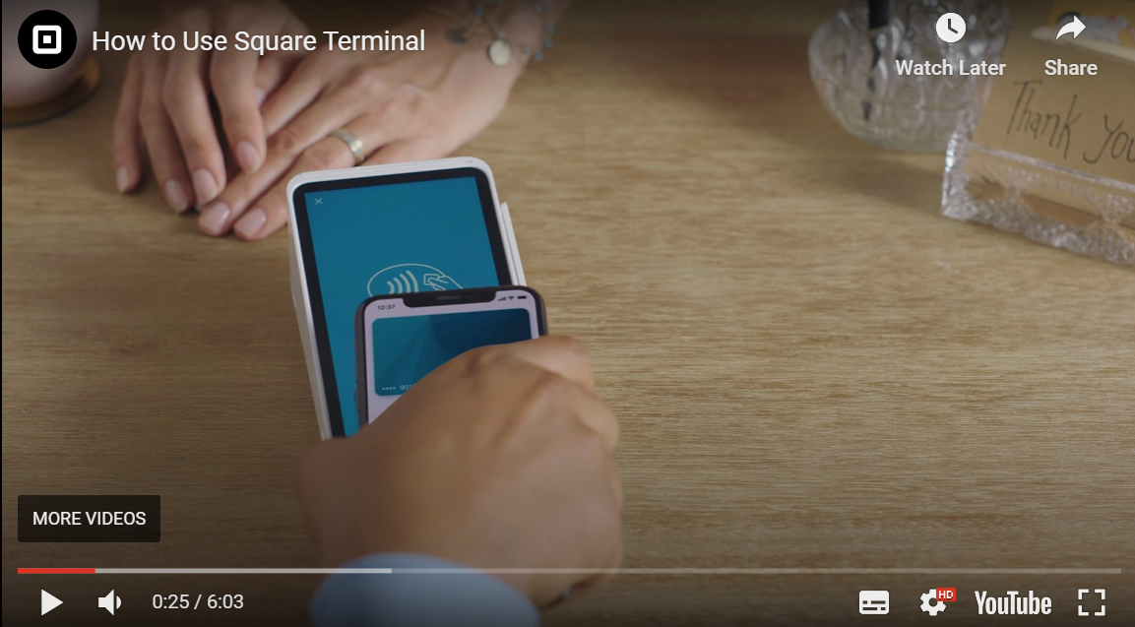  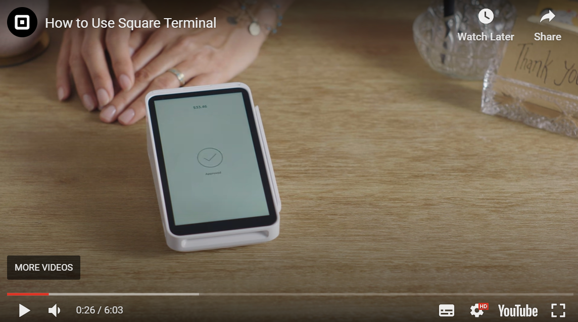  Source: https://youtu.be/qOuCvwvslho
a memory for storing POS terminal information for identifying the POS terminal, the POS terminal information being associated with merchant account information on a transaction server of the mobile payment system; | The POS terminal (i.e., Square Terminal) includes a memory for storing POS terminal information (i.e., unique device identifier or serial number information or merchant ID) for identifying the POS terminal, the POS terminal information being associated with merchant account information on a transaction server (i.e., Square Server) of the mobile payment system.  A request is sent to check the Square Terminal device status and in response, the Square terminal response back with the device information or device metadata such as serial number, merchant ID etc., that are associated with the seller or merchant account used in the mobile payment system. Further, the Square Terminal device serial number information can be accessed through the settings of the Square Terminal Device. This means that the Square Terminal device has a memory to store the device metadata.  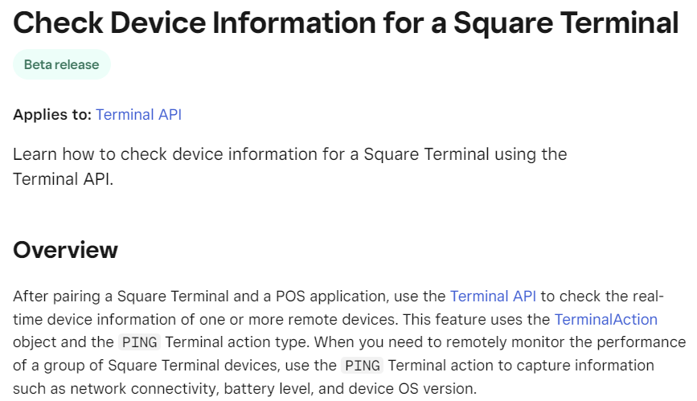  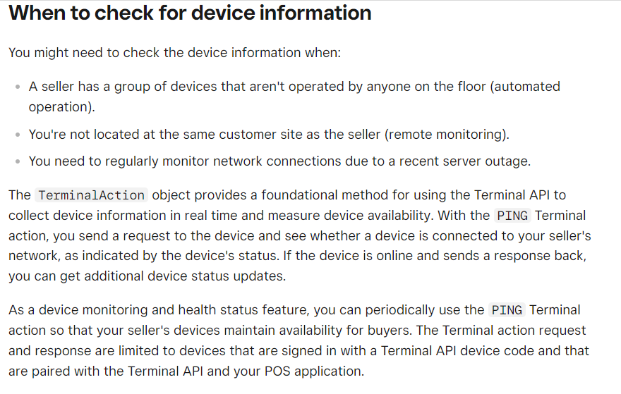  Square Terminal information such as serial number, merchant ID etc. is associated with merchant account information or seller account on the Square Servers  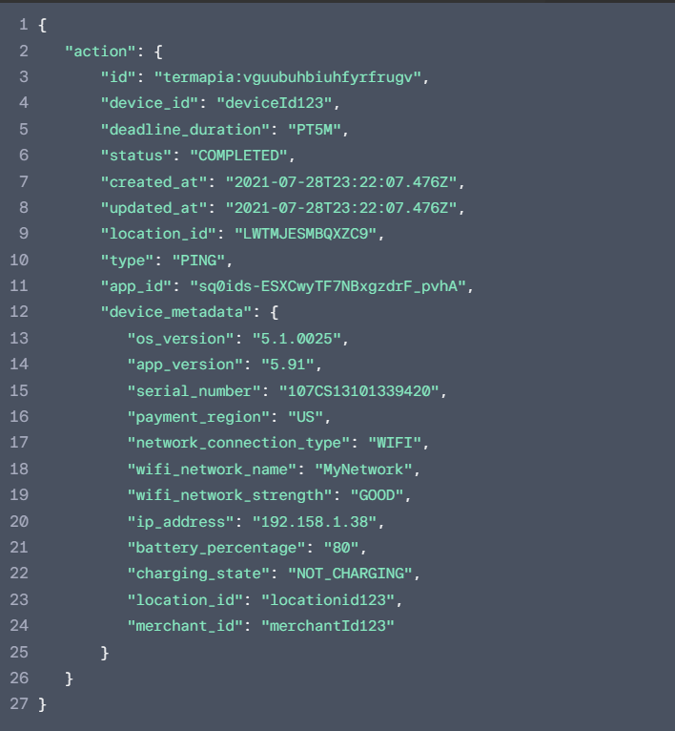  Source: https://developer.squareup.com/docs/terminal-api/advanced-features/check-device-information  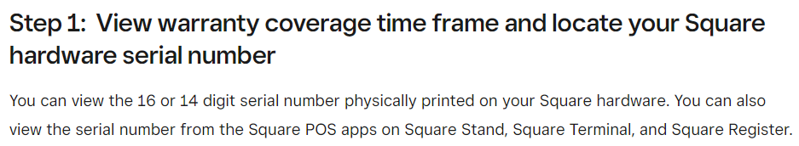  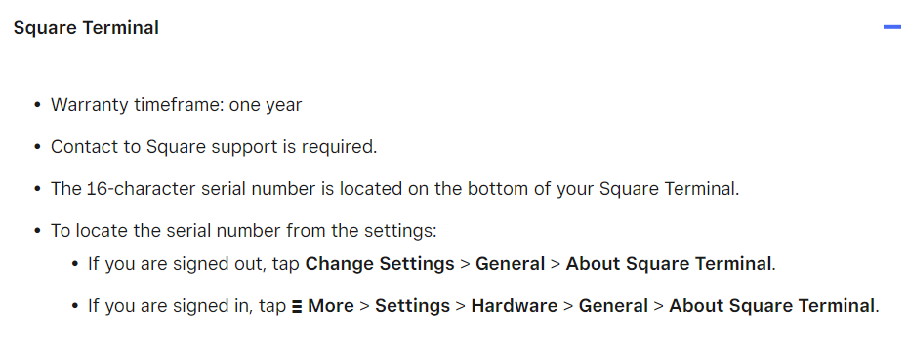  Source: https://squareup.com/help/us/en/article/5148-square-hardware-limited-warranty-and-returns
a wireless interface for receiving location information of a mobile terminal of the mobile payment system and a unique ID for identifying a customer from mobile terminal, the unique ID being associated with customer account information and mobile terminal information on the transaction server; and | The POS terminal (i.e., Square Terminal) includes a wireless interface (i.e., NFC) for receiving location information (i.e., customer location information) of a mobile terminal (i.e., Android phone or iPhone) of the mobile payment system (i.e., Google pay or Apple Pay or Samsung Pay) and a unique ID (i.e., unique device identifier or customer identification information) for identifying a customer (i.e., buyer) from mobile terminal, the unique ID being associated with customer account information and mobile terminal information on the transaction server (i.e., financial server or payment network).  The Square Terminal interacts with a customer’s mobile device such as Android or iPhone using NFC. When the customer interacts using the mobile device with the Square Terminal, the Square Terminal collects location information and the device or customer information (such as device identifier, device name, customer name, customer phone number etc.,). Further, Square utilizes the collected information about the customer for processing the payments. This suggests that this information is related to the customer account in the transaction server (i.e., financial server or payment network).  Mobile terminal  Source: https://squareup.com/us/en/hardware/terminal  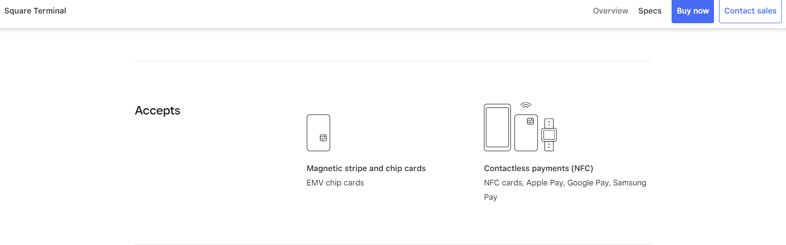  Wireless Interface  Source: https://squareup.com/us/en/hardware/terminal/specs  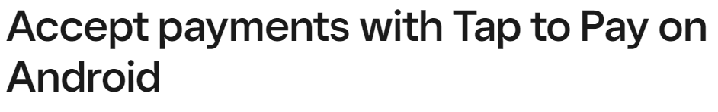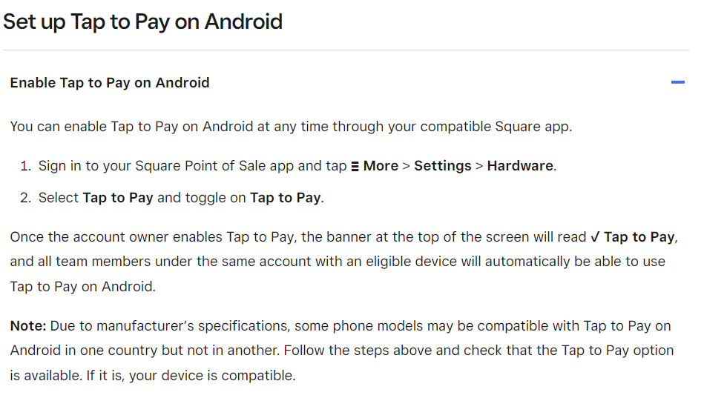  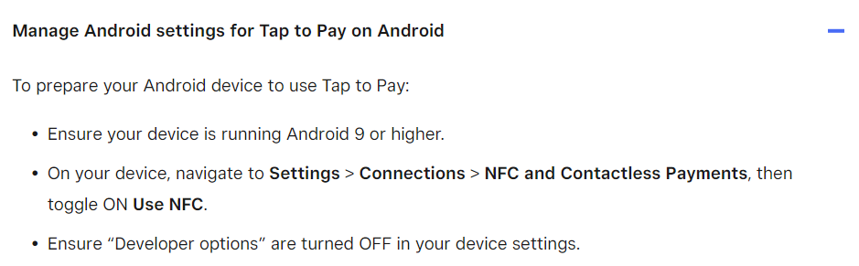  Source: https://squareup.com/help/us/en/article/7960-get-started-with-tap-to-pay-on-android  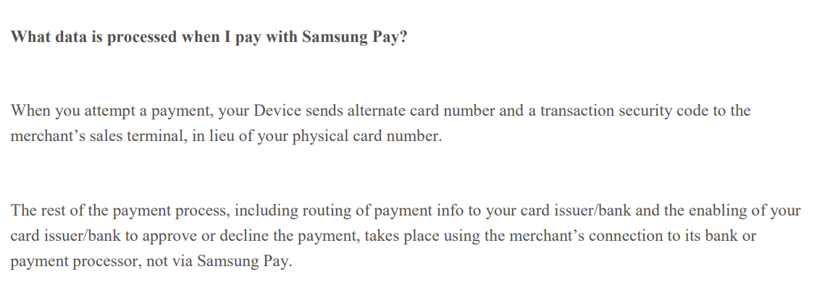  Source: https://images.samsung.com/is/content/samsung/assets/za/samsung-pay/Samsung_Pay-Privacy_Notice.pdf  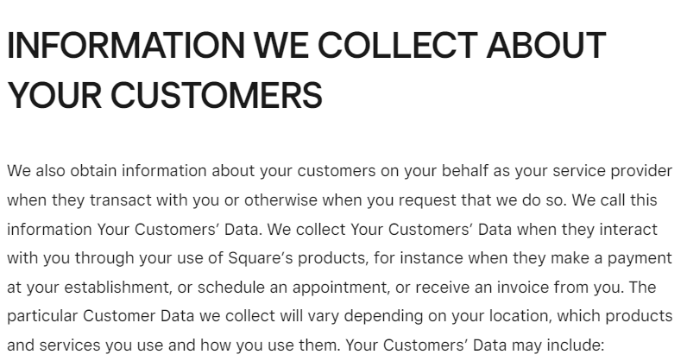  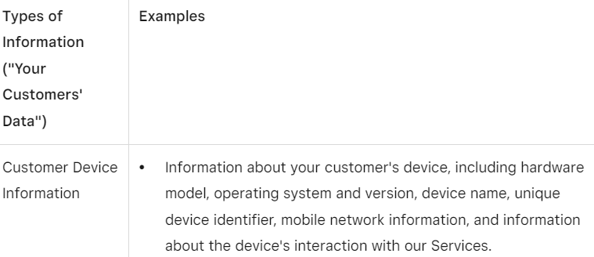  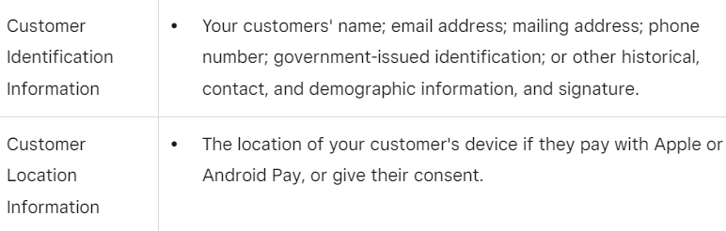  Location information and customer identification information  Source: https://squareup.com/us/en/legal/general/privacy  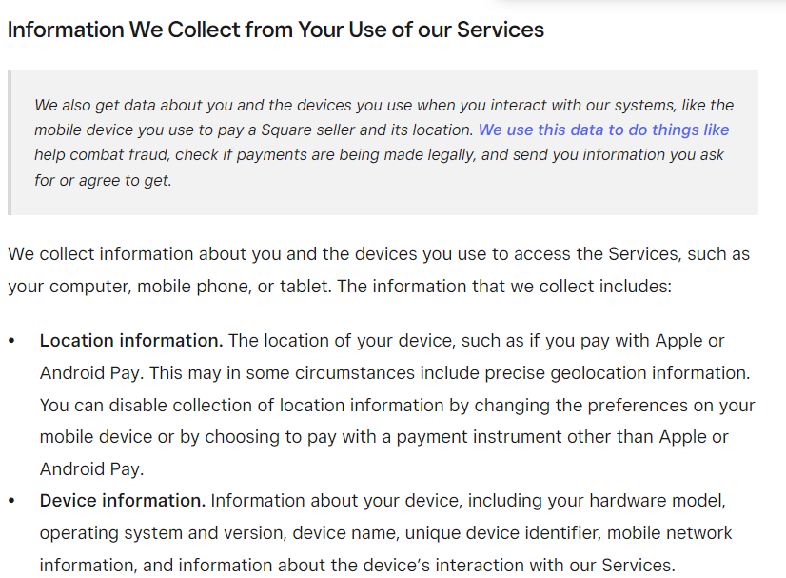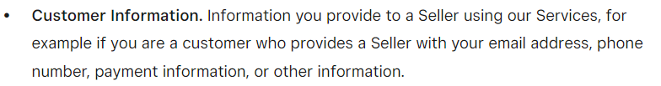  Customer device location and customer information to process or check payments  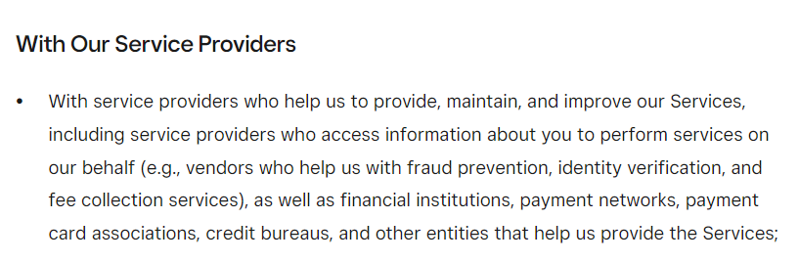  Location information and customer identification information  Source: https://squareup.com/us/en/legal/general/privacy-no-account
a network interface for communicating with the transaction server for transmitting the received unique ID and location information of the mobile terminal, the POS terminal information, and a payment amount to the transaction server. | The POS terminal (i.e., Square Terminal) includes a network interface (i.e., Wi-Fi) for communicating with the transaction server (i.e., financial server or payment network) for transmitting the received unique ID (i.e., unique device identifier or customer identification information) and location information of the mobile terminal (i.e., Android or iPhone), the POS terminal information (i.e., unique device identifier or serial number information or merchant ID), and a payment amount to the transaction server.  The Square Terminal communicates or sends the customer location information, customer device ID, POS terminal information and the transaction amount to the financial server or payment network using the internet. The following information is utilized by the servers to process the payment  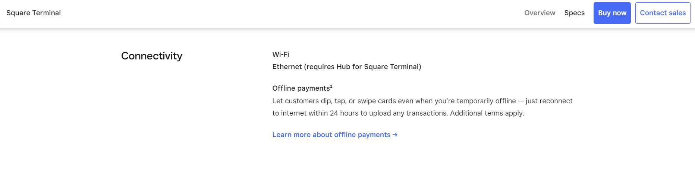  Network interface  Source: https://squareup.com/us/en/hardware/terminal/specs  Source: https://youtu.be/qOuCvwvslho  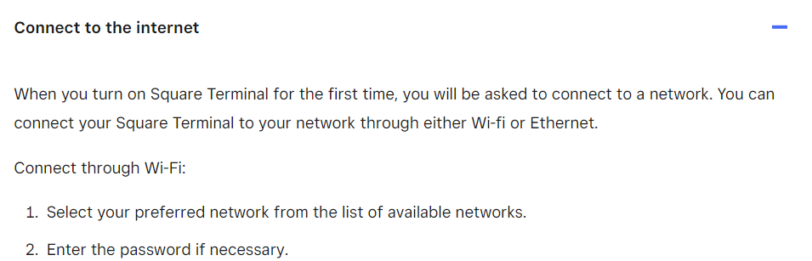  Source: https://squareup.com/help/us/en/article/6535-set-up-square-terminal  Square Terminal information such as serial number, merchant ID etc. is associated with merchant account information or seller account on the Square Servers  Source: https://developer.squareup.com/docs/terminal-api/advanced-features/check-device-information  Location information and customer identification information  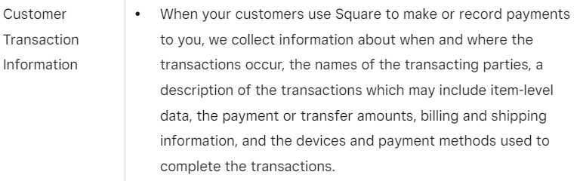  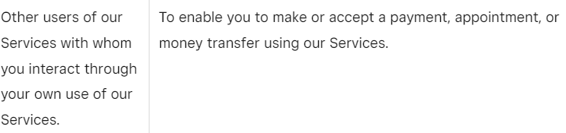    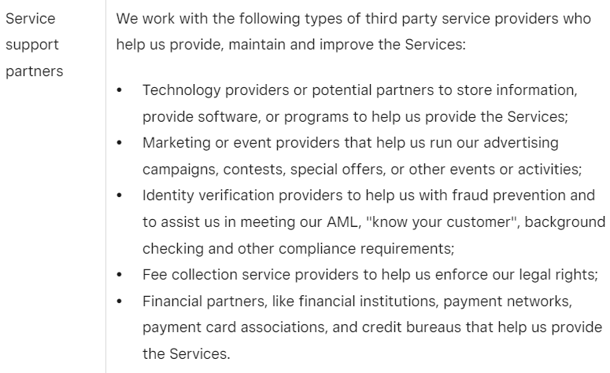Source: https://squareup.com/us/en/legal/general/privacy  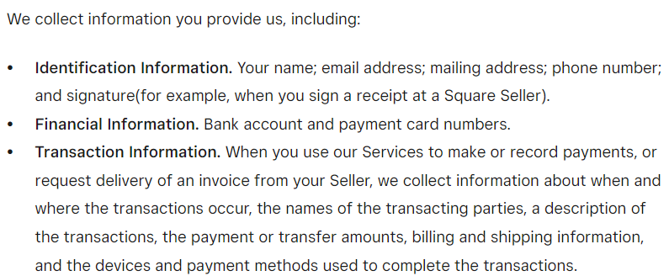  Payment amount  Customer device location and customer identification information to process or check payments  Location information and customer identification information  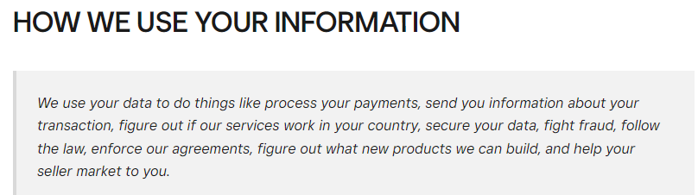  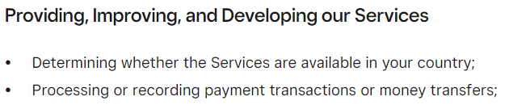  Source: https://squareup.com/us/en/legal/general/privacy-no-account  Collected information sent to bank server  Source: https://images.samsung.com/is/content/samsung/assets/za/samsung-pay/Samsung_Pay-Privacy_Notice.pdf

