Infringement Report

Subject Patent: US7482916B2
Priority Date: March 15, 2004
Infringing Entity Name: Tesla
Chart Strength: High
Patent Technology: Vehicle Automatic Turn Signal
Product Name: Tesla Automatic Lane Change
Tesla Revenue: $97.69 Billion
Product Release date: 2019 (Source)

US7482916B2 | Tesla Automatic Lane Change
33. An automatic signaling system, comprising: | An automatic signaling system (i.e., Tesla’s Navigate automatic activate turn signal).  Tesla's Automatic Lane Change system communicates and automatically engages the turn signals.  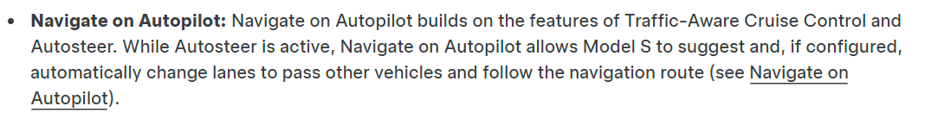  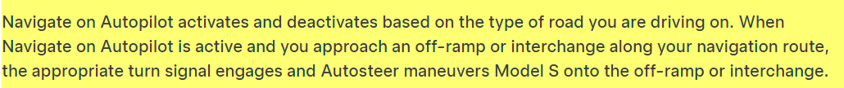  Source: https://www.tesla.com/ownersmanual/models/en_ie/GUID-20F2262F-CDF6-408E-A752-2AD9B0CC2FD6.html#GUID-C86D0044-87E5-4096-8C62-5AE24714AFB3    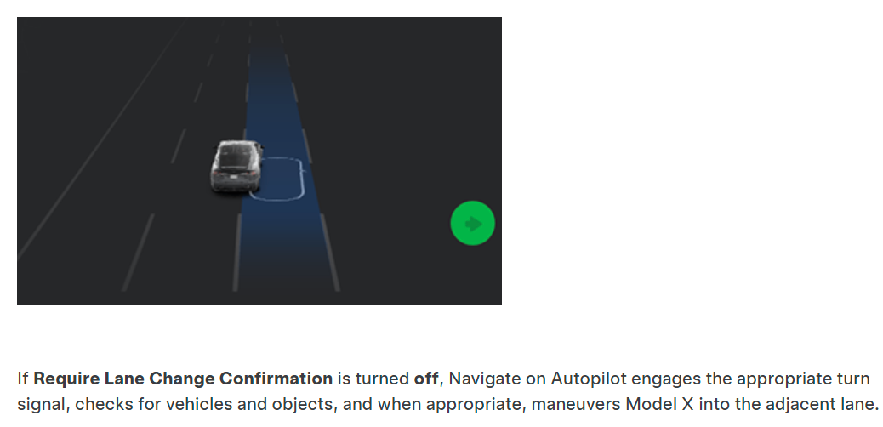  Source: https://www.tesla.com/ownersmanual/2015_2020_modelx/en_us/GUID-0535381F-643F-4C60-85AB-1783E723B9B6.html
a processor having an input for receiving information, and an output to be coupled to a signaling system of a vehicle, the signaling system having a turn signal light; | A processor (i.e., Hardware 3) having an input for receiving information (i.e., sensor data), and an output to be coupled to a signaling system (i.e., turn signals) of a vehicle, the signaling system having a turn signal light.  Tesla vehicle receives information from multiple sensors, including 8 cameras. The information helps the processor to execute the automatic lane change by activating or engaging the appropriate turn light of the vehicle.  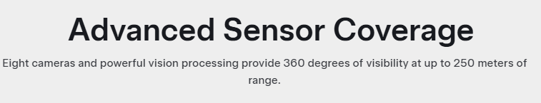  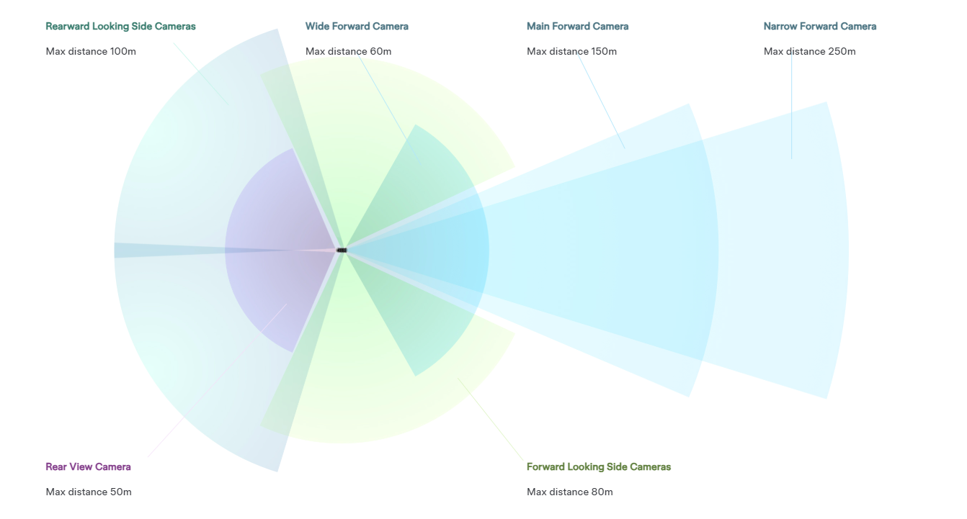  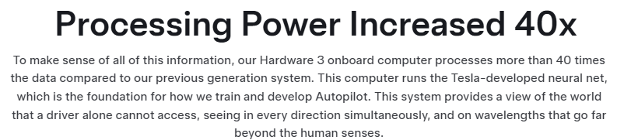  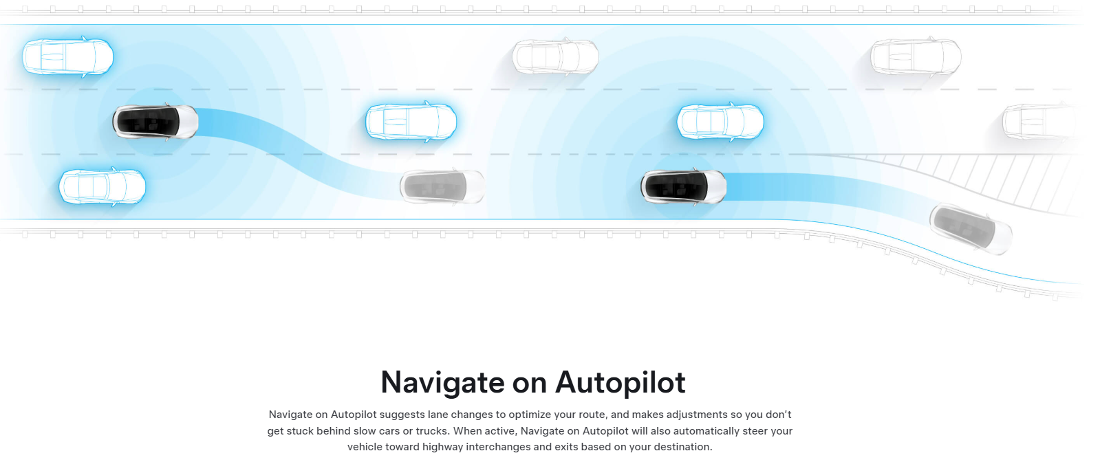  Source: https://www.tesla.com/autopilot  Source: https://www.tesla.com/ownersmanual/2015_2020_modelx/en_us/GUID-0535381F-643F-4C60-85AB-1783E723B9B6.html
wherein the processor is configured to process the information, and automatically activate the turn signal light based on the processed information before or when a portion of the vehicle reaches a boundary of a lane in which the vehicle is traveling. | wherein the processor (i.e., Hardware 3) is configured to process the information (i.e., sensor data), and automatically activate the turn signal light based on the processed information before or when a portion of the vehicle reaches a boundary of a lane in which the vehicle is traveling.  Tesla Hardware processes the information (such as lane availability, speed, and proximity of other vehicles) received from the sensors and enables the appropriate turn signal, checks for surroundings to determine whether it is safe to change the lane. The turn signal is activated at least before or when a portion of the vehicle reaches a boundary of the lane.  Source: https://www.tesla.com/autopilot  Source: https://www.tesla.com/ownersmanual/2015_2020_modelx/en_us/GUID-0535381F-643F-4C60-85AB-1783E723B9B6.html  Source: https://www.tesla.com/ownersmanual/models/en_ie/GUID-20F2262F-CDF6-408E-A752-2AD9B0CC2FD6.html#GUID-C86D0044-87E5-4096-8C62-5AE24714AFB3

Disclaimer
This claim chart is prepared for informational and analysis purposes only. It is not intended to allege infringement by any party but to compare the publicly available information of Tesla with the claims of the referenced patent(s). The content herein does not constitute a legal opinion or an assertion of liability. Any conclusions drawn from this chart should be independently verified.

