INTRODUCTION
The best transceiver station (BTS) is a piece of network equipment which facilitates wireless communcition between the device and the network.
There are 2 places that we analysis:
- Telkomsel
By using telkomsel provider we test in the area sersen sani. We did an experiment and got the following results:
- Wifi
Using Wifi, we test it in a wake-up area. We did an experimentand got the following results:
- Bayu Akbar Febrian (09011382025109)
- Faris Muaafi Latuconsina (09011382025141)
- Hana Luthfiah (09011382025137)
- Muhammad Ridho Ade Saputra (09011382025114)
- Siti Tri Wimarti (09011382025145)

Pengantar Telekomunikasi
Analisis A Base Transceiver Station for Client in UNSRI
- TELKOMSEL
 | 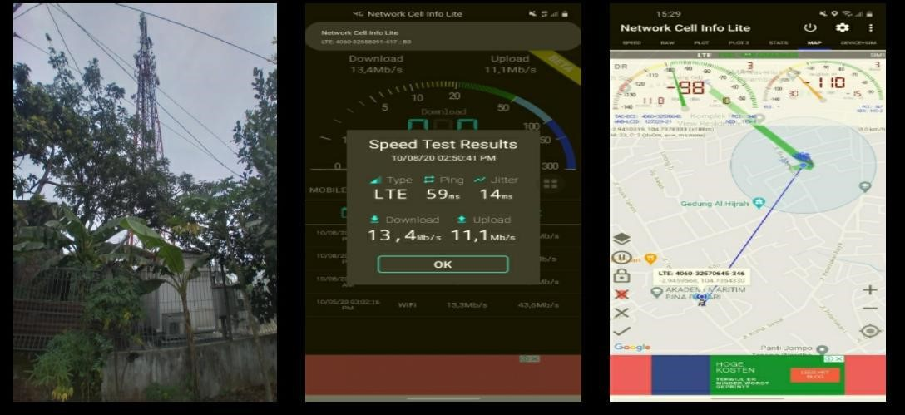
  Serving cell: Signal strength of the cell you are currently connected too Frequency: Measure the number of oscillation for the data signal per sec. In this case, only Wifi can get the frequency.
  Strength of signal: Signal strength refer to the transmitter power output as received by a reference antenna at a distance from the transmitting antenna.
  Speedtest: Measures the speed between your device and a test server, using your device's internet connection.
  Ping: Is available on every operating systems, and many online games display a visible ping you can use to understand latency.
- WIFI
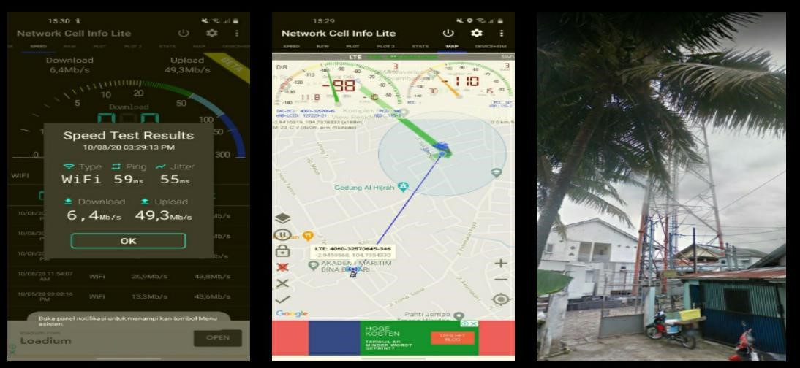
Location | Provider | Strength (db) | Speed (mbps) | Ping (ms) | Anaylisis
Sersen Sani | Telkomsel | -95 dBm | 14,7 Mb/s | 105ms | Based on Sersen sani area, the overall sig-nal and internet speed for telkomsel is better than Wif low frequency i, whereby wifi is poor state due to
Suka Bangun | Wifi | 98 dbm | 6,4  Mb/s | 95ms
CONCLUSION
In order to the have a good connection and better telecommunication service the main source should be strength of signal should be less of interruption, frequency should be have less interference and internet which has a lesser PING value. Wifi has a moderate connection level ,where students do have some difficulty to access wifi in certain area. Telkomsel have good coverage, and the speed of the internet is good but as a student is so expensive. Student might choose another telco service which is more reasonable.In the network cell lite also can see the maps between the device and the tower. It stated in the picture above under Netwerk Cell Info Lite. Last but not least, when have no data, students must find wifi to do anything.

