Jakarta, 02 February 2025

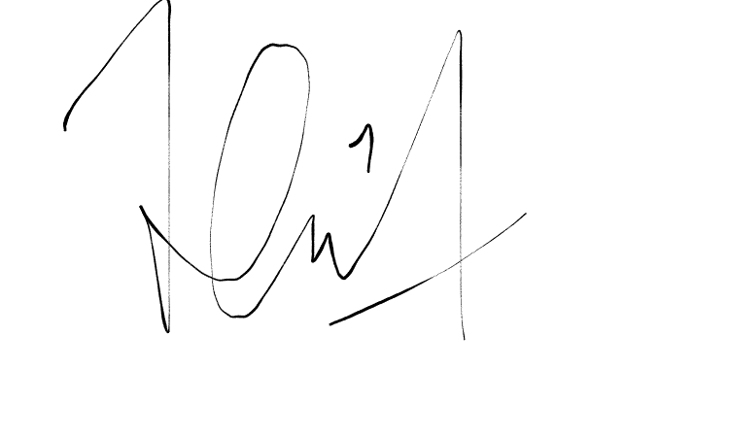

(Fill with Your Name bro)