**PANDUAN**

**TANDA TANGAN DIGITAL**

1. Create a new database with the name "ttd_db"

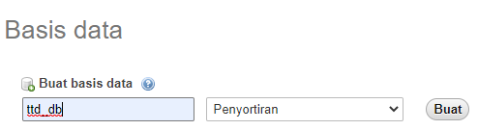

1. Import the database

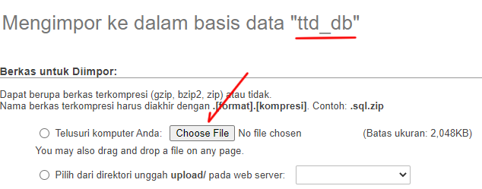

Choose file lalu klik Go/ Kirim

1. Extract .zip files to htdocs

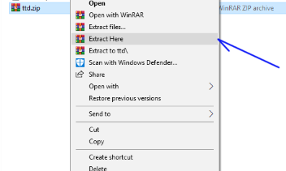

1. Run a web browser example: localhost/ttd, the following display appears, then create your signature

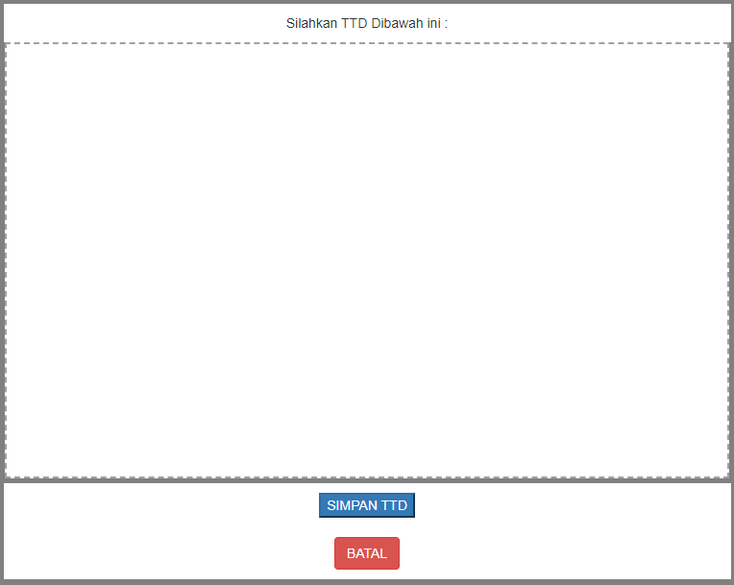

1. Click the SIMPAN TTD button (to save the signature), Click the CANCEL button (to cancel the signature)
2. If you have clicked the save button, the system will display your signature



1. The signature will be saved in the database (tb_ttd) and saved as an image with png format
2. Stored in the database

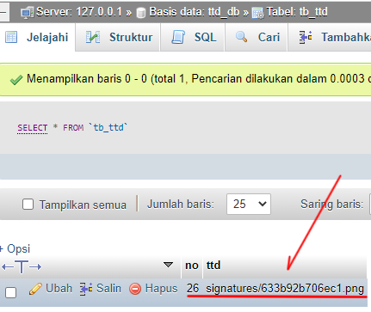

1. Stored in the signatures folder

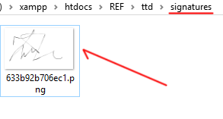

This is source codedigital signature, you can create simple signature and implemented to your aplication sistem based website. This system already stores data in a mysql database and is easy to manipulate and develop on your system