File Integrity Checker User Guide

  - JUNE 2025
  - Version 0.2

Student Name: Zhi Chen
Student ID: 20144855

Document Revisions

Date | Version Number | Document Changes
22/06/2025 | 0.1 | Initial Draft
30/06/2025 | 0.2 | Added more details for the updated script (more detail)

Table of Contents
1 Introduction 4
1.1 Scope and Purpose 4
1.1.1 Purpose of This User Guide 4
1.2 Assumption and prerequisites 4
1.2.1 Prerequisites 4
1.2.2 Installation 4
1.3 Process Overview 5
2 Procedures 7
2.1 Getting Started 7
2.1.1. Getting files ready: 7
2.1.2 Open terminal: 7
2.1.3 Enter the file path: 7
2.2 Using the Script 7
2.2.1. Running the script: 7
2.2.2. Start the script and follow the prompt: 7
2.2.3 Enter the file path: 8
2.2.4 Common in errors: 8
2.2.5 View results: 9
2.2.6 Common output errors: 9
2.2.7 Repeat or exit: 10
2.2.8 Possible outputs: 10
2.3 Summary 11
3 Appendices 12

Introduction

Scope and Purpose

This script is designed to assist users verify file’s integrity by calculating and tracking SHA-256 hashes using the file integrity checker python script.

Purpose of This User Guide:

This guide walks you from installing, configuring, and running the script. It covers prompts, expected outputs, and output results.

Assumptions and Prerequisites:

1.2.1 Prerequisites
- Python 3 Installed: Ensure you have Python available on your system. If you do have Python download yet, go to https://www.python.org/for more details.
- Command-Line Proficiency: Familiarity with opening a terminal or command prompt, navigating directories, and executing Python scripts. For more information go to https://support.apple.com/en-au/guide/terminal/
- Basic JSON Knowledge: Ability to inspect and understand simple JSON structures for user data inputs. For more information got to https://www.json.org/json-en.html
- The output location must have permission to write the results. JSON file. To change permissions for files, folders on Mac, go to https://support.apple.com/en-lk/guide/mac-help/mchlp1203/mac

1.2.2 Installation
- Download ZC_LAB13_S2.py to a folder
- Open Terminal and navigate to the folder

Process Overview
The script prompts for a file path, generates its current hash, and alerts you to any changes. It also maintains a history of all past hashes and their timestamps, storing the complete log (file path + datetime) in a JSON file.

Procedure

Getting Started

Getting Files Ready

- ZC_LAB13_S2.py to a known folder
- Input .JSON file at a known file path.

Open Terminal

In the Finder , open the /Applications/Utilities folder, then double-click Terminal or ⌘+Space, type “Terminal”, Enter.

Navigate to the script folder:

Use cd to go to your script’s folder, for example:

Using the Script

Run the script:
Type python3 to allow the python to start it, following by the script name (here the script name is ZC_LAB13_S2.py)

Start the script, follow the prompt:
After the script successfully run, you will be asked to enter the .JSON file path
or
type ‘e’ to exit the script, as it is shown below: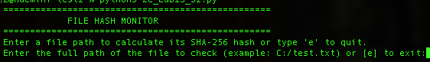

Enter file path:

- Type the full path to your file and press Enter

- Or exit by entering ‘e’

Common input errors
However, you may see the below error messages, if
- Invalid input file path shows:
Solution: Ensure you typed the correct path exactly.

View results:

The script will display the new has and timestamp then it lists all previous hashes for that same file, so you can compare.

It then lists results like below:

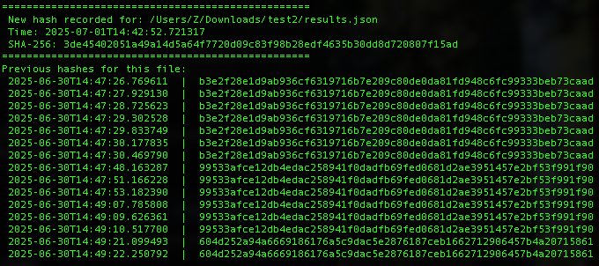

Common output errors

However, you may see an error message below when:
Permission denied accessing the file shows:

Solution: Ensure your output result folder is read and write enabled. To see how to enable the read and write go to https://support.apple.com/en-lk/guide/mac-help/mchlp1203/mac

Repeat or exit:

To check another file, enter its path and press Enter again.

Or

To quit, type “e” and press Enter.

Possible Outputs

You can find a file named as “file_hash_log” JSON file created and stored in the same folder where the ZC_Lab13_S2.py stored. Here are the possible results:
- No previous hashes found (First time file hash check)

In the Terminal, the script prints:
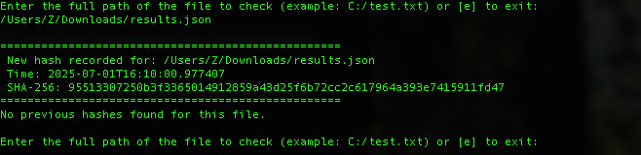

, and you can find the hash recorded for the file appends to file_hash_log.JSON It contains the datetime, the file path and the hash. See the sample file_hash_log.JSON in below:

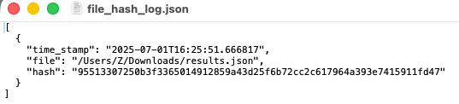

- Different hashes for the file

Once the same file content has any changed from the last check, the script will give you a warning message. The new hash and list all previous hashes.
In the Terminal, the script prints as below example:

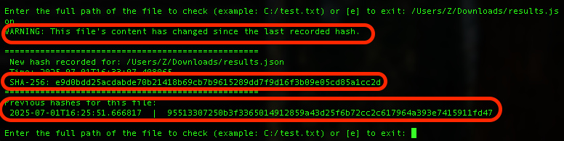

, and the new hash will append to the file_hash_log.JSON, It contains the datetime, the file path and the hash. See the sample file_hash_log.JSON in below:

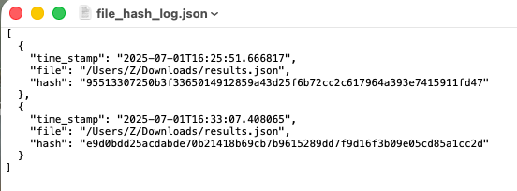

- Same hash for the file

If the file has no changes since the last check, the script will print the new hash as same as the last check hash, and list all previous hashes with the checking datetime in terminal see the below example:
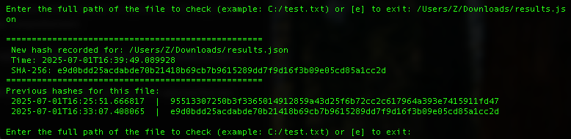
, and the new hash will append to the file_hash_log.JSON even it has the same hash and file path, BUT with different datetime. See the sample file_hash_log.JSON in below:
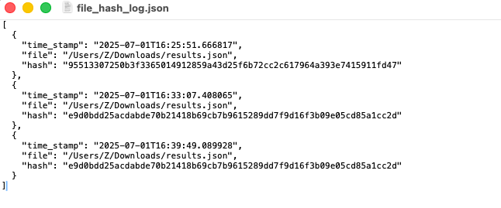
- Permission error:

In some cases, if you do not have the permission (Read and Write) with the file_hash_log.JSON file, you would find a warning message in the Terminal as below:

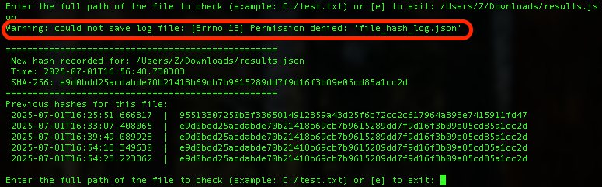
, the new hash will not be able to record in the file_hash_log.JSON as it has been locked.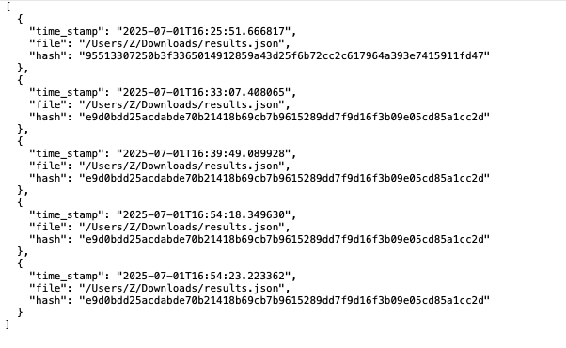
Solutions: enable the read and write permission for the folder (where the file_hash_log.JSON stored) and file_hash_log.JSON.
- Corrupted log file:

In some cases, if your file_hash_log.JSON has been corrupted (unreadable, rename or delete), you may see a warning message in Terminal, the new hash record and time , but the previous hash may not be available as below:
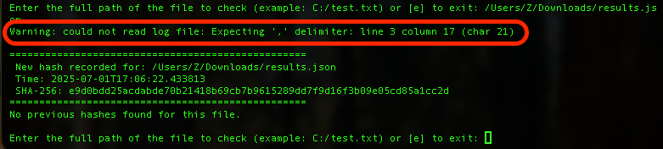
, and a file_hash_log.JSON will be created to replace the corrupted log file as below:
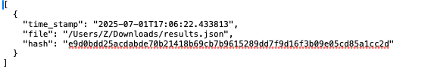

Summary

The script checks any file’s hash by entering the file path, generating a new hash, giving a warning when the file has changed, and list all previous hashes with its datetime and finally the user will be able to find all hashes check’s log in a JSON file with the file path and datetime.

Appendices

Output file_hash_log.JSON file sample

