**Business Problem**

Mobile apps are everywhere. They are easy to create and can be lucrative. Because of these two factors, more and more apps are being developed. We will assume the role of a company looking to invest money into Android app market by comparing over ten thousand apps in Google Play across different categories.



**Research Questions**

1. What are the categories the company should invest in?
2. What Type of app should the company go for?
3. What should be the target audience for the app?

**Hypothesis**

* Free Apps would be more popular
* Most popular category would be ‘Game’
* I suspect we should try and capture some niche market

**Analysis and Findings**

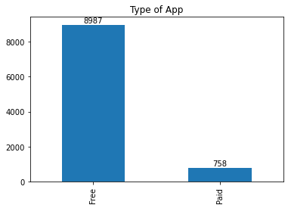

Almost 12x the number of Free apps available on the google play store app. We choose ‘Number of Installs’ as our KPI to gauge the popularity of the type of app. KPI’s are metrics that help us in achieving our goal of finding the answers to the research question. ’Installs’ is a good KPI because it is measurable, simple and relevant to our goal.

|  |  |
| --- | --- |
| Type | Installs |
| Free | 100000 |
| Paid | 1000 |

As 'Installs' is our KPI, it can be measured and gives a good indication of popularity, my hypothesis was true that we should invest our money into 'Free' Apps as the median number of downloads tell us. The median number of downloads for the Free Type is 100 times more than the paid one.

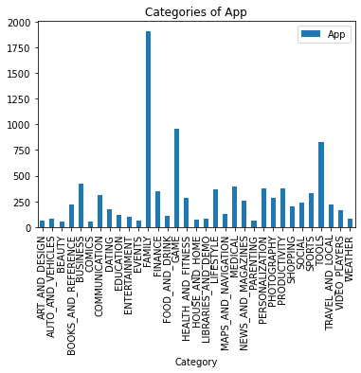

There are several Categories of Apps but we are interested in the more popular ones.

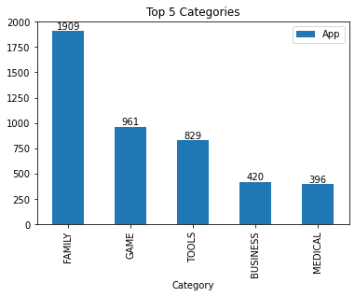

Family and Game seem to be the most popular Categories on the play store.

Let’s look at our KPI(‘Installs’)

|  |  |
| --- | --- |
| Category | Installs |
| Game | 1000000 |
| Family | 100000 |
| Tools | 50000 |
| Business | 1000 |
| Medical | 1000 |

Though the number of Apps are greater of 'Family but 'Game' Category on average has 10 times more Installs than ‘Family’ Category.

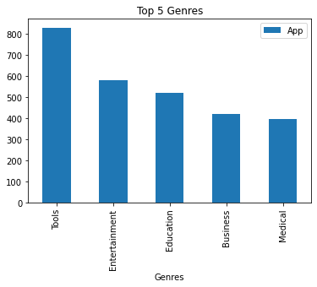

These are the top Genres for all games but we will be focusing our attention towards ‘Game’ and ‘Family’ Category, which Genres are more popular in those Categories.

|  |  |  |
| --- | --- | --- |
| Category | Genres | Installs |
| Family | Education | 5000 |
|  | Entertainment | 10000 |

In Family Category, ‘Education’ and ‘Entertainment’ are the more popular genres.

|  |  |  |
| --- | --- | --- |
| Category | Genres | count |
| Game | Action | 299 |
|  | Arcade | 185 |
|  | Racing | 91 |
|  | Adventure | 73 |
|  | Card | 47 |

Well it seems like if thinking of investing in games Action and Arcade are the more popular Genres for a game to be designed in.

|  |  |  |  |  |  |
| --- | --- | --- | --- | --- | --- |
| Content Rating | Everyone | Everyone 10+ | Mature 17+ | Teen | Unrated |
| Category |  |  |  |  |  |
| Family | 50000 | 1000000 | 100000 | 100000 | 500 |
| Game | 1000000 | 1000000 | 1000000 | 1000000 | Nan |

GAME Category is popular across the board but FAMILY is more downloaded with the audience of 'Everyone 10+' and 'Mature 17+'

**Suggestions**

* The Finance company could invest in Free type of App's rather than paid one's.
* Invest in GAME and FAMILY category as they have the highest number of installs on average
* In GAME Category the Genres to focus on are Action and Arcade
* In FAMILY Category the Genres to focus on are Education and Entertainment
* In GAME Category the Content could be for anyone
* In FAMILY category should focus more on 'Everyone 10+' or 'Mature 17+'