VmazON
AN E-COMMERCE SIMULATION

Name: Rudra Mishra
Reg no.: 25BAS10052
Faculty: Dr Sivabalan KR

INTRODUCTION

Vmazon is an E commerce simulation project developed with python programming language, which aims to prepare an environment which replicates the back end aspect of popular e-commerce programs.
This program helps the user give a better understand of how these programs work and give us a room to work on larger programs in the future.

OBJECTIVES

The primary objective of this project is to develop a functional command-line interface (CLI) application that simulates the core functionalities of an online e-commerce platform. This includes user authentication (registration/login), product browsing, order placement, shopping cart management, and order tracking. The project serves as a demonstration of basic Python programming concepts, file handling, dictionary manipulation, and structured application flow.

System Requirements

Hardware Requirements:
- Atleast 2GB of RAM
- Enough Storage to run any OS

Software Requirements:
- Python version 3.x
- Data entry: Comma Seperated values support
- Modules for Python

List of Defined Functions
1)Customer():
This is one of the most trivial defined functions of the program. This holds all the functions to perform for the user who is allocated to buy from the program.

2)Distributor():
This processed functions for the distributors and inventory holder.
Function accessible to staff usage only

OUTPUT
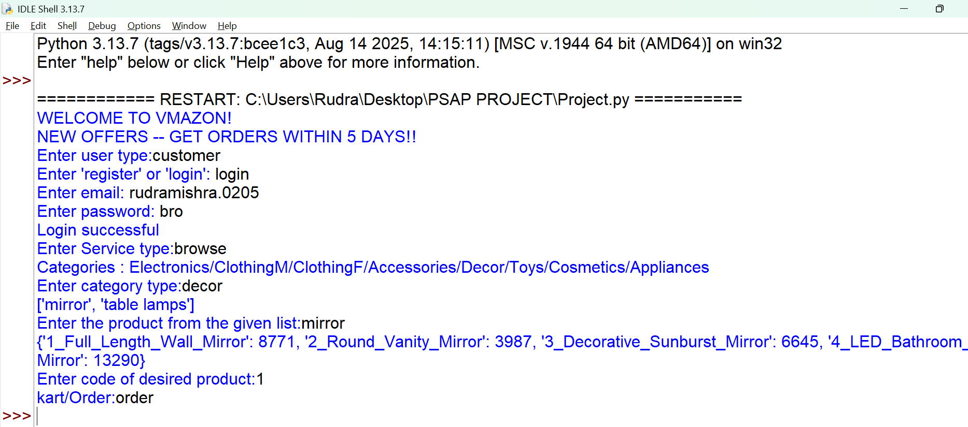
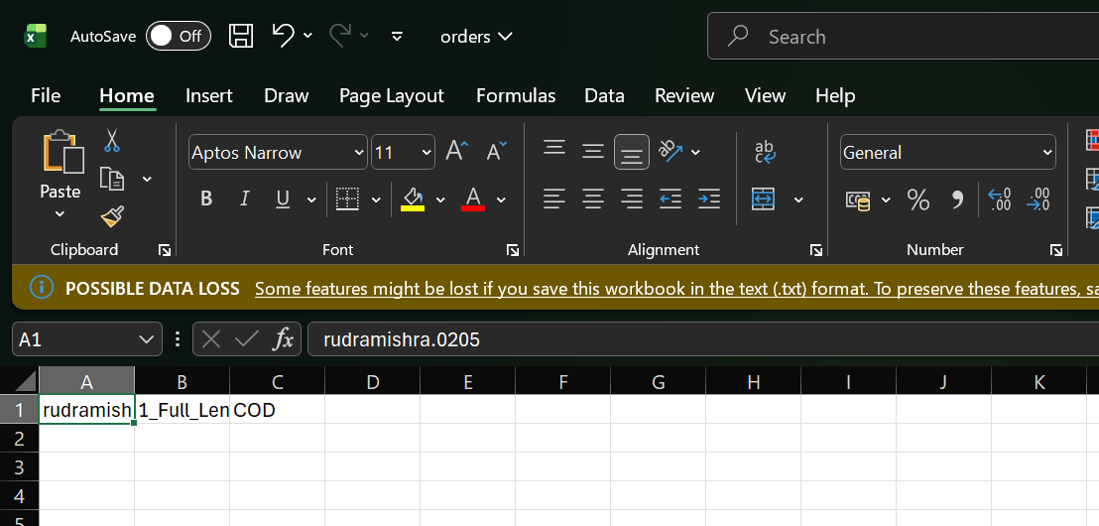
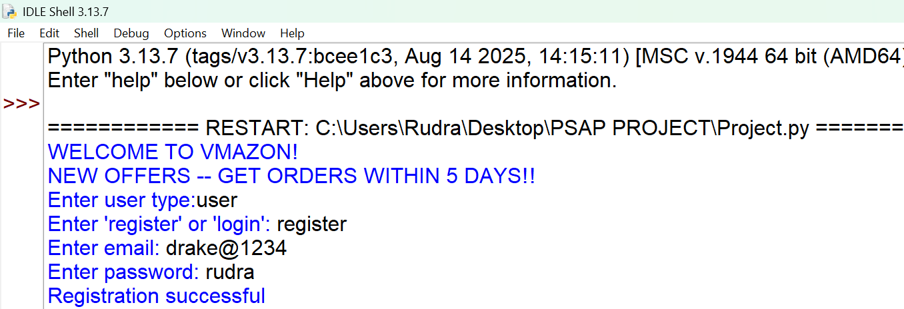
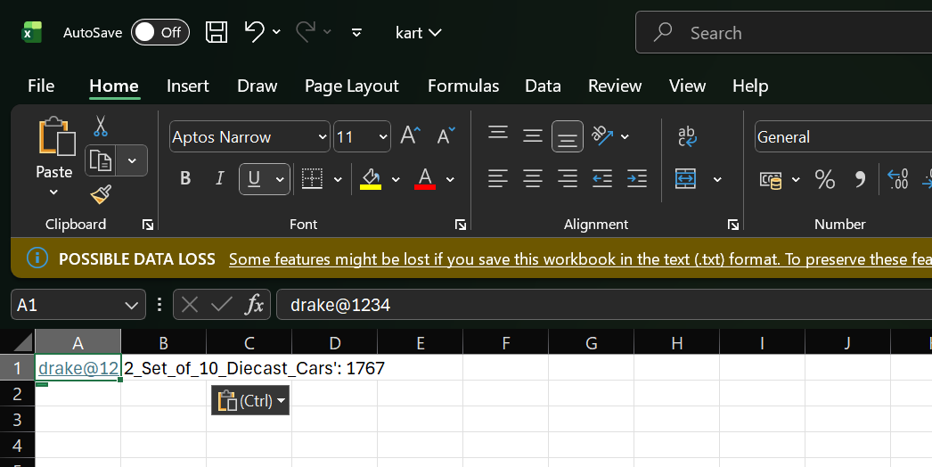
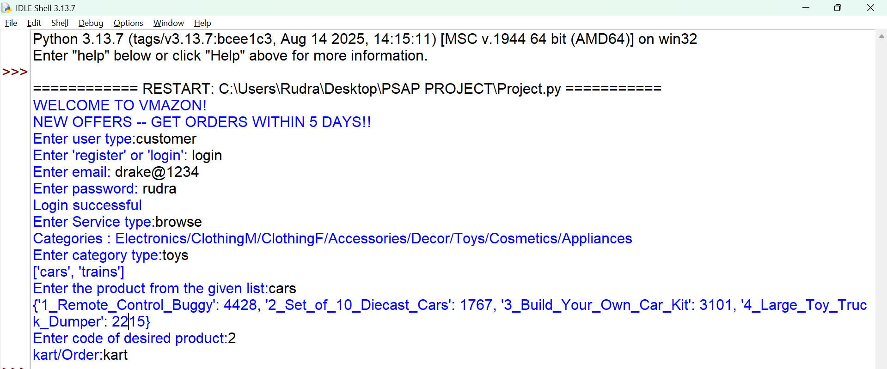
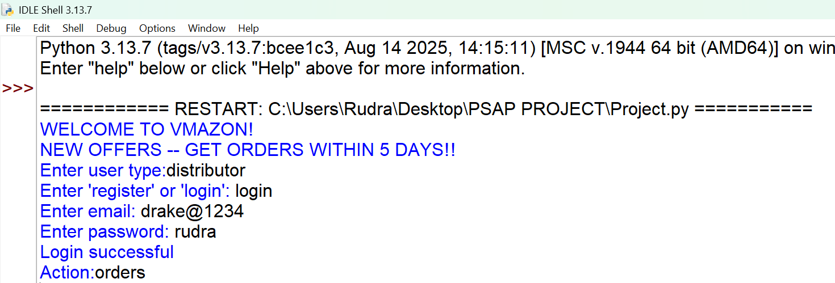

FUTURE ENHANCEMENTS

- Quantities and Price Calculation: Implement logic to allow users to order multiple quantities of the same item and calculate a final total price before checkout.
- Linking all data into one similar list for better algorithm control.

- Analyse user data and suggest better reccomendations.

- Tracking orders with linking time and date library

CONCLUSION

The VmazON E-commerce Console Application successfully provides a working simulation of a basic online shopping platform. It demonstrates effective use of Python dictionaries for data modeling and the csv module for lightweight data persistence, fulfilling the requirements for user authentication and transaction processing.

THANK YOU

