Group member

Tao Zhang UF-ID:7636-6624

Haowen Chen UF-ID:8141-1485

1. Size of Work Unit:

64 work units that my determined results in the best performance for my implementation. The total number of tasks we set is 512. When the worker is equal to 8, the worker will get the number of sub-questions from the boss as 64. Each worker gets equal of work at every instant. The size of our work unit is determined by regulating the actors and determining the ideal distribution of sub-problems for a fixed number of workers.

1. Result for k=4 (4 0's in the hash notation) 30rows

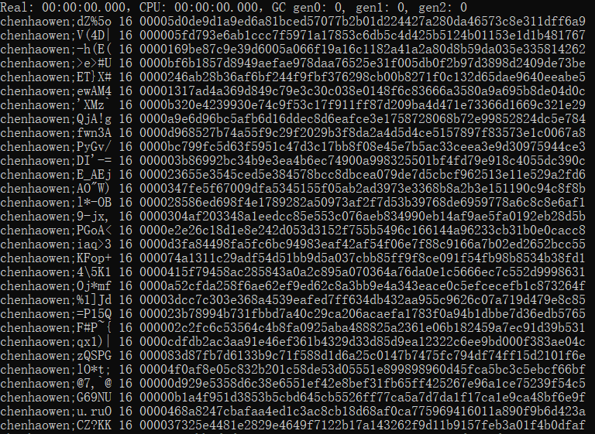

1. Running time for worker = 1, 2, 4, 8, 16, 32, 64, 128, 256.

512 rows in total (4 core machine)

Worker = 1, ratio = CPU/Real ≈ 1.00

c752d102e3331858d7a32e04b8b7194

Worker = 2, ratio = CPU/Real ≈ 1.82

a63eb8ad7c3f3caa6fa880cb3219940

Worker = 4, ratio = CPU/Real ≈ 3.22

2e31503be71a1cd3a13951c9573e8a7

Worker = 8, ratio = CPU/Real ≈ 5.48

1859da47e6e4dac37985b95442c62f3

Worker = 16, ratio = CPU/Real ≈ 4.50

41618452b9d7160a8c983794b53825d

Worker = 32, ratio = CPU/Real ≈ 4.70

2a9b4811f6c16d83c5fb14e2c242ca5

Worker = 64, ratio = CPU/Real ≈ 3.71

1cca2b13af52ad0d496a3344967c2c1

Worker = 128, ratio = CPU/Real ≈ 4.28

22a38f1d80295c232a71efa1532d843

Worker = 256, ratio = CPU/Real ≈ 4.69

441cb797d60fade14737ab3b5c99b5c

Worker = 512, ratio = CPU/Real ≈ 4.57



In a word, worker=8, ratio is the maximum.

1. Coin with max k=7

chenhaowen;A>g}% 0000000ab8895931c3c9209d413d73725f5a6654c0a4ab0e75375b29548415d3

1. Largest Number of working machines used to run code: 2
2. Client.fsx and Server.fsx

In the same WiFi environment.

Server: Haowen Chen’s machine IP:10.136.97.12

Client: Tao Zhang’s machine IP:10.136.32.178

The first step: first open the server.fsx, so that the server can run autonomously to mine Bitcoin, the result is shown in Figure 1.

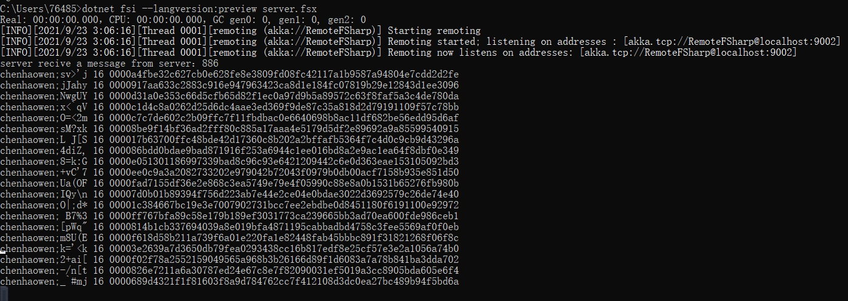

Figure 1

Step 2: Then open the client.fsx, the service.fsx will connect to the service remotely, and then the client will receive the information from the service, and when the client receives the information, it will start mining bitcoin, the result is shown in Figure 2.

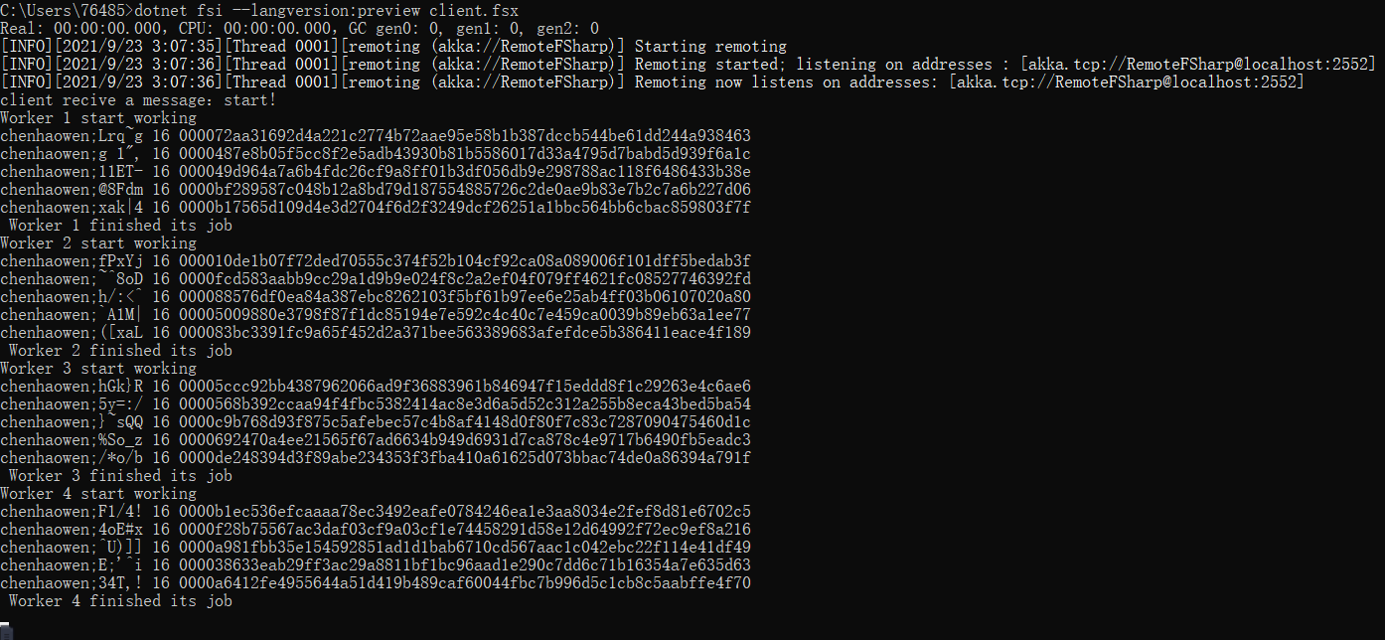

Figure 2

Step 3: The client results will be displayed in the service.

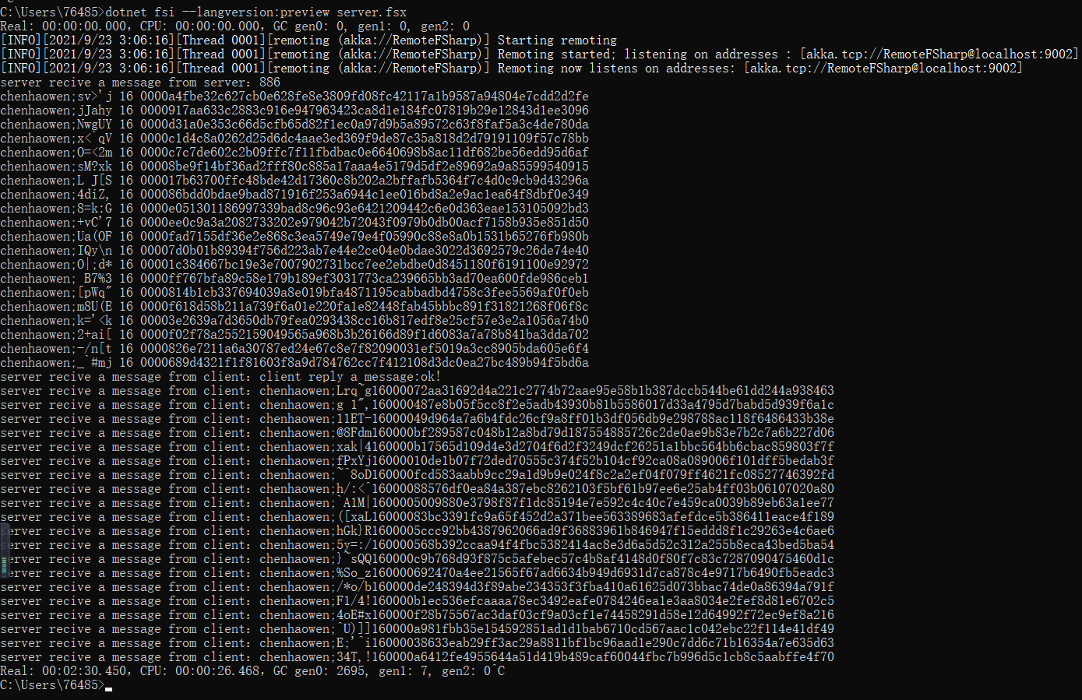

Figure 3

1. Note:

How to run the code: open the command prompt(cmd+enter)

(1) project1.fsx dotnet fsi --langversion:preview project1.fsx

(2) server.fsx dotnet fsi --langversion:preview server.fsx

(3) client.fsx dotnet fsi --langversion:preview client.fsx

My find256 function means that "chenhaowen" is gatorlink ID as “prefix”, 5 means random string length as n. 4 means 4 0's in the hash notation as k. “count” means Number of bitcoin output. The 16 in the output means "chenhaowen" + ";" + "5 random string length". Total length = 10+1+5=16.