Readme

**Team:**

Tao Zhang UF-ID:7636-6624

Haowen Chen UF-ID: 8141-1485

**YouTube**:https://youtu.be/i893DZNs4hw

Project Description:

In this project we have used Suave web framework to implement a WebSocket interface to our part I implementation, the twitter clone we have implemented supports register an account, login using username and password, send tweets, subscribe to user’s tweets, do retweets of user’s tweets, and deliver all these functions live without querying for logged in users,we have designed a JSON based API that represents all messages and their replies(including errors).

**Bonus**(256-bit ElipticCurve):

We used the 256-bit ElipticCurve algorithm to encrypt the registered user name on the client side, and then deserialized and decrypted it on the server side to get the user name. The result is shown in the figure below.

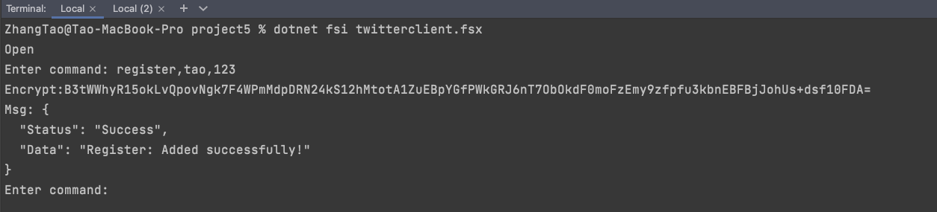

Client

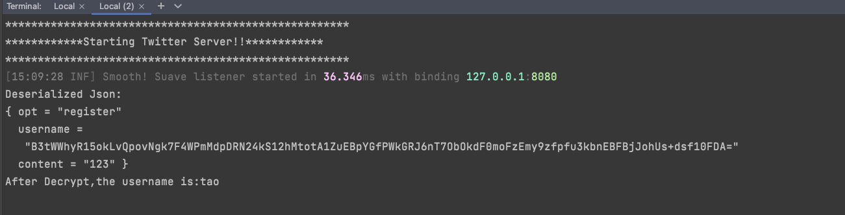

Server

**How to run:**

references.fsx This is a required document.

AseEncryption.fsx:This is the **bonus** part, encrypt the registered user name.

Firstly open Server:dotnet fsi --langversion:preview Server.fsx

Secondly open Client:dotnet fsi --langversion:preview Client.fsx N

N:Number of users

**Implementation:**

Server:

1. **WebSocket**:

The server is based on the Suave web framework and once it is triggered it will start the server on localhost:8080 and will be waiting to get connection requests from WebSocket clients. Once the connection is made it has the WebSocket and context details. For each WebSocket, we will be creating an actor and as the socket receives the message is forwarded to its actor and the actor reads the received JSON object and based on the request URL it deserializes the body into corresponding type record and based on the request URL it also forwards the deserialized object to corresponding actors which in turn performs the requested task and sends the response back to WebSocket actor.

1. actor:
2. register_actor: This Actor is responsible to register username and password.
3. login_actor: This Actor is responsible to log in with a registered username and password.
4. sendTweet_actor:This Actor is responsible to send tweets to other users.
5. subscribe_actor:This Actor is responsible to subscribe other users.
6. retweet_actor:This Actor is responsible to retweet other users tweet.
7. querySubscrible_actor:This Actor is responsible to query about what users subscribe to a user.
8. queryHashtag_actor:This Actor is responsible to query special Hashtag.
9. queryMention_actor:This Actor is responsible to query what content the user mentioned.

Client:

1. **Client WebSocket**:In the client, we are using ClientWebSocket class for dotnet. The client initially creates a web socket connection to the server URL. Once the socket is created, we take input from the console and serialize it and send it to the server along with this task there will be another task running parallelly on the client-side for receiving the response. As it receives the responses it deserializes them and formats and prints the response on the console.
2. Zipf_subscribe:Each client is ranked from 1-N where N is the number of users. Each client will make 1/rank number of tweets per millisecond to the server.number of subscribes, simulate a Zipf distribution.

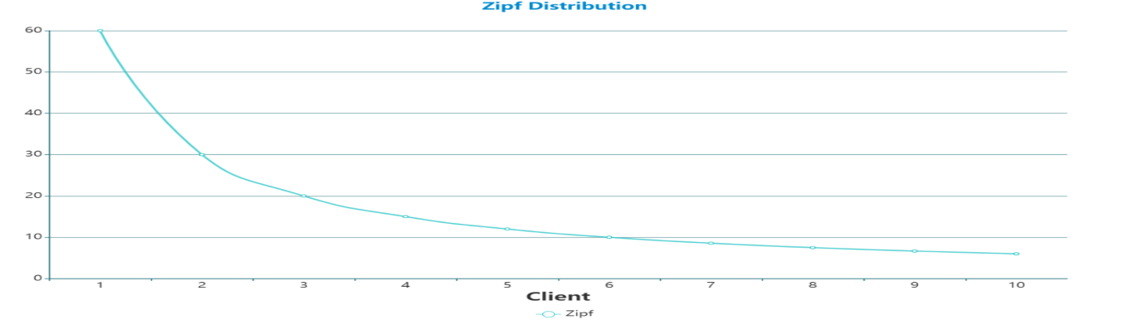

1. client_simulator:This actor will evaluate the performance of Twitter by recording registered users, sending tweets, subscribing to users, Zipf, retweets, querying subscriptions, querying hashtags, and querying the time mentioned.
2. connect and disconnect: By default, all users are connected. There is a 10% probability that they will not be connected. The tags and mentions of users who are not connected will not exist, and other users who subscribe to him will not see him online.

**Result:JSON represents all messages and their replies and errors(The complete result is in result.pdf)**

**Server:**  **Client:**

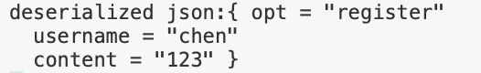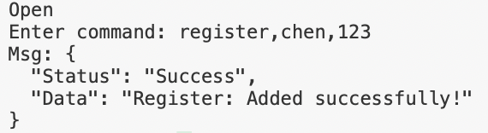

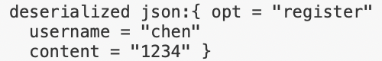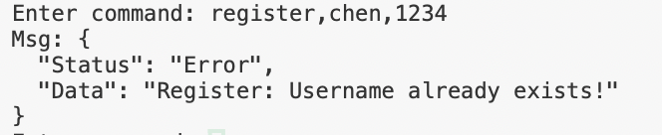

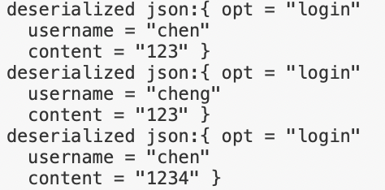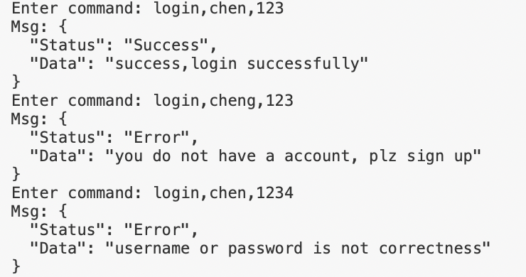

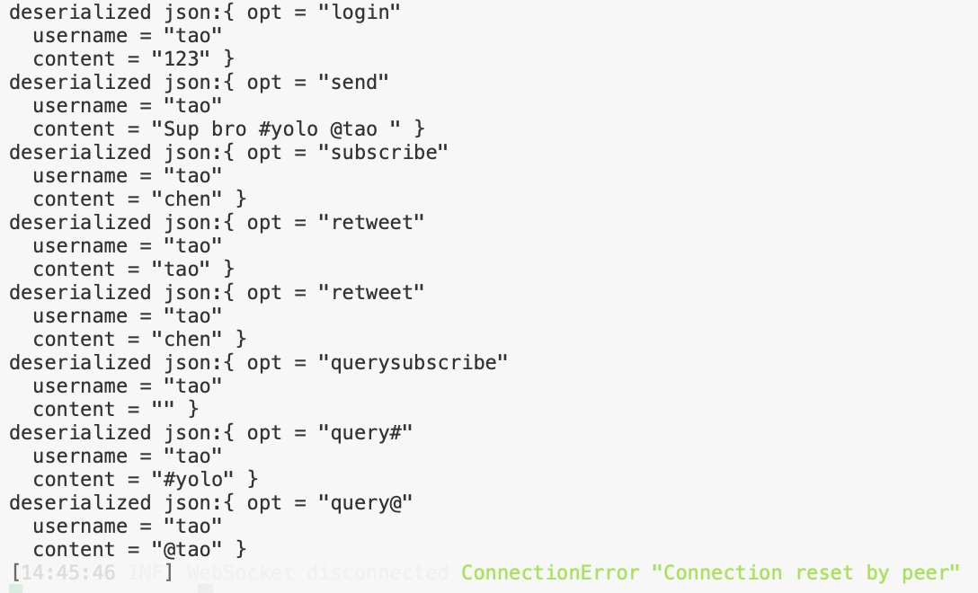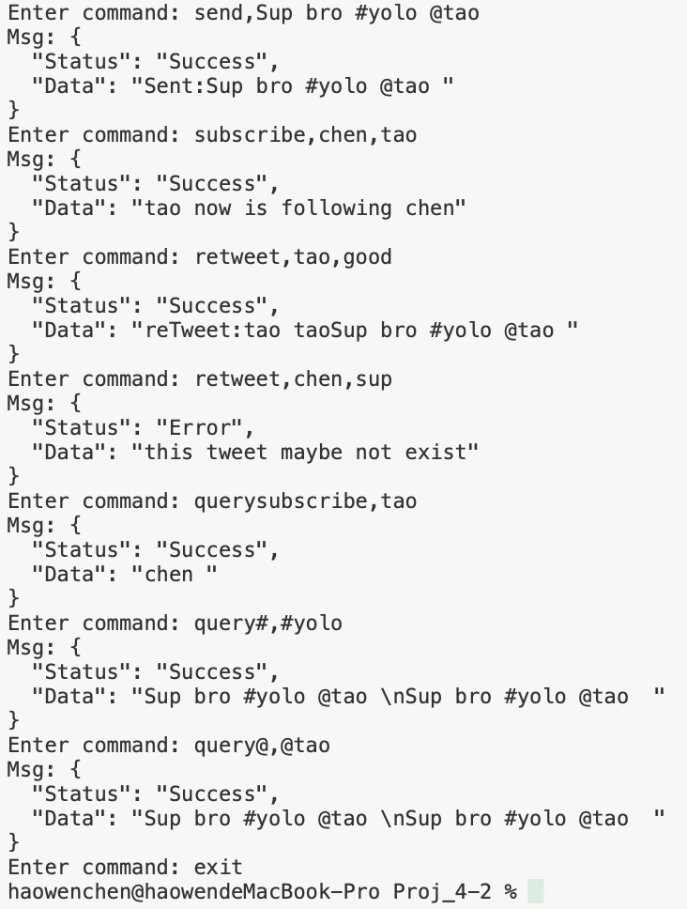

**Performance:**

|  |  |  |  |  |  |  |  |
| --- | --- | --- | --- | --- | --- | --- | --- |
| users | register | send | zipf | retweet | subscribe | hashtag | mention |
| 5 | 329.3377 | 18.2400 | 12.2065 | 15.5313 | 6.3305 | 8.9978 | 14.3804 |
| 10 | 282.0952 | 33.1688 | 27.6950 | 32.7091 | 19.4049 | 15.0906 | 17.6283 |
| 50 | 343.0404 | 136.3510 | 213.9374 | 142.1209 | 78.2160 | 75.9960 | 79.1146 |
| 100 | 491.9659 | 270.3742 | 298.7337 | 294.5574 | 147.3760 | 230.2821 | 196.8646 |
| 200 | 598.8412 | 528.3827 | 594.8456 | 634.3038 | 308.4170 | 342.1422 | 340.9901 |
| 500 | 1124.9816 | 1529.5842 | 1490.7523 | 1397.0603 | 685.2494 | 837.6207 | 766.9667 |
| 1000 | 2089.2842 | 2716.4888 | 3010.5645 | 2905.7171 | 1459.2135 | 1531.3520 | 1559.0295 |
| 2000 | 3339.0786 | 4843.0530 | 3469.6742 | 4556.9809 | 2297.7820 | 2116.2172 | 2493.1995 |
| 3000 | 4987.1042 | 8383.3438 | 9437.7915 | 10412.5130 | 4351.1768 | 5143.2575 | 4822.3235 |
| 4000 | 6600.2778 | 11153.1924 | 13180.6067 | 16095.5663 | 6007.4597 | 7367.5819 | 6575.7702 |
| 5000 | 8530.7216 | 14097.9365 | 26572.4532 | 17060.1862 | 7070.4842 | 7596.6053 | 7140.3560 |

## 传统折线图 (4)

## What is the largest network you managed to deal with:

The biggest number of users we tested is 5000.