RC

Dnipro
in
Use
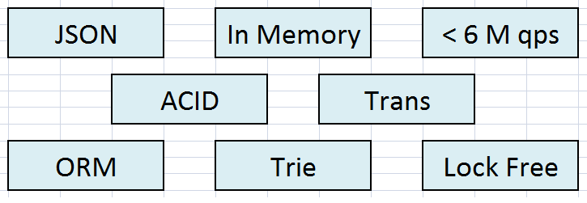

(c)2016
Overview
Introduction 4
Architecture 5
Installation 8
Base queries 11
Extended queries 20
Queries inside doc 30
Blob Values 35
Collections 36
Dynamic queries 37
Transactions 38
Administration 46
Afterwords 48

What’s Inside
Introduction 4
Architecture 5
Implementation 5
Performance 7
Requirements 7
Installation 8
Windows 8
.NET 8
Java 9
C++ 9
Linux 10
Console 10
Java 10
C++ 10
Base queries 11
Modify queries 11
Add document 11
Update document 13
Delete document 16
Select queries 17
Extended queries 20
Select queries 22
Modify queries 25
Aggregate 26
Expressions 26
Join 27
Queries inside doc 30
Blob Values 35
Collections 36
Dynamic queries 37
Transactions 38
Read Commited 39
Repeatable Read 40
Snapshot 41
Cascade transactions 42
Resolve deadlocks 44
Performance 45
Administration 46
Afterwords 48

Introduction
DniproDB is one of the fastest document oriented database in the world. The database has innovated on core based Trie structures, Inverted indexes and Lock Free algorithms. In the contrast to other NoSql solutions, mentioned database has complete support of ACID, Transactions and additionally contains easy query language on the basis of JSON notation. As of today are also available ORM (Object Relation Mapping) adapters for server languages. They help to integrate DniproDB into your project with minimum efforts.
In the book we use next notations:

Example of code
on C#, Java or C++

Notes about performance and architecture
Advices about Best practise
What whould be available in new versions

Architecture

Implementation
The database has different design in comparison to other databases. Principal idea is that JSON document is just an abstraction. On the bottom level JSON represents set of Keys in Key/Value storage. During converting of JSON into document to Keys the document is inverted twice. This process is illustrated on the picture below.
This approach has several advantages. Especially, when we use Trie structures as Key\Value container.
- JSON document is indexed by all attributes by default (except composite indexes, and indexes on blob attributes)
- Trie structures work very fast. For example: up to 10 millions queries per second on random 128 bit keys.
- JSON documents of inverted index in many cases stores with compression. Because of long path, each attribute is saved only once.
- When we need to filter all documents by attribute value on Core level, it is necessary only one lookup on key in Key\Value storage (it’s very fast operation, about 50 ns)

- When we need to insert\delete\update an attribute into a document, we just insert\delete\update a key in Key\Value storage. Document is not overwritten on the whole.
- When we need to select an attribute from a document, we load only one key from Key\Value storage instead of the document. It is good for traffic.

Picture 1: Process of convertation JSON document 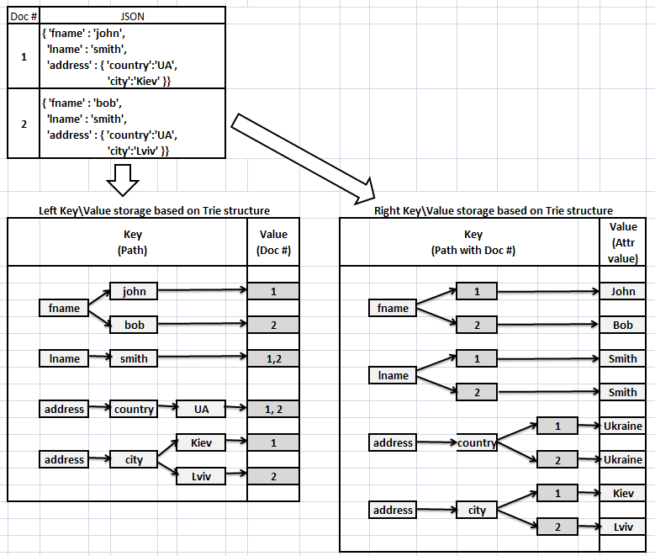

Performance
New design provides very high performance of the database. Difference in performance with traditional databases (RDBMS, Mongo, Rethink, Couch etc.) can be 10 times or even more.
Despite of high performance, for user, it is still convenient to apply JSON format, ORM and supporting ACID with Transactions.
As of today, we made four benchmarks, but, of course, each case is individual and we recommend carrying out of measurements according to your business requirements.
http://forum.pikosec.com/viewforum.php?f=7

Requirements
This is In Memory (except blob values, which saving and reading from HDD) database with transaction log on HDD. Thus, your server should contain enough RAM in order to load database into the memory.
We do not recommend to apply database if you have many delete operations (for example more than 20% of all operations), because delete operation in Key\Value storage does not lead to the physical removal and wouldn’t reduce size of database.
In new version we are going to implement functionality to shrink database after massive deleting. Also we are going to implement distributed model for the database.

Installation
The database required Windows or Linux platform. Installation package contains two applications.
- DniproServer
Written on C++ and running as console application which opens port 4477.
- DniproClient
Provider for communication with server.
For .NET it is DniproClient.NET library.
For Java it is DniproClient.JVM library.

Windows

.NET
- Download DniproServer application from
https://github.com/Bazist/DniproServer.WIN
(Top right corner, click Download Zip)
- Download DniproClient.NET application from
https://github.com/Bazist/DniproClient.NET
(Top right corner, click Download Zip)
- Open your .NET solution and add DniproClient.NET\DniproClient\bin\Release\DniproClient.dll as reference to your project.
- Run DniproServer.exe console application As Administrator. The application opens 4477 port for communication with client.
- Use next code to run Hello World ! sample in your application.
//use local server
DniproDB db = new DniproDB("127.0.0.1", 4477);

//add a document
db.AddDoc("{'book':'Dnipro in Using', 'message':'Hello World !'}");

//print an attribute
db.GetWhere("{'book':' Dnipro in Using'}")
.Print("{'message':$}");

Java
As today we are released only simple Java provider. But we will finish ORM provider asap.
https://github.com/Bazist/DniproClient.JVM

C++
Functionality for using database in embedded mode is not implemented yet.

Linux

Console
- Download DniproServer application from
https://github.com/Bazist/DniproServer.UNX
(Top right corner, click Download Zip)
2. Run the server and type in console db.SelfTest() to run self tests.

Java
As today we are released only simple Java provider. But we will finish ORM provider asap.
https://github.com/Bazist/DniproClient.JVM

C++
Functionality for use database in embedded mode is not implemented yet.

Base queries
DniproDB class implements basic API to work with database. In order to communicate with server, specify server address and port in constructor of the class.
//use local server
DniproDB db = new DniproDB("127.0.0.1", 4477);

Modify queries

Add document
There are few methods to add new document in the database.
- Add JSON document to the database directly

//Using JSON directly
db.AddDoc("{'FirstName':'John','LastName':'Smith'}");

Quotes in the document are allowed two types: ordinary and doubled. Attribute names in JSON case insensitive.

- Or add a Business Object to the database directly.
//Create a class for business object
public class User
{
public string FirstName { get; set; }
public string LastName { get; set; }
}
//Create an object
User user = new User()
{
FirstName = "John",
LastName = "Smith"
};

//Add object to the database, method returns ID of //added document
var docID = db.AddDoc(user);

- Or add an object of anonymous class (actual for .NET)
//Serializator will convert the object to JSON
db.AddDoc(new {FirstName = "John",
LastName = "Smith"});

- Or add array of objects
//To the database will be added three documents
db.AddDocs(new object[] { new {Color = "Red" },
new {Color = "Green"},
new {Color = "Blue" }});

Use AddDocs method when you need to insert several documents. This method has better performance in comparison with using of AddDoc method on several times.
It occurs because every call of the method initiates Open and Close connection to the server that will have some overhead of performance.
Documents in the database are indexed by all attributes by default. Thus, you don’t need to take care about indexes. Exception is only for composite indexes and indexes on blob attributes which are not supported yet.
Add a document(s) is very fast operation. It costs adding several Keys to Key\Value storage. If you insert list of documents in one batch, you can achieve up to 2-3 million inserts of attributes.

Update document
To update document you need specify attributes which should be updated and specify document id. Next query update in document FirstName and LastName attributes.

//Method will update only one attribute
uint docID = 1; //document ID which was received from
//AddDoc method

db.UpdPartDoc("{'FirstName':'Bob',
'LastName':'Parker'}",
docID);

Also you can do it through object model

db.UpdPartDoc (new {FirstName = 'Bob'}, docID);

Sometimes you have a big object in your code that you want to save or update partially. For this purpose, you can specify template with attributes which should be saved.

//Create a class for business object
public class User
{
public string FirstName { get; set; }
public string LastName { get; set; }
public string Status { get; set; }
}

//Create an object
User user = new User()
{
FirstName = "John",
LastName = "Smith",
Status = "Offline",
};

//Add object to the database, methods returns ID of //added document
var docID = db.AddDoc(user);

//sometime later User status has been changed …
user.Status = "Online";

//and we want update only status attribute in the
//database. We take attribute value from user object //according template and update it in database

db.UpdPartDoc(user, "{'Status': $}”, docID);

If your businesses object have nested objects you can update them as a part of document.

//create nested object
Address address = new Address()
{ Country = "United Kingdom",
City = "London" };

//create parent object
User user = new User()
{
FirstName = "John",
LastName = "Smith",
Address = address
};

//update only address in the User document
db.UpdPartDoc(user,
Change.Create(user.Address,
ChangeEnum.UpdateRecursively),
docID);

Sometimes you need add new attribute to the existing document. For these purposes we can use next method.

//insert new attribute to the existing document
db.InsPartDoc("{'Age':'21'}", docID);

//insert new nested object to the existing document
Car car = new Car(){ Model = "Dodge" };
db.InsPartDoc(car, docID);

Update of the document is also rapid operation. Update or insert one or several attributes does not increase overwriting document. We update only keys in the storage.

Delete document

To delete part of a document we should specify attributes which should be deleted.

//delete two attributes from the document
db.DelPartDoc("{'FirstName':$,'LastName':$}", docID);

Document is considered as deleted if all its attributes are removed. Thus, you should specify structure of the document in your template.

//User object was created in previous examples
db.DelPartDoc(user, docID);

Besides, you must consider that delete does not reduce database size, because deleted nodes just marked as deleted in the storage.

Select queries

DniproDB class provides basic methods to load document from the database. To find all documents by attribute you can use next method

//Find all documents by attribute
int[] docIDs = db.GetDocsByAttr("{'FirstName':'John'}");

There is possibility to load entire document by id and then deserialize him into Business Object

//Load object from storage by document Id
User user = db.GetDoc<User>(docID);

Sometimes you already have a Business Object and you need just load some parts of the object.

//create nested object
Address address = new Address()
{ Country = "United Kingdom",
City = "London" };

//create parent object
User user = new User()
{
FirstName = "John",
LastName = "Smith",
Address = address
};

//Update in existing object only FirstName and //LastName from the database
User user =
db.GetPartDoc<User>(user,
"{'FirstName':$,'LastName':$}",
docID);

//Update in existing object only Address
User user =
db.GetPartDoc<User>(user,
Load.Create(user.Address,
LoadEnum.LoadRecursively),
docID);

If Business Object has many nested objects, you can specify that you want to load from the database only top level.

//Update in existing object only top level of
//attributes. Ignore nested entities.
User user =
db.GetPartDoc<User>(user,
Load.Create(user.Address,
LoadEnum.LoadOnlyTopLevel),
docID);

These basic methods allow loading of the document with minimum traffic. If you have a big Business Object which contains hundreds of nested entities, you can load only part of them. Moreover, you don't need to recreate Buisness Object every time when it should be read from the database. You can use existing object - our JSON Serialization class can update existing object from the database partially.
GetDocsByAttr is basic method for the database. He costs only one lookup from Key\Value storage. Other methods calculated from formula: One attribute = One lookup.

Extended queries
In most cases the base queries is not enough to write the compact code. DniproQuery interface are used for extended queries. With this interface we can build a query with many parts. DniproQuery class implements three groups of methods.
Group A – starts of query with filter
To start extended query DniproDB class implements next methods
GetWhere – find documents by filter
GetWhereElems - find document parts by filter
GetAll – take all documents from the storage
Group B – continue query with filter
After methods of Group A you can continue filter by next methods
AndWhere – add a condition with AND logic
AndWhereElems – add a condition for part of document with AND logic
OrWhere – add a condition with OR logic
OrWhereElems – add a condition for part of document with OR logic
Take – take some amout of documents from the begining
Skip – skip some amount of documents from the beginning
Join – inner join several documents by attribute
Sort – reorder found documents
Group C – finish query
Select – get documents which were found. Also in this method we can specify a template and load only required attributes.
Print – print documents which were found. Actual for Console Applications
Value – get a scalar value of attribute
Insert – insert attributes to documents
Update – update attributes in documents
Delete – delete attributes in documents
Count – get amount documents which were found
Thus, an extended query always starts from method of Group A, then continuing with method(s) of Group B (but this group could be skipped) and then query is completed by method of Group C. DniproQuery class uses lazy calculations and call to server will be last method of Group C.

Select queries

Take a look next example.
//use local server
DniproDB db = new DniproDB("127.0.0.1", 4477);

//create nested object
Address address = new Address()
{ Country = "UK",
City = "London" };

//create parent object
User user = new User()
{
FirstName = "John",
LastName = "Smith",
Address = address
};

//Returns all documents where FirstName is John.
User[] users =
db.GetWhere("{'FirstName':'John'})")
.Select<User>();

//Load only FirstName and LastName attributes
User[] users =
db.GetWhere("{'FirstName':'John'})")
.Select<User>("{'FirstName':$,'LastName':$}");

This code finds documents where FirstName is John and selects them.

Returns only documents where FirstName is John and his country is UK
//Use methods Group A, Group B and Group C
User[] users =
db.GetWhere("{'FirstName':'John'})")
.AndWhere("{'Address':{'Country':'UK'}})"
.Select<User>("{'FirstName':$,'LastName':$}");

Query above we can rewrite a bit shorter.
//Use methods Group A and Group C
User[] users =
db.GetWhere(
"{'FirstName':'John','Address':{'Country':'UK'}}")
.Select<User>("{'FirstName':$,'LastName':$}");

Sometimes, we need to deserialize a nested object from document directly. For this purposes, you can put “!” before bracket in order to identify which part of document should be deserialized.
//Load all addresses from all persons
Address[] addreses =
db.GetAll()
.Select<Address>(
"{'Address':!{'Country':$, 'City':$}}");

If you don’t want create a new Business Object, just fill existing one from the database, you can use next way

//the object was created earlier
User user = new User();

//Fill only FirstName and LastName in existing object
//Query works only if there is one document with John
user =
db.GetWhere("{'FirstName':'John'}")
.Select<User>(user, "{'FirstName':$,'LastName':$}");

There is possibility to deserialize document into DataTable (actual for .NET)
DataTable dt = new DataTable();
dt.Columns.Add("Country");
dt.Columns.Add("City");

//Load all addresses from all persons into DataTable
db.GetAll()
.Select<Address>(dt,
"{'Address':!{'Country':$, 'City':$}}",
false, //distinct is false
new Serialization.DataTableBehaviour());

Using Take and Skip methods you can load data by portions.

//Load first portion with 10 documents
User[] users =
db.GetAll()
.Skip(0)
.Take(10)
.Select<User>();

//Load second portion with 10 documents
User[] users =
db.GetAll()
.Skip(10)
.Take(10)
.Select<User>();

Modify queries
When you need to modify one or many documents, you can use Insert, Update or Delete methods. Next query will find all documents where attribute FirstName is John and change them on Bob.
//Fill only FirstName and LastName in existing object
//Query works only if there is one document with John
db.GetWhere("{'FirstName':'John'}")
.Update("{'FirstName':'Bob'}");

The same schema for insert and delete attributes in documents.
//Find John and add to his address new attribute –
//Street name
db.GetWhere("{'FirstName':'John'}")
.Insert("{'Address':{'Street':'5th Avenue'}}");

//Delete new attribute
db.GetWhere("{'FirstName':'John'}")
.Delete("{'Address':{'Street':'5th Avenue'}}");

In a case when will be found many documents, they will be modified all.

Aggregate

In current version there is only one aggregate method.
//Get amount of all documents
uint count = db.All().Count();

Expressions
The core supports queries by range or by mask of an attribute. When you need to specify that its expression, use symbol “@” before quotes.
See next examples:
//Add several documents with numeric attributes
db.AddDoc("{'Num':1}");
db.AddDoc("{'Num':2}");
db.AddDoc("{'Num':3}");

//calculate amount documents where Num from 1 to 3
uint count = db.GetWhere("{'Num':@'1-3'}").Count();

//where num less or equal 2
count = db.GetWhere("{'Num':@'<=2'}").Count();

//where num great than 1
count = db.GetWhere("{'Num':@'>2'}").Count();

Also you can specify a mask for string attributes
//Add several documents with string attribute
db.AddDoc("{'Str':'abc'}");
db.AddDoc("{'Str':'abd'}");
db.AddDoc("{'Str':'adc'}");

//this query returns amount of documents where the
//attribute starts from ‘ab’
uint count = db.GetWhere("{'Str':@'ab*'}").Count();

Join
For relational databases Join operation is one of the most required. But, for documented database it’s optional. JSON document has already joined data, because it has hierarchy structure. However, we are sure, that Join operation also has sense in documented database. The principal question is how to join documents to each other if they have different hierarchy structure?
When you join several documents the core creates an abstract table. In the table, in each cell there is a document. Row in the table indicates that documents in the row have relation. The relation indicates that documents are equals by specified attributes in the Join. When a document has relation to several documents the rows are duplicated. Join process illustrated on Picture 2.

Picture 2: Process of join JSON documents
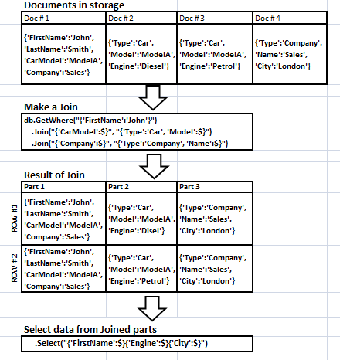

On the last stage you can deserialize attributes from several parts of the documents into one object.
//Four documents were added, see first stage on the
//Picture above.
//Create a class to collect results of join
class JoinResult
{
public string FirstName;
public string Engine;
public string City;
}

//Double join of documents and deserialization them into //one object
JoinResult[] jrs =
db.GetWhere("{'FirstName':'John'}")
.Join("{'CarModel':$}","{'Type':'Car', 'Model':$}")
.Join("{'Company':$}","{'Type':'Company', 'Name':$}")
.Select<JoinResult>
("{'FirstName':$}{'Engine':$}{'City':$}");

Queries inside doc
In all our examples above we filter documents under criteria. But JSON documents can have difficult structure with nested arrays of objects and sometimes we need to find an object inside of one document.
Take a look few examples JSON documents with nested arrays.
//Document with scalar array
db.AddDoc("{'Array':[1,2,3]}");

//Document with multi dimensional scalar array
db.AddDoc("{'Array':[1,[2,3],4]}");

//Document with array of colors
db.AddDoc
("{'Colors':[
{'Name':'Red','Code':'#FF0000'},
{'Name':'Green','Code':'#00FF00'},
{'Name':'Blue','Code':'#0000FF'}
]}");

How to get elements from array by order

//create a document with scalar array
uint docID = db.AddDoc("{'Array':[1,2]}");

//get first two elements from array.
//In the result will be {'Array':[1,2]}
string json = db.GetPartDoc("{'Array':[$,$]}", docID);

If you want get element by index from array – use operator @

//In the result will be {'Array':[2]}
string json = db.GetPartDoc("{'Array':[@2,$]}", docID);

With @ also possible update an element inside array

//Before update document contains {'Array':[1,2]}
//After update document contains {'Array':[1,4]}
db.UpdPartDoc("{'Array':[@2,4]}", docID);

Add new element into array. The element will be added as last element in the array.

//Add new element to the array
//In the result will be ("{'Array':[1,2,3]}
db.InsPartDoc("{'Array':[Add,3]}", docID);

Get Last element from the array

//In the result will be {'Array':[3]}
string json = db.GetPartDoc("{'Array':[Last,$]}", docID);

Get Count elements in the array

//In the result will be {'Array':[3]}
string json =
db.GetPartDoc("{'Array':[Count,$]}", docID);

Get Portion elements from the array. First parameter after P is start position (indexes start from 1), second parameter is size of portion

//In the result will be {'Array':[2,3]}
string json =
db.GetPartDoc("{'Array':[P,2,2,$]}", docID);

Next queries are useful when you find documents by template in the array. In means that all specified elements should be in array.

//Add several documents with arrays
db.AddDoc("{'arr':['1','2','3']}");
db.AddDoc("{'arr':['3','4','2']}");
db.AddDoc("{'arr':['2','3','4']}");
db.AddDoc("{'arr':['3','4','5']}");

//Find only documents where there are 2 and 3 in array. //Will be found two documents
db.GetWhere("{'arr':[In,'2','3']}")
.Print("{'arr':[$,$,$]}");

Nin (not in) means that all specified elements should not be in array

//Find documents where there are no 2 and 3 in array. //Will be found three documents.
db.GetWhere("{'arr':[Nin,'1','2']}")
.Print("{'arr':[$,$,$]}");

Any means that at least one element should be found in the array

//Find only documents where there is 1 or 5 in array.
//array. Will be found two documents
db.GetWhere("{'arr':[Any,'1','5']}")
.Print("{'arr':[$,$,$]}");

When an array contains many elements, you can specify template with Repeat keyword. It means that you don’t need to specify all elements in your JSON, only template for one element. If array contains many similar elements, they will be loaded in your JSON.

//Add document with four objecs in the array
uint docID = db.AddDoc("{'arr':[{'attr':'1'},
{'attr':'2'},
{'attr':'3'},
{'attr':'4'}
]}");

//Get document with all four elements from array
string json = db.GetPartDoc("{'arr':[R,{'attr':$}]}");

There is possibility to find nested object in array by attribute. For this purposes we use GetWhereElems method. It can find elements inside of the documents. See next code sample.

//Add object dictionary with three colors
db.AddDoc(new {name = "dictionary",
colors =
new object[]
{new {eng="red",ua="червоний"},
new {eng="blue",ua="синiй"},
new {eng="green",ua="зелений"}}});

//Find inside document translation for green item
//In the result will be {'colors':[{'ua':'зелений'}]}
db.GetWhereElems("{'colors':[{'eng':'green'}]}")
.Print("{'colors':[{'ua':$}]}");

Inserts, Update or Find elements in an array also very fast operation. They cost insert, update or find keys in Key\Value storage. Sometimes core can scan sub tree of Trie that is also quite fast operation. But there is feature. When you delete an item from the middle of array, indexes of other elements are not shifted, inside array stays empty space.
Inserts, Update or Find elements in an array also very fast operation. They cost insert, update or find keys in Key\Value storage. Sometimes core can scan sub tree of Trie that is also quite fast operation. But there is feature. When you delete an item from the middle of array, indexes of other elements are not shifted, inside array stays empty space.

Blob Values
Attribute of document can contain very big value. We call it Blob Values and use for storage of media content like pictures, video clips, long text and etc. In contrast to simple attribute values, attribute blob values never indexed and always stored on disc (HDD). In manual mode there are two methods to manage blob values on the server.
- AddBlobValue - add a blob value to the database
- GetBlobValue - get a blob value from the database
Under ORM process of creation and reading of attribute values is hidden. If you create a member of class with byte[] type - in database it will be blob value. If your business object doesn't have byte [] array (picture, or video or something else), in the process of creation, you can create document with empty attribute. Later you can insert new or update existing attribute with blob value.
//create document with blob attributes
Contact contact = new Contact()
{ FullName = "JohnSmith",
Photo = new byte[700000]};

//Add document. Photo attribute will be stored as blob //value on disc without index.
db.AddDoc(contact);

Collections
In all our examples mentioned above, we always work with one collection. Collection has schemaless structure and you can store all your documents in one Default collection. But, for logical purposes you can split your database into many independent collections (maximum 256).

//add new collection to the database
db.AddColl("Car");

//add to the collection new document
db["car"].AddDoc(new { name = "ZAZ" });

//set default collection in the database
db.SetDefColl("Car");

//add to Car collection second document
db.AddDoc(new { name = "Lanos" });

//drop collection
db.DelColl("Car");

Dynamic queries
DniproDB supports intepreter queries. Any query above you can be executed as:
- Type query in console Dnipro Server
- Through method db.Exec(query)
- Through executing script. Method
db.ExecScript(fileName)
The simplest way to create driver to access server from other languages is in using dynamic queries. You need just implement Socket Client which will be send and receive text messages from port 4477. When server receives just a text, he executes db.Exec method.
All dynamic queries should start from db prefix.

//get amount documents on the server through dynamic //query
string str = db.Exec("db.GetAll().Count()");

Transactions
ACID (Atomicity, Consistency, Isolation, Durability) is a set of properties that guarantee that database transactions are processed reliably. In the context of databases, a single logical operation on the data is called a transaction. For example, a transfer of funds from one bank account to another, even involving multiple changes such as debiting one account and crediting another, is a single transaction.
DniproDB supports ACID and three types of transactions. All modification operations are registered in transaction log. Even if your server was stopped without expectations (hardware or other causes), the database and all committed transactions will be restored. There is possibility to rollback whole database (even committed data) into the specific date (see RestoreOnDate method).
For every transaction, server allocates personal storage. All changes of the transaction are saved in this personal storage. You can start long interactive transaction and don’t take care about blocks of other transactions. At least, if you use Read Committed isolation level. If transaction is successful, data from personal storage appears in main storage. If you use Repeatable Read or Snapshot isolation level, your transaction could lock data in main storage on reading, but as a rule, these locking occur on Attribute Value level. It gives maximum parallelism. Many transactions can change one document at the same time. If changing attributes are not crossed, they change without conflicts to each other. They wouldn’t overwrite changes to each other.

Read Commited
This isolation level ensures that your transaction will see only committed data from other transactions. If some transaction completed before finish of your transaction, you will see phantom changes. Use this isolation level if it is enough for your business task.

//use local server
DniproDB db = new DniproDB("127.0.0.1", 4477);

//Start transaction by default, ReadCommited
db.BeginTran();

//Add doc
db.AddDoc(new {FirstName = "John",
LastName = "Smith"});
//Commit changes
db.CommitTran();

If you run only one query without BeginTran and CommitTran statements, you start Read Committed transaction implicitly. In this database all queries are executing under explicitly and implicitly transactions.

Repeatable Read
This isolation level is similar with Read Committed, but all attribute values, which were read, are locked while your transaction is not committed or roll-backed. Not all attribute values are locking, only attribute values which returning in Select statement. For example in next code:

//create an object
User user = new User()
{
FirstName = "John",
LastName = "Smith",
Age = 21
};

//add document to the database
db.AddDoc(user);

//Start transaction Repeatable Read
db.BeginTran(TranType.RepeatableRead);

//Load only Age attribute (blocked).
//FirstName and LastName attributes are not blocked.
User user =
db.GetWhere(
"{'FirstName':'John','LastName':'Smith'})")
.Select<User>("{'Age':$}");

//Atomic update, other transactions are isolated from //the attribute and if they want change him, they will //wait
db.UpdPartDoc("{'Age':25}");

//Commit changes
db.CommitTran();

FirstName and LastName attributes are not blocked by transaction, but of course, they have been read. Only Age attribute is blocked on reading. Other transactions can’t read this attribute until this transaction doesn’t make commit or rollback.
This isolation is good if you want to make an atomic counter, for example. Only one transaction can increase the counter in the same time. Situation when two transactions read the same value of counter and then overwrites to each other is excluded.

Snapshot
This isolation level is similar with Repeatable Read, but it ensures that store is not changed during this transaction. It achieves by block of all commits from other transactions. Other transactions are not blocked in all operations. Reading and changes are still allowed in parallel transactions. But when they want commit their changes, they will wait. This isolation level should be used very carefully.

//Start transaction Snapshot. Since this moment
//database is not changing by other transactions.
db.BeginTran(TranType.Snapshot);

//Add doc
db.AddDoc(new {FirstName = "John",
LastName = "Smith"});
//Commit changes
db.CommitTran();

Cascade transactions
The database supports cascade (nested) transactions. This functionality has next restrictions:
- Max depth of nesting transactions is 32
- Isolation level of a child transaction can not be more than parent transaction
- Any parent transaction can have many child transactions, but two or more child transactions can not be opened (started and not finished) in the same time.
It's useful pattern in many cases of application. For example, you can build an application into which you can edit a big document (configuration screen, for example). The principal form can edit only general information of this document and many other nested forms can edit parts of this document. Each form has two standard buttons Ok and Cancel to store intermediate information in the document. If you click Cancel on the form then data of this form and data of all child forms will be roll-backed, even if that child forms were committed earlier. The principal form on button Ok stores all committed data to database.
When you a start long interactive ReadCommited transaction it does not prevent other activities on the server, because all transactions use separated store for changes. We recommend applying of it in your application to simplify logic of your application.

Other standard usage - when you build a method that contains a small part of business logic with transaction. This method can be performed under parent transaction, and can be performed without parent transaction in standalone mode.
//by default method doesn't have parent tran
void MyMethod()
{
try
{
db.BeginTran(TranType.ReadCommited);

//some logic ...

db.CommitTran();
}
catch(Exception ex)
{
db.RollbackTran();
}
}

//1. Call method in standalone mode
MyMethod();

//2. Call method under parent transaction
try
{
db.BeginTran(TranType.Snapshot);

MyMethod();

db.CommitTran();
}
catch(Exception ex)
{
db.RollbackTran();
}

Resolve deadlocks
When you use Repeatable Read or Snapshot transactions with massive updates you can catch a deadlock. This happens if two parallel transactions are blocked in the same attribute values in different sequences. It can be fixed in the application code (this issue is described in many tutorials). Until you fix that code, the database resolves deadlocks by next algorithm.
If a thread of transaction is blocked on reading an attribute value, the database waits 10 second. After that timeout, the transaction notifies core of the database in order to verify locking with suspicious on deadlock. If core finds two transaction threads that locking to each other, one of them will be killed with rollback and Deadlock Transaction Error. Deadlock Transaction Error contains text of queries and attributes values which participated in deadlock. This information may help to fix the problem in application code.

Performance
We recommend usage of explicit transactions where you make several changes in one batch. You should understand that Commit operation always requires physical flush data on disc, that quite slow operation. Thus, the best practice, when you execute Commit operation later as possible.
Bad code. Not more 160 thousands transactions per second on core level.

for(int i=0; i<1000000; i++)
{
//Each executing requires start new transaction
//and flush it on disc in each iteration
db.AddDoc(new {Text = "Test"});
}

Good code. Up to 3 millions inserts per second on core level.

//begin Read Commited tran
db.BeginTran();

for(int i=0; i<1000000; i++)
{
//Write data in personal transaction storage
db.AddDoc(new {Text = "Test"});
}

//Save it on disc in the end of the transaction
db.CommitTran();

Administration
When you run Dnipro Server you can see interpreter screen, where you can type any administration or other query.
For example, if you want run tests, you can type db.SelfTest() method.

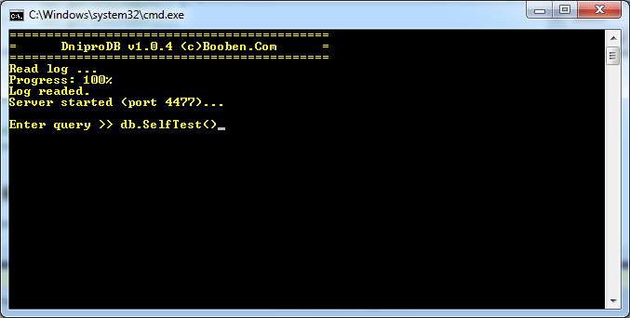
Also server supports next administration commands:
- db.GetInfo() - Get all information about current database
- db.Clear() - Remove all data from database.
- db.RestoreOnDate(yyyy, mm, dd, hh, mm, ss) - Restore database on a specific date using transaction log.

//Restore database on 2016-04-05 02:00:00
db.RestoreOnDate(2016,4,5,2,0,0);

Afterwords
This database was prepared as Research And Development project. In the database we are concentrated on creation of perfect Mathematical Model and on making of prototype for proof ideas. We have tested database on several different projects but it still Beta version, and for us it is really important to receive any feedback about real using.
Please, contact with us if
- You have find a bug and you want to fix it asap
- You have written benchmark and received new results to compare with other DB systems
- You want to start usage of the database in your project. We will consult your team free of charge.
- You have ideas in development of the database
- You want to become part of our team or to help our project in other way
- Fill free in any other questions
Email: dnipro@pikosec.com
Notes: The project in active developing process. Don't forget download latest version from GIT !
https://github.com/Bazist/

About Author
Viacheslav Makoveichuk

Software developer with 12+ years of
experience in the development.
Author several commercial and non
commercial projects from scratch.

