Info Angel

Info Angel is a FREE personal organizer and reliable partner for those who value their information and time.

This personal manager will help you create documents with its text editor similar to Microsoft Word, store contact information about your friends and colleagues, work in the Internet with its built-in browser and plan your time.

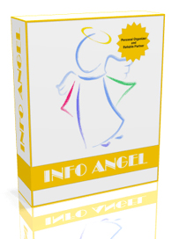

Info Angel stores all data in the form of a tree similar to Windows Explorer, which allows you to quickly manage and access any information.

Read More: http://www.angelicsoftware.com/en/info-angel.html

Download: http://www.angelicsoftware.com/downloads/InfoAngelSetup.exe

