1. Peiyun(Seed) Zeng Jing LU

2-6 Ouputs:

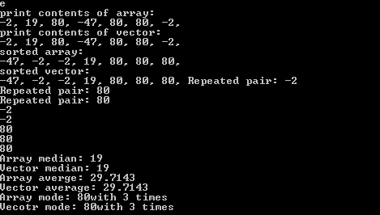

Code for

3.

