1. Lu Jing++, ++Peiyun Zeng

2. Well, cannot do that, since no insertion operator (to ostream object is defined) here

3. Initialized it with default constructor and can successfully print out the two instance variables.

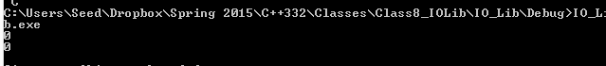

4. here you go

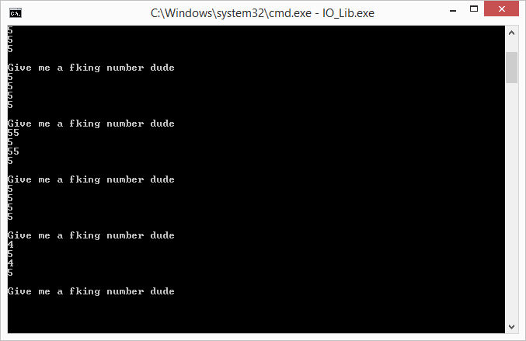

5.

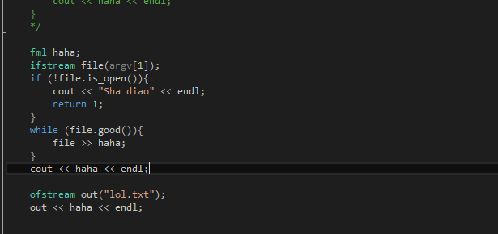

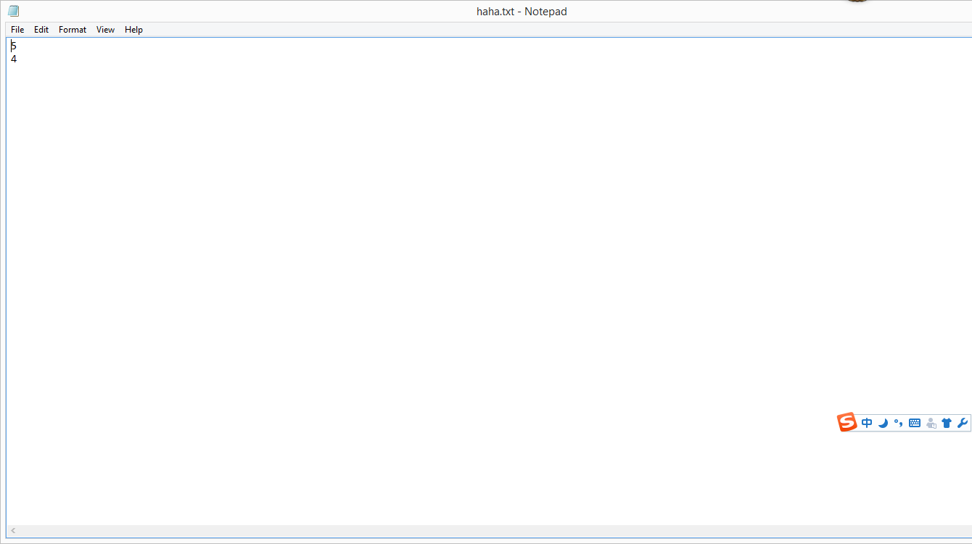

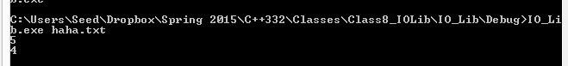

+

6.

Input

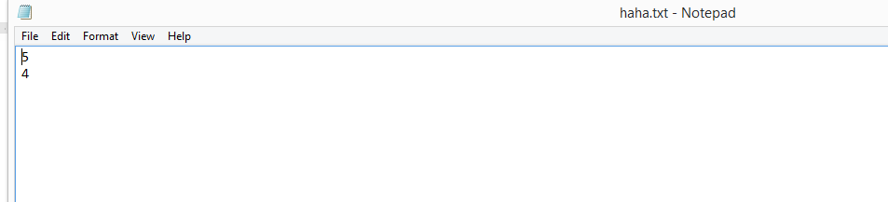

output

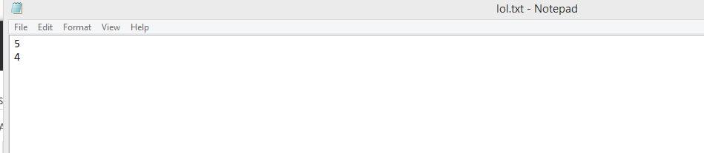

Code

