1. Seed(Peiyun) Zheng, Jing Lu

Code

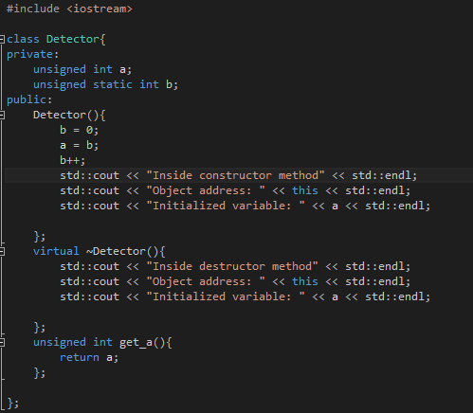

3.

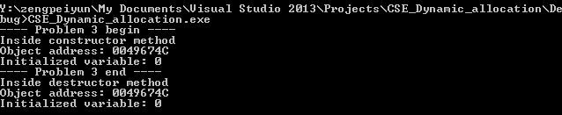

This makes sense so, everything (in this the constructor) is invoked inside the main frame and only the destructor is invoked after the main frame (stack) collapses

4.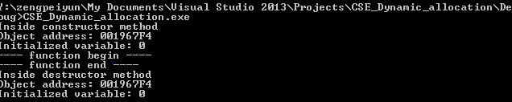

(a) The object is destroyed (always) by the shared_pointer at outermost stack, in this case the shared_ptr in main frame.

(b) it happens when the corresponding stack shrinks. in this case, the main frame shrinks

(c) only once

(d) does not exist anymore

****************************************************ASK*********************************************

5.

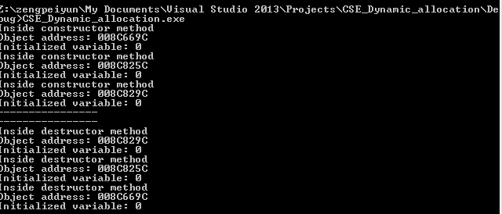

5.(a) more, if you make at least three

(b) wait for answer

6. 