1. Seed(Peiyun) Zeng, Jing Lu

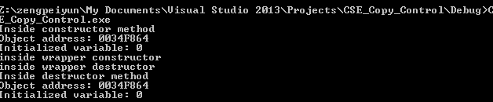

(1). Two created (one wrap, one detector)

(2). Two destroyed (one wrap, one detector)

3. 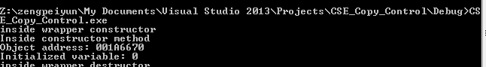

(1). Two created (One wrapper, one detector)

(2). one destroyed ( Wrapper destructor)

\*\*\*\*\*\*\*\*\*\*\*\*\*\*\*\*\*\*\*\*\*\*\*\*\*\*\*\*\*\*ASk Jiang Su yan\*\*\*\*\*\*\*\*\*\*\*\*\*\*\*\*\*\*\*\*\*\*\*\*\*\*\*\*\*\*\*\*\*\*\*\*\*\*\*\*\*\*\*\*

4.

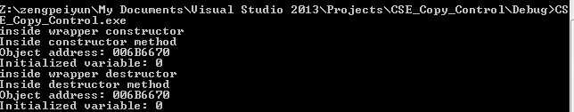

(1). Two created (One wrapper, one detector)

(2). Two destroyed ( Wrapper destructor, detector destructor)

5.

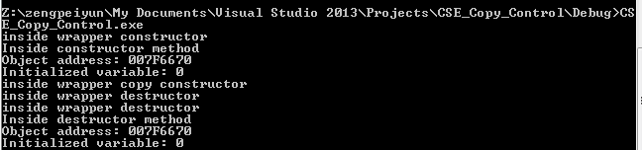

1. Detector created once, deleted once
2. Nope since you have a damn smart bool
3. The constructor constructed wrapper will delete the detector

6.

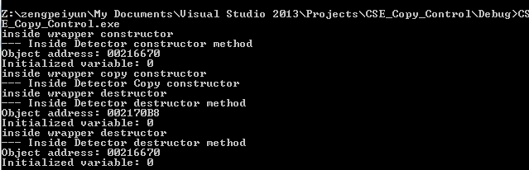

(a): Two wrappers created/destroyed

(b): Two detector created/destroyed