1. Peiyun(Seed) Zeng, Jing Lu

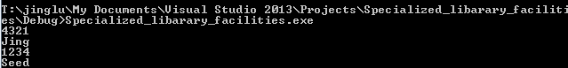

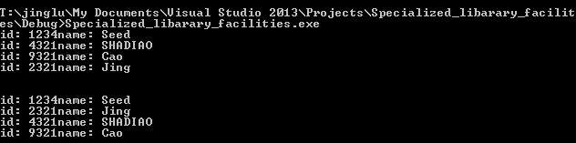

1000 Cathy Freshman

8888 Evan Freshman

1234 Alice Sophomore

3333 David Junior

5678 Bob senior

Use 2 bits to represent the classification by enumeration. (freshman=00;sophomore=01;junior=10;senior=11)

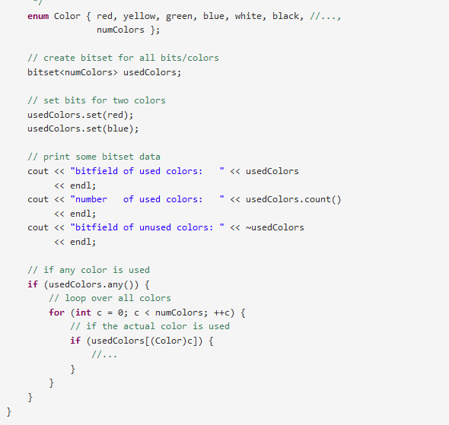

("(A|M)” ) \*

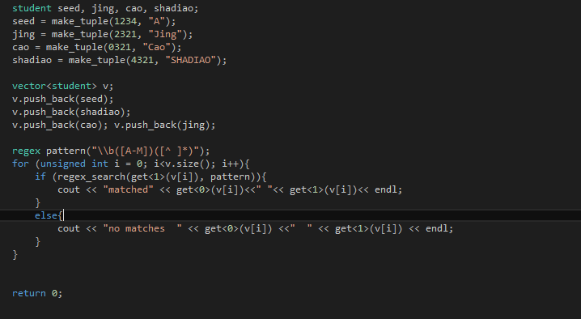

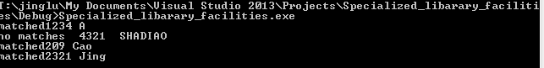

Case with time diff and no time dif

