1. Peiyun(Seed) Zeng. JING LU
2. Animal.cpp Animal.h

Endangered.cpp Endangered,h

Bear.cpp Bear.h

Panda.cpp Panda.h

Grizzly.cpp Grizzly.h

3.

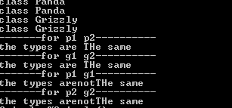

4.

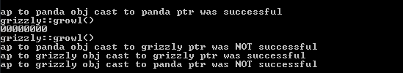

5.

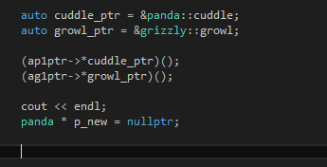

6.

