1. Members: Seed Zeng, Zihao Ma, Luke Lones
2. (a): CSE332_studio2.exe (b): always the program name contained in argv[0]

3.

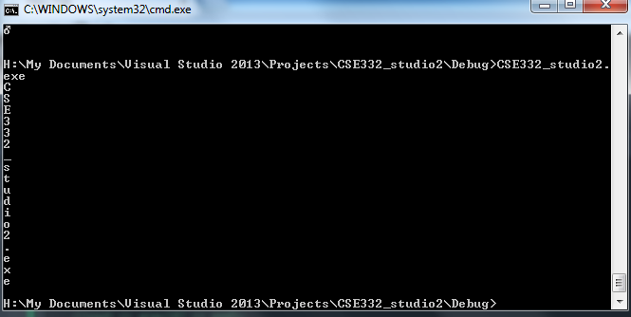

4.

(a):the reference cannot point to nothing

(b): the reference must be typed

(c): it is “const” intrinsically (cannot refer to a different object)

(c ) is the reason why this donot work for our task because we lost the ability to iterate through the string

5. no difference at all. And it should not be so that we can put faith in C++

6. ++ and deference (*)

++ iterate the pointer to the next position (in address)

* deference the pointer, gives back the object itself at which the pointer points to