1. Peiyun Zeng; Pu Chai
2. Studio5
3. Expected to crash

And it did

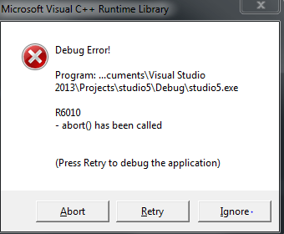

4.

Input: H:\My Documents\Visual Studio 2013\Projects\studio5\Debug>studio5.exe

Output: 5

So it catches and prints out the integer we threw. Life is good

5. since catch int cannot catch the things we threw, the exceptions will be caught by catch(…) and print out “Shadiao” (what we output inside the block)

6.

Defined functions and try catch block

//int

void SB() {

throw 5;

}

//int*

void sb_int(){

int i = 5;

int * p = &i;

throw p;

}

//char *

void SB_charstar(){

char* notstring = "hahaha";

throw notstring;

}

//char

void SB_char(){

char* notstring = "hahaha";

throw * notstring;

}

//string

void SB_string(){

throw "it is a string";

}

//long

void sb_long(){

long l = 4;

throw l;

}

int main(int argc, char* argv[])

{

//int

try{

SB();

}

catch (int &i){

cout << i << endl;

}

catch (...){

cout << " Shadiao " << endl;

}

/////////////////////////////////////////////////////

// int*

try{

sb_int();

}

catch (int* &i){

cout << i << endl;

}

catch (...){

cout << " Shadiao " << endl;

}

//////////////////////////////////////////////

//long

try{

//sb_long();

sb_long();

}

catch (long &i){

cout << i << endl;

}

catch (...){

cout << " Shadiao " << endl;

}

/////////////////////////////

//char*

try{

SB_charstar();

}

catch (char* &i){

cout << (void*)i << endl;

}

catch (...){

cout << " Shadiao " << endl;

}

//////////////////////////////////////

//char*

try{

SB_char();

}

catch (char &i){

cout << i << endl;

}

catch (...){

cout << " Shadiao " << endl;

}

return 0;

}

Output:

H:\My Documents\Visual Studio 2013\Projects\studio5\Debug>studio5.exe

5

003FF6A0

4

0086DC84

h