1. Peiyun Zeng
2. Factorial.h; Factorial.cpp

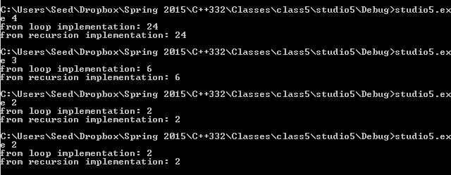

1. Pretty simple

In the new version, function takes in two arguments new (int f, int&result)

In the end we pass the final result to result

In the main function, initialize an integer Result. Then call new(t, Result)

Then cout new

Ez

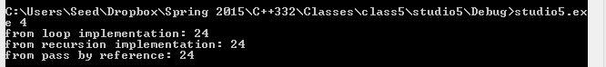

Let me show the code

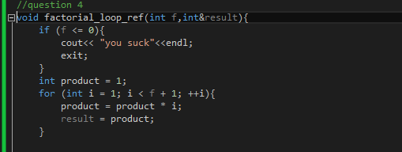

5.

Two things for the new funciton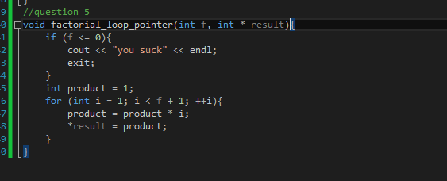

In the parameter def, it takes in a pointer instead.

Also when we pass the value, we need to dereference the variable using \*

Also in the main function, 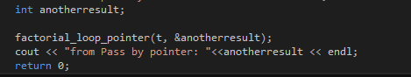

We need to pass in the address of the int (a pointer essentially) instead.

6.

(1) it will take the default value of the second parameter (to the power of) and get the correct result.

(2) it will not comiple

(3) it take the default values and prints out the correct result.