1. awesome Seed, Chris Ogle, Menga Lin

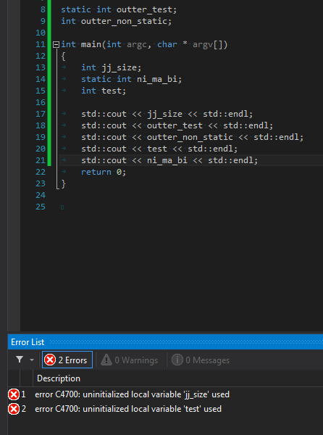

So here we can see that regardless of the scope both of the static variables did indeed compile, but the nonstatic variables caused the program to error out; however, it was only the local variable that caused this to occur and not the nonstatic global variable(outter_non_static) that caused this.

3.

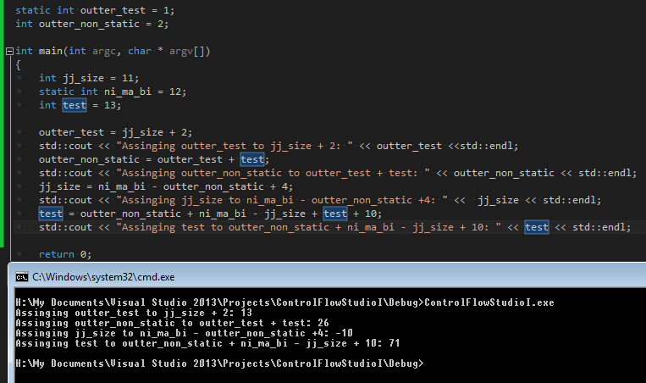

Following the variable “test” it is first used as a lvalue when it assigned the value of 13 during the initialization. Then when adding to outter_non_static the variable “test” appears on teh right hand side as a rvalue. Finally it appears as both a lvalue and rvalue when being assigned at the very last line in the screenshot above.