EDA

Table of Contents

Load the Required Packages 1

Load library 1

Read the data 3

Inspect the data 3

Computation of the annual budget performance 4

Transform the dataset into timeseries 4

Summary Statistics 4

PLots 10

Revenue variables with budget performance 10

Expenditure variables with budget performance 11

Individual Graphs 12

Revenue 12

Expenditure 15

Correlation Matrix 17

## Load the Required Packages

install.packages("pastecs")   
install.packages("fBasics")  
install.packages("timeDate")  
install.packages("timeSeries")  
install.packages("stats")  
install.packages("vars")  
install.packages("ggfortify")  
tinytex::install_tinytex()  
install.packages("tibble")

## Load library

library(pastecs)  
library(timeDate)  
library(timeSeries)  
library(fBasics)  
library(dplyr)

##   
## Attaching package: 'dplyr'

## The following objects are masked from 'package:timeSeries':  
##   
## filter, lag

## The following objects are masked from 'package:pastecs':  
##   
## first, last

## The following objects are masked from 'package:stats':  
##   
## filter, lag

## The following objects are masked from 'package:base':  
##   
## intersect, setdiff, setequal, union

library(ggplot2)  
library(tidyr)

##   
## Attaching package: 'tidyr'

## The following object is masked from 'package:pastecs':  
##   
## extract

library(vars)

## Loading required package: MASS

##   
## Attaching package: 'MASS'

## The following object is masked from 'package:dplyr':  
##   
## select

## Loading required package: strucchange

## Loading required package: zoo

##   
## Attaching package: 'zoo'

## The following object is masked from 'package:timeSeries':  
##   
## time<-

## The following objects are masked from 'package:base':  
##   
## as.Date, as.Date.numeric

## Loading required package: sandwich

## Loading required package: urca

## Loading required package: lmtest

library(ggfortify)  
library(GGally)

## Registered S3 method overwritten by 'GGally':  
## method from   
## +.gg ggplot2

library(ggpubr)  
library(tinytex)  
library(tibble)

## Read the data

bud <- read.csv("~/PhD_Thesis/Data/budget_information.csv", header = TRUE)  
bud <- as_tibble(bud)

## Inspect the data

names(bud) # To know the variable names

## [1] "period" "PCe" "PCa" "OCe" "OCa" "CRFCe" "CRFCa" "SFe"   
## [9] "SFa" "CAPEXe" "CAPEXa" "IGRe" "IGRa" "SAe" "SAa" "VATe"   
## [17] "VATa" "ORe" "ORa" "CRe" "CRa" "TRRe" "TRRa" "TRe"   
## [25] "TRa" "TREe" "TREa" "TEe" "TEa"

str(bud) # To know the class of the variables

## tibble [22 x 29] (S3: tbl_df/tbl/data.frame)  
## $ period: int [1:22] 1999 2000 2001 2002 2003 2004 2005 2006 2007 2008 ...  
## $ PCe : num [1:22] 2.00e+09 4.05e+09 9.11e+09 1.01e+10 1.14e+10 ...  
## $ PCa : num [1:22] 3.07e+09 5.90e+09 7.49e+09 7.65e+09 9.39e+09 ...  
## $ OCe : num [1:22] 4.35e+08 7.15e+08 1.11e+09 1.71e+09 2.10e+09 ...  
## $ OCa : num [1:22] 4.36e+08 6.39e+08 1.02e+09 8.59e+08 1.24e+09 ...  
## $ CRFCe : num [1:22] 1.15e+09 7.47e+08 1.84e+09 1.77e+09 2.50e+09 ...  
## $ CRFCa : num [1:22] 2.03e+08 1.01e+09 1.75e+09 4.55e+09 1.43e+09 ...  
## $ SFe : num [1:22] 1.2e+07 0.0 0.0 0.0 0.0 0.0 0.0 0.0 0.0 0.0 ...  
## $ SFa : num [1:22] 0 0 0 0 0 0 0 0 0 0 ...  
## $ CAPEXe: num [1:22] 5.33e+09 4.55e+09 8.27e+09 1.30e+10 1.26e+10 ...  
## $ CAPEXa: num [1:22] 3.25e+09 3.18e+09 4.15e+09 5.17e+09 3.04e+09 ...  
## $ IGRe : num [1:22] 1.96e+09 1.79e+09 4.41e+09 5.55e+09 3.50e+09 ...  
## $ IGRa : num [1:22] 1.06e+09 1.19e+09 1.44e+09 1.78e+09 2.41e+09 ...  
## $ SAe : num [1:22] 5.29e+08 7.00e+08 1.00e+09 1.50e+09 2.00e+09 ...  
## $ SAa : num [1:22] 7.58e+08 8.82e+08 1.37e+09 1.69e+09 1.98e+09 ...  
## $ VATe : num [1:22] 2.06e+09 5.90e+09 1.19e+10 1.55e+10 1.60e+10 ...  
## $ VATa : num [1:22] 3.17e+09 9.18e+09 8.48e+09 9.92e+09 1.29e+10 ...  
## $ ORe : num [1:22] 0 0 0 0 0 ...  
## $ ORa : num [1:22] 0 0 0 0 0 ...  
## $ CRe : num [1:22] 4.38e+09 1.67e+09 3.00e+09 4.00e+09 7.08e+09 ...  
## $ CRa : num [1:22] 1.81e+09 3.69e+07 3.57e+07 3.21e+09 9.83e+06 ...  
## $ TRRe : num [1:22] 4.54e+09 8.39e+09 1.73e+10 2.26e+10 2.15e+10 ...  
## $ TRRa : num [1:22] 4.99e+09 1.13e+10 1.13e+10 1.34e+10 1.73e+10 ...  
## $ TRe : num [1:22] 8.92e+09 1.01e+10 2.03e+10 2.66e+10 2.86e+10 ...  
## $ TRa : num [1:22] 6.80e+09 1.13e+10 1.13e+10 1.66e+10 1.73e+10 ...  
## $ TREe : num [1:22] 3.60e+09 5.51e+09 1.21e+10 1.36e+10 1.60e+10 ...  
## $ TREa : num [1:22] 3.71e+09 7.55e+09 1.03e+10 1.31e+10 1.21e+10 ...  
## $ TEe : num [1:22] 8.92e+09 1.01e+10 2.03e+10 2.66e+10 2.86e+10 ...  
## $ TEa : num [1:22] 6.96e+09 1.07e+10 1.44e+10 1.82e+10 1.51e+10 ...

## Computation of the annual budget performance

Annual Budget performance is Given as

$$bud_perf=\frac{TEa}{TEe}*100\%$$

Where: bud_perf = Annual Budget Performance TEa = Actual Total Expenditure TEe = Estimated Total Expenditure

bud <- bud %>%   
 mutate(bud_perf=(TEa/TEe)*100)  
  
names(bud)

## [1] "period" "PCe" "PCa" "OCe" "OCa" "CRFCe"   
## [7] "CRFCa" "SFe" "SFa" "CAPEXe" "CAPEXa" "IGRe"   
## [13] "IGRa" "SAe" "SAa" "VATe" "VATa" "ORe"   
## [19] "ORa" "CRe" "CRa" "TRRe" "TRRa" "TRe"   
## [25] "TRa" "TREe" "TREa" "TEe" "TEa" "bud_perf"

## Transform the dataset into timeseries

bud <- bud %>%   
 dplyr::select(-period) %>%   
 ts(start = 1999, end = 2020, frequency = 1)

## Summary Statistics

pastecs::stat.desc(bud)

## PCe PCa OCe OCa CRFCe  
## nbr.val 2.200000e+01 2.200000e+01 2.200000e+01 2.200000e+01 2.200000e+01  
## nbr.null 0.000000e+00 0.000000e+00 0.000000e+00 0.000000e+00 0.000000e+00  
## nbr.na 0.000000e+00 0.000000e+00 0.000000e+00 0.000000e+00 0.000000e+00  
## min 1.995955e+09 3.067967e+09 4.353460e+08 4.356722e+08 7.471015e+08  
## max 5.607377e+10 5.148414e+10 2.539972e+10 1.902633e+10 5.328749e+10  
## range 5.407782e+10 4.841617e+10 2.496438e+10 1.859066e+10 5.254039e+10  
## sum 6.080931e+11 5.152027e+11 2.391109e+11 1.555501e+11 4.141703e+11  
## median 2.425031e+10 1.913066e+10 1.182963e+10 6.536960e+09 1.637587e+10  
## mean 2.764060e+10 2.341830e+10 1.086868e+10 7.070458e+09 1.882592e+10  
## SE.mean 3.832713e+09 3.166897e+09 1.777243e+09 1.164820e+09 3.439842e+09  
## CI.mean.0.95 7.970563e+09 6.585922e+09 3.695979e+09 2.422376e+09 7.153544e+09  
## var 3.231731e+20 2.206432e+20 6.948902e+19 2.984974e+19 2.603154e+20  
## std.dev 1.797702e+10 1.485406e+10 8.336008e+09 5.463491e+09 1.613429e+10  
## coef.var 6.503846e-01 6.342929e-01 7.669754e-01 7.727210e-01 8.570254e-01  
## CRFCa SFe SFa CAPEXe CAPEXa  
## nbr.val 2.200000e+01 2.200000e+01 22 2.200000e+01 2.200000e+01  
## nbr.null 0.000000e+00 2.100000e+01 22 0.000000e+00 0.000000e+00  
## nbr.na 0.000000e+00 0.000000e+00 0 0.000000e+00 0.000000e+00  
## min 2.034293e+08 0.000000e+00 0 4.546056e+09 3.043301e+09  
## max 3.644220e+10 1.200000e+07 0 1.499420e+11 3.613193e+10  
## range 3.623877e+10 1.200000e+07 0 1.453959e+11 3.308863e+10  
## sum 3.119938e+11 1.200000e+07 0 1.221274e+12 3.871056e+11  
## median 1.181449e+10 0.000000e+00 0 6.011838e+10 1.788523e+10  
## mean 1.418154e+10 5.454545e+05 0 5.551243e+10 1.759571e+10  
## SE.mean 2.552612e+09 5.454545e+05 0 8.415488e+09 2.564071e+09  
## CI.mean.0.95 5.308446e+09 1.134335e+06 0 1.750097e+10 5.332278e+09  
## var 1.433482e+20 6.545455e+12 0 1.558050e+21 1.446381e+20  
## std.dev 1.197281e+10 2.558409e+06 0 3.947214e+10 1.202656e+10  
## coef.var 8.442533e-01 4.690416e+00 NaN 7.110504e-01 6.834938e-01  
## IGRe IGRa SAe SAa VATe  
## nbr.val 2.200000e+01 2.200000e+01 2.200000e+01 2.200000e+01 2.200000e+01  
## nbr.null 0.000000e+00 0.000000e+00 0.000000e+00 0.000000e+00 0.000000e+00  
## nbr.na 0.000000e+00 0.000000e+00 0.000000e+00 0.000000e+00 0.000000e+00  
## min 1.790893e+09 1.060040e+09 5.292727e+08 7.580331e+08 2.057721e+09  
## max 1.254768e+11 3.058315e+10 5.500000e+10 4.855481e+10 5.040000e+10  
## range 1.236859e+11 2.952311e+10 5.447073e+10 4.779678e+10 4.834228e+10  
## sum 7.151716e+11 2.651138e+11 5.644044e+11 3.705486e+11 3.135282e+11  
## median 2.921859e+10 1.171777e+10 2.981554e+10 1.039273e+10 1.101538e+10  
## mean 3.250780e+10 1.205063e+10 2.565475e+10 1.684312e+10 1.425128e+10  
## SE.mean 7.089304e+09 2.028867e+09 3.738544e+09 3.235597e+09 2.838402e+09  
## CI.mean.0.95 1.474301e+10 4.219260e+09 7.774728e+09 6.728792e+09 5.902779e+09  
## var 1.105681e+21 9.055863e+19 3.074877e+20 2.303199e+20 1.772435e+20  
## std.dev 3.325178e+10 9.516230e+09 1.753533e+10 1.517629e+10 1.331328e+10  
## coef.var 1.022886e+00 7.896876e-01 6.835120e-01 9.010384e-01 9.341814e-01  
## VATa ORe ORa CRe CRa  
## nbr.val 2.200000e+01 2.200000e+01 2.200000e+01 2.200000e+01 2.200000e+01  
## nbr.null 0.000000e+00 5.000000e+00 1.300000e+01 0.000000e+00 0.000000e+00  
## nbr.na 0.000000e+00 0.000000e+00 0.000000e+00 0.000000e+00 0.000000e+00  
## min 3.172675e+09 0.000000e+00 0.000000e+00 1.668723e+09 9.825133e+06  
## max 5.907908e+10 4.021280e+10 3.692084e+10 7.850000e+10 2.974011e+10  
## range 5.590641e+10 4.021280e+10 3.692084e+10 7.683128e+10 2.973029e+10  
## sum 3.931256e+11 2.251282e+11 1.573972e+11 6.169314e+11 1.335369e+11  
## median 1.254095e+10 4.871593e+09 0.000000e+00 2.774831e+10 3.496137e+09  
## mean 1.786935e+10 1.023310e+10 7.154419e+09 2.804234e+10 6.069860e+09  
## SE.mean 3.317743e+09 2.476304e+09 2.455728e+09 5.003122e+09 1.618311e+09  
## CI.mean.0.95 6.899625e+09 5.149756e+09 5.106967e+09 1.040456e+10 3.365462e+09  
## var 2.421632e+20 1.349058e+20 1.326732e+20 5.506871e+20 5.761648e+19  
## std.dev 1.556160e+10 1.161490e+10 1.151839e+10 2.346672e+10 7.590552e+09  
## coef.var 8.708543e-01 1.135032e+00 1.609968e+00 8.368320e-01 1.250532e+00  
## TRRe TRRa TRe TRa TREe  
## nbr.val 2.200000e+01 2.200000e+01 2.200000e+01 2.200000e+01 2.200000e+01  
## nbr.null 0.000000e+00 0.000000e+00 0.000000e+00 0.000000e+00 0.000000e+00  
## nbr.na 0.000000e+00 0.000000e+00 0.000000e+00 0.000000e+00 0.000000e+00  
## min 4.544790e+09 4.990748e+09 8.923847e+09 6.797918e+09 3.597494e+09  
## max 2.266896e+11 1.318472e+11 2.717317e+11 1.424030e+11 1.275747e+11  
## range 2.221448e+11 1.268564e+11 2.628079e+11 1.356051e+11 1.239772e+11  
## sum 1.790592e+12 1.186185e+12 2.407523e+12 1.319722e+12 1.261386e+12  
## median 7.674014e+10 5.606187e+10 1.136801e+11 5.824857e+10 5.266902e+10  
## mean 8.139054e+10 5.391751e+10 1.094329e+11 5.998737e+10 5.733574e+10  
## SE.mean 1.244989e+10 7.656967e+09 1.631274e+10 8.803720e+09 8.753286e+09  
## CI.mean.0.95 2.589095e+10 1.592353e+10 3.392420e+10 1.830834e+10 1.820345e+10  
## var 3.409992e+21 1.289841e+21 5.854320e+21 1.705121e+21 1.685640e+21  
## std.dev 5.839514e+10 3.591436e+10 7.651353e+10 4.129311e+10 4.105655e+10  
## coef.var 7.174684e-01 6.660983e-01 6.991823e-01 6.883634e-01 7.160726e-01  
## TREa TEe TEa bud_perf  
## nbr.val 2.200000e+01 2.200000e+01 2.200000e+01 22.0000000  
## nbr.null 0.000000e+00 0.000000e+00 0.000000e+00 0.0000000  
## nbr.na 0.000000e+00 0.000000e+00 0.000000e+00 0.0000000  
## min 3.707068e+09 8.923847e+09 6.956472e+09 32.0997054  
## max 1.018134e+11 2.717317e+11 1.379453e+11 106.6111519  
## range 9.810628e+10 2.628079e+11 1.309888e+11 74.5114465  
## sum 9.827465e+11 2.482660e+12 1.369852e+12 1365.2154511  
## median 3.831700e+10 1.336301e+11 6.198883e+10 61.9580887  
## mean 4.467030e+10 1.128482e+11 6.226601e+10 62.0552478  
## SE.mean 6.709072e+09 1.656382e+10 8.735885e+09 3.6591990  
## CI.mean.0.95 1.395228e+10 3.444636e+10 1.816727e+10 7.6097209  
## var 9.902564e+20 6.035926e+21 1.678945e+21 294.5742182  
## std.dev 3.146834e+10 7.769122e+10 4.097493e+10 17.1631646  
## coef.var 7.044578e-01 6.884580e-01 6.580626e-01 0.2765788

fBasics::basicStats(bud)

## PCe PCa OCe OCa  
## nobs 2.200000e+01 2.200000e+01 2.200000e+01 2.200000e+01  
## NAs 0.000000e+00 0.000000e+00 0.000000e+00 0.000000e+00  
## Minimum 1.995955e+09 3.067967e+09 4.353460e+08 4.356722e+08  
## Maximum 5.607377e+10 5.148414e+10 2.539972e+10 1.902633e+10  
## 1. Quartile 1.134098e+10 9.478036e+09 2.643657e+09 2.615196e+09  
## 3. Quartile 4.299762e+10 3.566710e+10 1.811273e+10 1.148824e+10  
## Mean 2.764060e+10 2.341830e+10 1.086868e+10 7.070458e+09  
## Median 2.425031e+10 1.913066e+10 1.182963e+10 6.536960e+09  
## Sum 6.080931e+11 5.152027e+11 2.391109e+11 1.555501e+11  
## SE Mean 3.832713e+09 3.166897e+09 1.777243e+09 1.164820e+09  
## LCL Mean 1.967003e+10 1.683238e+10 7.172698e+09 4.648082e+09  
## UCL Mean 3.561116e+10 3.000422e+10 1.456466e+10 9.492834e+09  
## Variance 3.231731e+20 2.206432e+20 6.948902e+19 2.984974e+19  
## Stdev 1.797702e+10 1.485406e+10 8.336008e+09 5.463491e+09  
## Skewness 1.468180e-01 2.645450e-01 1.599770e-01 5.021680e-01  
## Kurtosis -1.638912e+00 -1.428906e+00 -1.569667e+00 -9.814010e-01  
## CRFCe CRFCa SFe SFa CAPEXe  
## nobs 2.200000e+01 2.200000e+01 2.200000e+01 22 2.200000e+01  
## NAs 0.000000e+00 0.000000e+00 0.000000e+00 0 0.000000e+00  
## Minimum 7.471015e+08 2.034293e+08 0.000000e+00 0 4.546056e+09  
## Maximum 5.328749e+10 3.644220e+10 1.200000e+07 0 1.499420e+11  
## 1. Quartile 5.435720e+09 4.553518e+09 0.000000e+00 0 1.650293e+10  
## 3. Quartile 2.643750e+10 2.140213e+10 0.000000e+00 0 8.043055e+10  
## Mean 1.882592e+10 1.418154e+10 5.454545e+05 0 5.551243e+10  
## Median 1.637587e+10 1.181449e+10 0.000000e+00 0 6.011838e+10  
## Sum 4.141703e+11 3.119938e+11 1.200000e+07 0 1.221274e+12  
## SE Mean 3.439842e+09 2.552612e+09 5.454545e+05 0 8.415488e+09  
## LCL Mean 1.167238e+10 8.873091e+09 -5.888803e+05 0 3.801147e+10  
## UCL Mean 2.597946e+10 1.948998e+10 1.679789e+06 0 7.301340e+10  
## Variance 2.603154e+20 1.433482e+20 6.545455e+12 0 1.558050e+21  
## Stdev 1.613429e+10 1.197281e+10 2.558409e+06 0 3.947214e+10  
## Skewness 6.880860e-01 6.149930e-01 4.070195e+00 NaN 3.729960e-01  
## Kurtosis -6.998700e-01 -9.443970e-01 1.526653e+01 NaN -6.893680e-01  
## CAPEXa IGRe IGRa SAe  
## nobs 2.200000e+01 2.200000e+01 2.200000e+01 2.200000e+01  
## NAs 0.000000e+00 0.000000e+00 0.000000e+00 0.000000e+00  
## Minimum 3.043301e+09 1.790893e+09 1.060040e+09 5.292727e+08  
## Maximum 3.613193e+10 1.254768e+11 3.058315e+10 5.500000e+10  
## 1. Quartile 5.284413e+09 7.364712e+09 3.050654e+09 1.137500e+10  
## 3. Quartile 2.946524e+10 3.685005e+10 1.627155e+10 3.918900e+10  
## Mean 1.759571e+10 3.250780e+10 1.205063e+10 2.565475e+10  
## Median 1.788523e+10 2.921859e+10 1.171777e+10 2.981554e+10  
## Sum 3.871056e+11 7.151716e+11 2.651138e+11 5.644044e+11  
## SE Mean 2.564071e+09 7.089304e+09 2.028867e+09 3.738544e+09  
## LCL Mean 1.226343e+10 1.776479e+10 7.831365e+09 1.788002e+10  
## UCL Mean 2.292799e+10 4.725081e+10 1.626988e+10 3.342947e+10  
## Variance 1.446381e+20 1.105681e+21 9.055863e+19 3.074877e+20  
## Stdev 1.202656e+10 3.325178e+10 9.516230e+09 1.753533e+10  
## Skewness 1.133220e-01 1.390183e+00 5.040740e-01 -1.413070e-01  
## Kurtosis -1.684043e+00 1.244670e+00 -9.432840e-01 -1.374042e+00  
## SAa VATe VATa ORe ORa  
## nobs 2.200000e+01 2.200000e+01 2.200000e+01 2.200000e+01 2.200000e+01  
## NAs 0.000000e+00 0.000000e+00 0.000000e+00 0.000000e+00 0.000000e+00  
## Minimum 7.580331e+08 2.057721e+09 3.172675e+09 0.000000e+00 0.000000e+00  
## Maximum 4.855481e+10 5.040000e+10 5.907908e+10 4.021280e+10 3.692084e+10  
## 1. Quartile 2.430940e+09 4.625000e+09 8.521639e+09 2.187500e+09 0.000000e+00  
## 3. Quartile 2.936026e+10 1.587500e+10 1.950781e+10 1.575000e+10 1.104438e+10  
## Mean 1.684312e+10 1.425128e+10 1.786935e+10 1.023310e+10 7.154419e+09  
## Median 1.039273e+10 1.101538e+10 1.254095e+10 4.871593e+09 0.000000e+00  
## Sum 3.705486e+11 3.135282e+11 3.931256e+11 2.251282e+11 1.573972e+11  
## SE Mean 3.235597e+09 2.838402e+09 3.317743e+09 2.476304e+09 2.455728e+09  
## LCL Mean 1.011432e+10 8.348504e+09 1.096972e+10 5.083342e+09 2.047453e+09  
## UCL Mean 2.357191e+10 2.015406e+10 2.476897e+10 1.538285e+10 1.226139e+10  
## Variance 2.303199e+20 1.772435e+20 2.421632e+20 1.349058e+20 1.326732e+20  
## Stdev 1.517629e+10 1.331328e+10 1.556160e+10 1.161490e+10 1.151839e+10  
## Skewness 4.575860e-01 1.705042e+00 1.557811e+00 1.099644e+00 1.446848e+00  
## Kurtosis -1.254280e+00 2.117332e+00 1.337699e+00 7.354200e-02 7.717860e-01  
## CRe CRa TRRe TRRa  
## nobs 2.200000e+01 2.200000e+01 2.200000e+01 2.200000e+01  
## NAs 0.000000e+00 0.000000e+00 0.000000e+00 0.000000e+00  
## Minimum 1.668723e+09 9.825133e+06 4.544790e+09 4.990748e+09  
## Maximum 7.850000e+10 2.974011e+10 2.266896e+11 1.318472e+11  
## 1. Quartile 5.683313e+09 6.988559e+08 3.140664e+10 2.413090e+10  
## 3. Quartile 4.563896e+10 8.097979e+09 1.107055e+11 7.898707e+10  
## Mean 2.804234e+10 6.069860e+09 8.139054e+10 5.391751e+10  
## Median 2.774831e+10 3.496137e+09 7.674014e+10 5.606187e+10  
## Sum 6.169314e+11 1.335369e+11 1.790592e+12 1.186185e+12  
## SE Mean 5.003122e+09 1.618311e+09 1.244989e+10 7.656967e+09  
## LCL Mean 1.763777e+10 2.704398e+09 5.549958e+10 3.799397e+10  
## UCL Mean 3.844690e+10 9.435322e+09 1.072815e+11 6.984104e+10  
## Variance 5.506871e+20 5.761648e+19 3.409992e+21 1.289841e+21  
## Stdev 2.346672e+10 7.590552e+09 5.839514e+10 3.591436e+10  
## Skewness 4.833140e-01 1.595515e+00 6.417210e-01 3.505030e-01  
## Kurtosis -1.021868e+00 2.004840e+00 -2.625360e-01 -1.053963e+00  
## TRe TRa TREe TREa  
## nobs 2.200000e+01 2.200000e+01 2.200000e+01 2.200000e+01  
## NAs 0.000000e+00 0.000000e+00 0.000000e+00 0.000000e+00  
## Minimum 8.923847e+09 6.797918e+09 3.597494e+09 3.707068e+09  
## Maximum 2.717317e+11 1.424030e+11 1.275747e+11 1.018134e+11  
## 1. Quartile 3.586869e+10 2.496480e+10 1.936576e+10 1.506436e+10  
## 3. Quartile 1.693068e+11 8.384217e+10 9.548369e+10 6.842455e+10  
## Mean 1.094329e+11 5.998737e+10 5.733574e+10 4.467030e+10  
## Median 1.136801e+11 5.824857e+10 5.266902e+10 3.831700e+10  
## Sum 2.407523e+12 1.319722e+12 1.261386e+12 9.827465e+11  
## SE Mean 1.631274e+10 8.803720e+09 8.753286e+09 6.709072e+09  
## LCL Mean 7.550868e+10 4.167903e+10 3.913228e+10 3.071802e+10  
## UCL Mean 1.433571e+11 7.829570e+10 7.553919e+10 5.862258e+10  
## Variance 5.854320e+21 1.705121e+21 1.685640e+21 9.902564e+20  
## Stdev 7.651353e+10 4.129311e+10 4.105655e+10 3.146834e+10  
## Skewness 2.557980e-01 3.903830e-01 2.095040e-01 3.695490e-01  
## Kurtosis -1.170685e+00 -1.138558e+00 -1.535804e+00 -1.250881e+00  
## TEe TEa bud_perf  
## nobs 2.200000e+01 2.200000e+01 22.000000  
## NAs 0.000000e+00 0.000000e+00 0.000000  
## Minimum 8.923847e+09 6.956472e+09 32.099705  
## Maximum 2.717317e+11 1.379453e+11 106.611152  
## 1. Quartile 3.586869e+10 2.447802e+10 50.576244  
## 3. Quartile 1.732055e+11 8.975216e+10 70.568327  
## Mean 1.128482e+11 6.226601e+10 62.055248  
## Median 1.336301e+11 6.198883e+10 61.958089  
## Sum 2.482660e+12 1.369852e+12 1365.215451  
## SE Mean 1.656382e+10 8.735885e+09 3.659199  
## LCL Mean 7.840181e+10 4.409874e+10 54.445527  
## UCL Mean 1.472945e+11 8.043328e+10 69.664969  
## Variance 6.035926e+21 1.678945e+21 294.574218  
## Stdev 7.769122e+10 4.097493e+10 17.163165  
## Skewness 1.446790e-01 3.257690e-01 0.608395  
## Kurtosis -1.293833e+00 -1.165923e+00 0.171133

## PLots

# Revenue variables with budget performance

We overlayed budget performace with other revenue variables to identify any visual relationship Where:- IGRa - Actual Internally Generated Revenue SAa - Actual Statutory Allocation VATa - Actual VAT ORa - Actual Other Revenue CRA - Actual Capital Receipts

bud_rev <- bud[,c(12,14,16,18,20,29)]  
bud_rev %>%   
ggplot2::autoplot()

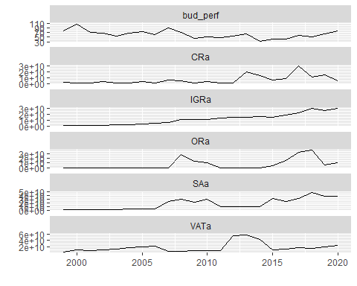

# Expenditure variables with budget performance

We overlayed budget performace with other expenditure variables to identify any visual relationship Where:- PCa - Actual Personnel Cost OCa - Actual Overhead Cost CRFCa - Actual Consolidated Revenue Fund Charges SFa - Actual Stablisation Fund CAPEXa - Actual Capital Expenditure

bud_exp <- bud[,c(2,4,6,8,10,29)]  
bud_exp %>%   
ggplot2::autoplot()

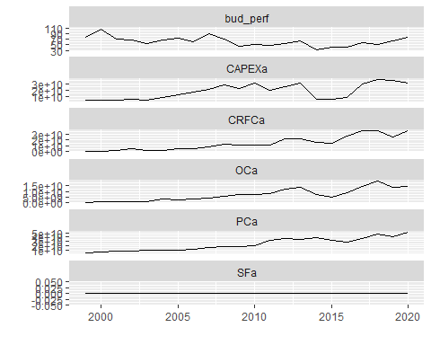

## Individual Graphs

# Revenue

g_IGRa <- bud_rev[,1] %>%   
 ggplot2::autoplot() +  
 theme(text = element_text(size = 12, face = "bold"))+  
 xlab("Period") +   
 ylab("Internally Generated Revenue")  
  
g_SAa <- bud_rev[,2] %>%   
 ggplot2::autoplot() +  
 theme(text = element_text(size = 12, face = "bold"))+  
 xlab("Period") +   
 ylab("Statutory Allocation")  
  
g_VATa <- bud_rev[,3] %>%   
 ggplot2::autoplot() +  
 theme(text = element_text(size = 12, face = "bold"))+  
 xlab("Period") +   
 ylab("VAT")  
  
  
g_ORa <- bud_rev[,4] %>%   
 ggplot2::autoplot() +  
 theme(text = element_text(size = 12, face = "bold"))+  
 xlab("Period") +   
 ylab("Other Revenue")  
  
g_CRa <- bud_rev[,5] %>%   
 ggplot2::autoplot() +  
 theme(text = element_text(size = 12, face = "bold"))+  
 xlab("Period") +   
 ylab("Actual Capital Receipts")  
  
g_bud_perf <- bud_rev[,6] %>%   
 ggplot2::autoplot() +  
 theme(text = element_text(size = 12, face = "bold"))+  
 xlab("Period") +   
 ylab("Budget Performance")  
  
ggarrange(g_IGRa, g_SAa,   
 labels = c("A", "B"),  
 ncol = 2, nrow = 1)

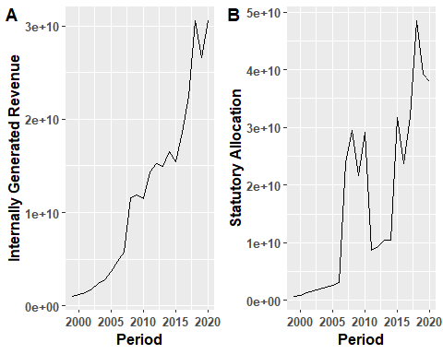

ggarrange(g_VATa, g_ORa,   
 labels = c("C", "D"),  
 ncol = 2, nrow = 1)

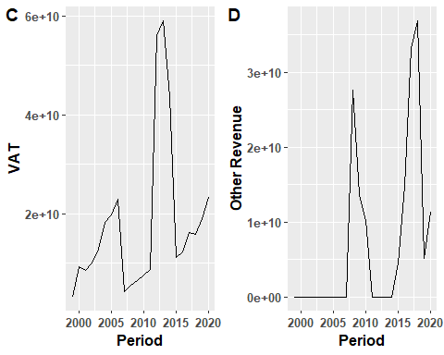

ggarrange(g_CRa, g_bud_perf,   
 labels = c("E", "F"),  
 ncol = 2, nrow = 1)

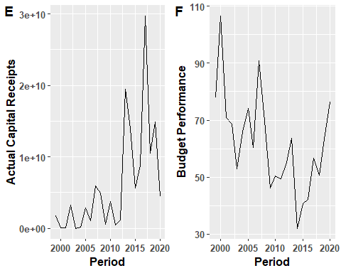

# Expenditure

g_PCa <- bud_exp[,1] %>%   
 ggplot2::autoplot() +  
 theme(text = element_text(size = 12, face = "bold"))+  
 xlab("Period") +   
 ylab("Actual Capital Expenditure")  
  
g_OCa <- bud_exp[,2] %>%   
 ggplot2::autoplot() +  
 theme(text = element_text(size = 12, face = "bold"))+  
 xlab("Period") +   
 ylab("Actual Overhead Cost")  
  
g_CRFCa <- bud_exp[,3] %>%   
 ggplot2::autoplot() +  
 theme(text = element_text(size = 12, face = "bold"))+  
 xlab("Period") +   
 ylab("Actual Consolidated Renue Fund Charges")  
  
  
g_SFa <- bud_exp[,4] %>%   
 ggplot2::autoplot() +  
 theme(text = element_text(size = 12, face = "bold"))+  
 xlab("Period") +   
 ylab("Actual Stablisation Fund")  
  
g_CAPEXa <- bud_exp[,5] %>%   
 ggplot2::autoplot() +  
 theme(text = element_text(size = 12, face = "bold"))+  
 xlab("Period") +   
 ylab("Actual Capital Expenditure")  
  
  
ggarrange(g_PCa, g_OCa,   
 labels = c("G", "H"),  
 ncol = 2, nrow = 1)

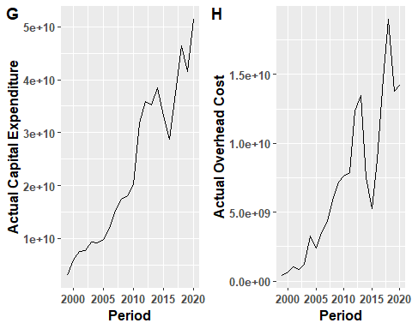

ggarrange(g_CRFCa, g_SFa,   
 labels = c("I", "J"),  
 ncol = 2, nrow = 1)

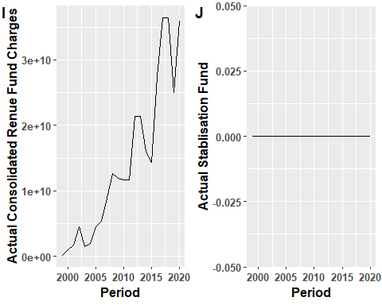

ggarrange(g_CAPEXa,   
 labels = c("K"),  
 ncol = 2, nrow = 1)

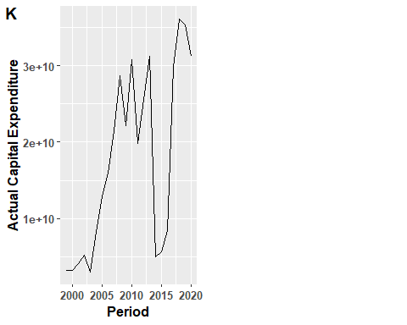

## Correlation Matrix

bud_corr <- bud[,c(2,4,6,8,10,12,14,16,18,20,29)]  
bud_corr %>%   
 as.data.frame() %>%   
 ggpairs()

## Warning in cor(x, y): the standard deviation is zero  
  
## Warning in cor(x, y): the standard deviation is zero  
  
## Warning in cor(x, y): the standard deviation is zero  
  
## Warning in cor(x, y): the standard deviation is zero  
  
## Warning in cor(x, y): the standard deviation is zero  
  
## Warning in cor(x, y): the standard deviation is zero  
  
## Warning in cor(x, y): the standard deviation is zero  
  
## Warning in cor(x, y): the standard deviation is zero  
  
## Warning in cor(x, y): the standard deviation is zero  
  
## Warning in cor(x, y): the standard deviation is zero

