EDA

Table of Contents

## Load the Required Packages

install.packages("pastecs")   
install.packages("fBasics")  
install.packages("timeDate")  
install.packages("timeSeries")  
install.packages("stats")  
install.packages("vars")  
install.packages("ggfortify")  
tinytex::install_tinytex()  
install.packages("tibble")

## Load library

library(pastecs)  
library(timeDate)  
library(timeSeries)  
library(fBasics)  
library(dplyr)

##   
## Attaching package: 'dplyr'

## The following objects are masked from 'package:timeSeries':  
##   
## filter, lag

## The following objects are masked from 'package:pastecs':  
##   
## first, last

## The following objects are masked from 'package:stats':  
##   
## filter, lag

## The following objects are masked from 'package:base':  
##   
## intersect, setdiff, setequal, union

library(ggplot2)  
library(tidyr)

##   
## Attaching package: 'tidyr'

## The following object is masked from 'package:pastecs':  
##   
## extract

library(vars)

## Loading required package: MASS

##   
## Attaching package: 'MASS'

## The following object is masked from 'package:dplyr':  
##   
## select

## Loading required package: strucchange

## Loading required package: zoo

##   
## Attaching package: 'zoo'

## The following object is masked from 'package:timeSeries':  
##   
## time<-

## The following objects are masked from 'package:base':  
##   
## as.Date, as.Date.numeric

## Loading required package: sandwich

## Loading required package: urca

## Loading required package: lmtest

library(ggfortify)  
library(GGally)

## Registered S3 method overwritten by 'GGally':  
## method from   
## +.gg ggplot2

library(ggpubr)  
library(tinytex)  
library(tibble)

## Read the data

bud <- read.csv("~/PhD_Thesis/Data/budget_information.csv", header = TRUE)  
bud <- as_tibble(bud)

## Inspect the data

names(bud) # To know the variable names

## [1] "period" "PCe" "PCa" "OCe" "OCa" "CRFCe" "CRFCa" "SFe"   
## [9] "SFa" "CAPEXe" "CAPEXa" "IGRe" "IGRa" "SAe" "SAa" "VATe"   
## [17] "VATa" "ORe" "ORa" "CRe" "CRa" "TRRe" "TRRa" "TRe"   
## [25] "TRa" "TREe" "TREa" "TEe" "TEa"

str(bud) # To know the class of the variables

## tibble [22 x 29] (S3: tbl_df/tbl/data.frame)  
## $ period: int [1:22] 1999 2000 2001 2002 2003 2004 2005 2006 2007 2008 ...  
## $ PCe : num [1:22] 2.00e+09 4.05e+09 9.11e+09 1.01e+10 1.14e+10 ...  
## $ PCa : num [1:22] 3.07e+09 5.90e+09 7.49e+09 7.65e+09 9.39e+09 ...  
## $ OCe : num [1:22] 4.35e+08 7.15e+08 1.11e+09 1.71e+09 2.10e+09 ...  
## $ OCa : num [1:22] 4.36e+08 6.39e+08 1.02e+09 8.59e+08 1.24e+09 ...  
## $ CRFCe : num [1:22] 1.15e+09 7.47e+08 1.84e+09 1.77e+09 2.50e+09 ...  
## $ CRFCa : num [1:22] 2.03e+08 1.01e+09 1.75e+09 4.55e+09 1.43e+09 ...  
## $ SFe : num [1:22] 1.2e+07 0.0 0.0 0.0 0.0 0.0 0.0 0.0 0.0 0.0 ...  
## $ SFa : num [1:22] 0 0 0 0 0 0 0 0 0 0 ...  
## $ CAPEXe: num [1:22] 5.33e+09 4.55e+09 8.27e+09 1.30e+10 1.26e+10 ...  
## $ CAPEXa: num [1:22] 3.25e+09 3.18e+09 4.15e+09 5.17e+09 3.04e+09 ...  
## $ IGRe : num [1:22] 1.96e+09 1.79e+09 4.41e+09 5.55e+09 3.50e+09 ...  
## $ IGRa : num [1:22] 1.06e+09 1.19e+09 1.44e+09 1.78e+09 2.41e+09 ...  
## $ SAe : num [1:22] 5.29e+08 7.00e+08 1.00e+09 1.50e+09 2.00e+09 ...  
## $ SAa : num [1:22] 7.58e+08 8.82e+08 1.37e+09 1.69e+09 1.98e+09 ...  
## $ VATe : num [1:22] 2.06e+09 5.90e+09 1.19e+10 1.55e+10 1.60e+10 ...  
## $ VATa : num [1:22] 3.17e+09 9.18e+09 8.48e+09 9.92e+09 1.29e+10 ...  
## $ ORe : num [1:22] 0 0 0 0 0 ...  
## $ ORa : num [1:22] 0 0 0 0 0 ...  
## $ CRe : num [1:22] 4.38e+09 1.67e+09 3.00e+09 4.00e+09 7.08e+09 ...  
## $ CRa : num [1:22] 1.81e+09 3.69e+07 3.57e+07 3.21e+09 9.83e+06 ...  
## $ TRRe : num [1:22] 4.54e+09 8.39e+09 1.73e+10 2.26e+10 2.15e+10 ...  
## $ TRRa : num [1:22] 4.99e+09 1.13e+10 1.13e+10 1.34e+10 1.73e+10 ...  
## $ TRe : num [1:22] 8.92e+09 1.01e+10 2.03e+10 2.66e+10 2.86e+10 ...  
## $ TRa : num [1:22] 6.80e+09 1.13e+10 1.13e+10 1.66e+10 1.73e+10 ...  
## $ TREe : num [1:22] 3.60e+09 5.51e+09 1.21e+10 1.36e+10 1.60e+10 ...  
## $ TREa : num [1:22] 3.71e+09 7.55e+09 1.03e+10 1.31e+10 1.21e+10 ...  
## $ TEe : num [1:22] 8.92e+09 1.01e+10 2.03e+10 2.66e+10 2.86e+10 ...  
## $ TEa : num [1:22] 6.96e+09 1.07e+10 1.44e+10 1.82e+10 1.51e+10 ...

## Computation of the annual budget performance

Annual Budget performance is Given as

$$bud_perf=\frac{TEa}{TEe}*100\%$$

Where: bud_perf = Annual Budget Performance TEa = Actual Total Expenditure TEe = Estimated Total Expenditure

bud <- bud %>%   
 mutate(bud_perf=(TEa/TEe)*100)  
  
names(bud)

## [1] "period" "PCe" "PCa" "OCe" "OCa" "CRFCe"   
## [7] "CRFCa" "SFe" "SFa" "CAPEXe" "CAPEXa" "IGRe"   
## [13] "IGRa" "SAe" "SAa" "VATe" "VATa" "ORe"   
## [19] "ORa" "CRe" "CRa" "TRRe" "TRRa" "TRe"   
## [25] "TRa" "TREe" "TREa" "TEe" "TEa" "bud_perf"

## Transform the dataset into timeseries

bud <- bud %>%   
 dplyr::select(-period) %>%   
 ts(start = 1999, end = 2020, frequency = 1)  
  
bud[,c(1:28)] <- round((bud[,c(1:28)])/1e9,4) # Round values to Billion Naira

## Summary Statistics

pastecs::stat.desc(bud)

## PCe PCa OCe OCa CRFCe  
## nbr.val 22.0000000 22.0000000 22.0000000 22.0000000 22.000000  
## nbr.null 0.0000000 0.0000000 0.0000000 0.0000000 0.000000  
## nbr.na 0.0000000 0.0000000 0.0000000 0.0000000 0.000000  
## min 1.9960000 3.0680000 0.4353000 0.4357000 0.747100  
## max 56.0738000 51.4841000 25.3997000 19.0263000 53.287500  
## range 54.0778000 48.4161000 24.9644000 18.5906000 52.540400  
## sum 608.0931000 515.2026000 239.1108000 155.5500000 414.170400  
## median 24.2503000 19.1306500 11.8296000 6.5369500 16.375850  
## mean 27.6405955 23.4183000 10.8686727 7.0704545 18.825927  
## SE.mean 3.8327130 3.1668960 1.7772418 1.1648187 3.439842  
## CI.mean.0.95 7.9705630 6.5859207 3.6959767 2.4223731 7.153543  
## var 323.1731550 220.6430625 69.4889483 29.8496575 260.315298  
## std.dev 17.9770174 14.8540588 8.3360031 5.4634840 16.134290  
## coef.var 0.6503846 0.6342928 0.7669753 0.7727203 0.857025  
## CRFCa SFe SFa CAPEXe CAPEXa IGRe  
## nbr.val 22.0000000 2.200000e+01 22 22.0000000 22.0000000 22.000000  
## nbr.null 0.0000000 2.100000e+01 22 0.0000000 0.0000000 0.000000  
## nbr.na 0.0000000 0.000000e+00 0 0.0000000 0.0000000 0.000000  
## min 0.2034000 0.000000e+00 0 4.5461000 3.0433000 1.790900  
## max 36.4422000 1.200000e-02 0 149.9420000 36.1319000 125.476800  
## range 36.2388000 1.200000e-02 0 145.3959000 33.0886000 123.685900  
## sum 311.9938000 1.200000e-02 0 1221.2736000 387.1054000 715.171500  
## median 11.8145000 0.000000e+00 0 60.1184000 17.8852000 29.218600  
## mean 14.1815364 5.454545e-04 0 55.5124364 17.5957000 32.507795  
## SE.mean 2.5526103 5.454545e-04 0 8.4154864 2.5640696 7.089303  
## CI.mean.0.95 5.3084438 1.134335e-03 0 17.5009620 5.3322747 14.743013  
## var 143.3480304 6.545455e-06 0 1558.0490383 144.6379685 1105.680804  
## std.dev 11.9728038 2.558409e-03 0 39.4721299 12.0265526 33.251779  
## coef.var 0.8442529 4.690416e+00 NaN 0.7110502 0.6834938 1.022886  
## IGRa SAe SAa VATe VATa  
## nbr.val 22.0000000 22.0000000 22.0000000 22.0000000 22.0000000  
## nbr.null 0.0000000 0.0000000 0.0000000 0.0000000 0.0000000  
## nbr.na 0.0000000 0.0000000 0.0000000 0.0000000 0.0000000  
## min 1.0600000 0.5293000 0.7580000 2.0577000 3.1727000  
## max 30.5832000 55.0000000 48.5548000 50.4000000 59.0791000  
## range 29.5232000 54.4707000 47.7968000 48.3423000 55.9064000  
## sum 265.1137000 564.4045000 370.5486000 313.5282000 393.1257000  
## median 11.7177500 29.8155500 10.3927500 11.0154000 12.5409500  
## mean 12.0506227 25.6547500 16.8431182 14.2512818 17.8693500  
## SE.mean 2.0288685 3.7385442 3.2355963 2.8384015 3.3177444  
## CI.mean.0.95 4.2192630 7.7747282 6.7287909 5.9027791 6.8996272  
## var 90.5587634 307.4876766 230.3198365 177.2435077 242.1634177  
## std.dev 9.5162368 17.5353265 15.1762919 13.3132831 15.5616007  
## coef.var 0.7896884 0.6835119 0.9010381 0.9341815 0.8708543  
## ORe ORa CRe CRa TRRe  
## nbr.val 22.000000 22.000000 22.000000 22.000000 22.0000000  
## nbr.null 5.000000 13.000000 0.000000 0.000000 0.0000000  
## nbr.na 0.000000 0.000000 0.000000 0.000000 0.0000000  
## min 0.000000 0.000000 1.668700 0.009800 4.5448000  
## max 40.212800 36.920800 78.500000 29.740100 226.6896000  
## range 40.212800 36.920800 76.831300 29.730300 222.1448000  
## sum 225.128100 157.397200 616.931300 133.536900 1790.5918000  
## median 4.871600 0.000000 27.748300 3.496150 76.7401000  
## mean 10.233095 7.154418 28.042332 6.069859 81.3905364  
## SE.mean 2.476304 2.455726 5.003121 1.618309 12.4498854  
## CI.mean.0.95 5.149755 5.106963 10.404561 3.365458 25.8909540  
## var 134.905755 132.673036 550.686923 57.616325 3409.9921994  
## std.dev 11.614894 11.518378 23.466719 7.590542 58.3951385  
## coef.var 1.135032 1.609967 0.836832 1.250530 0.7174684  
## TRRa TRe TRa TREe TREa  
## nbr.val 22.0000000 22.0000000 22.0000000 22.0000000 22.0000000  
## nbr.null 0.0000000 0.0000000 0.0000000 0.0000000 0.0000000  
## nbr.na 0.0000000 0.0000000 0.0000000 0.0000000 0.0000000  
## min 4.9907000 8.9238000 6.7979000 3.5975000 3.7071000  
## max 131.8472000 271.7317000 142.4030000 127.5747000 101.8134000  
## range 126.8565000 262.8079000 135.6051000 123.9772000 98.1063000  
## sum 1186.1851000 2407.5231000 1319.7222000 1261.3863000 982.7465000  
## median 56.0618500 113.6801500 58.2485500 52.6690000 38.3169500  
## mean 53.9175045 109.4328682 59.9873727 57.3357409 44.6702955  
## SE.mean 7.6569666 16.3127377 8.8037221 8.7532852 6.7090728  
## CI.mean.0.95 15.9235338 33.9241952 18.3083423 18.2034531 13.9522806  
## var 1289.8410370 5854.3190525 1705.1214891 1685.6400446 990.2564641  
## std.dev 35.9143570 76.5135220 41.2931167 41.0565469 31.4683407  
## coef.var 0.6660983 0.6991823 0.6883635 0.7160725 0.7044579  
## TEe TEa bud_perf  
## nbr.val 22.000000 22.0000000 22.0000000  
## nbr.null 0.000000 0.0000000 0.0000000  
## nbr.na 0.000000 0.0000000 0.0000000  
## min 8.923800 6.9565000 32.0997054  
## max 271.731700 137.9453000 106.6111519  
## range 262.807900 130.9888000 74.5114465  
## sum 2482.659700 1369.8520000 1365.2154511  
## median 133.630100 61.9888500 61.9580887  
## mean 112.848168 62.2660000 62.0552478  
## SE.mean 16.563824 8.7358849 3.6591990  
## CI.mean.0.95 34.446357 18.1672673 7.6097209  
## var 6035.925516 1678.9450857 294.5742182  
## std.dev 77.691219 40.9749324 17.1631646  
## coef.var 0.688458 0.6580627 0.2765788

fBasics::basicStats(bud)

## PCe PCa OCe OCa CRFCe CRFCa  
## nobs 22.000000 22.000000 22.000000 22.000000 22.000000 22.000000  
## NAs 0.000000 0.000000 0.000000 0.000000 0.000000 0.000000  
## Minimum 1.996000 3.068000 0.435300 0.435700 0.747100 0.203400  
## Maximum 56.073800 51.484100 25.399700 19.026300 53.287500 36.442200  
## 1. Quartile 11.340975 9.478000 2.643675 2.615200 5.435725 4.553525  
## 3. Quartile 42.997600 35.667075 18.112750 11.488250 26.437500 21.402125  
## Mean 27.640595 23.418300 10.868673 7.070455 18.825927 14.181536  
## Median 24.250300 19.130650 11.829600 6.536950 16.375850 11.814500  
## Sum 608.093100 515.202600 239.110800 155.550000 414.170400 311.993800  
## SE Mean 3.832713 3.166896 1.777242 1.164819 3.439842 2.552610  
## LCL Mean 19.670032 16.832379 7.172696 4.648081 11.672384 8.873093  
## UCL Mean 35.611158 30.004221 14.564649 9.492828 25.979470 19.489980  
## Variance 323.173155 220.643063 69.488948 29.849657 260.315298 143.348030  
## Stdev 17.977017 14.854059 8.336003 5.463484 16.134290 11.972804  
## Skewness 0.146818 0.264545 0.159977 0.502170 0.688087 0.614994  
## Kurtosis -1.638912 -1.428909 -1.569667 -0.981403 -0.699870 -0.944396  
## SFe SFa CAPEXe CAPEXa IGRe IGRa  
## nobs 22.000000 22 22.000000 22.000000 22.000000 22.000000  
## NAs 0.000000 0 0.000000 0.000000 0.000000 0.000000  
## Minimum 0.000000 0 4.546100 3.043300 1.790900 1.060000  
## Maximum 0.012000 0 149.942000 36.131900 125.476800 30.583200  
## 1. Quartile 0.000000 0 16.502900 5.284400 7.364700 3.050675  
## 3. Quartile 0.000000 0 80.430550 29.465225 36.850025 16.271525  
## Mean 0.000545 0 55.512436 17.595700 32.507795 12.050623  
## Median 0.000000 0 60.118400 17.885200 29.218600 11.717750  
## Sum 0.012000 0 1221.273600 387.105400 715.171500 265.113700  
## SE Mean 0.000545 0 8.415486 2.564070 7.089303 2.028869  
## LCL Mean -0.000589 0 38.011474 12.263425 17.764783 7.831360  
## UCL Mean 0.001680 0 73.013398 22.927975 47.250808 16.269886  
## Variance 0.000007 0 1558.049038 144.637969 1105.680804 90.558763  
## Stdev 0.002558 0 39.472130 12.026553 33.251779 9.516237  
## Skewness 4.070195 NaN 0.372996 0.113322 1.390184 0.504076  
## Kurtosis 15.266529 NaN -0.689368 -1.684043 1.244671 -0.943279  
## SAe SAa VATe VATa ORe ORa  
## nobs 22.000000 22.000000 22.000000 22.000000 22.000000 22.000000  
## NAs 0.000000 0.000000 0.000000 0.000000 0.000000 0.000000  
## Minimum 0.529300 0.758000 2.057700 3.172700 0.000000 0.000000  
## Maximum 55.000000 48.554800 50.400000 59.079100 40.212800 36.920800  
## 1. Quartile 11.375000 2.430975 4.625000 8.521650 2.187500 0.000000  
## 3. Quartile 39.189000 29.360275 15.875000 19.507800 15.750000 11.044400  
## Mean 25.654750 16.843118 14.251282 17.869350 10.233095 7.154418  
## Median 29.815550 10.392750 11.015400 12.540950 4.871600 0.000000  
## Sum 564.404500 370.548600 313.528200 393.125700 225.128100 157.397200  
## SE Mean 3.738544 3.235596 2.838402 3.317744 2.476304 2.455726  
## LCL Mean 17.880022 10.114327 8.348503 10.969723 5.083340 2.047455  
## UCL Mean 33.429478 23.571909 20.154061 24.768977 15.382851 12.261381  
## Variance 307.487677 230.319837 177.243508 242.163418 134.905755 132.673036  
## Stdev 17.535327 15.176292 13.313283 15.561601 11.614894 11.518378  
## Skewness -0.141307 0.457585 1.705042 1.557811 1.099645 1.446845  
## Kurtosis -1.374043 -1.254281 2.117334 1.337699 0.073544 0.771780  
## CRe CRa TRRe TRRa TRe  
## nobs 22.000000 22.000000 22.000000 22.000000 22.000000  
## NAs 0.000000 0.000000 0.000000 0.000000 0.000000  
## Minimum 1.668700 0.009800 4.544800 4.990700 8.923800  
## Maximum 78.500000 29.740100 226.689600 131.847200 271.731700  
## 1. Quartile 5.683300 0.698850 31.406600 24.130925 35.868675  
## 3. Quartile 45.638950 8.097975 110.705550 78.987075 169.306750  
## Mean 28.042332 6.069859 81.390536 53.917505 109.432868  
## Median 27.748300 3.496150 76.740100 56.061850 113.680150  
## Sum 616.931300 133.536900 1790.591800 1186.185100 2407.523100  
## SE Mean 5.003121 1.618309 12.449885 7.656967 16.312738  
## LCL Mean 17.637771 2.704401 55.499582 37.993971 75.508673  
## UCL Mean 38.446892 9.435317 107.281490 69.841038 143.357063  
## Variance 550.686923 57.616325 3409.992199 1289.841037 5854.319053  
## Stdev 23.466719 7.590542 58.395138 35.914357 76.513522  
## Skewness 0.483315 1.595517 0.641721 0.350503 0.255797  
## Kurtosis -1.021866 2.004853 -0.262536 -1.053961 -1.170685  
## TRa TREe TREa TEe TEa  
## nobs 22.000000 22.000000 22.000000 22.000000 22.000000  
## NAs 0.000000 0.000000 0.000000 0.000000 0.000000  
## Minimum 6.797900 3.597500 3.707100 8.923800 6.956500  
## Maximum 142.403000 127.574700 101.813400 271.731700 137.945300  
## 1. Quartile 24.964775 19.365775 15.064350 35.868675 24.477975  
## 3. Quartile 83.842200 95.483725 68.424550 173.205525 89.752150  
## Mean 59.987373 57.335741 44.670295 112.848168 62.266000  
## Median 58.248550 52.669000 38.316950 133.630100 61.988850  
## Sum 1319.722200 1261.386300 982.746500 2482.659700 1369.852000  
## SE Mean 8.803722 8.753285 6.709073 16.563824 8.735885  
## LCL Mean 41.679030 39.132288 30.718015 78.401811 44.098733  
## UCL Mean 78.295715 75.539194 58.622576 147.294525 80.433267  
## Variance 1705.121489 1685.640045 990.256464 6035.925516 1678.945086  
## Stdev 41.293117 41.056547 31.468341 77.691219 40.974932  
## Skewness 0.390383 0.209503 0.369550 0.144679 0.325769  
## Kurtosis -1.138558 -1.535804 -1.250881 -1.293834 -1.165924  
## bud_perf  
## nobs 22.000000  
## NAs 0.000000  
## Minimum 32.099705  
## Maximum 106.611152  
## 1. Quartile 50.576244  
## 3. Quartile 70.568327  
## Mean 62.055248  
## Median 61.958089  
## Sum 1365.215451  
## SE Mean 3.659199  
## LCL Mean 54.445527  
## UCL Mean 69.664969  
## Variance 294.574218  
## Stdev 17.163165  
## Skewness 0.608395  
## Kurtosis 0.171133

## PLots

# Revenue variables with budget performance

We overlayed budget performace with other revenue variables to identify any visual relationship Where:- IGRa - Actual Internally Generated Revenue SAa - Actual Statutory Allocation VATa - Actual VAT ORa - Actual Other Revenue CRA - Actual Capital Receipts

bud_rev <- bud[,c(12,14,16,18,20,29)]  
bud_rev %>%   
ggplot2::autoplot()

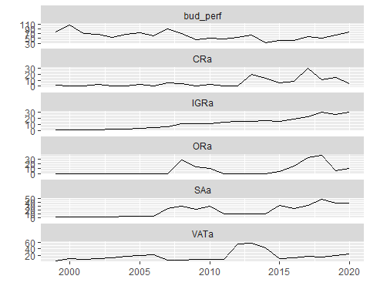

# Expenditure variables with budget performance

We overlayed budget performace with other expenditure variables to identify any visual relationship Where:- PCa - Actual Personnel Cost OCa - Actual Overhead Cost CRFCa - Actual Consolidated Revenue Fund Charges SFa - Actual Stablisation Fund CAPEXa - Actual Capital Expenditure

bud_exp <- bud[,c(2,4,6,8,10,29)]  
bud_exp %>%   
ggplot2::autoplot()

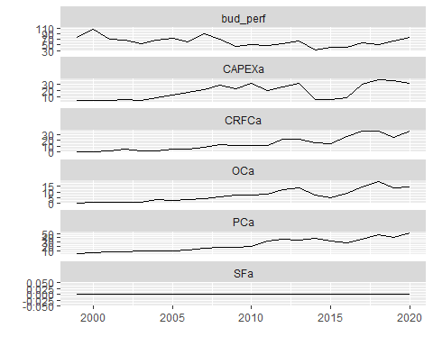

## Individual Graphs

# Revenue

g_IGRa <- bud_rev[,1] %>%   
 ggplot2::autoplot() +  
 theme(text = element_text(size = 12, face = "bold"))+  
 xlab("Period") +   
 ylab("Internally Generated Revenue (N Billion)")  
  
g_SAa <- bud_rev[,2] %>%   
 ggplot2::autoplot() +  
 theme(text = element_text(size = 12, face = "bold"))+  
 xlab("Period") +   
 ylab("Statutory Allocation (N Billion)")  
  
g_VATa <- bud_rev[,3] %>%   
 ggplot2::autoplot() +  
 theme(text = element_text(size = 12, face = "bold"))+  
 xlab("Period") +   
 ylab("VAT (N Billion)")  
  
  
g_ORa <- bud_rev[,4] %>%   
 ggplot2::autoplot() +  
 theme(text = element_text(size = 12, face = "bold"))+  
 xlab("Period") +   
 ylab("Other Revenue (N Billion)")  
  
g_CRa <- bud_rev[,5] %>%   
 ggplot2::autoplot() +  
 theme(text = element_text(size = 12, face = "bold"))+  
 xlab("Period") +   
 ylab("Actual Capital Receipts (N Billion)")  
  
g_bud_perf <- bud_rev[,6] %>%   
 ggplot2::autoplot() +  
 theme(text = element_text(size = 12, face = "bold"))+  
 xlab("Period") +   
 ylab("Budget Performance (%, Percentage)")  
  
ggarrange(g_IGRa, g_SAa,   
 labels = c("A", "B"),  
 ncol = 2, nrow = 1)

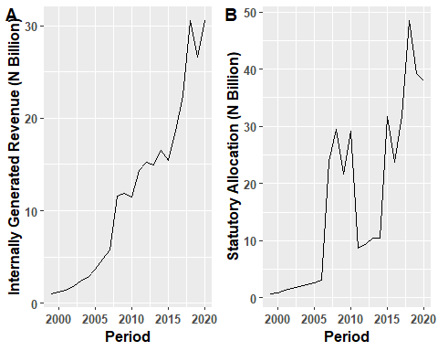

ggarrange(g_VATa, g_ORa,   
 labels = c("C", "D"),  
 ncol = 2, nrow = 1)

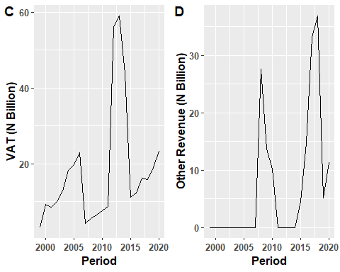

ggarrange(g_CRa, g_bud_perf,   
 labels = c("E", "F"),  
 ncol = 2, nrow = 1)

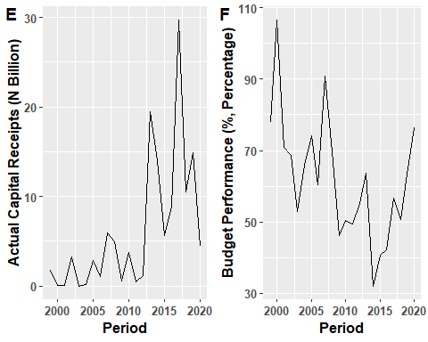

# Expenditure

g_PCa <- bud_exp[,1] %>%   
 ggplot2::autoplot() +  
 theme(text = element_text(size = 12, face = "bold"))+  
 xlab("Period") +   
 ylab("Actual Capital Expenditure (N Billion)")  
  
g_OCa <- bud_exp[,2] %>%   
 ggplot2::autoplot() +  
 theme(text = element_text(size = 12, face = "bold"))+  
 xlab("Period") +   
 ylab("Actual Overhead Cost (N Billion)")  
  
g_CRFCa <- bud_exp[,3] %>%   
 ggplot2::autoplot() +  
 theme(text = element_text(size = 12, face = "bold"))+  
 xlab("Period") +   
 ylab("Actual Consolidated Renue Fund Charges (N Billion)")  
  
  
g_SFa <- bud_exp[,4] %>%   
 ggplot2::autoplot() +  
 theme(text = element_text(size = 12, face = "bold"))+  
 xlab("Period") +   
 ylab("Actual Stablisation Fund (N Billion)")  
  
g_CAPEXa <- bud_exp[,5] %>%   
 ggplot2::autoplot() +  
 theme(text = element_text(size = 12, face = "bold"))+  
 xlab("Period") +   
 ylab("Actual Capital Expenditure (N Billion)")  
  
  
ggarrange(g_PCa, g_OCa,   
 labels = c("G", "H"),  
 ncol = 2, nrow = 1)

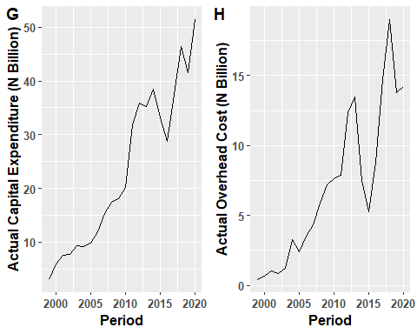

ggarrange(g_CRFCa, g_SFa,   
 labels = c("I", "J"),  
 ncol = 2, nrow = 1)

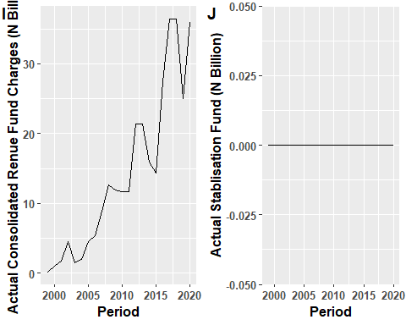

ggarrange(g_CAPEXa,   
 labels = c("K"),  
 ncol = 2, nrow = 1)

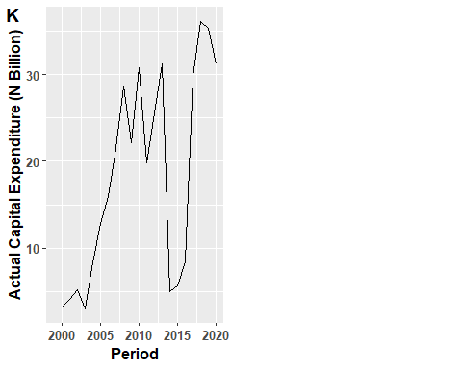

## Correlation Matrix

bud_corr <- bud[,c(2,4,6,10,12,14,16,18,20,29)]  
bud_corr %>%   
 as.data.frame() %>%   
 ggpairs()

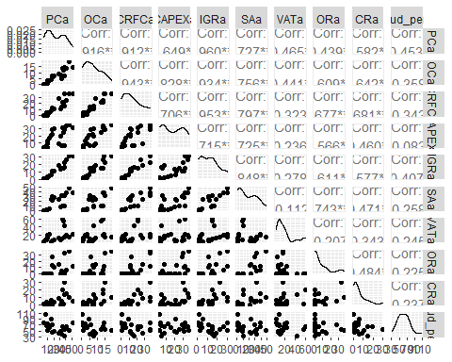

## Box plot

boxplot(bud_corr)

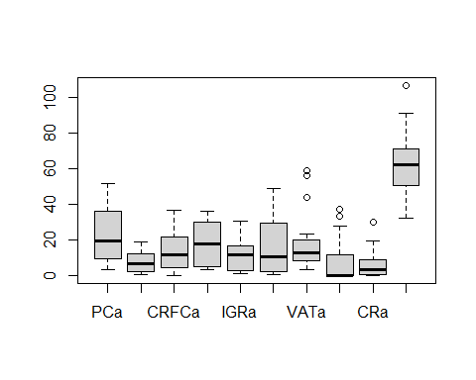

## Timeseries Model