OSI MODEL

VoltageTime
there are seven layers of the OSI reference model
1.Physical layer
2.Data link layer
3.Internet layer
4.Transport layer
5.Session layer
6.Presentation layer
7.Application layer

PHYSICAL LAYER

Physical Layer Standards
In the previous topic, you gained a high level overview of the physical layer and its place in a network. This topic dives a bit deeper into the specifics of the physical layer. This includes the components and the media used to build a network, as well as the standards that are required so that everything works together.
The protocols and operations of the upper OSI layer
s are performed using software designed by software engineers and computer scientists. The services and protocols in the TCP/IP suite are defined by the Internet Engineering Task Force (IETF).
The physical layer consists of electronic circuitry, media, and connectors developed by engineers. Therefore, it is appropriate that the standards governing this hardware are defined by the relevant electrical and communications engineering organizations.
There are many different international and national organizations, regulatory government organizations, and private companies involved in establishing and maintaining physical layer standards. For instance, the physical layer hardware, media, encoding, and signaling standards are defined and governed by these standards organizations:
- International Organization for Standardization (ISO)
- Telecommunications Industry Association/Electronic Industries Association (TIA/EIA)
- International Telecommunication Union (ITU)
- American National Standards Institute (ANSI)
- Institute of Electrical and Electronics Engineers (IEEE)
- National telecommunications regulatory authorities including the Federal Communication Commission (FCC) in the USA and the European Telecommunications Standards Institute (ETSI)
In addition to these, there are often regional cabling standards groups such as CSA (Canadian Standards Association), CENELEC (European Committee for Electrotechnical Standardization), and JSA/JIS (Japanese Standards Association), which develop local specifications.
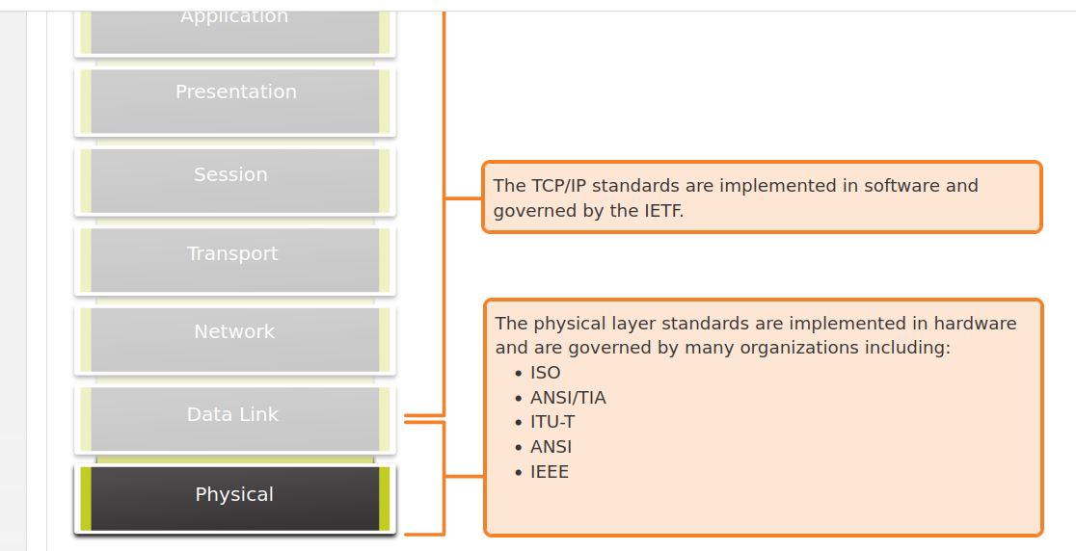

Physical Components
The physical layer standards address three functional areas:
- Physical Components
- Encoding
- Signaling
Physical Components
The physical components are the electronic hardware devices, media, and other connectors that transmit the signals that represent the bits. Hardware components such as NICs, interfaces and connectors, cable materials, and cable designs are all specified in standards associated with the physical layer. The various ports and interfaces on a Cisco 1941 router are also examples of physical components with specific connectors and pinouts resulting from standards.

4.2.3

Encoding

Encoding or line encoding is a method of converting a stream of data bits into a predefined "code”. Codes are groupings of bits used to provide a predictable pattern that can be recognized by both the sender and the receiver. In other words, encoding is the method or pattern used to represent digital information. This is similar to how Morse code encodes a message using a series of dots and dashes.
For example, Manchester encoding represents a 0 bit by a high to low voltage transition, and a 1 bit is represented as a low to high voltage transition. An example of Manchester encoding is illustrated in the figure. The transition occurs at the middle of each bit period. This type of encoding is used in 10 Mbps Ethernet. Faster data rates require more complex encoding. Manchester encoding is used in older Ethernet standards such as 10BASE-T. Ethernet 100BASE-TX uses 4B/5B encoding and 1000BASE-T uses 8B/10B encoding.

The image is a line graph of voltage over time depicting Manchester encoding of a stream of seven bits. There are horizontal lines spaced evenly apart that represent bit periods. There is also a vertical line drawn halfway up the y axis used as a reference point. As the stream of bits (signal) is sent, there are drops and rises in voltage levels in the middle of each bit period. If the bit is a binary zero, then the voltage drops in the middle. If the bit is a binary one, then the voltage rises in the middle. The bits transmitted are 0100110.

The transition occurs at the middle of each bit period.

4.2.4

Signaling
The physical layer must generate the electrical, optical, or wireless signals that represent the "1" and "0" on the media. The way that bits are represented is called the signaling method. The physical layer standards must define what type of signal represents a "1" and what type of signal represents a "0". This can be as simple as a change in the level of an electrical signal or optical pulse. For example, a long pulse might represent a 1 whereas a short pulse might represent a 0.
This is similar to the signaling method used in Morse code, which may use a series of on-off tones, lights, or clicks to send text over telephone wires or between ships at sea.
4.2.5

Bandwidth
Different physical media support the transfer of bits at different rates. Data transfer is usually discussed in terms of bandwidth. Bandwidth is the capacity at which a medium can carry data. Digital bandwidth measures the amount of data that can flow from one place to another in a given amount of time. Bandwidth is typically measured in kilobits per second (kbps), megabits per second (Mbps), or gigabits per second (Gbps). Bandwidth is sometimes thought of as the speed that bits travel, however this is not accurate. For example, in both 10Mbps and 100Mbps Ethernet, the bits are sent at the speed of electricity. The difference is the number of bits that are transmitted per second.
A combination of factors determines the practical bandwidth of a network:
- The properties of the physical media
- The technologies chosen for signaling and detecting network signals
Physical media properties, current technologies, and the laws of physics all play a role in determining the available bandwidth.
The table shows the commonly used units of measure for bandwidth.

Table caption
Unit of Bandwidth | Abbreviation | Equivalence
Bits per second | bps | 1 bps = fundamental unit of bandwidth
Kilobits per second | Kbps | 1 Kbps = 1,000 bps = 103 bps
Megabits per second | Mbps | 1 Mbps = 1,000,000 bps = 106 bps
Gigabits per second | Gbps | 1 Gbps = 1,000,000,000 bps = 109 bps
Terabits per second | Tbps | 1 Tbps = 1,000,000,000,000 bps = 1012 bps

4.2.6

Bandwidth Terminology
Terms used to measure the quality of bandwidth include:
- Latency
- Throughput
- Goodput
Latency
Latency refers to the amount of time, including delays, for data to travel from one given point to another.
In an internetwork, or a network with multiple segments, throughput cannot be faster than the slowest link in the path from source to destination. Even if all, or most, of the segments have high bandwidth, it will only take one segment in the path with low throughput to create a bottleneck in the throughput of the entire network.
Throughput
Throughput is the measure of the transfer of bits across the media over a given period of time.
Due to a number of factors, throughput usually does not match the specified bandwidth in physical layer implementations. Throughput is usually lower than the bandwidth. There are many factors that influence throughput:
- The amount of traffic
- The type of traffic
- The latency created by the number of network devices encountered between source and destination
There are many online speed tests that can reveal the throughput of an internet connection. The figure provides sample results from a speed test.
Goodput
There is a third measurement to assess the transfer of usable data; it is known as goodput. Goodput is the measure of usable data transferred over a given period of time. Goodput is throughput minus traffic overhead for establishing sessions, acknowledgments, encapsulation, and retransmitted bits. Goodput is always lower than throughput, which is generally lower than the bandwidth.

a meter measuring Mbps ranges from 0 - 100 Mbps with a display showing 80.78 Mbps for a download speed and another display showing 8.78 Mbps for an upload speed

4.3.1

Characteristics of Copper Cabling
Copper cabling is the most common type of cabling used in networks today. In fact, copper cabling is not just one type of cable. There are three different types of copper cabling that are each used in specific situations.
Networks use copper media because it is inexpensive, easy to install, and has low resistance to electrical current. However, copper media is limited by distance and signal interference.
Data is transmitted on copper cables as electrical pulses. A detector in the network interface of a destination device must receive a signal that can be successfully decoded to match the signal sent. However, the farther the signal travels, the more it deteriorates. This is referred to as signal attenuation. For this reason, all copper media must follow strict distance limitations as specified by the guiding standards.
The timing and voltage values of the electrical pulses are also susceptible to interference from two sources:
- Electromagnetic interference (EMI) or radio frequency interference (RFI) - EMI and RFI signals can distort and corrupt the data signals being carried by copper media. Potential sources of EMI and RFI include radio waves and electromagnetic devices, such as fluorescent lights or electric motors.
- Crosstalk - Crosstalk is a disturbance caused by the electric or magnetic fields of a signal on one wire to the signal in an adjacent wire. In telephone circuits, crosstalk can result in hearing part of another voice conversation from an adjacent circuit. Specifically, when an electrical current flows through a wire, it creates a small, circular magnetic field around the wire, which can be picked up by an adjacent wire.

To counter the negative effects of EMI and RFI, some types of copper cables are wrapped in metallic shielding and require proper grounding connections.
To counter the negative effects of crosstalk, some types of copper cables have opposing circuit wire pairs twisted together, which effectively cancels the crosstalk.
The susceptibility of copper cables to electronic noise can also be limited using these recommendations:
- Selecting the cable type or category most suited to a given networking environment
- Designing a cable infrastructure to avoid known and potential sources of interference in the building structure
- Using cabling techniques that include the proper handling and termination of the cables

4.3.2

Types of Copper Cabling
There are three main types of copper media used in networking.

The figure is composed of pictures showing the three types of copper cabling, each with a portion of the outer cable jacket stripped to expose the cable construction. The first picture shows unshielded twisted-pair (UTP) cable with four color pairs of twisted wires - blue, orange, green, and brown. The second picture is shielded twisted-pair (STP) cable showing four pairs of twisted wires - blue, green, brown, and orange - with a foil shield surrounding all four pairs. The last picture shows a center copper conductor surrounded by plastic insulation surrounded by a braided shield.

4.3.3

Unshielded twisted-pair (UTP)
Unshielded twisted-pair (UTP) cabling is the most common networking media. UTP cabling, terminated with RJ-45 connectors, is used for interconnecting network hosts with intermediary networking devices, such as switches and routers.
In LANs, UTP cable consists of four pairs of color-coded wires that have been twisted together and then encased in a flexible plastic sheath that protects from minor physical damage. The twisting of wires helps protect against signal interference from other wires.
As seen in the figure, the color codes identify the individual pairs and wires and aid in cable termination.
4.3.4

Shielded twisted-pair (STP)
Shielded twisted-pair (STP) provides better noise protection than UTP cabling. However, compared to UTP cable, STP cable is significantly more expensive and difficult to install. Like UTP cable, STP uses an RJ-45 connector.
STP cables combine the techniques of shielding to counter EMI and RFI, and wire twisting to counter crosstalk. To gain the full benefit of the shielding, STP cables are terminated with special shielded STP data connectors. If the cable is improperly grounded, the shield may act as an antenna and pick up unwanted signals.
The STP cable shown uses four pairs of wires, each wrapped in a foil shield, which are then wrapped in an overall metallic braid or foil.

STP cable showing the outer cable jacket (labeled 1), a braided shield around all the wire pairs (labeled 2), foil shields around the individual wire pairs (labeled 3), and the twisted colored wire pairs (labeled 4)

4.3.5

Coaxial cable
Coaxial cable, or coax for short, gets its name from the fact that there are two conductors that share the same axis. As shown in the figure, coaxial cable consists of the following:
- A copper conductor is used to transmit the electronic signals.
- A layer of flexible plastic insulation surrounds a copper conductor.
- The insulating material is surrounded in a woven copper braid, or metallic foil, that acts as the second wire in the circuit and as a shield for the inner conductor. This second layer, or shield, also reduces the amount of outside electromagnetic interference.
- The entire cable is covered with a cable jacket to prevent minor physical damage.
There are different types of connectors used with coax cable. The Bayonet Neill–Concelman (BNC), N type, and F type connectors are shown in the figure.
Although UTP cable has essentially replaced coaxial cable in modern Ethernet installations, the coaxial cable design is used in the following situations:
- Wireless installations - Coaxial cables attach antennas to wireless devices. The coaxial cable carries radio frequency (RF) energy between the antennas and the radio equipment.
- Cable internet installations - Cable service providers provide internet connectivity to their customers by replacing portions of the coaxial cable and supporting amplification elements with fiber-optic cable. However, the wiring inside the customer's premises is still coax cable.

