1. 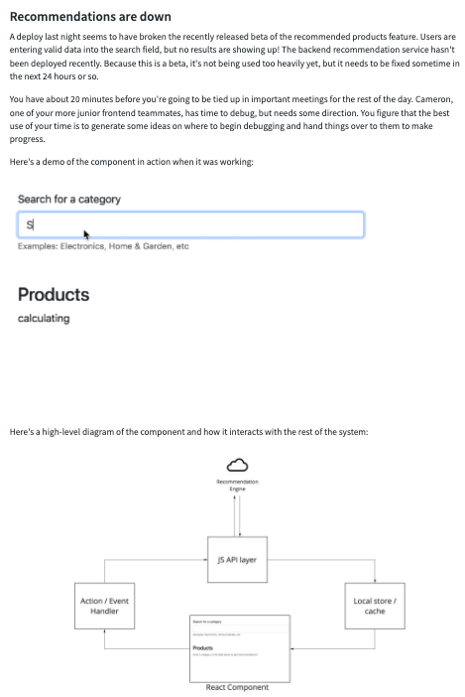

Based on your understanding of the architecture, **spend 5-10 minutes generating a list** of as many specific reasons that the frontend might not be displaying search results as possible. Try to go as broad and deep as you can – you never know what the issue might be!

Possible issues:

* Rendering Issue - Some css class might be missing.
* Event Handling Issues : Check Keydown/Keyup event is embeded into it.
* Web Service Issues : API server may not be responding data.
* GET/POST : Maybe use Proper Method to handle request.
* Store and State Issues: State should changing properly, if not check it.
* Database Issues : Check in the database, Is data available or not?
* ACL Issues: Check the access control level since it's user based.

2. Cameron, your more junior frontend teammate, has time to work on the problem this afternoon. Choose 2 promising directions from your list and **spend 10-15 minutes composing an email** explaining how they can start debugging while you're unavailable.

Cameron is smart, but new to this system, so they might not know all of the commands and tools you know. Be sure to provide context on the problem, provide specific commands, and explain why you're suggesting these actions to help them make progress.

(Pretend the textarea below is the email.)

Hi Cameron,

A deploy last night seems to have broken the recently released beta of the recommened prouct features. I will require your help in resolving the issues. You can soimply start by looking the follwoing points:

* Web Service Issue: Check if the API is working or not with GET/POST method.
* Event and Method Issue: Keydown or Keyup method embaded or not, in the input component.
* Store and State Issue: Check if the state is changing properly or not.  
  Tip: Use developer console of chrome browser.

3.

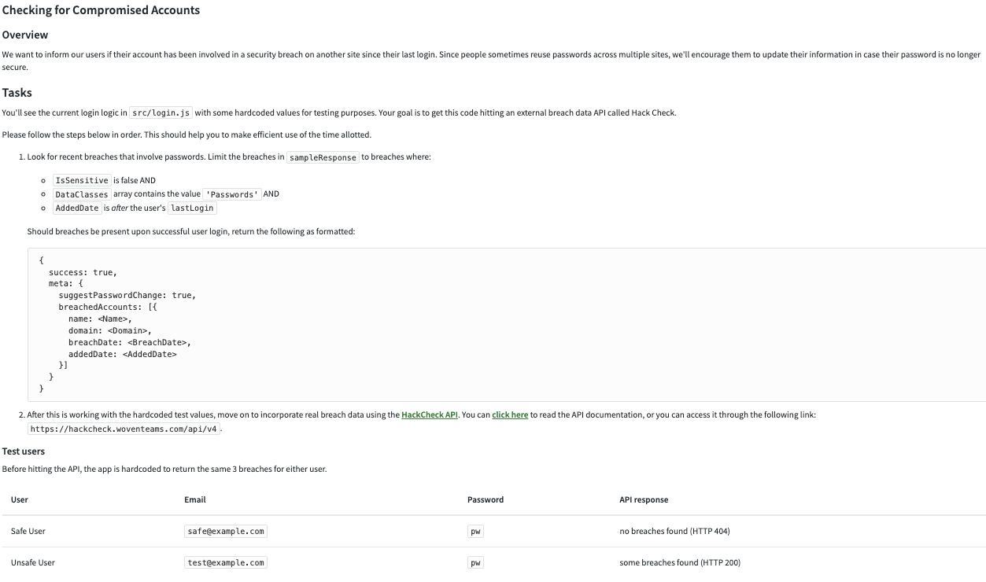

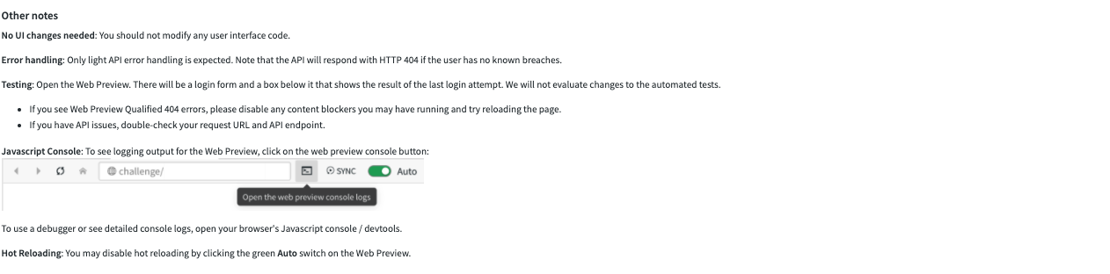

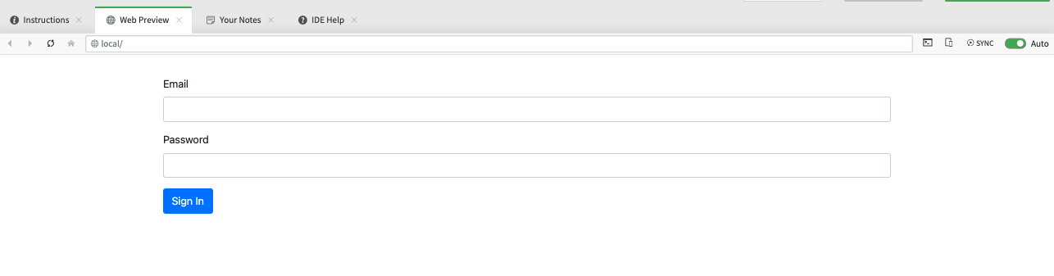

4.

4.

